Your First Job: Onboarding, I-9 & Direct Deposit
STUDENT ACTIVITY
Name: | Date: | Period:
ESSENTIAL QUESTION
You got the job - now what? What paperwork and steps do you complete during onboarding to prove you can work, set how you are taxed, set up how you get paid, and walk in ready on day one?
THE SCENARIO
Meet JORDAN ELLIS, a high school senior who just got a first job as a stocker at Brightway Grocery. Getting the offer was step one - now Jordan has to complete ONBOARDING: the paperwork that officially makes you an employee before your first paycheck.
BY THE END, YOU CAN:
✓ Identify the paperwork and steps required to start a new job, including the I-9 and W-4
✓ Explain what Form I-9 verifies and which acceptable documents prove work eligibility
✓ Set up direct deposit using a bank routing number and account number, and explain its advantages
✓ Assemble the right first-day documents and meet basic workplace expectations to complete onboarding
HOW IT WORKS (do Parts 1–5 in order)
Part 1 — Onboarding Reference Guide - Complete the Missing Terms
Part 2 — Apply the Terms - Onboarding Vocabulary in Context
Part 3 — Read the Real Form I-9
Part 4 — Complete Jordan's W-4 During Onboarding
Part 5 — Build Your Own Onboarding Plan
TIME about 45 minutes YOU’LL NEED the lesson slides and your Guided Notes.

PART 1

Onboarding Reference Guide - Complete the Missing Terms
Fill in the missing term for each blank row — the definition is your clue. Your Guided Notes and the lesson slides have every term.

Term | Definition
___________ | The process of completing the paperwork and steps that officially make you an employee on your first days at a new job
Form I-9 | The federal Employment Eligibility Verification form every new hire completes to prove they are legally allowed to work in the United States
___________ | Proof that you are legally allowed to work in the United States, which you establish with acceptable documents on the I-9
Form W-4 | The IRS form you complete so your employer knows how much federal income tax to withhold from your pay
___________ | An electronic transfer that sends your paycheck straight into your bank account automatically, instead of giving you a paper check
Routing number | The nine-digit number that identifies your bank, used along with your account number to set up direct deposit
___________ | The number that identifies your specific bank account, needed along with the routing number to set up direct deposit
Acceptable documents | The IDs the I-9 accepts to prove identity and work authorization, such as a passport (List A) or a driver's license (List B) plus a Social Security card (List C)
___________ | The IDs and information you bring on your first day so you can complete onboarding, such as a photo ID, Social Security card, and bank account details
Workplace expectations | The basic standards a new employee is expected to meet, such as showing up on time, dressing appropriately, and following the employer's rules

PART 2

Apply the Terms - Onboarding Vocabulary in Context
WORD BANK work eligibility · onboarding · first day documents · account number · direct deposit
1. The process of completing the paperwork that officially makes you an employee on your first days at a new job is called .

2. Proof that you are legally allowed to work in the United States, which you establish with acceptable documents on the I-9, is your .

3. An electronic transfer that sends your paycheck straight into your bank account automatically, instead of a paper check, is .

4. The number that identifies your specific bank account, needed along with the routing number to set up direct deposit, is your .

5. The IDs and information you bring on your first day so you can complete onboarding are your - .

PART 3

Read the Real Form I-9
Jordan Ellis's beat continues - Part 3 focus: Jordan completes Section 1 of the I-9 (the EMPLOYEE section) to attest they are eligible to work in the United States, and the EMPLOYER completes Section 2 after reviewing Jordan's documents: a List A doc, or a List B plus a List C doc.
Below is the actual USCIS Form I-9, Employment Eligibility Verification - the same form Jordan Ellis completes on day one at Brightway Grocery. Study the form image (form_i9) printed on this page. Find SECTION 1 (Employee Information and Attestation) and SECTION 2 (Employer Review and Verification), and notice the List A, List B, and List C document columns. Use what you see on the real form to answer the questions, just like Jordan does at onboarding.
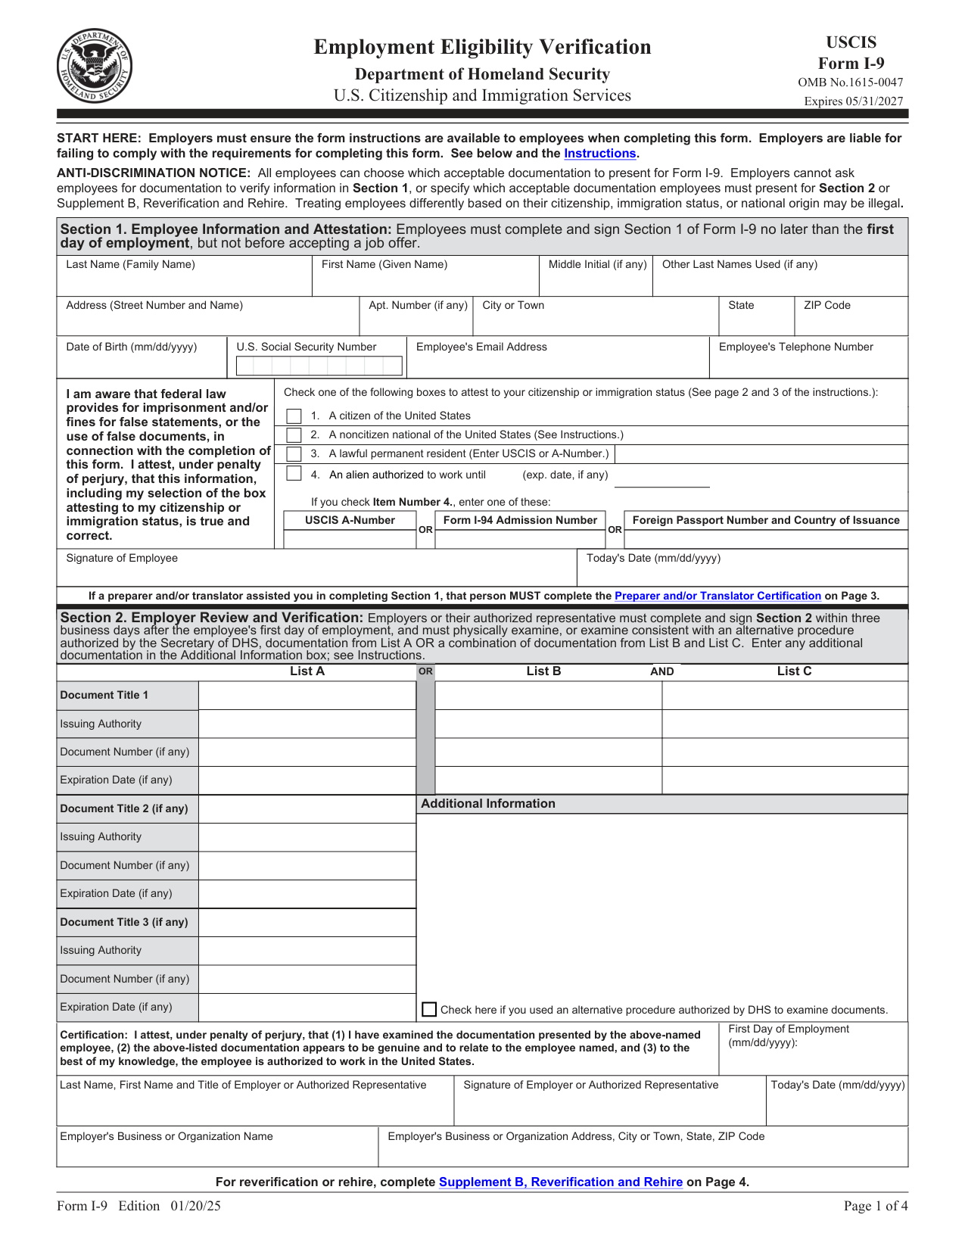

I-9 part | Who completes it / what it is for
Section 1: Employee Information and Attestation | The EMPLOYEE (Jordan) - attests they are eligible to work
Section 2: Employer Review and Verification | The EMPLOYER (Brightway) - verifies the documents
List A documents | Prove identity AND work authorization by themselves (e.g., U.S. passport)
List B + List C documents | List B proves identity (e.g., driver’s license); List C proves work authorization (e.g., Social Security card)

Calculations
1. A3-Q1. As Jordan Ellis, look at the real I-9. Which SECTION do YOU (the employee) complete, and which section does your EMPLOYER (Brightway Grocery) complete? Give the section number and its title for each.

2. A3-Q2. What does Form I-9 actually verify, and on the form, where does the new hire attest (swear) that the information is true? Name the form's purpose and the section that holds the attestation.

Analysis
1. A3-Q3. Jordan brings a driver's license and a Social Security card to onboarding. Using the List A / List B / List C columns on the I-9, explain whether those two documents satisfy the form's requirement, and give ONE other combination that would also work.

PART 4

Complete Jordan's W-4 During Onboarding
Jordan Ellis's beat continues - Part 4 focus: Jordan fills out the W-4 so payroll knows how much federal income tax to withhold, then sets up direct deposit.
Now complete the W-4 your manager at Brightway Grocery handed Jordan Ellis on day one. Jordan is single, has one job, and no dependents. Complete Step 1 (your information and filing status) and Step 5 (sign and date); you can skip Steps 2-4. (Sample document for educational use.) Then answer the onboarding questions below.

Form W-4 Employee's Withholding Certificate 2026
Department of the Treasury — Internal Revenue Service
OMB No. 1545-0074
Step 1 — Enter Personal Information
First name and middle initial | Last name
Social Security number | Address
Step 1(c) — Filing Status
Check one | Single or Married filing separately
Check one | Married filing jointly
Check one | Head of household
Step 3 — Claim Dependent and Other Credits
Dependents | Amount
Qualifying children under 17 × $2,000
Other dependents × $500
Total credits
Step 5 — Sign Here
Employee’s signature |  |  | Date
Sample document for educational use only — not an official government or financial record.

Now Finish Setting Up How Jordan Gets Paid
1. As Jordan Ellis, you just completed the W-4. In one sentence, explain what your employer will DO with the W-4 you filled out.

2. Jordan also wants to set up DIRECT DEPOSIT so the Brightway paycheck lands in the bank automatically. Name the TWO numbers payroll needs, and say where Jordan can find them.

3. Give ONE reason Jordan would choose direct deposit over a paper check.

PART 5

Build Your Own Onboarding Plan
Now plan YOUR OWN onboarding, the same way Jordan did. Imagine you just got a first job. Fill in the plan below: list the documents you would bring, the two numbers you need for direct deposit, and the onboarding steps in order. (The answer key shows ONE worked sample - your own answers will be a little different and that is expected.)

Onboarding element | Your answer
My first job (where I imagine working)
Form that proves I can work
My acceptable documents for the I-9
Form that sets my tax withholding
How I will get paid
Two numbers I need for direct deposit
My first-day documents to bring
One workplace expectation I will meet

Put the Onboarding Steps in Order
Before you write your plan, remember Jordan Ellis's onboarding sequence as a model: Jordan first completed Section 1 of the I-9 to prove work eligibility, then completed the W-4 and set up direct deposit so Brightway knew how to tax and pay them, then brought first-day documents and met workplace expectations from shift one. Use that same order in your own plan below.

Your Onboarding Plan Write-Up
FINAL PLAN
1. FINAL PLAN. Write a 5-7 sentence write-up (120-180 words) of how YOU would complete onboarding at your first job, in order. Check off each required element as you include it.
YOUR RESPONSE MUST:
☐ PROVE YOU CAN WORK - name Form I-9, say you complete Section 1, and name the acceptable documents you would bring (List A, or List B + List C).
☐ SET YOUR TAXES - name Form W-4 and say what it tells your employer to do (how much federal income tax to withhold).
☐ SET UP YOUR PAY - name DIRECT DEPOSIT and give the two numbers payroll needs (routing number and account number).
☐ BRING YOUR DOCUMENTS - list the first-day documents you would pack so you can finish onboarding in one visit.
☐ MEET EXPECTATIONS - name at least one workplace expectation you would meet from your first shift.

