PERSONAL FINANCE

YOUR FIRST JOB: ONBOARDING, I-9 & DIRECT DEPOSIT
ANSWER KEY ACTIVITY

PART 1

Onboarding Reference Guide - Complete the Missing Terms

Term | Definition
Onboarding | The process of completing the paperwork and steps that officially make you an employee on your first days at a new job
Form I-9 | The federal Employment Eligibility Verification form every new hire completes to prove they are legally allowed to work in the United States
Work eligibility | Proof that you are legally allowed to work in the United States, which you establish with acceptable documents on the I-9
Form W-4 | The IRS form you complete so your employer knows how much federal income tax to withhold from your pay
Direct deposit | An electronic transfer that sends your paycheck straight into your bank account automatically, instead of giving you a paper check
Routing number | The nine-digit number that identifies your bank, used along with your account number to set up direct deposit
Account number | The number that identifies your specific bank account, needed along with the routing number to set up direct deposit
Acceptable documents | The IDs the I-9 accepts to prove identity and work authorization, such as a passport (List A) or a driver's license (List B) plus a Social Security card (List C)
First-day documents | The IDs and information you bring on your first day so you can complete onboarding, such as a photo ID, Social Security card, and bank account details
Workplace expectations | The basic standards a new employee is expected to meet, such as showing up on time, dressing appropriately, and following the employer's rules

PART 2

Apply the Terms - Onboarding Vocabulary in Context
WORD BANK work eligibility · onboarding · first day documents · account number · direct deposit
1. The process of completing the paperwork that officially makes you an employee on your first days at a new job is called onboarding.
onboarding
2. Proof that you are legally allowed to work in the United States, which you establish with acceptable documents on the I-9, is your work eligibility.
work eligibility
3. An electronic transfer that sends your paycheck straight into your bank account automatically, instead of a paper check, is direct deposit.
direct deposit
4. The number that identifies your specific bank account, needed along with the routing number to set up direct deposit, is your account number.
account number
5. The IDs and information you bring on your first day so you can complete onboarding are your first-day documents.
first day documents

PART 3

Read the Real Form I-9
Jordan Ellis's beat continues - Part 3 focus: Jordan completes Section 1 of the I-9 (the EMPLOYEE section) to attest they are eligible to work in the United States, and the EMPLOYER completes Section 2 after reviewing Jordan's documents: a List A doc, or a List B plus a List C doc.
Below is the actual USCIS Form I-9, Employment Eligibility Verification - the same form Jordan Ellis completes on day one at Brightway Grocery. Study the form image (form_i9) printed on this page. Find SECTION 1 (Employee Information and Attestation) and SECTION 2 (Employer Review and Verification), and notice the List A, List B, and List C document columns. Use what you see on the real form to answer the questions, just like Jordan does at onboarding.
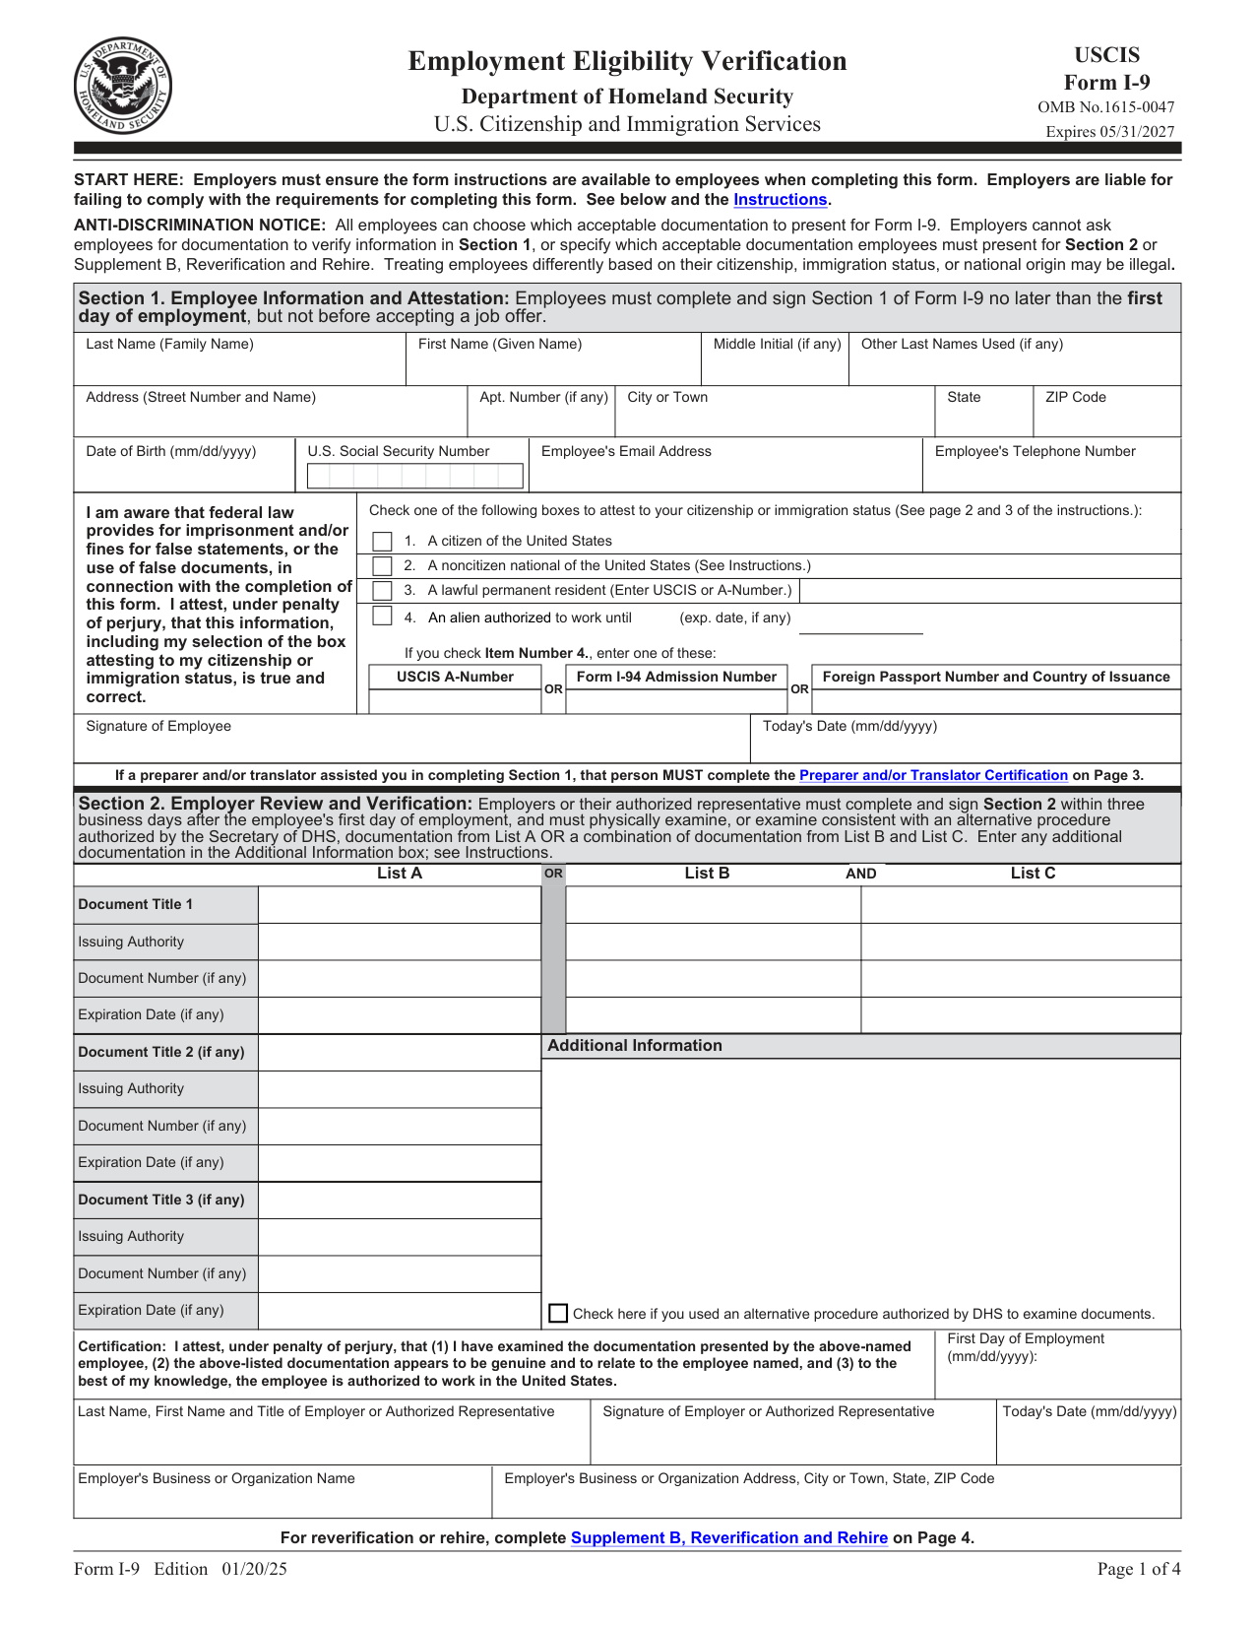

I-9 part | Who completes it / what it is for
Section 1: Employee Information and Attestation | The EMPLOYEE (Jordan) - attests they are eligible to work
Section 2: Employer Review and Verification | The EMPLOYER (Brightway) - verifies the documents
List A documents | Prove identity AND work authorization by themselves (e.g., U.S. passport)
List B + List C documents | List B proves identity (e.g., driver’s license); List C proves work authorization (e.g., Social Security card)

Calculations
1. A3-Q1. As Jordan Ellis, look at the real I-9. Which SECTION do YOU (the employee) complete, and which section does your EMPLOYER (Brightway Grocery) complete? Give the section number and its title for each.
(1) The EMPLOYEE completes Section 1 - Employee Information and Attestation; (2) The EMPLOYER completes Section 2 - Employer Review and Verification. Accept any answer that puts the employee in Section 1 (attestation) and the employer in Section 2 (review/verification).

2. A3-Q2. What does Form I-9 actually verify, and on the form, where does the new hire attest (swear) that the information is true? Name the form's purpose and the section that holds the attestation.
Form I-9 verifies WORK ELIGIBILITY - that the person is legally allowed to work in the United States. The new hire attests to that in Section 1 (Employee Information and Attestation). Accept: it proves you can legally work in the U.S., and the attestation is in Section 1.

Analysis
1. A3-Q3. Jordan brings a driver's license and a Social Security card to onboarding. Using the List A / List B / List C columns on the I-9, explain whether those two documents satisfy the form's requirement, and give ONE other combination that would also work.
Yes - a driver's license is a List B document (proves identity) and a Social Security card is a List C document (proves work authorization), and one List B plus one List C satisfies the I-9. Another combination that works is a single List A document by itself, such as a U.S. passport, which proves identity AND work authorization at once. Accept: license (List B) + Social Security card (List C) works because B+C is allowed; alternative = any single List A document (e.g., U.S. passport).

PART 4

Complete Jordan's W-4 During Onboarding
Jordan Ellis's beat continues - Part 4 focus: Jordan fills out the W-4 so payroll knows how much federal income tax to withhold, then sets up direct deposit.
Now complete the W-4 your manager at Brightway Grocery handed Jordan Ellis on day one. Jordan is single, has one job, and no dependents. Complete Step 1 (your information and filing status) and Step 5 (sign and date); you can skip Steps 2-4. (Sample document for educational use.) Then answer the onboarding questions below.

Form W-4 Employee's Withholding Certificate 2026
Department of the Treasury — Internal Revenue Service
OMB No. 1545-0074
Step 1 — Enter Personal Information
First name and middle initial  Jordan | Last name  Ellis
Social Security number  XXX-XX-6610 | Address  72 Larkspur Drive, Apt 4, Glenmore, OH 45042
Step 1(c) — Filing Status
Check one  X | Single or Married filing separately
Check one | Married filing jointly
Check one | Head of household
Step 3 — Claim Dependent and Other Credits
Dependents | Amount
Qualifying children under 17 (0 × $2,000) | $0.00
Other dependents (0 × $500) | $0.00
Total credits | $0.00
Step 5 — Sign Here
Employee’s signature  Jordan Ellis |  |  | Date  09/03/2026
Sample document for educational use only — not an official government or financial record.

Now Finish Setting Up How Jordan Gets Paid
1. As Jordan Ellis, you just completed the W-4. In one sentence, explain what your employer will DO with the W-4 you filled out.
The employer (Brightway Grocery) uses the W-4 to decide how much federal income tax to withhold from each of Jordan's paychecks.
2. Jordan also wants to set up DIRECT DEPOSIT so the Brightway paycheck lands in the bank automatically. Name the TWO numbers payroll needs, and say where Jordan can find them.
(1) The ROUTING NUMBER (the nine-digit number that identifies the bank) and (2) the ACCOUNT NUMBER (identifies Jordan's specific account). Jordan can find both on a check (or a voided check) or in the bank's app. Accept routing number and account number, found on a check or in the bank app.
3. Give ONE reason Jordan would choose direct deposit over a paper check.
Accept any one: it is automatic (no check to cash or lose); the pay usually arrives 1-2 days faster than a paper check; it is safer because there is no paper check to be lost or stolen; most employers require or prefer it.

PART 5

Build Your Own Onboarding Plan
Now plan YOUR OWN onboarding, the same way Jordan did. Imagine you just got a first job. Fill in the plan below: list the documents you would bring, the two numbers you need for direct deposit, and the onboarding steps in order. (The answer key shows ONE worked sample - your own answers will be a little different and that is expected.)

Onboarding element | Your answer
My first job (where I imagine working) | SAMPLE: Cashier at a local hardware store
Form that proves I can work | SAMPLE: Form I-9 - I complete Section 1; my employer completes Section 2
My acceptable documents for the I-9 | SAMPLE: Driver’s license (List B) + Social Security card (List C)
Form that sets my tax withholding | SAMPLE: Form W-4 - Step 1 and Step 5 required
How I will get paid | SAMPLE: Direct deposit into my checking account
Two numbers I need for direct deposit | SAMPLE: My bank routing number and my account number (from a voided check)
My first-day documents to bring | SAMPLE: Photo ID, Social Security card, voided check, and emergency contact info
One workplace expectation I will meet | SAMPLE: Show up on time and in the right uniform for every shift

Put the Onboarding Steps in Order
Before you write your plan, remember Jordan Ellis's onboarding sequence as a model: Jordan first completed Section 1 of the I-9 to prove work eligibility, then completed the W-4 and set up direct deposit so Brightway knew how to tax and pay them, then brought first-day documents and met workplace expectations from shift one. Use that same order in your own plan below.

Your Onboarding Plan Write-Up
FINAL PLAN
1. FINAL PLAN. Write a 5-7 sentence write-up (120-180 words) of how YOU would complete onboarding at your first job, in order. Check off each required element as you include it.
YOUR RESPONSE MUST:
☐ PROVE YOU CAN WORK - name Form I-9, say you complete Section 1, and name the acceptable documents you would bring (List A, or List B + List C).
☐ SET YOUR TAXES - name Form W-4 and say what it tells your employer to do (how much federal income tax to withhold).
☐ SET UP YOUR PAY - name DIRECT DEPOSIT and give the two numbers payroll needs (routing number and account number).
☐ BRING YOUR DOCUMENTS - list the first-day documents you would pack so you can finish onboarding in one visit.
☐ MEET EXPECTATIONS - name at least one workplace expectation you would meet from your first shift.
GRADING RUBRIC
Grade the evidence and reasoning, not the conclusion — any defensible position is valid. Score against the 5 requirements above.
FULL CREDIT — clear position; meets all 5 requirements with accurate, specific numbers and evidence from the lesson.
PARTIAL — position stated, but misses 1-2 requirements or uses vague / incorrect numbers.
MINIMAL — no clear position, or missing most requirements and numbers.
WHAT TO LOOK FOR IN THIS LESSON
Sample full-credit write-up (student details will vary):
To complete onboarding at my first job as a cashier, I would start by proving I can work: I would complete Section 1 of Form I-9 (the employer completes Section 2) and bring my driver's license (List B) and Social Security card (List C) as my acceptable documents. Next I would set my taxes by completing Form W-4, which tells my employer how much federal income tax to withhold from each paycheck - I would fill in Step 1 and sign Step 5. Then I would set up direct deposit so my pay lands in my bank account automatically; for that, payroll needs my bank routing number and my account number, which I can get from a voided check. I would pack my first-day documents - photo ID, Social Security card, a voided check, and my emergency contact - so I can finish onboarding in one visit. Finally, I would meet workplace expectations by showing up on time and in the right uniform from my very first shift.
REQUIRED-ELEMENT CHECKLIST (award credit per item): [1] names Form I-9, employee completes Section 1, and acceptable documents (List A or List B + List C); [2] names Form W-4 and that it sets federal income tax withholding; [3] names direct deposit AND the routing number + account number; [4] lists first-day documents to bring; [5] names at least one workplace expectation.
MORE LESSONS LESS PLANNING
Thank You!
If you enjoyed this product, please do not forget to rate and review to assist other teachers.

Looking for future discounts? Earn TPT credits by reviewing purchased products.

Please contact me if you have any issues with this product. Just like our students, I am always looking for opportunities to grow.

