Why Your Internet Only Has One Provider
STUDENT ACTIVITY
Name: | Date: | Period:
ESSENTIAL QUESTION
Why does your family get only one choice for home internet, and who profits from it?
THE SCENARIO
You report for a paid summer internship at the U.S. Federal Communications Commission (FCC) Wireline Competition Bureau and you are assigned to ALEX TORRES's broadband competition team. Alex's job is figuring out what the FCC should do about local broadband monopolies - the fact that roughly 30 percent of U.S. households still have only ONE wired internet provider at high speeds.
BY THE END, YOU CAN:
✓ Apply the four defining features of MONOPOLY from TK 22 (one seller, no close substitutes, high barriers to entry, price-maker firm) to LOCAL BROADBAND ISPs and identify why ~30 percent of U.S. households have only one wired provider
✓ Define NATURAL MONOPOLY, SUNK COST, and BARRIER TO ENTRY and explain why laying fiber or cable to every home is the central infrastructure cost that locks in local broadband monopolies
✓ Read three real charts (U.S. broadband competition distribution, price by competition level, and the Chattanooga municipal broadband case) and write a Final Recommendation Memo identifying what the FCC should do about local broadband monopolies and whether municipal broadband should be allowed in all states
HOW IT WORKS (do Parts 1–5 in order)
Part 1 — ISP Monopoly Reference Guide - Complete the Missing Terms
Part 2 — Apply the Terms - Key ISP Monopoly Vocabulary in Context
Part 3 — You Read the Three Broadband Charts with Alex Torres at the FCC
Part 4 — Four Real Scenarios with Alex Torres - Apply the Model
Part 5 — Your Final Recommendation Memo to Alex Torres
TIME about 45 minutes YOU’LL NEED the lesson slides and your Guided Notes.

PART 1

ISP Monopoly Reference Guide - Complete the Missing Terms
Fill in the missing term for each blank row — the definition is your clue. Your Guided Notes and the lesson slides have every term.

Term | Definition
___________ | A market where one provider serves all demand at lower cost than two competitors because fixed costs make duplication wasteful
Local monopoly | A monopoly that exists within a specific geographic area such as a city or zip code
___________ | A cost already spent that cannot be recovered such as laying cable to every home
Barrier to entry | Anything that prevents new firms from competing such as sunk infrastructure cost in ISPs
___________ | A historical city contract granting an ISP an exclusive license to operate
Municipal broadband | When a local government builds and operates its own broadband network
___________ | When a second wired ISP lays a duplicate network in an area already served (rare)
FCC Form 477 | The FCC broadband deployment dataset that all ISPs file twice a year
___________ | 1934 Communications Act class for common-carrier utilities restored for broadband in April 2024
Common carrier | Designation for essential infrastructure that must serve all customers at non-discriminatory FCC-regulated prices

PART 2

Apply the Terms - Key ISP Monopoly Vocabulary in Context
WORD BANK sunk cost · overbuilding · franchise agreement · title ii · natural monopoly
1. Alex starts with the core idea. Local broadband is the textbook case where ONE provider can serve every home at a LOWER cost than two competing providers could, because building duplicate cable to the same houses wastes resources - economists call this a .

2. Alex explains why a second ISP rarely shows up. The money a provider already spent laying fiber to every home - $1,200 to $2,500 per home passed - can never be recovered, so it is a textbook .

3. Before 1992, many cities handed a single cable company an exclusive license to wire the whole town. That historical city contract granting one ISP the right to operate is called a .

4. Alex notes a rare exception. When a second wired ISP lays a duplicate network in an area the incumbent already serves - which almost never earns back the cost - the industry calls it .

5. In April 2024 the FCC again placed broadband under the 1934 Communications Act common-carrier category, giving the agency the power to regulate ISP prices. That regulatory category is classification.

PART 3

You Read the Three Broadband Charts with Alex Torres at the FCC
1. Use Chart Reference 1 (chart_broadband_competition_distribution) - the bar chart showing the percent of U.S. households with one, two, three, or four-plus wired broadband providers shown below - to evaluate the U.S. competitive landscape.
(a) Read the four percentages off the chart.

(b) Combine the one-provider and two-provider percentages to get the share of U.S. households with AT MOST TWO wired choices.

(c) Identify which bar is the LARGEST and which is the SMALLEST.

(d) In 1-2 sentences, explain why the FCC Wireline Competition Bureau treats the ~30% one-provider market as the central policy concern.

2. Use Chart Reference 2 (chart_broadband_price_by_competition) - the bar chart showing average monthly broadband price by local competition level shown below - to compute the monopoly price premium.
(a) Read the three prices off the chart (monopoly market, duopoly market, three-plus competitor market).

(b) Calculate the monthly gap between the MONOPOLY price and the COMPETITIVE (three-plus) price.

(c) Multiply by 12 to get the annual extra cost per household.

(d) In 1-2 sentences, explain why the four features of monopoly predict this exact price pattern.

3. Use Chart Reference 3 (chart_chattanooga_municipal_case) - the bar chart showing average monthly broadband price in Chattanooga TN before and after the EPB Fiber municipal network launched in September 2010 shown below - to evaluate whether municipal broadband works.
(a) Read the three prices off the chart (2009 pre-launch, 2011 one year after, 2012 two years after).

(b) Calculate the total price drop in dollars AND in percent.

(c) Identify the TWO mechanisms that produced the drop.

(d) In 1-2 sentences, explain why this is evidence that ISP monopoly pricing reflects market power - not cost.

PART 4

Four Real Scenarios with Alex Torres - Apply the Model
1. THE FCC FORM 477 DATASET ANALYSIS. Alex hands you the FCC Form 477 broadband deployment dataset - the master file showing which ISPs offer service in which U.S. census blocks.
(a) In 1 sentence, define FCC Form 477.

(b) Name TWO ways the FCC uses this dataset for policy work.

(c) Identify ONE specific WEAKNESS of the Form 477 dataset that Alex says you should flag in any policy memo.

(d) Recommend ONE specific improvement to how the FCC collects broadband competition data.

2. THE CHATTANOOGA REPLICATION QUESTION. The Chattanooga case shows that when a municipal provider entered, prices dropped 35% in two years. Suppose your state allows municipal broadband (it might - check the list of 19 banned states).
(a) Name ONE structural reason most cities have NOT tried to replicate Chattanooga even when allowed.

(b) Identify the ONE specific advantage Chattanooga had that most cities lack.

(c) Predict what would happen to local incumbent ISP prices if YOUR city built a municipal fiber network.

(d) Argue whether the federal government should SUBSIDIZE municipal broadband builds the way the BEAD program subsidizes private ISPs.

3. THE RURAL BROADBAND SUBSIDY DECISION. The 2021 Infrastructure Investment and Jobs Act allocated $42.5 billion for rural broadband through the BEAD program. Suppose the FCC asks you to recommend HOW the BEAD funds should be distributed - to private ISPs, to municipal providers, or to satellite (like Starlink).
(a) Name the central pedagogical question: should BEAD fund the LOWEST-COST option (often satellite) or the HIGHEST-CAPACITY option (typically fiber)?

(b) Argue the case for funding fiber-to-the-home for rural households.

(c) Argue the case for funding satellite (Starlink) instead.

(d) Pick a recommendation - what specific allocation principle would you propose?

4. THE TITLE II CLASSIFICATION TRADE-OFF. In April 2024 the FCC restored Title II classification - broadband is once again a 'common carrier' utility under the 1934 Communications Act.
(a) In 1 sentence, define Title II classification.

(b) Identify the SPECIFIC regulatory power Title II gives the FCC over ISP monopolies.

(c) Argue the case AGAINST Title II - what is the trade-off ISPs raise?

(d) In 1-2 sentences, recommend whether the FCC should USE its Title II powers to regulate ISP prices directly - or hold back.

PART 5

Your Final Recommendation Memo to Alex Torres
FCC LOCAL BROADBAND POLICY RECOMMENDATION MEMO
1. Alex is briefing the FCC Wireline Competition Bureau next week and needs a one-page recommendation drafted by an intern.
Using your work from Parts 1-4, what should the FCC do about local broadband monopolies, and which single policy lever should it prioritize over the next 12 months?
YOUR RESPONSE MUST:
☐ Names a SPECIFIC POLICY LEVER (Title II classification, BEAD subsidy redirection, preempting state municipal broadband bans, FCC Form 477 reform, or another) AND ties the choice to the four features of monopoly.
☐ Uses the term NATURAL MONOPOLY correctly - explains why local broadband is the textbook natural monopoly because of high fixed infrastructure costs.
☐ Uses the term SUNK COST correctly - identifies the $1,200-$2,500 per home cost of laying cable as the central barrier to entry.
☐ Uses the term MUNICIPAL BROADBAND correctly - either recommends preempting state bans on it OR explains why municipal broadband works (Chattanooga case).
☐ Quotes at least ONE specific value from the chart appendix (the ~30% of households with one wired provider, the $30/month monopoly price premium, the $360/year extra cost, the Chattanooga $89 to $58 drop, the 35% Chattanooga reduction, or another) to ground the recommendation in real data.
☐ Closes with a SPECIFIC PROCEDURAL NEXT STEP the FCC should take in the next 12 months (e.g., issue notice of proposed rulemaking on wholesale access under Title II, request congressional clarification on Tenth Amendment preemption of state municipal broadband bans, expand BEAD program reporting requirements).
MEMO
To: Alex Torres, Senior Policy Analyst
From:
Date:
Re: FCC Local Broadband Monopoly Policy Recommendation

CHART REFERENCE 1: U.S. HOUSEHOLDS BY NUMBER OF WIRED BROADBAND PROVIDERS (FCC FORM 477, 2024 ESTIMATE AT 100 MBPS)
Use Chart Reference 1 (chart_broadband_competition_distribution) - the bar chart showing the percent of U.S. households with one, two, three, or four-plus wired broadband providers shown below.
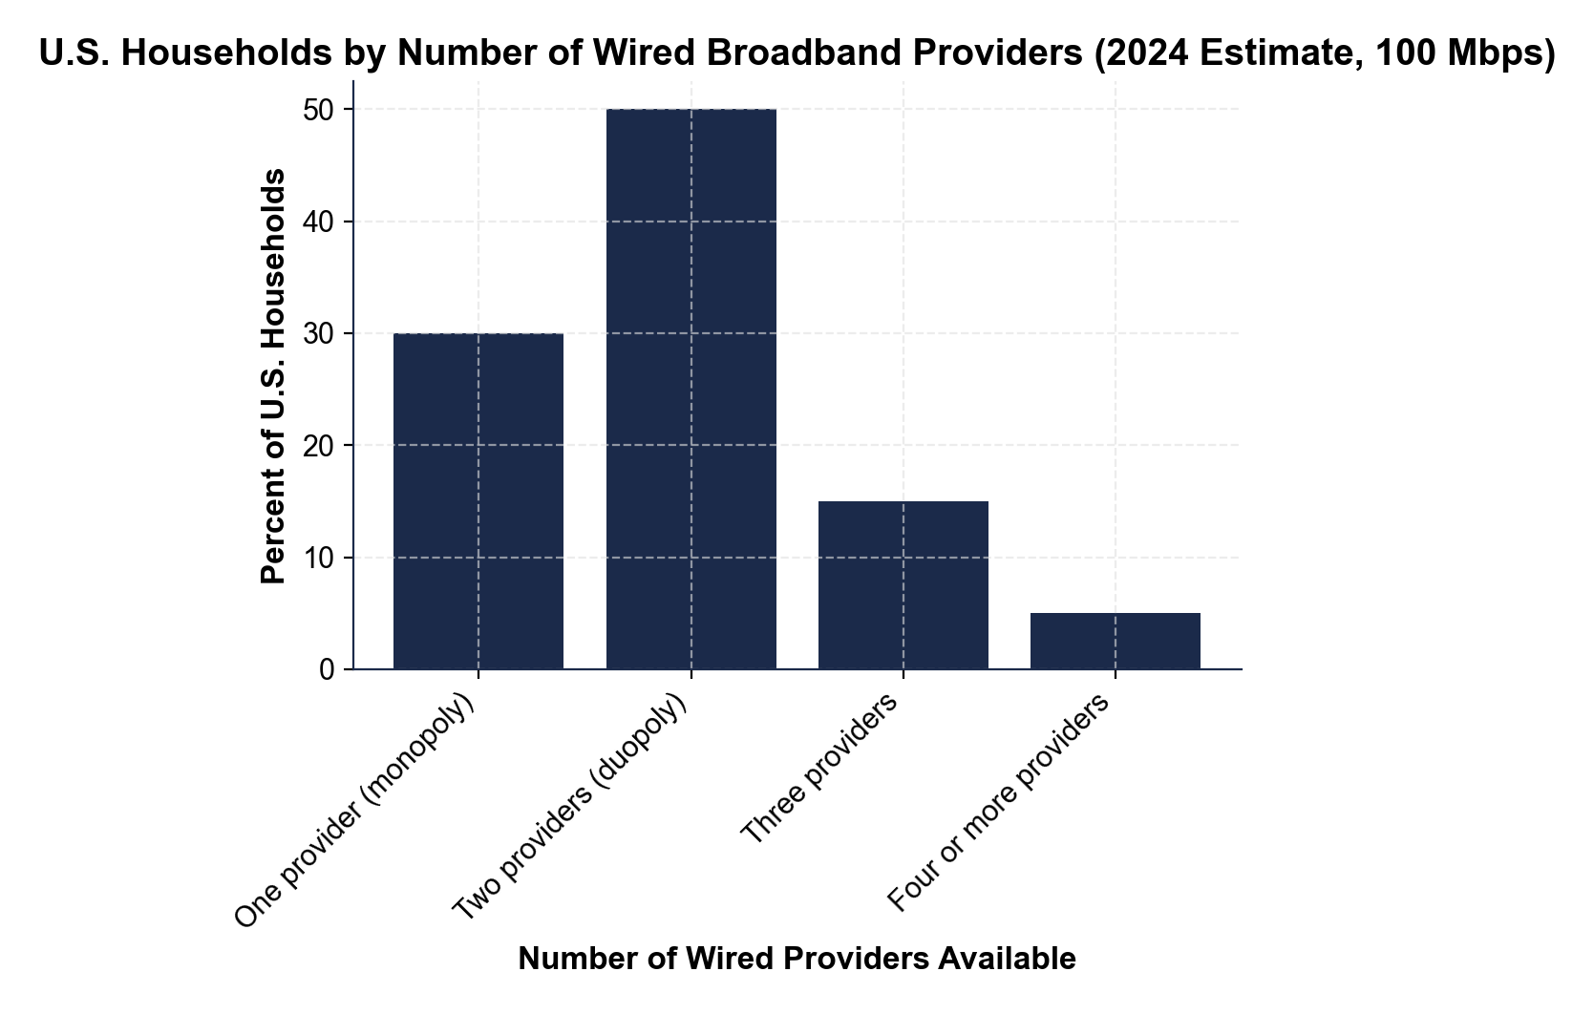
CHART REFERENCE 2: AVERAGE MONTHLY BROADBAND PRICE BY NUMBER OF COMPETITORS IN THE LOCAL MARKET
Use Chart Reference 2 (chart_broadband_price_by_competition) - the bar chart showing average monthly broadband price ($/month) for monopoly, duopoly, and three-plus competitor markets shown below.
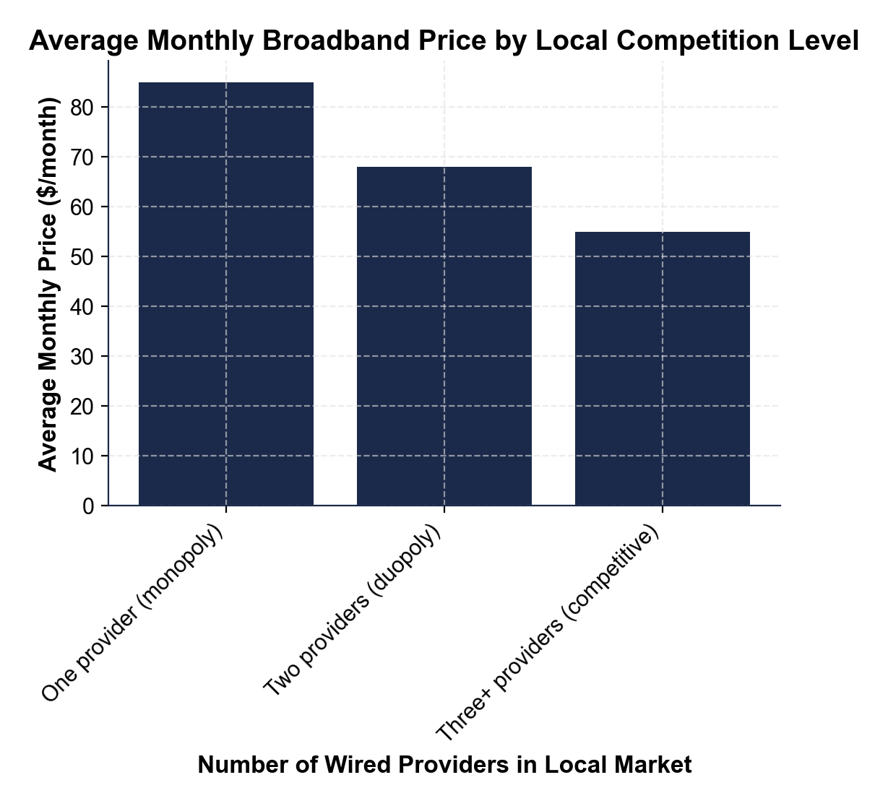
CHART REFERENCE 3: CHATTANOOGA EPB FIBER MUNICIPAL BROADBAND CASE STUDY - PRICE BEFORE AND AFTER LAUNCH
Use Chart Reference 3 (chart_chattanooga_municipal_case) - the bar chart showing average monthly broadband price in Chattanooga before EPB Fiber launched (2009), one year after launch (2011), and two years after launch (2012) shown below.
