ECONOMICS

WHY YOUR INTERNET ONLY HAS ONE PROVIDER
ANSWER KEY ACTIVITY - ANSWER KEY

PART 1

ISP Monopoly Reference Guide - Complete the Missing Terms

Term | Definition
Natural monopoly | A market where one provider serves all demand at lower cost than two competitors because fixed costs make duplication wasteful
Local monopoly | A monopoly that exists within a specific geographic area such as a city or zip code
Sunk cost | A cost already spent that cannot be recovered such as laying cable to every home
Barrier to entry | Anything that prevents new firms from competing such as sunk infrastructure cost in ISPs
Franchise agreement | A historical city contract granting an ISP an exclusive license to operate
Municipal broadband | When a local government builds and operates its own broadband network
Overbuilding | When a second wired ISP lays a duplicate network in an area already served (rare)
FCC Form 477 | The FCC broadband deployment dataset that all ISPs file twice a year
Title II classification | 1934 Communications Act class for common-carrier utilities restored for broadband in April 2024
Common carrier | Designation for essential infrastructure that must serve all customers at non-discriminatory FCC-regulated prices

PART 2

Apply the Terms - Key ISP Monopoly Vocabulary in Context
WORD BANK sunk cost · overbuilding · franchise agreement · title ii · natural monopoly
1. Alex starts with the core idea. Local broadband is the textbook case where ONE provider can serve every home at a LOWER cost than two competing providers could, because building duplicate cable to the same houses wastes resources - economists call this a natural monopoly.
natural monopoly
2. Alex explains why a second ISP rarely shows up. The money a provider already spent laying fiber to every home - $1,200 to $2,500 per home passed - can never be recovered, so it is a textbook sunk cost.
sunk cost
3. Before 1992, many cities handed a single cable company an exclusive license to wire the whole town. That historical city contract granting one ISP the right to operate is called a franchise agreement.
franchise agreement
4. Alex notes a rare exception. When a second wired ISP lays a duplicate network in an area the incumbent already serves - which almost never earns back the cost - the industry calls it Overbuilding.
Overbuilding. A second wired ISP lays a duplicate network in territory the incumbent already serves, and the build almost never earns back its cost.
5. In April 2024 the FCC again placed broadband under the 1934 Communications Act common-carrier category, giving the agency the power to regulate ISP prices. That regulatory category is Title II classification.
Title II
PART 3

You Read the Three Broadband Charts with Alex Torres at the FCC
1. Use Chart Reference 1 (chart_broadband_competition_distribution) - the bar chart showing the percent of U.S. households with one, two, three, or four-plus wired broadband providers shown below - to evaluate the U.S. competitive landscape.
(a) Read the four percentages off the chart.
PERCENTAGES (from the chart): One provider (monopoly) = 30%; two providers (duopoly) = 50%; three providers = 15%; four or more = 5%.
(b) Combine the one-provider and two-provider percentages to get the share of U.S. households with AT MOST TWO wired choices.
COMBINED AT MOST TWO PROVIDERS: 30% + 50% = 80% of U.S. households have at most TWO wired broadband choices at 100 Mbps.
(c) Identify which bar is the LARGEST and which is the SMALLEST.
LARGEST: two providers at 50%. SMALLEST: four or more at 5%.
(d) In 1-2 sentences, explain why the FCC Wireline Competition Bureau treats the ~30% one-provider market as the central policy concern.
The 30% one-provider category is the FCC's central concern because these households cannot 'shop around' for a better deal - they face a textbook monopoly.
2. Use Chart Reference 2 (chart_broadband_price_by_competition) - the bar chart showing average monthly broadband price by local competition level shown below - to compute the monopoly price premium.
(a) Read the three prices off the chart (monopoly market, duopoly market, three-plus competitor market).
PRICES (from the chart): Monopoly market = $85/month; duopoly market = $68/month; three-plus competitor (competitive) market = $55/month.
(b) Calculate the monthly gap between the MONOPOLY price and the COMPETITIVE (three-plus) price.
MONTHLY GAP: $85 - $55 = $30/month between monopoly and competitive markets.
(c) Multiply by 12 to get the annual extra cost per household.
ANNUAL EXTRA COST: $30 x 12 = $360/year per household in a monopoly market vs a competitive market.
(d) In 1-2 sentences, explain why the four features of monopoly predict this exact price pattern.
The four features predict this exactly: with ONE seller (feature 1), NO close substitutes (feature 2), and HIGH barriers preventing new entry (feature 3), the firm becomes a PRICE-MAKER (feature 4) and sets prices above the competitive level.
3. Use Chart Reference 3 (chart_chattanooga_municipal_case) - the bar chart showing average monthly broadband price in Chattanooga TN before and after the EPB Fiber municipal network launched in September 2010 shown below - to evaluate whether municipal broadband works.
(a) Read the three prices off the chart (2009 pre-launch, 2011 one year after, 2012 two years after).
PRICES (from the chart): 2009 (pre-launch, Comcast monopoly) = $89/month; 2011 (one year after EPB launched) = $68/month; 2012 (two years after) = $58/month.
(b) Calculate the total price drop in dollars AND in percent.
TOTAL DROP: $89 - $58 = $31/month. PERCENT DROP: $31/$89 = 35% reduction.
(c) Identify the TWO mechanisms that produced the drop.
TWO MECHANISMS: (i) EPB Fiber set its prices LOW ($58/month for 1 Gbps fiber) - direct competition from a public provider; (ii) Comcast Xfinity ALSO CUT prices to compete with EPB (Comcast went from $89 to roughly $65). Both contributed to the drop.
(d) In 1-2 sentences, explain why this is evidence that ISP monopoly pricing reflects market power - not cost.
This is direct evidence that ISP monopoly pricing reflects MARKET POWER, not cost. If the original $89 price had been driven by Comcast's unit cost, Comcast could NOT have cut prices by $24/month and stayed in business - but they did.
PART 4

Four Real Scenarios with Alex Torres - Apply the Model
1. THE FCC FORM 477 DATASET ANALYSIS. Alex hands you the FCC Form 477 broadband deployment dataset - the master file showing which ISPs offer service in which U.S. census blocks.
(a) In 1 sentence, define FCC Form 477.
FCC FORM 477 is the FCC's primary broadband deployment dataset - all U.S. ISPs must report which census blocks they offer service in, twice a year.
(b) Name TWO ways the FCC uses this dataset for policy work.
TWO POLICY USES: (i) National competition analysis - the FCC publishes the data behind the ~30% one-provider statistic; (ii) Federal broadband subsidy targeting - the BEAD program and Universal Service Fund use Form 477 to decide which census blocks are 'served' vs 'unserved' for funding purposes.
(c) Identify ONE specific WEAKNESS of the Form 477 dataset that Alex says you should flag in any policy memo.
ONE WEAKNESS: ISPs self-report at the CENSUS BLOCK level - meaning if a block has ANY address served, the whole block counts as 'served', even if 90% of homes in the block are not served. The FCC has known this overstates real competition for years.
(d) Recommend ONE specific improvement to how the FCC collects broadband competition data.
RECOMMENDED IMPROVEMENT: shift to ADDRESS-LEVEL reporting (which the FCC's 2022-2024 'Broadband DATA Act' map is doing) AND require ISPs to verify pricing data with sample bills - not just claimed advertised prices.
2. THE CHATTANOOGA REPLICATION QUESTION. The Chattanooga case shows that when a municipal provider entered, prices dropped 35% in two years. Suppose your state allows municipal broadband (it might - check the list of 19 banned states).
(a) Name ONE structural reason most cities have NOT tried to replicate Chattanooga even when allowed.
ONE STRUCTURAL REASON: the up-front capital cost - building a city-wide fiber network costs hundreds of millions of dollars; most cities cannot finance this without bond elections, and incumbent ISPs lobby against the elections.
(b) Identify the ONE specific advantage Chattanooga had that most cities lack.
ONE SPECIFIC CHATTANOOGA ADVANTAGE: Chattanooga ALREADY OWNED EPB - the city electric utility - and could leverage existing utility-pole infrastructure, existing billing systems, and existing customer relationships. Most cities do not have a public electric utility that can absorb the broadband network.
(c) Predict what would happen to local incumbent ISP prices if YOUR city built a municipal fiber network.
PREDICTED PRICE EFFECT: incumbent ISP prices would fall significantly (likely 25-40% within 2-3 years), mirroring Chattanooga; Comcast and Spectrum would cut prices to compete AND lose some customers to the municipal provider.
(d) Argue whether the federal government should SUBSIDIZE municipal broadband builds the way the BEAD program subsidizes private ISPs.
FEDERAL SUBSIDY ARGUMENT: yes, the federal government should subsidize municipal broadband builds the way the BEAD program subsidizes private ISPs - because the price reduction is a public good and 19 state bans create market failures Congress can address by funding directly.
3. THE RURAL BROADBAND SUBSIDY DECISION. The 2021 Infrastructure Investment and Jobs Act allocated $42.5 billion for rural broadband through the BEAD program. Suppose the FCC asks you to recommend HOW the BEAD funds should be distributed - to private ISPs, to municipal providers, or to satellite (like Starlink).
(a) Name the central pedagogical question: should BEAD fund the LOWEST-COST option (often satellite) or the HIGHEST-CAPACITY option (typically fiber)?
CENTRAL QUESTION: should BEAD fund the LOWEST per-household subsidy cost (likely satellite at $500-$1,000 per home) or the HIGHEST capacity (fiber at $5,000-$25,000 per home in rural areas)?
(b) Argue the case for funding fiber-to-the-home for rural households.
FIBER ARGUMENT: fiber-to-the-home delivers symmetrical 1 Gbps+ speeds that support remote work, telehealth, and online education for decades. The capital cost is high but the per-decade cost is reasonable.
(c) Argue the case for funding satellite (Starlink) instead.
SATELLITE ARGUMENT: Starlink delivers 100+ Mbps to remote rural areas where fiber would cost $25,000+ per home. For the most rural 5% of U.S. households, fiber economics never close.
(d) Pick a recommendation - what specific allocation principle would you propose?
RECOMMENDED ALLOCATION: a TIERED principle - fund FIBER where the per-household subsidy cost is under $5,000-$10,000 (which covers most rural areas), and fund SATELLITE for the truly remote 5% where fiber costs exceed that threshold.
4. THE TITLE II CLASSIFICATION TRADE-OFF. In April 2024 the FCC restored Title II classification - broadband is once again a 'common carrier' utility under the 1934 Communications Act.
(a) In 1 sentence, define Title II classification.
TITLE II CLASSIFICATION places broadband under the 1934 Communications Act 'common carrier' utility category - the same category as 1934-era telephone service - subjecting broadband to FCC price and conduct regulation.
(b) Identify the SPECIFIC regulatory power Title II gives the FCC over ISP monopolies.
SPECIFIC POWER: Title II authorizes the FCC to regulate ISP PRICES - including price caps, rate-of-return regulation, and non-discrimination requirements. It also lets the FCC require ISPs to offer service to all customers in their service area at consistent rates (no redlining).
(c) Argue the case AGAINST Title II - what is the trade-off ISPs raise?
TRADE-OFF AGAINST TITLE II: ISPs argue regulated prices reduce their incentive to invest in network upgrades; treating broadband as a 1934-era utility may slow fiber build-outs and 5G expansion.
(d) In 1-2 sentences, recommend whether the FCC should USE its Title II powers to regulate ISP prices directly - or hold back.
RECOMMENDATION: the FCC should USE Title II authority SELECTIVELY - require non-discrimination and 'open access' wholesale terms (so competitors can buy capacity at regulated wholesale rates) but AVOID direct retail-price caps in the short term.
PART 5

Your Final Recommendation Memo to Alex Torres
FCC LOCAL BROADBAND POLICY RECOMMENDATION MEMO
1. Alex is briefing the FCC Wireline Competition Bureau next week and needs a one-page recommendation drafted by an intern.
Using your work from Parts 1-4, what should the FCC do about local broadband monopolies, and which single policy lever should it prioritize over the next 12 months?
YOUR RESPONSE MUST:
☐ Names a SPECIFIC POLICY LEVER (Title II classification, BEAD subsidy redirection, preempting state municipal broadband bans, FCC Form 477 reform, or another) AND ties the choice to the four features of monopoly.
☐ Uses the term NATURAL MONOPOLY correctly - explains why local broadband is the textbook natural monopoly because of high fixed infrastructure costs.
☐ Uses the term SUNK COST correctly - identifies the $1,200-$2,500 per home cost of laying cable as the central barrier to entry.
☐ Uses the term MUNICIPAL BROADBAND correctly - either recommends preempting state bans on it OR explains why municipal broadband works (Chattanooga case).
☐ Quotes at least ONE specific value from the chart appendix (the ~30% of households with one wired provider, the $30/month monopoly price premium, the $360/year extra cost, the Chattanooga $89 to $58 drop, the 35% Chattanooga reduction, or another) to ground the recommendation in real data.
☐ Closes with a SPECIFIC PROCEDURAL NEXT STEP the FCC should take in the next 12 months (e.g., issue notice of proposed rulemaking on wholesale access under Title II, request congressional clarification on Tenth Amendment preemption of state municipal broadband bans, expand BEAD program reporting requirements).
MEMO
To: Alex Torres, Senior Policy Analyst
From: [student completes]
Date: [student completes]
Re: FCC Local Broadband Monopoly Policy Recommendation
GRADING RUBRIC
Grade the evidence and reasoning, not the conclusion — any defensible position is valid. Score against the 6 requirements above.
FULL CREDIT — clear position; meets all 6 requirements with accurate, specific numbers and evidence from the lesson.
PARTIAL — position stated, but misses 1-2 requirements or uses vague / incorrect numbers.
MINIMAL — no clear position, or missing most requirements and numbers.
CHART REFERENCE 1: U.S. HOUSEHOLDS BY NUMBER OF WIRED BROADBAND PROVIDERS (FCC FORM 477, 2024 ESTIMATE AT 100 MBPS)
Use Chart Reference 1 (chart_broadband_competition_distribution) - the bar chart showing the percent of U.S. households with one, two, three, or four-plus wired broadband providers shown below.
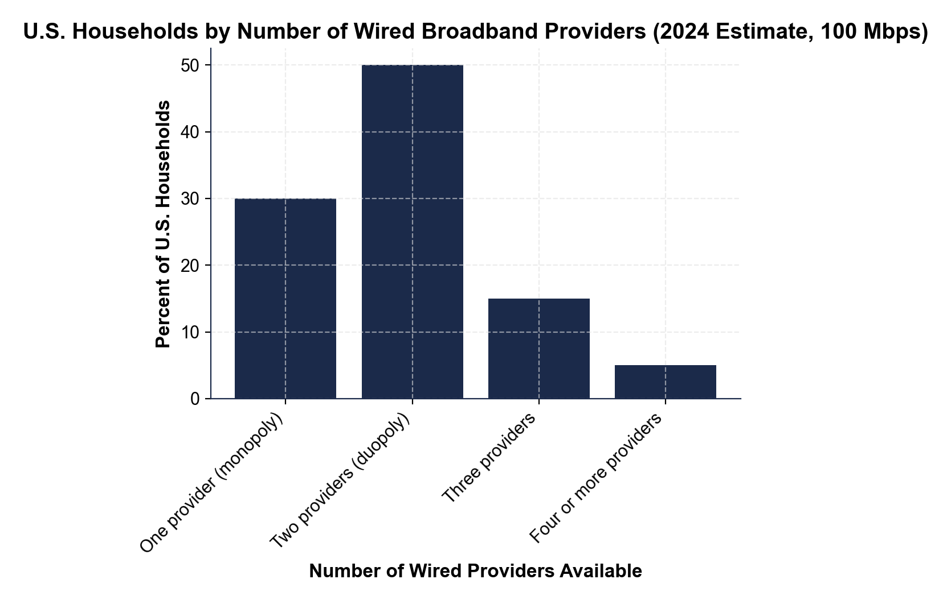
CHART REFERENCE 2: AVERAGE MONTHLY BROADBAND PRICE BY NUMBER OF COMPETITORS IN THE LOCAL MARKET
Use Chart Reference 2 (chart_broadband_price_by_competition) - the bar chart showing average monthly broadband price ($/month) for monopoly, duopoly, and three-plus competitor markets shown below.
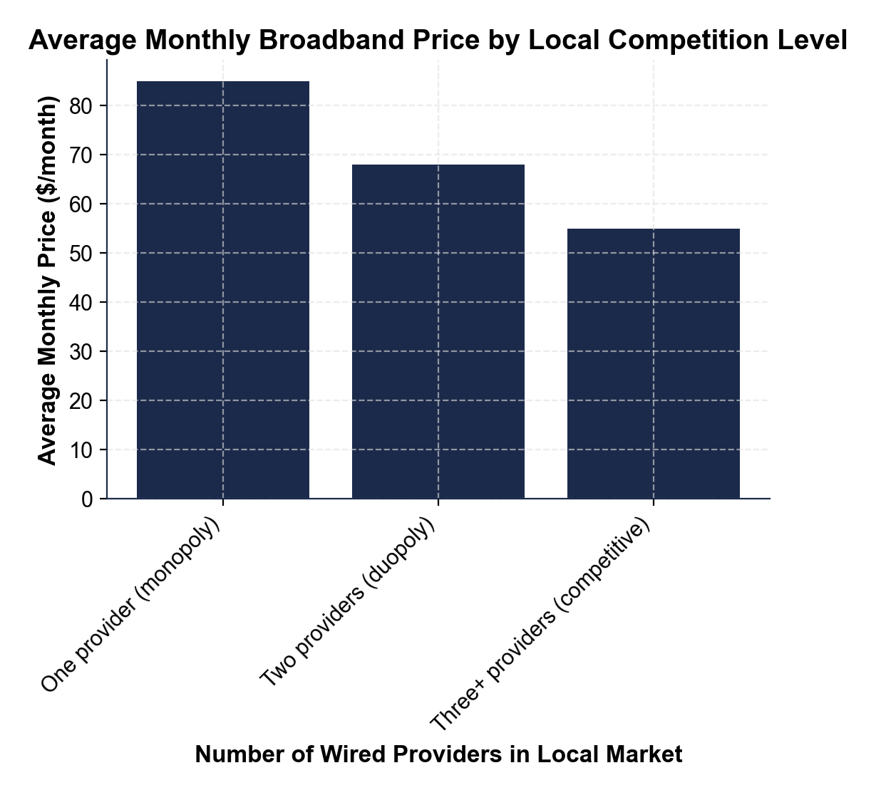
CHART REFERENCE 3: CHATTANOOGA EPB FIBER MUNICIPAL BROADBAND CASE STUDY - PRICE BEFORE AND AFTER LAUNCH
Use Chart Reference 3 (chart_chattanooga_municipal_case) - the bar chart showing average monthly broadband price in Chattanooga before EPB Fiber launched (2009), one year after launch (2011), and two years after launch (2012) shown below.
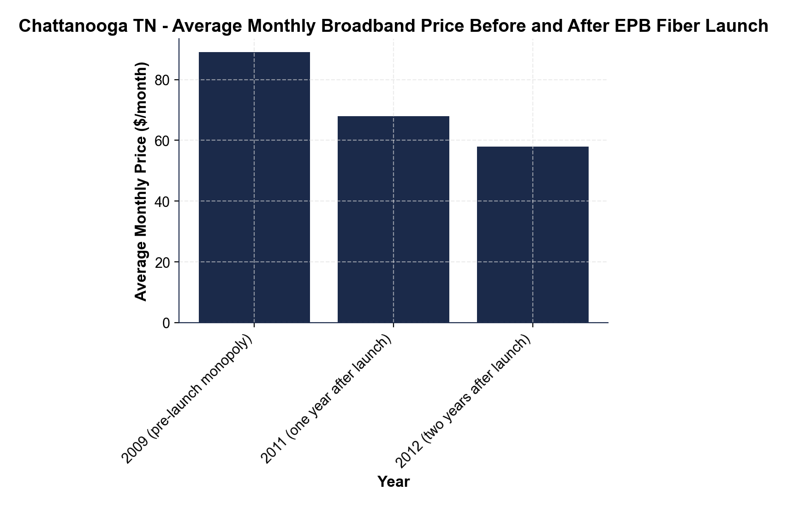

MORE LESSONS LESS PLANNING
Thank You!
If you enjoyed this product, please do not forget to rate and review to assist other teachers.

Looking for future discounts? Earn TPT credits by reviewing purchased products.

Please contact me if you have any issues with this product. Just like our students, I am always looking for opportunities to grow.

