Why Young People Pay More (or Less) - Risk Pricing in Auto Insurance
STUDENT ACTIVITY
Name: | Date: | Period:
ESSENTIAL QUESTION
How do insurers price risk, why do age and driving record drive up a young driver's premium, and how does a new driver calculate the annual premium and the premium difference between risk profiles - and then choose habits that lower their own price over time?
THE SCENARIO
You are MARCUS BELL, an insurance agent who explains to new drivers exactly why their car-insurance quote is what it is and how to lower it. TYLER is 17, about to get a license, and is shocked by a $3,600 quote for a first policy: 'Why is MY insurance so expensive when my parents pay so much less?' Your job is to teach Tyler how insurers PRICE RISK and, with real numbers, what a driver can do about it.
BY THE END, YOU CAN:
✓ Explain how insurers price risk and why premiums vary from driver to driver
✓ Explain why age and driving experience are major factors in a young driver's premium
✓ Explain how a driving record (tickets, accidents) changes a driver's risk multiplier and premium
✓ Calculate the annual premium and the premium difference between driver risk profiles using a labeled model
HOW IT WORKS (do Parts 1–5 in order)
Part 1 — Risk Pricing Reference Guide - Complete the Missing Terms
Part 2 — Apply the Terms - Risk Pricing Vocabulary in Context
Part 3 — Calculate the Annual Premium - Use the Labeled Model
Part 4 — Read the Chart - Annual Auto Premium by Driver Risk Profile
Part 5 — Advise a New Driver - Help Tyler Understand the Quote
TIME about 45 minutes YOU’LL NEED the lesson slides and your Guided Notes.

PART 1

Risk Pricing Reference Guide - Complete the Missing Terms
Fill in the missing term for each blank row — the definition is your clue. Your Guided Notes and the lesson slides have every term.

Term | Definition
___________ | The amount you pay for your insurance coverage
Risk pool | The group of policyholders whose payments cover each other's claims
___________ | The process an insurer uses to measure your risk and set your price
Base rate | The starting price for a clean-record adult driver before risk factors adjust it
___________ | A number that raises or lowers your premium based on how risky you are
Deductible | The amount you pay out of pocket on a claim before insurance pays
___________ | The statistical likelihood that a group of drivers will file claims
Driving record | Your history of tickets and accidents that insurers use to price you
___________ | The contract that spells out what your insurance covers and costs
Liability coverage | The part of auto insurance that pays for damage you cause to others

PART 2

Apply the Terms - Risk Pricing Vocabulary in Context
WORD BANK risk multiplier · policy · underwriting · premium · actuarial risk
1. Q1. The amount you pay for your insurance coverage is your .

2. Q2. The process an insurer uses to measure your risk and set your price is called .

3. Q3. The number that raises or lowers your premium based on how risky you are is the .

4. Q4. The statistical likelihood that a group of drivers will file claims is called .

5. Q5. The contract that spells out what your insurance covers and costs is your .

PART 3

Calculate the Annual Premium - Use the Labeled Model
1. As Marcus Bell, work Tyler's quote. The base rate is $1,200/year, and an 18-year-old new driver has a risk multiplier of 3.00.
(a) Using ANNUAL PREMIUM = BASE RATE x RISK MULTIPLIER, what is the annual premium for an 18-year-old new driver?

(b) In one sentence, explain WHY new drivers get such a high risk multiplier.

2. As Marcus Bell, work the driving-record scenario. A 20-year-old driver gets a single speeding ticket, and the risk multiplier rises to 2.00 on the same $1,200 base rate.
(a) Using ANNUAL PREMIUM = BASE RATE x RISK MULTIPLIER, what is the new annual premium?

(b) Compare that to a clean-record driver at the base rate ($1,200) - what is the PREMIUM DIFFERENCE?

(c) In one sentence, what does this show about the driving-record factor?

3. As Marcus Bell, compare the riskiest and safest profiles from the lesson. The 18-year-old new driver pays $3,600/year and the 40-year-old with a clean record pays $1,020/year.
(a) Using PREMIUM DIFFERENCE = higher premium - lower premium, what is the dollar difference between these two profiles?

(b) Using PERCENT DIFFERENCE = (premium difference / lower premium) x 100, about what percent more does the 18-year-old pay?

(c) In one sentence, explain why these two profiles are priced so differently.

PART 4

Read the Chart - Annual Auto Premium by Driver Risk Profile
As Marcus Bell, study the bar chart titled "Annual Auto Premium by Driver Risk Profile" (it appears with A4-Q1). It puts four annual premiums side by side, from the riskiest driver profile to the safest. The same values are listed in the data table below. Use the chart and table to answer A4-Q1 to A4-Q3, then connect the risk multiplier to Tyler's own quote in A4-Q4.

Driver profile | Annual premium
18-yr new driver (risk multiplier x3.00) | $3,600
20-yr, speeding ticket (x2.00) | $2,400
25-yr, clean record - base rate (x1.00) | $1,200
40-yr, clean record (x0.85) | $1,020

Analysis
1. A4-Q1. As Marcus Bell, study the bar chart on this page titled "Annual Auto Premium by Driver Risk Profile." It shows four annual premiums side by side. Read the chart and write each value: (a) the 18-year-old new driver's premium, (b) the 20-year-old with a speeding ticket's premium, (c) the 25-year-old clean-record premium, and (d) the 40-year-old clean-record premium.
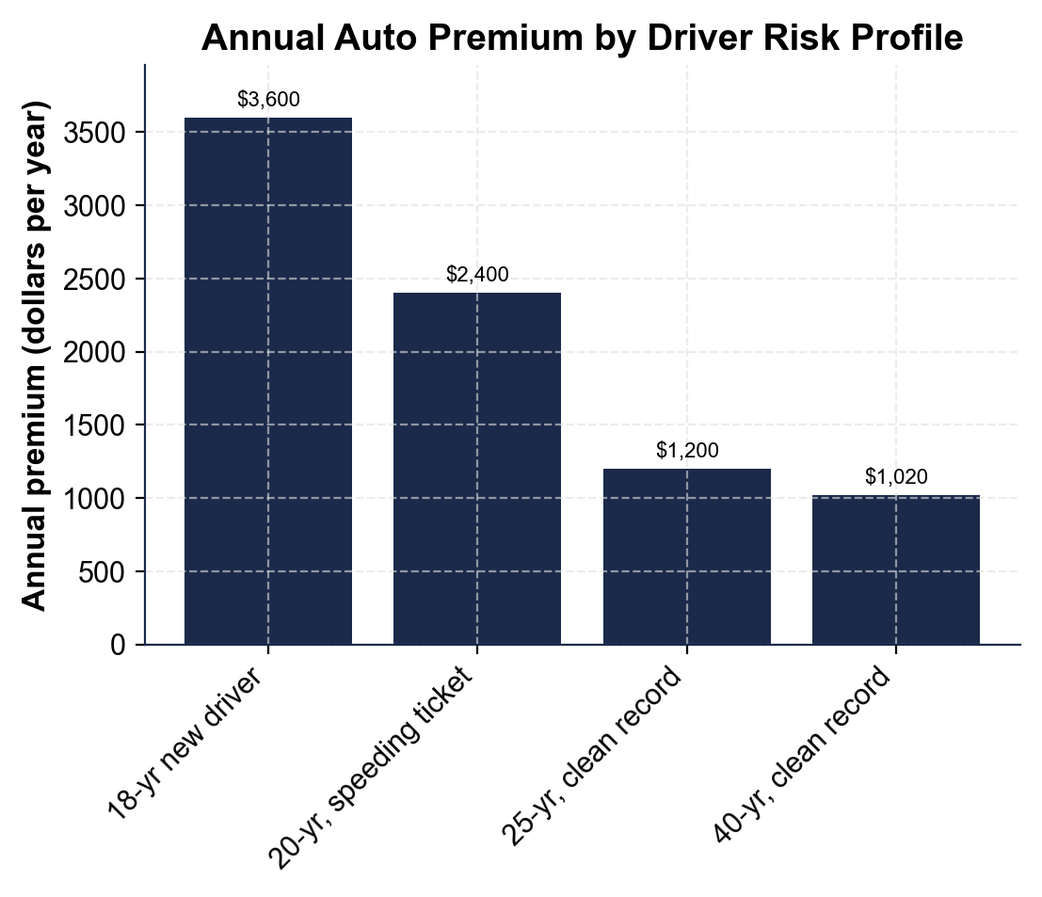

2. A4-Q2. As Marcus Bell, use the same chart to make the point to Tyler. (a) Which bar is the tallest, and which is the shortest? (b) How much MORE does the tallest bar's driver pay than the shortest bar's driver? Show your subtraction. (c) In one sentence, what pattern do you see as you move from left (riskiest) to right (safest) on the chart?

3. A4-Q3. As Marcus Bell, use the chart to give Tyler the percentage that convinces. (a) Using the 25-year-old clean-record premium ($1,200, the base rate) and the 20-year-old with a ticket ($2,400), what percent MORE does the ticket profile pay? (You can estimate: the difference divided by $1,200.) (b) In one sentence, use that percent to explain to Tyler why a driving record matters just as much as age.

4. A4-Q4. As Marcus Bell, connect the chart to what Tyler is actually choosing. (a) Every bar on this chart comes from the same $1,200 base rate - name the ONE thing that changes to create four different prices. (b) Name the two risk factors from this lesson that combine to make the 18-year-old new driver's bar the tallest. (c) In one sentence, name one concrete way Tyler could lower that bar over the next few years.

PART 5

Advise a New Driver - Help Tyler Understand the Quote
1. As Marcus Bell, answer Tyler's first question: 'Why is MY insurance so expensive?'
(a) In one to two sentences, explain how insurers price risk using the labeled model.

(b) In one sentence, name the biggest factor in Tyler's own premium and why.

2. As Marcus Bell, explain the numbers to Tyler. Using the base rate ($1,200) and Tyler's risk multiplier as an 18-year-old new driver (3.00):
(a) walk Tyler through the annual premium, naming the model you used.

(b) Then compare it to a 40-year-old clean-record driver's premium ($1,020) - what is the PREMIUM DIFFERENCE and about what PERCENT DIFFERENCE is that?

(c) In one sentence, tell Tyler what that difference shows.

3. As Marcus Bell, help Tyler plan ahead. Tyler wants to know how to pay less.
(a) In one to two sentences, name at least two concrete things Tyler can do to lower the risk multiplier over the next few years.

(b) In one sentence, give Tyler a clear first move for keeping the premium as low as possible starting on day one.

FINAL QUOTE EXPLANATION FOR TYLER
4. FINAL QUOTE EXPLANATION FOR TYLER. As Marcus Bell, put your explanation in writing for Tyler. Write a 5-7 sentence explanation (120-180 words) that explains how insurers price risk using the labeled model, works Tyler's annual premium as an 18-year-old new driver (ANNUAL PREMIUM = BASE RATE x RISK MULTIPLIER), compares it to the safest profile in the lesson using premium difference and percent difference, explains the two factors (age/experience and driving record) that make Tyler's multiplier high, and gives Tyler at least two concrete ways to lower the premium over time. Check off each required element as you include it.
YOUR RESPONSE MUST:
☐ EXPLAIN HOW INSURERS PRICE RISK - ANNUAL PREMIUM = BASE RATE x RISK MULTIPLIER, with the same $1,200 base rate for every driver and the risk multiplier changing based on how risky the driver is.
☐ WORK TYLER'S PREMIUM - show ANNUAL PREMIUM = $1,200 x 3.00 = $3,600 a year for an 18-year-old new driver.
☐ COMPARE TO THE SAFEST PROFILE - PREMIUM DIFFERENCE = $3,600 - $1,020 = $2,580; PERCENT DIFFERENCE = about 253% more.
☐ EXPLAIN THE TWO FACTORS - age/experience (new drivers crash more often) and driving record (tickets and accidents raise the multiplier) both push Tyler's multiplier up.
☐ GIVE AT LEAST TWO WAYS TO LOWER THE PREMIUM - for example: keep a clean record, take a defensive driving course, qualify for a good-student discount, or gain experience over time.

