PERSONAL FINANCE

WHY YOUNG PEOPLE PAY MORE (OR LESS) - RISK PRICING IN AUTO INSURANCE
ANSWER KEY ACTIVITY - ANSWER KEY

PART 1

Risk Pricing Reference Guide - Complete the Missing Terms

Term | Definition
Premium | The amount you pay for your insurance coverage
Risk pool | The group of policyholders whose payments cover each other's claims
Underwriting | The process an insurer uses to measure your risk and set your price
Base rate | The starting price for a clean-record adult driver before risk factors adjust it
Risk multiplier | A number that raises or lowers your premium based on how risky you are
Deductible | The amount you pay out of pocket on a claim before insurance pays
Actuarial risk | The statistical likelihood that a group of drivers will file claims
Driving record | Your history of tickets and accidents that insurers use to price you
Policy | The contract that spells out what your insurance covers and costs
Liability coverage | The part of auto insurance that pays for damage you cause to others

PART 2

Apply the Terms - Risk Pricing Vocabulary in Context
WORD BANK risk multiplier · policy · underwriting · premium · actuarial risk
1. Q1. The amount you pay for your insurance coverage is your premium.
premium
2. Q2. The process an insurer uses to measure your risk and set your price is called underwriting.
underwriting
3. Q3. The number that raises or lowers your premium based on how risky you are is the risk multiplier.
risk multiplier
4. Q4. The statistical likelihood that a group of drivers will file claims is called actuarial risk.
actuarial risk
5. Q5. The contract that spells out what your insurance covers and costs is your policy.
policy

PART 3

Calculate the Annual Premium - Use the Labeled Model
1. As Marcus Bell, work Tyler's quote. The base rate is $1,200/year, and an 18-year-old new driver has a risk multiplier of 3.00.
(a) Using ANNUAL PREMIUM = BASE RATE x RISK MULTIPLIER, what is the annual premium for an 18-year-old new driver?
(b) In one sentence, explain WHY new drivers get such a high risk multiplier.
(1) ANNUAL PREMIUM = $1,200 x 3.00 = $3,600 a year. (2) New drivers get a high risk multiplier because they have little or no experience behind the wheel, and inexperienced drivers are statistically the most likely group to file a claim. Accept $3,600 and an inexperience/highest-risk-group explanation.
2. As Marcus Bell, work the driving-record scenario. A 20-year-old driver gets a single speeding ticket, and the risk multiplier rises to 2.00 on the same $1,200 base rate.
(a) Using ANNUAL PREMIUM = BASE RATE x RISK MULTIPLIER, what is the new annual premium?
(b) Compare that to a clean-record driver at the base rate ($1,200) - what is the PREMIUM DIFFERENCE?
(c) In one sentence, what does this show about the driving-record factor?
(1) ANNUAL PREMIUM = $1,200 x 2.00 = $2,400 a year. (2) PREMIUM DIFFERENCE = $2,400 - $1,200 = $1,200 a year more than the clean-record price. (3) This shows the driving-record factor is powerful, not minor - one speeding ticket exactly DOUBLED this driver's premium. Accept $2,400, a $1,200 difference, and a doubled-premium/powerful-factor explanation.
3. As Marcus Bell, compare the riskiest and safest profiles from the lesson. The 18-year-old new driver pays $3,600/year and the 40-year-old with a clean record pays $1,020/year.
(a) Using PREMIUM DIFFERENCE = higher premium - lower premium, what is the dollar difference between these two profiles?
(b) Using PERCENT DIFFERENCE = (premium difference / lower premium) x 100, about what percent more does the 18-year-old pay?
(c) In one sentence, explain why these two profiles are priced so differently.
(1) PREMIUM DIFFERENCE = $3,600 - $1,020 = $2,580 a year. (2) PERCENT DIFFERENCE = ($2,580 / $1,020) x 100 = about 253% more. (3) These two profiles are priced so differently because the 18-year-old is a brand-new driver (the highest age-related risk) with no proven driving-record history, while the 40-year-old has decades of experience and a clean record - the lowest risk in the data. Accept $2,580, about 253%, and an experience/clean-record explanation.

PART 4

Read the Chart - Annual Auto Premium by Driver Risk Profile
As Marcus Bell, study the bar chart titled "Annual Auto Premium by Driver Risk Profile" (it appears with A4-Q1). It puts four annual premiums side by side, from the riskiest driver profile to the safest. The same values are listed in the data table below. Use the chart and table to answer A4-Q1 to A4-Q3, then connect the risk multiplier to Tyler's own quote in A4-Q4.

Driver profile | Annual premium
18-yr new driver (risk multiplier x3.00) | $3,600
20-yr, speeding ticket (x2.00) | $2,400
25-yr, clean record - base rate (x1.00) | $1,200
40-yr, clean record (x0.85) | $1,020

Analysis

1. A4-Q1. As Marcus Bell, study the bar chart on this page titled "Annual Auto Premium by Driver Risk Profile." It shows four annual premiums side by side. Read the chart and write each value: (a) the 18-year-old new driver's premium, (b) the 20-year-old with a speeding ticket's premium, (c) the 25-year-old clean-record premium, and (d) the 40-year-old clean-record premium.
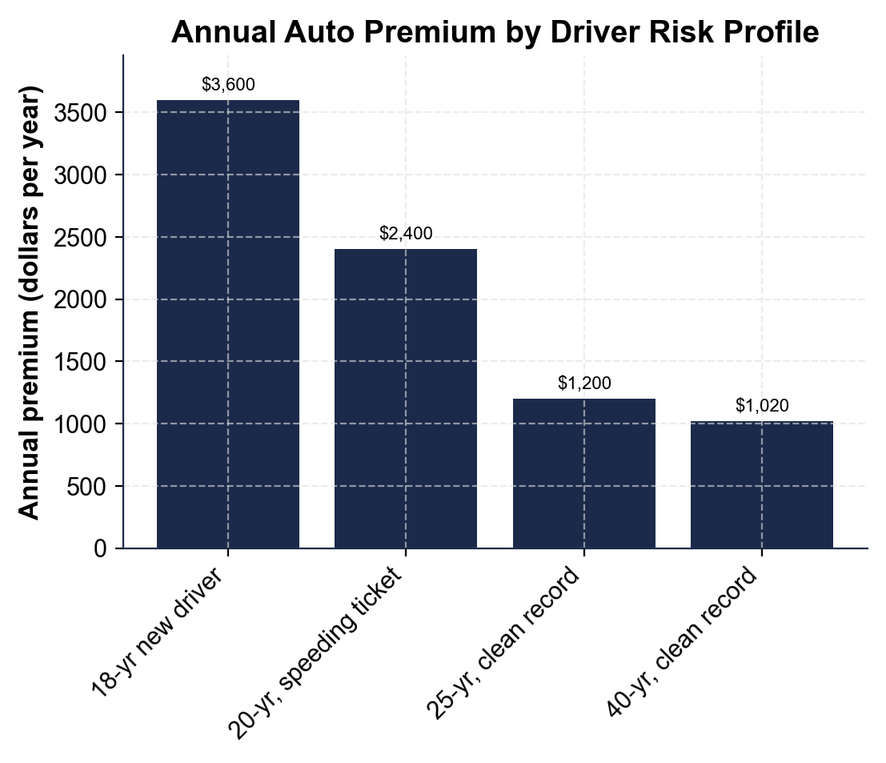
(a) 18-yr new driver = $3,600. (b) 20-yr, speeding ticket = $2,400. (c) 25-yr, clean record = $1,200. (d) 40-yr, clean record = $1,020. Accept these four values read directly off the chart.

2. A4-Q2. As Marcus Bell, use the same chart to make the point to Tyler. (a) Which bar is the tallest, and which is the shortest? (b) How much MORE does the tallest bar's driver pay than the shortest bar's driver? Show your subtraction. (c) In one sentence, what pattern do you see as you move from left (riskiest) to right (safest) on the chart?
(1) The tallest bar is the 18-year-old new driver ($3,600); the shortest is the 40-year-old clean-record driver ($1,020). (2) The tallest bar's driver pays $3,600 - $1,020 = $2,580 more per year. (3) The pattern is a staircase - the bars step DOWN from left to right, showing that as risk falls, the premium falls too. Accept the 18-yr/40-yr bar identification, a $2,580 difference, and a risk-and-price-move-together explanation.

3. A4-Q3. As Marcus Bell, use the chart to give Tyler the percentage that convinces. (a) Using the 25-year-old clean-record premium ($1,200, the base rate) and the 20-year-old with a ticket ($2,400), what percent MORE does the ticket profile pay? (You can estimate: the difference divided by $1,200.) (b) In one sentence, use that percent to explain to Tyler why a driving record matters just as much as age.
(1) The difference is $2,400 - $1,200 = $1,200; PERCENT DIFFERENCE = ($1,200 / $1,200) x 100 = 100% more (exactly double). (2) A driving record matters just as much as age because a single ticket can double a premium (100% more) - close to how much extra a brand-new teen driver pays for lacking experience. Accept 100% and a driving-record-matters-as-much-as-age explanation.

4. A4-Q4. As Marcus Bell, connect the chart to what Tyler is actually choosing. (a) Every bar on this chart comes from the same $1,200 base rate - name the ONE thing that changes to create four different prices. (b) Name the two risk factors from this lesson that combine to make the 18-year-old new driver's bar the tallest. (c) In one sentence, name one concrete way Tyler could lower that bar over the next few years.
(1) The ONE thing that changes is the RISK MULTIPLIER - the same base rate is scaled by a different multiplier for each profile. (2) The two risk factors that combine are AGE/EXPERIENCE (being a brand-new driver) and DRIVING RECORD (no proven history yet). (3) Tyler could lower the multiplier over time by keeping a clean driving record, taking a defensive driving course, qualifying for a good-student discount, or simply gaining years of experience. Accept risk multiplier, age/experience + driving record as the two factors, and any one concrete lowering action.

PART 5

Advise a New Driver - Help Tyler Understand the Quote
1. As Marcus Bell, answer Tyler's first question: 'Why is MY insurance so expensive?'
(a) In one to two sentences, explain how insurers price risk using the labeled model.
(b) In one sentence, name the biggest factor in Tyler's own premium and why.
(1) Insurers PRICE RISK using ANNUAL PREMIUM = BASE RATE x RISK MULTIPLIER - the same $1,200 base rate applies to every driver, and the risk multiplier (based on factors like age and driving record) is what changes the price. (2) The biggest factor in Tyler's premium is AGE/EXPERIENCE, because as a brand-new 17-year-old driver, Tyler falls into the highest-risk multiplier group (x3.00) - statistically the most likely group to file a claim. Accept the labeled model explanation and age/experience as the biggest factor.
2. As Marcus Bell, explain the numbers to Tyler. Using the base rate ($1,200) and Tyler's risk multiplier as an 18-year-old new driver (3.00):
(a) walk Tyler through the annual premium, naming the model you used.
(b) Then compare it to a 40-year-old clean-record driver's premium ($1,020) - what is the PREMIUM DIFFERENCE and about what PERCENT DIFFERENCE is that?
(c) In one sentence, tell Tyler what that difference shows.
(1) Using ANNUAL PREMIUM = BASE RATE x RISK MULTIPLIER = $1,200 x 3.00 = $3,600 a year. (2) PREMIUM DIFFERENCE = $3,600 - $1,020 = $2,580 a year; PERCENT DIFFERENCE = ($2,580 / $1,020) x 100 = about 253% more. (3) The difference shows that a brand-new driver's lack of experience is priced as a much higher risk than an experienced, clean-record adult's - it is not personal, it is statistics. Accept the $3,600 premium, the $2,580/253% comparison, and a risk-not-personal explanation.
3. As Marcus Bell, help Tyler plan ahead. Tyler wants to know how to pay less.
(a) In one to two sentences, name at least two concrete things Tyler can do to lower the risk multiplier over the next few years.
(b) In one sentence, give Tyler a clear first move for keeping the premium as low as possible starting on day one.
(1) Tyler can lower the risk multiplier by keeping a clean driving record (avoiding tickets and accidents), completing a DEFENSIVE DRIVING COURSE, qualifying for a GOOD-STUDENT DISCOUNT by maintaining good grades, and simply gaining years of driving experience over time. (2) Tyler's clear first move is to drive carefully and avoid any tickets or accidents starting with the very first drive, since a clean record is the single biggest lever a new driver controls. Accept any two concrete lowering actions and a clean-record-from-day-one first move.
FINAL QUOTE EXPLANATION FOR TYLER
4. FINAL QUOTE EXPLANATION FOR TYLER. As Marcus Bell, put your explanation in writing for Tyler. Write a 5-7 sentence explanation (120-180 words) that explains how insurers price risk using the labeled model, works Tyler's annual premium as an 18-year-old new driver (ANNUAL PREMIUM = BASE RATE x RISK MULTIPLIER), compares it to the safest profile in the lesson using premium difference and percent difference, explains the two factors (age/experience and driving record) that make Tyler's multiplier high, and gives Tyler at least two concrete ways to lower the premium over time. Check off each required element as you include it.
YOUR RESPONSE MUST:
☐ EXPLAIN HOW INSURERS PRICE RISK - ANNUAL PREMIUM = BASE RATE x RISK MULTIPLIER, with the same $1,200 base rate for every driver and the risk multiplier changing based on how risky the driver is.
☐ WORK TYLER'S PREMIUM - show ANNUAL PREMIUM = $1,200 x 3.00 = $3,600 a year for an 18-year-old new driver.
☐ COMPARE TO THE SAFEST PROFILE - PREMIUM DIFFERENCE = $3,600 - $1,020 = $2,580; PERCENT DIFFERENCE = about 253% more.
☐ EXPLAIN THE TWO FACTORS - age/experience (new drivers crash more often) and driving record (tickets and accidents raise the multiplier) both push Tyler's multiplier up.
☐ GIVE AT LEAST TWO WAYS TO LOWER THE PREMIUM - for example: keep a clean record, take a defensive driving course, qualify for a good-student discount, or gain experience over time.
GRADING RUBRIC
Grade the evidence and reasoning, not the conclusion — any defensible position is valid. Score against the 5 requirements above.
FULL CREDIT — clear position; meets all 5 requirements with accurate, specific numbers and evidence from the lesson.
PARTIAL — position stated, but misses 1-2 requirements or uses vague / incorrect numbers.
MINIMAL — no clear position, or missing most requirements and numbers.

MORE LESSONS LESS PLANNING
Thank You!
If you enjoyed this product, please do not forget to rate and review to assist other teachers.

Looking for future discounts? Earn TPT credits by reviewing purchased products.

Please contact me if you have any issues with this product. Just like our students, I am always looking for opportunities to grow.

