Why Save? The Power of Starting Young
STUDENT ACTIVITY
Name: | Date: | Period:
ESSENTIAL QUESTION
Why does building a saving habit early - paying yourself first and leaving money to compound over a long time horizon - dramatically increase long-term wealth, and how much does a ten-year head start really matter when two savers put in the same $100 a month at 7%?
THE SCENARIO
You are helping JORDAN understand why starting to save young matters so much. Jordan is 28 and just started saving $100 a month into an account that earns 7% a year.
BY THE END, YOU CAN:
✓ Explain why building a saving habit early - and paying yourself first - matters for long-term wealth
✓ Describe how a longer time horizon lets compounding turn small, regular savings into large sums
✓ Compare two savers who save the same amount but start ten years apart, and explain why starting young wins
✓ Choose where to keep short-term savings and set a specific, realistic first savings goal
HOW IT WORKS (do Parts 1–5 in order)
Part 1 — Saving Reference Guide - Complete the Missing Terms
Part 2 — Apply the Terms - Saving Vocabulary in Context
Part 3 — Read the Chart - Two Savers, Same Money, Different Start
Part 4 — Do the Head-Start Math - Contributions, Balances, and the Rule of 72
Part 5 — Starting Young and the Saving Habit - Make Your Recommendation
TIME about 45 minutes YOU’LL NEED the lesson slides and your Guided Notes.

PART 1

Saving Reference Guide - Complete the Missing Terms
Fill in the missing term for each blank row — the definition is your clue. Your Guided Notes and the lesson slides have every term.

Term | Definition
___________ | Moving money into savings as soon as you are paid, before you spend on anything else, so saving is treated like a bill
Emergency fund | Short-term savings set aside for surprise expenses, kept somewhere safe and easy to reach like a savings account
___________ | The number of years you leave money to grow before you need it; a longer time horizon gives compounding more years to work
Savings goal | A specific dollar amount you decide to save for a purpose and target date, which makes saving concrete and trackable
___________ | Earning returns on both the money you put in and the returns it has already earned, so a balance grows faster the longer it sits
High-yield savings account | A savings account that pays a higher interest rate than a regular one, a common safe place for short-term savings
___________ | What you give up by choosing one option over another; the opportunity cost of waiting to save is the growth those early dollars would have earned
Rule of 72 | A shortcut that estimates the years for money to double: years to double is about 72 divided by the interest rate percent
___________ | A regular routine of setting money aside on a schedule, so saving happens automatically instead of only when money is left over
Automatic transfer | A transfer that moves money to savings every payday, so the saving habit runs itself without willpower

PART 2

Apply the Terms - Saving Vocabulary in Context
WORD BANK compounding · opportunity cost · time horizon · pay yourself first · saving habit
1. Q1. Moving money into savings as soon as you are paid, before you spend on anything else, is called .

2. Q2. The number of years you leave money to grow before you need it is your .

3. Q3. Earning returns on both the money you put in and the returns it has already earned is called .

4. Q4. What you give up by choosing one option over another - for a late saver, the growth those early dollars would have earned - is the .

5. Q5. A regular routine of setting money aside on a schedule, so saving happens automatically, is a .

PART 3

Read the Chart - Two Savers, Same Money, Different Start
1. As you help Jordan, study the line chart on this page titled "Two Savers, Same Money, Different Start." One line belongs to Maya (who started at 18) and one to Jordan (who started at 28). Read the chart and write:
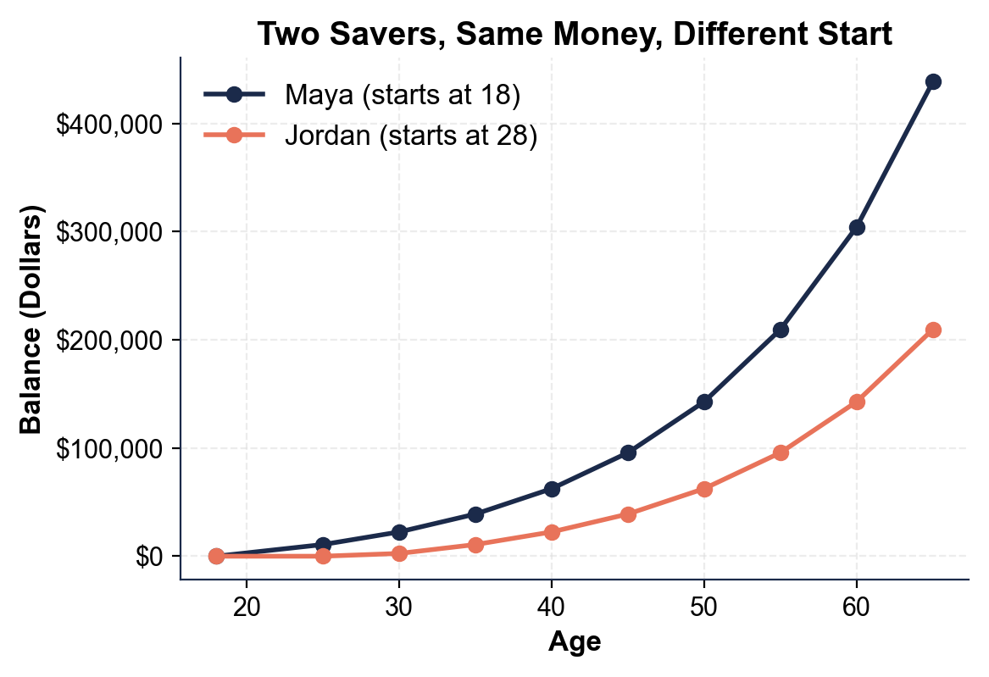
(a) which line stays at $0 the longest at the start

(b) whose line that is.

2. As you help Jordan, use the same chart to read the age-65 endpoints.
(a) About how much does MAYA have at age 65?

(b) About how much does JORDAN have at age 65?

(c) Subtract to find the gap between them.

3. As you help Jordan, look at how the two lines behave over time.
(a) At the start (ages 18 to 28), how far apart are the two lines?

(b) What happens to the space between them as the savers get older, and what does that growing space represent?

4. As you help Jordan, look at the overall pattern. In one or two sentences, explain what the chart shows about starting young versus starting late. Start your answer with: "The chart shows that..."

PART 4

Do the Head-Start Math - Contributions, Balances, and the Rule of 72
1. As you help Jordan, first find how much each saver actually PUTS IN over their life. Both save $100 a month; a year is 12 months.
(a) Maya saves from 18 to 65 - that is 47 years. How much does she contribute in total?

(b) Jordan saves from 28 to 65 - that is 37 years. How much does he contribute in total? Show your math.

2. As you help Jordan, compare what each saver ENDS with at age 65 (read these from the chart or the lesson).
(a) What is Maya's balance at 65?

(b) What is Jordan's balance at 65?

(c) How much MORE does Maya have? Show your subtraction.

3. As you help Jordan, this is the key comparison.
(a) How much MORE money did Maya put in over her life than Jordan (use your Part 4 Q1 answers)?

(b) How much MORE money does Maya END with than Jordan (from Q2)?

(c) In one sentence, explain how putting in only a little more led to so much more at the end.

4. As you help Jordan, name the cost of waiting precisely. OPPORTUNITY COST is what you give up by choosing one option over another.
(a) What did Jordan give up by waiting ten years to start - the $12,000 in deposits he skipped, or the ~$228,988.48 of growth those early dollars would have earned?

(b) Explain your choice in one sentence.

5. As you help Jordan, use the RULE OF 72 (years to double is about 72 divided by the rate percent) to see why time matters.
(a) At their 7% rate, about how many years does it take money to double?

(b) Over the 47 years Maya saves, about how many times could her early money double compared with Jordan's 37 years? Show your math.

PART 5

Starting Young and the Saving Habit - Make Your Recommendation
1. As you help Jordan, explain the core lesson.
(a) Maya and Jordan saved the SAME $100 a month at the SAME 7% - so what one thing made Maya end with more than twice as much?

(b) Why does that one thing matter so much?

2. As you help Jordan, connect it to the HABITS that make early saving work.
(a) What does it mean to PAY YOURSELF FIRST, and why does it work better than saving 'whatever is left over'?

(b) What is a SAVING HABIT, and how could Jordan make his automatic?

3. As you help Jordan, give him a realistic plan. He cannot go back to 18, but he is only 28. Name TWO specific things Jordan could do now to build the strongest possible saving habit and close some of the gap with Maya.

FINAL RECOMMENDATION
4. FINAL RECOMMENDATION. Jordan asks you to put it in writing. Write a 5-7 sentence note (120-180 words) telling Jordan why starting young matters, what his and Maya's numbers show, and exactly how he should build a saving habit now. Check off each required element as you include it.
YOUR RESPONSE MUST:
☐ EXPLAIN WHY EARLY WINS - state in your own words that starting young matters because a longer time horizon gives compounding more years to grow the money.
☐ NAME THE HABIT - mention PAY YOURSELF FIRST (save as soon as you are paid) and building a SAVING HABIT (a regular, automatic routine).
☐ USE A CALCULATED RESULT - state a figure you calculated yourself in Part 4 (for example, Maya's $438,642.92 vs Jordan's $209,654.44, the $228,988.48 gap, or the $12,000 extra contributed).
☐ NAME THE OPPORTUNITY COST - explain that the real cost of waiting is the growth given up (about $228,988.48), not just the skipped deposits.
☐ GIVE CLEAR ADVICE - tell Jordan two specific things to do now (for example, automate the transfer, save more per month, set a specific goal) to build the habit and close the gap.

