PERSONAL FINANCE

WHY SAVE? THE POWER OF STARTING YOUNG
ANSWER KEY ACTIVITY - ANSWER KEY

PART 1

Saving Reference Guide - Complete the Missing Terms

Term | Definition
Pay yourself first | Moving money into savings as soon as you are paid, before you spend on anything else, so saving is treated like a bill
Emergency fund | Short-term savings set aside for surprise expenses, kept somewhere safe and easy to reach like a savings account
Time horizon | The number of years you leave money to grow before you need it; a longer time horizon gives compounding more years to work
Savings goal | A specific dollar amount you decide to save for a purpose and target date, which makes saving concrete and trackable
Compounding | Earning returns on both the money you put in and the returns it has already earned, so a balance grows faster the longer it sits
High-yield savings account | A savings account that pays a higher interest rate than a regular one, a common safe place for short-term savings
Opportunity cost | What you give up by choosing one option over another; the opportunity cost of waiting to save is the growth those early dollars would have earned
Rule of 72 | A shortcut that estimates the years for money to double: years to double is about 72 divided by the interest rate percent
Saving habit | A regular routine of setting money aside on a schedule, so saving happens automatically instead of only when money is left over
Automatic transfer | A transfer that moves money to savings every payday, so the saving habit runs itself without willpower

PART 2

Apply the Terms - Saving Vocabulary in Context
WORD BANK compounding · opportunity cost · time horizon · pay yourself first · saving habit
1. Q1. Moving money into savings as soon as you are paid, before you spend on anything else, is called Pay yourself first.
Pay yourself first
2. Q2. The number of years you leave money to grow before you need it is your time horizon.
time horizon
3. Q3. Earning returns on both the money you put in and the returns it has already earned is called compounding.
compounding
4. Q4. What you give up by choosing one option over another - for a late saver, the growth those early dollars would have earned - is the opportunity cost.
opportunity cost
5. Q5. A regular routine of setting money aside on a schedule, so saving happens automatically, is a saving habit.
saving habit

PART 3

Read the Chart - Two Savers, Same Money, Different Start
1. As you help Jordan, study the line chart on this page titled "Two Savers, Same Money, Different Start." One line belongs to Maya (who started at 18) and one to Jordan (who started at 28). Read the chart and write:
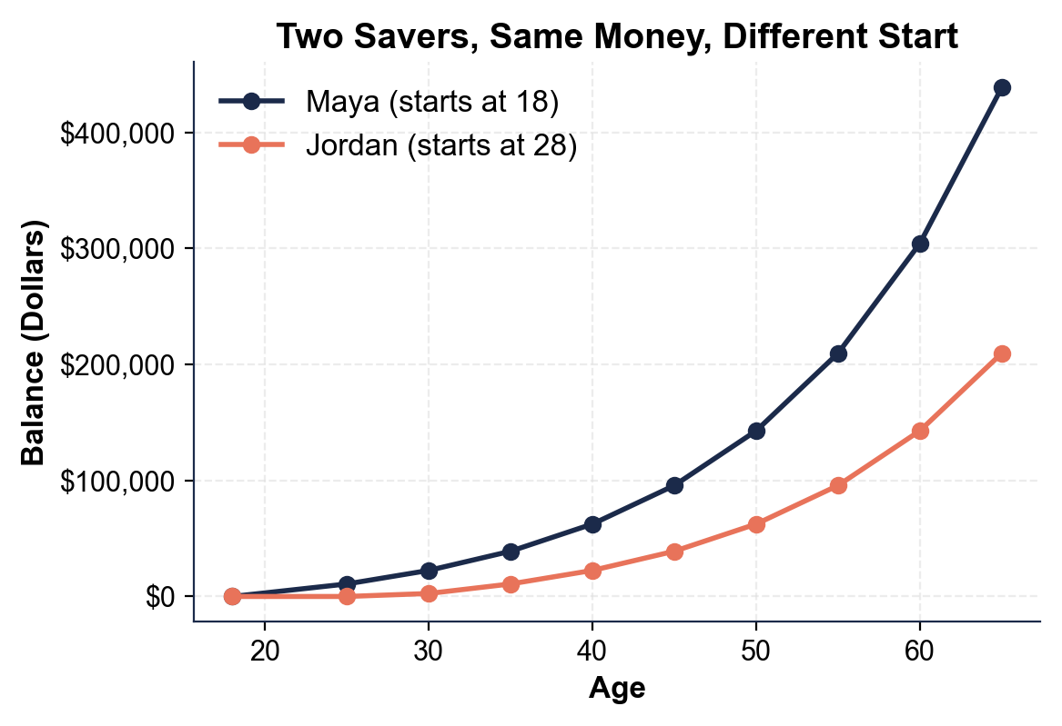
(a) which line stays at $0 the longest at the start
The lower line stays flat at $0 the longest at the start - it does not begin climbing until age 28.
(b) whose line that is.
That is JORDAN's line, because he did not start saving until 28. Maya's line (the upper one) begins climbing right away at 18.
2. As you help Jordan, use the same chart to read the age-65 endpoints.
(a) About how much does MAYA have at age 65?
MAYA has about $438,642.92 at age 65.
(b) About how much does JORDAN have at age 65?
JORDAN has about $209,654.44 at age 65.
(c) Subtract to find the gap between them.
The gap is $438,642.92 - $209,654.44 = $228,988.48 more for Maya. Accept about $438,643 for Maya, about $209,654 for Jordan, and a gap of about $228,988.
3. As you help Jordan, look at how the two lines behave over time.
(a) At the start (ages 18 to 28), how far apart are the two lines?
At the start the lines are far apart in a specific way: Maya's is already climbing while Jordan's is still flat at $0 until age 28, so a gap opens immediately.
(b) What happens to the space between them as the savers get older, and what does that growing space represent?
The space between them WIDENS the older they get - Maya's line pulls further and further above Jordan's. That growing space represents the value of Maya's ten-year HEAD START: her early dollars get a decade of extra compounding, so the advantage keeps growing.
4. As you help Jordan, look at the overall pattern. In one or two sentences, explain what the chart shows about starting young versus starting late. Start your answer with: "The chart shows that..."
The chart shows that starting young beats starting late even when you save the exact same amount: both savers put in $100 a month at 7%, but Maya (who started at 18) reaches $438,642.92 while Jordan (who started at 28) reaches only $209,654.44 by age 65.

PART 4

Do the Head-Start Math - Contributions, Balances, and the Rule of 72
1. As you help Jordan, first find how much each saver actually PUTS IN over their life. Both save $100 a month; a year is 12 months.
(a) Maya saves from 18 to 65 - that is 47 years. How much does she contribute in total?
(b) Jordan saves from 28 to 65 - that is 37 years. How much does he contribute in total? Show your math.
(1) MAYA contributes $100 x 12 x 47 = $56,400.00. (2) JORDAN contributes $100 x 12 x 37 = $44,400.00. Accept $56,400.00 for Maya and $44,400.00 for Jordan.
2. As you help Jordan, compare what each saver ENDS with at age 65 (read these from the chart or the lesson).
(a) What is Maya's balance at 65?
(b) What is Jordan's balance at 65?
(c) How much MORE does Maya have? Show your subtraction.
(1) MAYA's balance at 65 = $438,642.92. (2) JORDAN's balance at 65 = $209,654.44. (3) Maya has $438,642.92 - $209,654.44 = $228,988.48 MORE than Jordan. Accept $438,642.92, $209,654.44, and a difference of $228,988.48.
3. As you help Jordan, this is the key comparison.
(a) How much MORE money did Maya put in over her life than Jordan (use your Part 4 Q1 answers)?
(b) How much MORE money does Maya END with than Jordan (from Q2)?
(c) In one sentence, explain how putting in only a little more led to so much more at the end.
(1) EXTRA CONTRIBUTED = $56,400.00 - $44,400.00 = $12,000.00 more that Maya put in. (2) EXTRA AT THE END = $228,988.48 more that Maya has. (3) Maya put in only $12,000 more but ended with about $229,000 more because her ten-year head start gave those early dollars a whole extra decade of compounding - the growth, not the deposits, made the difference. Accept $12,000.00 extra contributed, $228,988.48 extra at the end, and an explanation that names the head start / extra years of compounding.
4. As you help Jordan, name the cost of waiting precisely. OPPORTUNITY COST is what you give up by choosing one option over another.
(a) What did Jordan give up by waiting ten years to start - the $12,000 in deposits he skipped, or the ~$228,988.48 of growth those early dollars would have earned?
(b) Explain your choice in one sentence.
(1) Jordan's OPPORTUNITY COST is the ~$228,988.48 of GROWTH those early dollars would have earned - not just the $12,000 of deposits he skipped. (2) The real cost of waiting is the compounding he missed: the ten years of growth Maya got on her early money is worth far more than the extra deposits themselves, so the lost growth is the true opportunity cost. Accept the ~$228,988.48 of lost growth (not the $12,000 of deposits) with an explanation about missed compounding.
5. As you help Jordan, use the RULE OF 72 (years to double is about 72 divided by the rate percent) to see why time matters.
(a) At their 7% rate, about how many years does it take money to double?
(b) Over the 47 years Maya saves, about how many times could her early money double compared with Jordan's 37 years? Show your math.
(1) At 7%: 72 / 7 = about 10 years to double. (2) In 47 years money doubling about every 10 years could double roughly 4-5 times, while in 37 years it could double about 3-4 times - so Maya's head start buys her roughly one extra doubling, which is why she ends with about twice as much. Accept about 10 years to double, and the idea that Maya's ten extra years buy about one extra doubling. (Answers of '4-5 times vs 3-4 times' or 'about one more doubling' earn full credit.)

PART 5

Starting Young and the Saving Habit - Make Your Recommendation
1. As you help Jordan, explain the core lesson.
(a) Maya and Jordan saved the SAME $100 a month at the SAME 7% - so what one thing made Maya end with more than twice as much?
The one thing was WHEN they started: Maya's ten-year head start (starting at 18 instead of 28) is the only difference, and it is what left her with far more.
(b) Why does that one thing matter so much?
It matters so much because of TIME HORIZON and COMPOUNDING - starting earlier gives the money more years to earn returns on its returns, and at 7% money roughly doubles every decade, so a ten-year head start buys about one extra doubling.
2. As you help Jordan, connect it to the HABITS that make early saving work.
(a) What does it mean to PAY YOURSELF FIRST, and why does it work better than saving 'whatever is left over'?
PAY YOURSELF FIRST means moving money into savings as soon as you are paid, before spending on anything else - treating saving like a bill. It works better than saving leftovers because at the end of the month there is usually nothing left, so saving first guarantees it happens.
(b) What is a SAVING HABIT, and how could Jordan make his automatic?
A SAVING HABIT is a regular routine of setting money aside on a schedule; Jordan could make his automatic by setting up an automatic transfer that moves a fixed amount to savings every payday, so the habit runs without willpower.
3. As you help Jordan, give him a realistic plan. He cannot go back to 18, but he is only 28. Name TWO specific things Jordan could do now to build the strongest possible saving habit and close some of the gap with Maya.
Accept any two sound, specific actions, such as: (1) pay himself first by automating a transfer to savings every payday so he never skips; (2) save MORE than $100 a month now that he is older and likely earns more, to make up for lost years; (3) start immediately and never take another break, since every additional year of delay costs more compounding; (4) set a specific savings goal with a dollar amount and date to stay on track; (5) keep his emergency fund safe in a high-yield savings account and let longer-term money grow through investing later in the unit. Award credit for any two specific, realistic habit-building or catch-up actions.
FINAL RECOMMENDATION
4. FINAL RECOMMENDATION. Jordan asks you to put it in writing. Write a 5-7 sentence note (120-180 words) telling Jordan why starting young matters, what his and Maya's numbers show, and exactly how he should build a saving habit now. Check off each required element as you include it.
YOUR RESPONSE MUST:
☐ EXPLAIN WHY EARLY WINS - state in your own words that starting young matters because a longer time horizon gives compounding more years to grow the money.
☐ NAME THE HABIT - mention PAY YOURSELF FIRST (save as soon as you are paid) and building a SAVING HABIT (a regular, automatic routine).
☐ USE A CALCULATED RESULT - state a figure you calculated yourself in Part 4 (for example, Maya's $438,642.92 vs Jordan's $209,654.44, the $228,988.48 gap, or the $12,000 extra contributed).
☐ NAME THE OPPORTUNITY COST - explain that the real cost of waiting is the growth given up (about $228,988.48), not just the skipped deposits.
☐ GIVE CLEAR ADVICE - tell Jordan two specific things to do now (for example, automate the transfer, save more per month, set a specific goal) to build the habit and close the gap.
GRADING RUBRIC
Grade the evidence and reasoning, not the conclusion — any defensible position is valid. Score against the 5 requirements above.
FULL CREDIT — clear position; meets all 5 requirements with accurate, specific numbers and evidence from the lesson.
PARTIAL — position stated, but misses 1-2 requirements or uses vague / incorrect numbers.
MINIMAL — no clear position, or missing most requirements and numbers.

MORE LESSONS LESS PLANNING
Thank You!
If you enjoyed this product, please do not forget to rate and review to assist other teachers.

Looking for future discounts? Earn TPT credits by reviewing purchased products.

Please contact me if you have any issues with this product. Just like our students, I am always looking for opportunities to grow.

