Why Gen Z Can't Buy a House
STUDENT ACTIVITY
Name: | Date: | Period:
ESSENTIAL QUESTION
Why is a starter home so much less affordable today than 40 years ago, what four forces caused it, and which fix should policymakers push first?
THE SCENARIO
The modern U.S. housing market is the least affordable it has been in 40 years, and the median first-time buyer is now in their late thirties. Four forces are hitting at once: MORTGAGE RATES jumped from about 3% in 2021 to about 7% by 2024, roughly doubling the monthly payment on the same priced home; PRICES rose far faster than wages since 2019, so the price-to-income gap widened; the U.S. faces a HOUSING SUPPLY SHORTAGE of several million units because builders did not keep up after 2008; and NIMBY ZONING - especially single-family-only rules covering most residential land - blocks the duplexes, apartments, and ADUs that would relieve the shortage.
BY THE END, YOU CAN:
✓ Identify the four causes of the modern U.S. housing affordability crisis: high mortgage rates, high prices, the supply shortage, and zoning rules that block building
✓ Compare the median age of Gen Z and millennial first-time homebuyers to earlier generations and explain what shifted
✓ Evaluate proposed policy solutions (zoning reform, builder incentives, down-payment assistance, rate cuts) using lesson data
HOW IT WORKS (do Parts 1–5 in order)
Part 1 — Housing Affordability Reference Guide - Complete the Missing Terms
Part 2 — Apply the Terms - Housing Vocabulary in Context
Part 3 — Explain the Causes, the Lock-In Effect, and Zoning
Part 4 — Read the Charts and Run the Numbers
Part 5 — Policy Memo - Which Fix Comes First?
TIME about 45 minutes YOU’LL NEED the lesson slides and your Guided Notes.

PART 1

Housing Affordability Reference Guide - Complete the Missing Terms
Fill in the missing term for each blank row — the definition is your clue. Your Guided Notes and the lesson slides have every term.

Term | Definition
___________ | The median home price divided by the median household income; about 3 was the long-run norm and 7 or more is the modern crisis level.
Mortgage rate | The interest rate on a home loan; it rose from about 3 percent in 2021 to about 7 percent by 2024, which doubled the monthly payment on the same priced home.
___________ | When existing homeowners with low 3 percent mortgages refuse to sell because moving means trading their 3 percent rate for a 7 percent rate, which locks housing supply away from buyers.
Housing supply shortage | The roughly 4 million housing units the U.S. is short of what it needs; the gap has grown since 2008 because builders did not keep up with population growth.
___________ | Zoning rules that allow only one detached house per lot; they cover about 75 percent of U.S. residential land and are the biggest single zoning constraint on new supply.
NIMBY | Short for Not In My Back Yard; existing homeowners who oppose new housing being built near them through public hearings, lawsuits, or zoning votes.
___________ | A zoning change that allows more units on the same land such as duplexes, apartments, and accessory dwelling units; the main supply-side reform economists recommend.
ADU (Accessory Dwelling Unit) | A small additional home on the same lot as a single-family house such as a backyard cottage, basement apartment, or garage conversion; legalizing ADUs is a common upzoning reform.
___________ | A score where 100 means the median family earns exactly enough to afford the median home; below 100 means the median family cannot afford the median home.
Down-payment assistance | State, local, and federal programs that help first-time buyers cover their down payment; a leading demand-side policy that helps buyers without raising prices much.

PART 2

Apply the Terms - Housing Vocabulary in Context
WORD BANK price-to-income ratio · upzoning · affordability index · single-family zoning · lock-in effect
1. The median home price divided by the median household income - about 3 was the long-run norm and 7 or more is the crisis level - is the .

2. When existing homeowners with low 3% mortgages refuse to sell because moving means trading their 3% rate for a 7% rate, locking supply away from buyers, that is the .

3. Zoning rules that allow only one detached house per lot, covering about 75% of U.S. residential land, are called .

4. A zoning change that allows MORE units on the same land - duplexes, apartments, and ADUs - the main supply-side reform, is .

5. A score where 100 means the median family earns exactly enough to afford the median home (below 100 they cannot) is the .

PART 3

Explain the Causes, the Lock-In Effect, and Zoning
1. In your own words, name the FOUR causes of the modern housing affordability crisis. Write one accurate sentence per cause.

2. Explain in 2-3 sentences what the LOCK-IN EFFECT is and why it makes the supply shortage worse, even though no one is forcing existing owners to stay in their homes.

3. Explain in 3-4 sentences why ZONING is a structural ROOT cause of the shortage, and how UPZONING (including legalizing ADUs) would relieve it.
Why does demand-side help alone not solve the shortage?

PART 4

Read the Charts and Run the Numbers
1. Use the U.S. PRICE-TO-INCOME RATIO chart (1985-2026), inserted below and shown in the slide deck.
(a) Read the ratio at 1985 and at 2024 directly off the curve.

(b) State how many TIMES higher the 2024 ratio is than the 1985 ratio.

(c) Compare the modern peak to the 2006 housing-bubble peak: which is higher, and by how much? (Chart: chart_price_to_income_1985_2026)
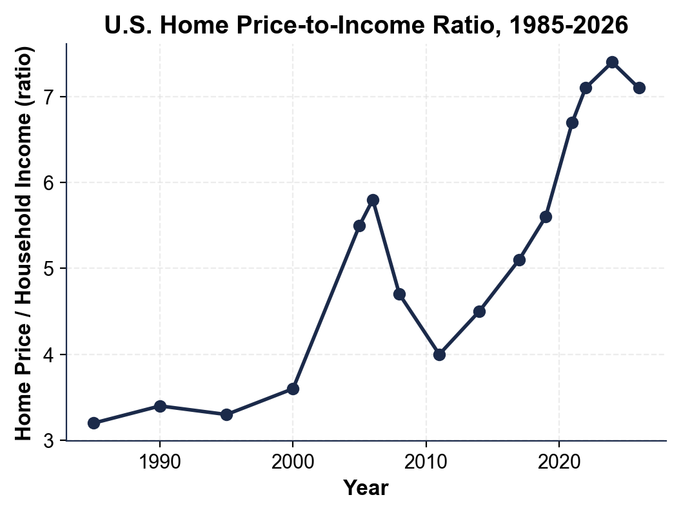

2. Use the HOUSING AFFORDABILITY INDEX BY METRO chart, inserted below and shown in the slide deck.
(a) Name the MOST affordable metro and its index value, and the LEAST affordable metro and its value.

(b) Name ALL the metros with an index BELOW 50.

(c) Explain in plain English what the LEAST-affordable metro's index (your answer to part a) means for a family living in that metro. (Chart: chart_affordability_by_metro)
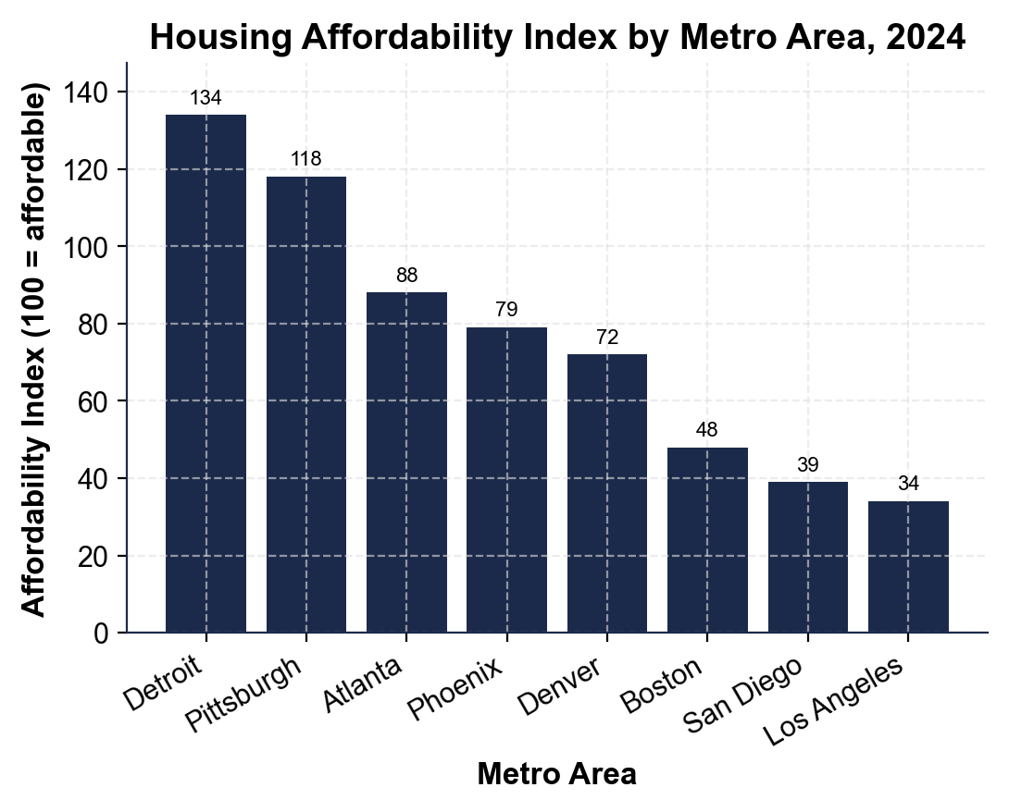

3. Use the MEDIAN AGE OF FIRST-TIME HOMEBUYER chart, inserted below and shown in the slide deck.
(a) Read the median first-home age for each generation: Boomers, Gen X, Millennials, Gen Z.

(b) Calculate the GAP in years between Boomers and Gen Z, and between Millennials and Gen Z.

(c) Explain in one sentence what buying about 8 years later than Boomers means for Gen Z's lifetime wealth, given that home equity is a main way Americans build wealth. (Chart: chart_first_home_age_genz_millennial)
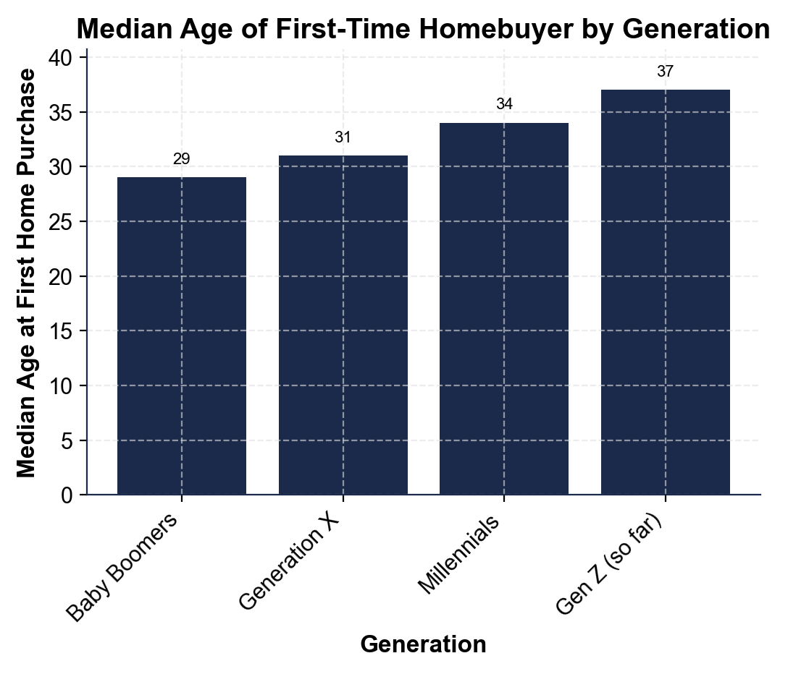

4. MORTGAGE-RATE MATH (no chart). On a 30-year fixed loan: a $300,000 loan costs about $1,265/month at 3% but about $1,996/month at 7%; a $400,000 loan at 7% costs about $2,661/month.
(a) Calculate the dollar DIFFERENCE between the $300K-at-3% payment and the $300K-at-7% payment.

(b) Explain in 1-2 sentences why a 4-point rate change creates such a large payment change on the SAME loan amount.

(c) Which moves the monthly payment MORE: the 4-point rate jump (3% to 7% on $300K), or the $100K loan-size jump ($300K to $400K, both at 7%)? Show your work.

5. AFFORDABILITY AND SUPPLY MATH (no chart). The 2026 median home (~$416,000) requires about $129,300 in household income to NOT be cost-burdened, but the median U.S. household earns about $80,000. Separately, from 2010 to 2020 the U.S. built about 5.5 million homes but needed about 9 million.
(a) Calculate the INCOME GAP in dollars and as a percentage of what is needed.

(b) Calculate the per-year housing SHORTFALL over that decade.

(c) Explain in one sentence why closing the shortage will take years, not months. Show your work.

PART 5

Policy Memo - Which Fix Comes First?
POLICY MEMO
1. POLICY MEMO. You are advising a state legislator on the housing affordability crisis and she votes soon. Write an 8-12 sentence memo (about 250-350 words) recommending ONE policy to push FIRST. Options: UPZONING (legalize duplexes, apartments, and ADUs on more land); BUILDER INCENTIVES (tax breaks and faster permits for new construction); DOWN-PAYMENT ASSISTANCE (grants for first-time buyers); or LOWER MORTGAGE RATES (wait for the Fed as inflation cools). Use the memo header below and check off each required element as you include it. (Sentence starter you may use: "I recommend the legislator push ___ first because ___.")
YOUR RESPONSE MUST:
☐ CLEAR RECOMMENDATION - name ONE policy in the first sentence. Do not hedge across multiple options.
☐ TWO LESSON NUMBERS - cite at least TWO specific facts or figures from the lesson or charts (for example: the price-to-income ratio is now about 7, the U.S. is short about 4 million units, single-family zoning covers about 75% of residential land, a 4-point rate jump adds about $731/month, the median household needs about $129,300 but earns about $80,000, or any chart value you extracted in Part 4).
☐ WINNERS AND LOSERS - name WHO benefits and WHO might lose under your recommendation.
☐ ONE REALISTIC OBJECTION - acknowledge one credible objection an opponent would raise.
☐ ONE TRADE-OFF - state one trade-off you accept by choosing this policy over the others.
MEMO
To: State Legislator (Your District)
From: Housing Policy Analyst
Date:
Re: Which Housing-Affordability Fix to Champion First

