ECONOMICS

WHY GEN Z CAN'T BUY A HOUSE
ANSWER KEY ACTIVITY - ANSWER KEY

PART 1

Housing Affordability Reference Guide - Complete the Missing Terms

Term | Definition
Price-to-income ratio | The median home price divided by the median household income; about 3 was the long-run norm and 7 or more is the modern crisis level.
Mortgage rate | The interest rate on a home loan; it rose from about 3 percent in 2021 to about 7 percent by 2024, which doubled the monthly payment on the same priced home.
Lock-in effect | When existing homeowners with low 3 percent mortgages refuse to sell because moving means trading their 3 percent rate for a 7 percent rate, which locks housing supply away from buyers.
Housing supply shortage | The roughly 4 million housing units the U.S. is short of what it needs; the gap has grown since 2008 because builders did not keep up with population growth.
Single-family zoning | Zoning rules that allow only one detached house per lot; they cover about 75 percent of U.S. residential land and are the biggest single zoning constraint on new supply.
NIMBY | Short for Not In My Back Yard; existing homeowners who oppose new housing being built near them through public hearings, lawsuits, or zoning votes.
Upzoning | A zoning change that allows more units on the same land such as duplexes, apartments, and accessory dwelling units; the main supply-side reform economists recommend.
ADU (Accessory Dwelling Unit) | A small additional home on the same lot as a single-family house such as a backyard cottage, basement apartment, or garage conversion; legalizing ADUs is a common upzoning reform.
Affordability index | A score where 100 means the median family earns exactly enough to afford the median home; below 100 means the median family cannot afford the median home.
Down-payment assistance | State, local, and federal programs that help first-time buyers cover their down payment; a leading demand-side policy that helps buyers without raising prices much.

PART 2

Apply the Terms - Housing Vocabulary in Context
WORD BANK price-to-income ratio · upzoning · affordability index · single-family zoning · lock-in effect
1. The median home price divided by the median household income - about 3 was the long-run norm and 7 or more is the crisis level - is the Price-to-income ratio __.
Price-to-income ratio
2. When existing homeowners with low 3% mortgages refuse to sell because moving means trading their 3% rate for a 7% rate, locking supply away from buyers, that is the Lock-in effect.
Lock-in effect
3. Zoning rules that allow only one detached house per lot, covering about 75% of U.S. residential land, are called Single-family zoning.
Single-family zoning
4. A zoning change that allows MORE units on the same land - duplexes, apartments, and ADUs - the main supply-side reform, is Upzoning.
Upzoning
5. A score where 100 means the median family earns exactly enough to afford the median home (below 100 they cannot) is the Affordability index.
Affordability index
PART 3

Explain the Causes, the Lock-In Effect, and Zoning
1. In your own words, name the FOUR causes of the modern housing affordability crisis. Write one accurate sentence per cause.
CAUSE 1 - MORTGAGE RATES: rates jumped from about 3% in 2021 to about 7% by 2024, which roughly doubled the monthly payment on the same priced home. CAUSE 2 - PRICES: home prices rose far faster than wages since 2019 (median home went from about $278K to about $416K while wages rose only about 25%), so the price-to-income gap widened. CAUSE 3 - SUPPLY SHORTAGE: the U.S. is short several million housing units because builders did not keep up with population growth after 2008. CAUSE 4 - NIMBY ZONING: single-family-only zoning covering about 75% of residential land blocks the duplexes, ADUs, and apartments that would relieve the shortage. Accept any answer that names rates, prices, supply, and zoning with one accurate sentence each.
2. Explain in 2-3 sentences what the LOCK-IN EFFECT is and why it makes the supply shortage worse, even though no one is forcing existing owners to stay in their homes.
LOCK-IN EFFECT: existing homeowners who locked in low ~3% mortgages in 2020-2021 refuse to sell, because moving means giving up that 3% rate and taking a new mortgage near 7% on their next home. WHY IT WORSENS THE SHORTAGE: even owners who would otherwise move (for a bigger or smaller home, a new job, or a new city) stay put because selling can mean a several-hundred-dollar jump in monthly payment for a similar home, just from the rate change. RESULT: homes that would normally cycle back onto the market never get listed, so existing supply stays frozen and first-time buyers face fewer choices at higher prices - no one is forced to stay, but the math punishes moving.
3. Explain in 3-4 sentences why ZONING is a structural ROOT cause of the shortage, and how UPZONING (including legalizing ADUs) would relieve it.
Why does demand-side help alone not solve the shortage?
WHY ZONING IS A ROOT CAUSE: single-family zoning - which allows only one detached house per lot and covers about 75% of U.S. residential land - legally caps how many homes can be built on most land, so even when high prices signal that more housing is needed, builders cannot add units where people want to live. HOW UPZONING AND ADUs HELP: upzoning changes the rules to allow MORE units on the same land - duplexes, triplexes, small apartment buildings, and accessory dwelling units (ADUs) like backyard cottages and basement apartments - which adds supply without needing new land. WHY DEMAND-SIDE HELP IS NOT ENOUGH: down-payment grants and lower rates let people bid for the homes that already exist but do not add a single new home, so without upzoning the underlying shortage - and the upward pressure on prices - remains.
PART 4

Read the Charts and Run the Numbers
1. Use the U.S. PRICE-TO-INCOME RATIO chart (1985-2026), inserted below and shown in the slide deck.
(a) Read the ratio at 1985 and at 2024 directly off the curve.
1985 RATIO: about 3.2 - the median home cost about 3.2 years of median income (accept 3.0-3.5). 2024 RATIO: about 7.4 - the median home costs about 7.4 years of median income (accept 7.0-7.6).
(b) State how many TIMES higher the 2024 ratio is than the 1985 ratio.
TIMES HIGHER: 7.4 / 3.2 = about 2.3 times the 1985 ratio - more than double.
(c) Compare the modern peak to the 2006 housing-bubble peak: which is higher, and by how much? (Chart: chart_price_to_income_1985_2026)
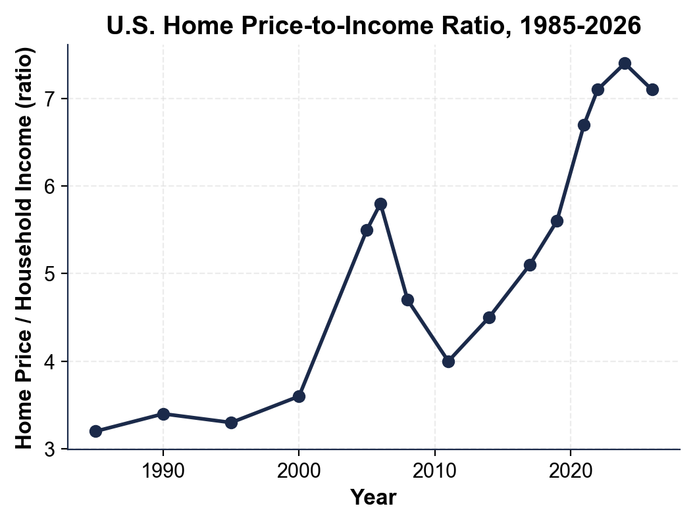
VERSUS 2006: the 2006 bubble peak was about 5.8; the 2024 peak (~7.4) is HIGHER by about 1.6 ratio points (7.4 - 5.8 = 1.6). MEANING: even at the peak of the bubble that caused the 2008 crash, homes were "only" about 5.8 times income; today they are about 7.4 times income, so the modern crisis is worse on this…
2. Use the HOUSING AFFORDABILITY INDEX BY METRO chart, inserted below and shown in the slide deck.
(a) Name the MOST affordable metro and its index value, and the LEAST affordable metro and its value.
MOST AFFORDABLE: DETROIT, index about 134 - the median Detroit family earns about 134% of what they need to afford the median home (accept Pittsburgh ~118 as an alternate if the student explains the 100 threshold). LEAST AFFORDABLE: LOS ANGELES, index about 34 - the median LA family earns only about 34% of what they need.
(b) Name ALL the metros with an index BELOW 50.
BELOW 50: BOSTON (~48), SAN DIEGO (~39), and LOS ANGELES (~34) - three metros where the median family earns less than half of what they need for the median home.
(c) Explain in plain English what the LEAST-affordable metro's index (your answer to part a) means for a family living in that metro. (Chart: chart_affordability_by_metro)
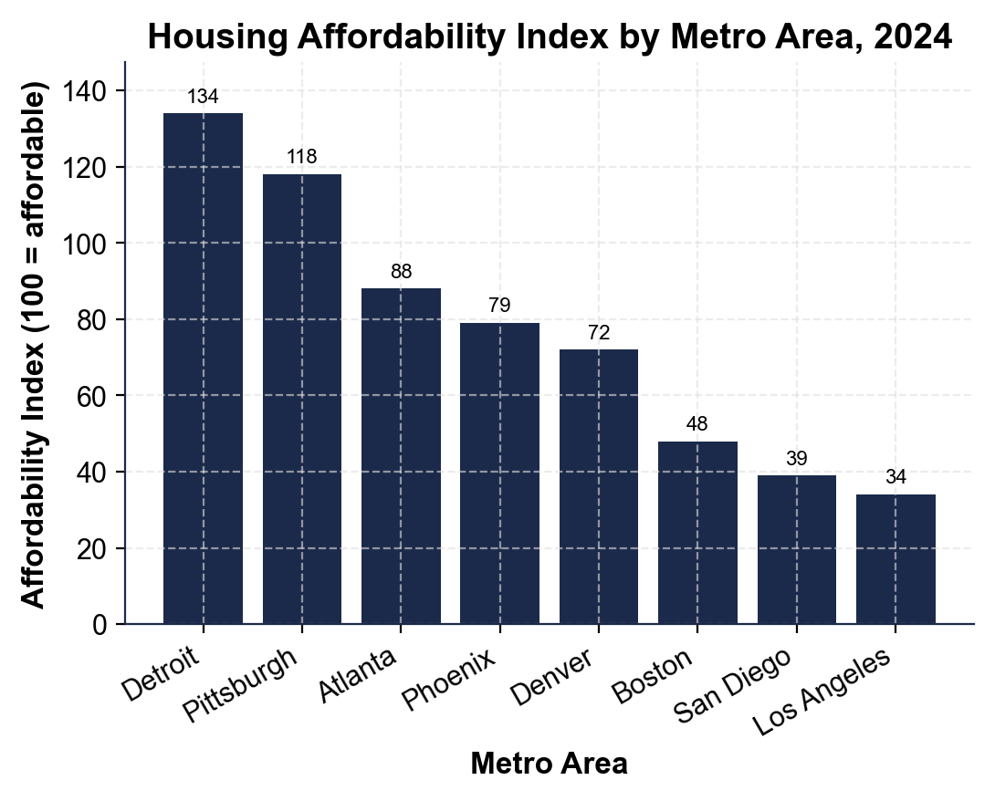
MEANING: a family earning the median income in the least-affordable metro earns only about a THIRD of what they would need to afford the median home there - so even saving aggressively, they cannot afford the typical home in their own city without a large income jump, family help, or moving somewhere cheaper.
3. Use the MEDIAN AGE OF FIRST-TIME HOMEBUYER chart, inserted below and shown in the slide deck.
(a) Read the median first-home age for each generation: Boomers, Gen X, Millennials, Gen Z.
BOOMERS: 29. GEN X: 31. MILLENNIALS: 34. GEN Z: 37 (accept within 1 year each). The pattern is monotonic - each generation buys later than the one before.
(b) Calculate the GAP in years between Boomers and Gen Z, and between Millennials and Gen Z.
BOOMER-TO-GEN-Z GAP: 37 - 29 = 8 YEARS. MILLENNIAL-TO-GEN-Z GAP: 37 - 34 = 3 YEARS.
(c) Explain in one sentence what buying about 8 years later than Boomers means for Gen Z's lifetime wealth, given that home equity is a main way Americans build wealth. (Chart: chart_first_home_age_genz_millennial)
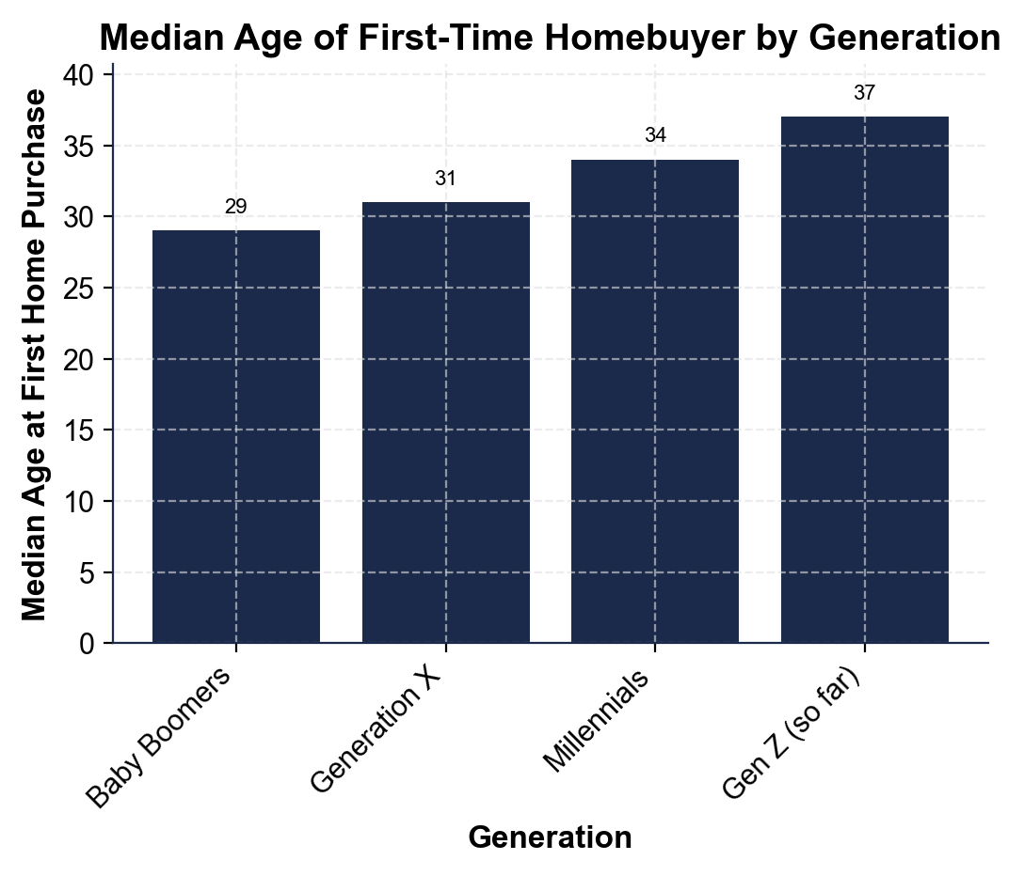
WEALTH MEANING: buying about 8 years later means roughly 8 fewer years of paying down a mortgage and of home-price appreciation by retirement, so Gen Z builds noticeably less home equity over a lifetime - which shows up later as smaller retirement wealth and less to pass on.
4. MORTGAGE-RATE MATH (no chart). On a 30-year fixed loan: a $300,000 loan costs about $1,265/month at 3% but about $1,996/month at 7%; a $400,000 loan at 7% costs about $2,661/month.
(a) Calculate the dollar DIFFERENCE between the $300K-at-3% payment and the $300K-at-7% payment.
RATE DIFFERENCE: $1,996 - $1,265 = $731 MORE per month at 7% than at 3% on the same $300,000 loan.
(b) Explain in 1-2 sentences why a 4-point rate change creates such a large payment change on the SAME loan amount.
WHY: mortgage interest is charged on the remaining balance every month for 360 months (30 years), so even a 4-point rate jump compounds into hundreds of extra dollars a month and tens of thousands over the loan - the price did not change at all, only the rate.
(c) Which moves the monthly payment MORE: the 4-point rate jump (3% to 7% on $300K), or the $100K loan-size jump ($300K to $400K, both at 7%)? Show your work.
COMPARISON: rate jump (3% to 7% on $300K) = $731/month; loan-size jump ($300K to $400K at 7%) = $2,661 - $1,996 = $665/month. The RATE JUMP moves the payment slightly MORE here ($731 vs $665) - the key point is that BOTH the rate and the loan size matter, and which dominates depends on the scenario. Accept reasonable estimates within $50.
5. AFFORDABILITY AND SUPPLY MATH (no chart). The 2026 median home (~$416,000) requires about $129,300 in household income to NOT be cost-burdened, but the median U.S. household earns about $80,000. Separately, from 2010 to 2020 the U.S. built about 5.5 million homes but needed about 9 million.
(a) Calculate the INCOME GAP in dollars and as a percentage of what is needed.
INCOME GAP: $129,300 - $80,000 = $49,300 SHORT per year. AS A PERCENTAGE: $80,000 / $129,300 = about 62%, so the median household earns only about 62% of what it needs (a gap of about 38%).
(b) Calculate the per-year housing SHORTFALL over that decade.
SHORTFALL: 9 million needed - 5.5 million built = 3.5 MILLION short over 10 years, which is 3.5M / 10 = about 350,000 homes short PER YEAR.
(c) Explain in one sentence why closing the shortage will take years, not months. Show your work.
WHY YEARS: new construction takes 12-18 months from permit to completion, crews and materials are limited, and zoning still blocks much of the land - so even a big building push closes a multi-million-unit gap only slowly, while the population keeps growing.
PART 5

Policy Memo - Which Fix Comes First?
POLICY MEMO
1. POLICY MEMO. You are advising a state legislator on the housing affordability crisis and she votes soon. Write an 8-12 sentence memo (about 250-350 words) recommending ONE policy to push FIRST. Options: UPZONING (legalize duplexes, apartments, and ADUs on more land); BUILDER INCENTIVES (tax breaks and faster permits for new construction); DOWN-PAYMENT ASSISTANCE (grants for first-time buyers); or LOWER MORTGAGE RATES (wait for the Fed as inflation cools). Use the memo header below and check off each required element as you include it. (Sentence starter you may use: "I recommend the legislator push ___ first because ___.")
YOUR RESPONSE MUST:
☐ CLEAR RECOMMENDATION - name ONE policy in the first sentence. Do not hedge across multiple options.
☐ TWO LESSON NUMBERS - cite at least TWO specific facts or figures from the lesson or charts (for example: the price-to-income ratio is now about 7, the U.S. is short about 4 million units, single-family zoning covers about 75% of residential land, a 4-point rate jump adds about $731/month, the median household needs about $129,300 but earns about $80,000, or any chart value you extracted in Part 4).
☐ WINNERS AND LOSERS - name WHO benefits and WHO might lose under your recommendation.
☐ ONE REALISTIC OBJECTION - acknowledge one credible objection an opponent would raise.
☐ ONE TRADE-OFF - state one trade-off you accept by choosing this policy over the others.
MEMO
To: State Legislator (Your District)
From: Housing Policy Analyst
Date: [student completes]
Re: Which Housing-Affordability Fix to Champion First
GRADING RUBRIC
Grade the evidence and reasoning, not the conclusion — any defensible position is valid. Score against the 5 requirements above.
FULL CREDIT — clear position; meets all 5 requirements with accurate, specific numbers and evidence from the lesson.
PARTIAL — position stated, but misses 1-2 requirements or uses vague / incorrect numbers.
MINIMAL — no clear position, or missing most requirements and numbers.

MORE LESSONS LESS PLANNING
Thank You!
If you enjoyed this product, please do not forget to rate and review to assist other teachers.

Looking for future discounts? Earn TPT credits by reviewing purchased products.

Please contact me if you have any issues with this product. Just like our students, I am always looking for opportunities to grow.

