What Is Insurance - Paying to Protect Yourself
STUDENT ACTIVITY
Name: | Date: | Period:
ESSENTIAL QUESTION
What is insurance, how does risk pooling let many people's small premiums protect the unlucky few from a big loss, and how does a new adult decide whether a given insurance is worth it?
THE SCENARIO
You are MAYA OKONKWO, a community insurance advisor who runs a free 'insurance basics' workshop for young adults. DEVON just got a first apartment and a used car and thinks insurance is a waste of money - 'you pay and pay and never use it.' Your job is to show Devon, with real numbers, what insurance actually is, how it works, and whether it is worth it.
BY THE END, YOU CAN:
✓ Define insurance as transferring the financial risk of a big, rare loss to an insurer for a small regular premium
✓ Explain how risk pooling lets many people's premiums cover the large losses of the unlucky few
✓ Identify the premium, deductible, policyholder, insurer, and claim as the basic parts of how insurance works
✓ Explain how insurance spreads financial risk across many people and calculate the protection value of coverage
HOW IT WORKS (do Parts 1–5 in order)
Part 1 — Insurance Basics Reference Guide - Complete the Missing Terms
Part 2 — Apply the Terms - Insurance Vocabulary in Context
Part 3 — Calculate Risk Pooling and Protection Value - Use the Labeled Models
Part 4 — Read the Chart - Premiums vs the Cost of an Uninsured Disaster
Part 5 — Advise Devon - Is Insurance Worth It?
TIME about 45 minutes YOU’LL NEED the lesson slides and your Guided Notes.

PART 1

Insurance Basics Reference Guide - Complete the Missing Terms
Fill in the missing term for each blank row — the definition is your clue. Your Guided Notes and the lesson slides have every term.

Term | Definition
___________ | A way to transfer the financial risk of a big, rare loss to an insurer in exchange for a small, regular payment
Risk of loss | The uncertainty that a costly event - like a crash, an illness, or a fire - could happen to you
___________ | Many people each pay premiums into a shared pool, and the pool pays the big claims of the unlucky few
Insurer | The company that collects premiums, holds the pool, and pays out claims when a covered loss happens
___________ | The regular payment you make to keep your insurance coverage active
Policyholder | The person who buys the insurance and is protected by it - you, when you own a policy
___________ | The amount you pay out of pocket on a claim before the insurer pays the rest
Policy | The contract that spells out what is covered, what you pay, and what the insurer pays
___________ | A request you file with your insurer to be paid for a covered loss
Catastrophic loss | A loss so large you could not pay it yourself; protecting against it is the main reason to buy insurance

PART 2

Apply the Terms - Insurance Vocabulary in Context
WORD BANK claim · deductible · risk pooling · insurance · premium
1. Q1. Transferring the financial risk of a big, rare loss to a company in exchange for a small, regular payment is called .

2. Q2. When many people each pay premiums into a shared pool that covers the big losses of the unlucky few, that is .

3. Q3. The regular payment you make to keep your insurance coverage active is your .

4. Q4. The amount you pay out of pocket on a claim before the insurer pays the rest is your .

5. Q5. The request you file with your insurer to be paid for a covered loss is a .

PART 3

Calculate Risk Pooling and Protection Value - Use the Labeled Models
1. As Maya Okonkwo, warm up the risk-pooling model with Devon. Suppose 100 renters each pay a $180 premium into a shared pool.
(a) Using POOL MONEY = number of people x premium each, how much is in the pool?

(b) If one renter has a $15,000 loss (a fire destroys most of their belongings), can the pool cover it?

(c) In one sentence, why did everyone else only pay $180 even though the pool covered a $15,000 loss?

2. As Maya Okonkwo, work Devon's protection value on the car. Devon's used car is worth $15,000, and the yearly car premium is $1,200.
(a) Using PROTECTION VALUE = uninsured loss - premium, how much financial risk does insuring the car transfer to the insurer?

(b) In one sentence, explain what that number means for Devon if the car is totaled.

3. As Maya Okonkwo, compare a small premium over time to a single disaster. Devon pays a $180-a-year renters premium.
(a) Using MULTI-YEAR PREMIUM = annual premium x years, how much would Devon pay in renters premiums over 5 years?

(b) How does that 5-year total compare to a single uninsured $50,000 house fire?

(c) In one to two sentences, what does this show about paying premiums versus facing a disaster uninsured?

PART 4

Read the Chart - Premiums vs the Cost of an Uninsured Disaster
As Maya Okonkwo, study the bar chart titled "Premiums vs the Cost of an Uninsured Disaster" (it appears with A4-Q1). It shows five costs side by side: two premiums and three uninsured disasters. The same values are listed in the data table below. Use the chart and table to answer A4-Q1 to A4-Q3, then apply the decision rule in A4-Q4.

Cost | Amount
Renters premium (1 yr) | $180
Car premium (1 yr) | $1,200
Uninsured ER visit | $3,000
Uninsured totaled car | $15,000
Uninsured house fire | $50,000

Analysis
1. A4-Q1. As Maya Okonkwo, study the bar chart on this page titled "Premiums vs the Cost of an Uninsured Disaster." It shows five costs side by side. Read the chart and write the amount of each bar: (a) renters premium (1 year), (b) car premium (1 year), (c) uninsured ER visit, (d) uninsured totaled car, and (e) uninsured house fire.
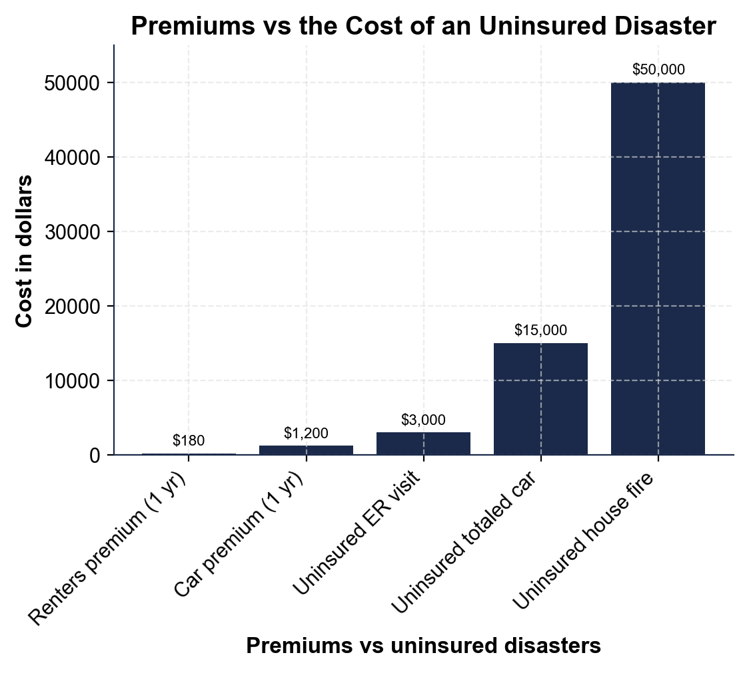

2. A4-Q2. As Maya Okonkwo, use the same chart to make the key point to Devon. (a) Which two bars are the premiums (the small, regular payments)? (b) Which three bars are the uninsured disasters (the big, rare losses)? (c) In one sentence, what does the chart show about how a premium compares to a disaster?

3. A4-Q3. As Maya Okonkwo, use the chart to help Devon compute the protection value. (a) Using PROTECTION VALUE = uninsured loss - premium, how much risk does the car policy transfer if the totaled-car bar is $15,000 and the car premium bar is $1,200? (b) In one sentence, state the tradeoff Devon makes by paying the premium.

4. A4-Q4. As Maya Okonkwo, apply the decision rule with Devon using the chart. Devon asks which of these to insure. (a) Should Devon insure the $15,000 car, and why? (b) Should Devon insure a $30 pair of headphones, and why? (c) In one sentence, state the rule that decides both cases.

PART 5

Advise Devon - Is Insurance Worth It?
1. As Maya Okonkwo, answer Devon's main objection. Devon says, 'Insurance is a waste - you pay and pay and never use it.'
(a) Using risk pooling, explain in one to two sentences why insurance is NOT a waste even if Devon never files a claim.

(b) In one sentence, what is the premium actually buying Devon?

2. As Maya Okonkwo, help Devon decide what to insure. Devon owns a $15,000 used car, the contents of a first apartment, and a $30 pair of headphones.
(a) Which of these should Devon insure, and which should Devon skip?

(b) For the car, name the premium Devon would pay and the protection value it provides.

(c) In one sentence, state the rule Devon should use for any future purchase.

3. As Maya Okonkwo, make sure Devon keeps the coverage working.
(a) What is the difference between Devon's premium and Devon's deductible?

(b) What happens if Devon stops paying the premium?

(c) When a covered loss happens, what does Devon file to be paid, and who pays it?

FINAL INSURANCE PLAN FOR DEVON
4. FINAL INSURANCE PLAN FOR DEVON. As Maya Okonkwo, put your advice in writing for Devon. Write a 5-7 sentence plan (120-180 words) that defines insurance in your own words, explains how risk pooling makes it work, names at least one thing Devon should insure and why, uses at least one calculated result from this activity (the $18,000 pool, the $13,800 protection value, or the $900 five-year premium), and tells Devon what a premium and a deductible are. Check off each required element as you include it.
YOUR RESPONSE MUST:
☐ DEFINE INSURANCE - explain in your own words that insurance transfers the risk of a big, rare loss to an insurer for a small, regular premium.
☐ EXPLAIN RISK POOLING - tell Devon that many people's premiums go into a shared pool that covers the big losses of the unlucky few.
☐ NAME SOMETHING TO INSURE AND WHY - tell Devon to insure the $15,000 car (or the apartment's contents) because it is a loss Devon could not afford to pay out of pocket.
☐ USE A CALCULATED RESULT - include a figure from this activity (the $18,000 pool, the $13,800 protection value, or $180 x 5 = $900 over five years).
☐ DEFINE PREMIUM AND DEDUCTIBLE - tell Devon the premium is the regular payment that keeps coverage active and the deductible is what Devon pays on a claim before the insurer pays the rest.

