PERSONAL FINANCE

WHAT IS INSURANCE - PAYING TO PROTECT YOURSELF
ANSWER KEY ACTIVITY - ANSWER KEY

PART 1

Insurance Basics Reference Guide - Complete the Missing Terms

Term | Definition
Insurance | A way to transfer the financial risk of a big, rare loss to an insurer in exchange for a small, regular payment
Risk of loss | The uncertainty that a costly event - like a crash, an illness, or a fire - could happen to you
Risk pooling | Many people each pay premiums into a shared pool, and the pool pays the big claims of the unlucky few
Insurer | The company that collects premiums, holds the pool, and pays out claims when a covered loss happens
Premium | The regular payment you make to keep your insurance coverage active
Policyholder | The person who buys the insurance and is protected by it - you, when you own a policy
Deductible | The amount you pay out of pocket on a claim before the insurer pays the rest
Policy | The contract that spells out what is covered, what you pay, and what the insurer pays
Claim | A request you file with your insurer to be paid for a covered loss
Catastrophic loss | A loss so large you could not pay it yourself; protecting against it is the main reason to buy insurance

PART 2

Apply the Terms - Insurance Vocabulary in Context
WORD BANK claim · deductible · risk pooling · insurance · premium
1. Q1. Transferring the financial risk of a big, rare loss to a company in exchange for a small, regular payment is called insurance.
insurance
2. Q2. When many people each pay premiums into a shared pool that covers the big losses of the unlucky few, that is risk pooling.
risk pooling
3. Q3. The regular payment you make to keep your insurance coverage active is your premium.
premium
4. Q4. The amount you pay out of pocket on a claim before the insurer pays the rest is your deductible.
deductible
5. Q5. The request you file with your insurer to be paid for a covered loss is a claim.
claim

PART 3

Calculate Risk Pooling and Protection Value - Use the Labeled Models
1. As Maya Okonkwo, warm up the risk-pooling model with Devon. Suppose 100 renters each pay a $180 premium into a shared pool.
(a) Using POOL MONEY = number of people x premium each, how much is in the pool?
(b) If one renter has a $15,000 loss (a fire destroys most of their belongings), can the pool cover it?
(c) In one sentence, why did everyone else only pay $180 even though the pool covered a $15,000 loss?
(1) POOL MONEY = 100 x $180 = $18,000 in the pool. (2) Yes - $18,000 is more than enough to cover the one $15,000 loss. (3) Everyone else only paid $180 because risk pooling spreads one person's big loss across the whole group's small premiums - most people did not have a loss, so their premiums covered the unlucky one. Accept $18,000, yes/it covers the loss, and a risk-is-spread-across-the-group explanation.
2. As Maya Okonkwo, work Devon's protection value on the car. Devon's used car is worth $15,000, and the yearly car premium is $1,200.
(a) Using PROTECTION VALUE = uninsured loss - premium, how much financial risk does insuring the car transfer to the insurer?
(b) In one sentence, explain what that number means for Devon if the car is totaled.
(1) PROTECTION VALUE = $15,000 - $1,200 = $13,800 transferred to the insurer. (2) It means that if the car is totaled, Devon is out only the $1,200 premium (plus any deductible) instead of the whole $15,000 - the insurer takes on $13,800 of the risk. Accept $13,800 and a Devon-pays-the-premium-not-the-whole-loss explanation.
3. As Maya Okonkwo, compare a small premium over time to a single disaster. Devon pays a $180-a-year renters premium.
(a) Using MULTI-YEAR PREMIUM = annual premium x years, how much would Devon pay in renters premiums over 5 years?
(b) How does that 5-year total compare to a single uninsured $50,000 house fire?
(c) In one to two sentences, what does this show about paying premiums versus facing a disaster uninsured?
(1) MULTI-YEAR PREMIUM = $180 x 5 = $900 over five years. (2) $900 is far below a single $50,000 house fire - the fire would cost about 55 times as much as five years of premiums. (3) It shows that even years of premiums add up to a small, plannable cost compared to one uninsured disaster - you would rather pay the small known amount over time than risk the huge unknown loss all at once. Accept $900, a far-below/much-smaller comparison, and a premiums-are-small-vs-a-disaster explanation.

PART 4

Read the Chart - Premiums vs the Cost of an Uninsured Disaster
As Maya Okonkwo, study the bar chart titled "Premiums vs the Cost of an Uninsured Disaster" (it appears with A4-Q1). It shows five costs side by side: two premiums and three uninsured disasters. The same values are listed in the data table below. Use the chart and table to answer A4-Q1 to A4-Q3, then apply the decision rule in A4-Q4.

Cost | Amount
Renters premium (1 yr) | $180
Car premium (1 yr) | $1,200
Uninsured ER visit | $3,000
Uninsured totaled car | $15,000
Uninsured house fire | $50,000

Analysis

1. A4-Q1. As Maya Okonkwo, study the bar chart on this page titled "Premiums vs the Cost of an Uninsured Disaster." It shows five costs side by side. Read the chart and write the amount of each bar: (a) renters premium (1 year), (b) car premium (1 year), (c) uninsured ER visit, (d) uninsured totaled car, and (e) uninsured house fire.
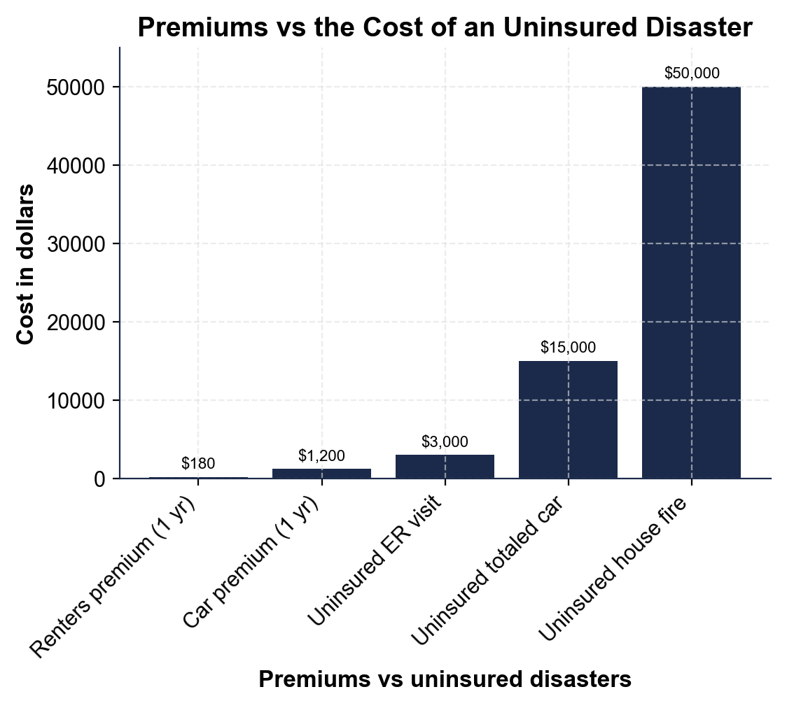
(a) Renters premium (1 yr) = $180. (b) Car premium (1 yr) = $1,200. (c) Uninsured ER visit = $3,000. (d) Uninsured totaled car = $15,000. (e) Uninsured house fire = $50,000. Accept these five values read directly off the chart.

2. A4-Q2. As Maya Okonkwo, use the same chart to make the key point to Devon. (a) Which two bars are the premiums (the small, regular payments)? (b) Which three bars are the uninsured disasters (the big, rare losses)? (c) In one sentence, what does the chart show about how a premium compares to a disaster?
(1) The two premium bars are the renters premium ($180) and the car premium ($1,200). (2) The three disaster bars are the uninsured ER visit ($3,000), the uninsured totaled car ($15,000), and the uninsured house fire ($50,000). (3) The chart shows that the disasters are many times bigger than the premiums - a premium is tiny compared to the loss it protects against. Accept the two premium bars, the three disaster bars, and a disasters-dwarf-premiums conclusion.

3. A4-Q3. As Maya Okonkwo, use the chart to help Devon compute the protection value. (a) Using PROTECTION VALUE = uninsured loss - premium, how much risk does the car policy transfer if the totaled-car bar is $15,000 and the car premium bar is $1,200? (b) In one sentence, state the tradeoff Devon makes by paying the premium.
(1) PROTECTION VALUE = $15,000 - $1,200 = $13,800 transferred to the insurer. (2) The tradeoff: Devon gives up a small, certain $1,200 premium in order to be protected against a huge, uncertain $15,000 loss they could not otherwise afford. Accept $13,800 and a small-certain-cost-for-protection-from-a-large-loss tradeoff.

4. A4-Q4. As Maya Okonkwo, apply the decision rule with Devon using the chart. Devon asks which of these to insure. (a) Should Devon insure the $15,000 car, and why? (b) Should Devon insure a $30 pair of headphones, and why? (c) In one sentence, state the rule that decides both cases.
(1) Yes, insure the $15,000 car - a $15,000 loss is far more than Devon could pay out of pocket, so the small premium is worth it for protection against a catastrophic loss. (2) No, do not insure the $30 headphones - Devon could easily replace them, and the premium plus deductible would cost more than the item is worth. (3) The rule: insure what you could NOT afford to lose, and skip small losses you could easily replace yourself. Accept insure-the-car (too big to lose), skip-the-headphones (small/replaceable), and the insure-what-you-cannot-afford-to-lose rule.

PART 5

Advise Devon - Is Insurance Worth It?
1. As Maya Okonkwo, answer Devon's main objection. Devon says, 'Insurance is a waste - you pay and pay and never use it.'
(a) Using risk pooling, explain in one to two sentences why insurance is NOT a waste even if Devon never files a claim.
(b) In one sentence, what is the premium actually buying Devon?
(1) Insurance is not a waste because of risk pooling: Devon's premium joins a shared pool that covers the big losses of the unlucky few - most years most people (including Devon) will not have a loss, but the pool is there for whoever does, and Devon could be that person any year. (2) The premium is buying Devon PROTECTION against a catastrophic loss - the certainty that a $15,000 or $50,000 disaster will not fall entirely on Devon. Accept a risk-pooling explanation and a buying-protection answer.
2. As Maya Okonkwo, help Devon decide what to insure. Devon owns a $15,000 used car, the contents of a first apartment, and a $30 pair of headphones.
(a) Which of these should Devon insure, and which should Devon skip?
(b) For the car, name the premium Devon would pay and the protection value it provides.
(c) In one sentence, state the rule Devon should use for any future purchase.
(1) Devon should INSURE the car and the apartment's contents (both are losses Devon could not afford to pay out of pocket) and SKIP insuring the $30 headphones (easily replaceable). (2) The car premium is about $1,200/year, and PROTECTION VALUE = $15,000 - $1,200 = $13,800 of risk transferred to the insurer. (3) The rule: insure anything you could not afford to lose, and skip small losses you could easily replace yourself. Accept insure-car-and-apartment/skip-headphones, the $1,200 premium and $13,800 protection value, and the insure-what-you-cannot-afford-to-lose rule.
3. As Maya Okonkwo, make sure Devon keeps the coverage working.
(a) What is the difference between Devon's premium and Devon's deductible?
(b) What happens if Devon stops paying the premium?
(c) When a covered loss happens, what does Devon file to be paid, and who pays it?
(1) The PREMIUM is the regular payment Devon makes to keep coverage active; the DEDUCTIBLE is the amount Devon pays out of pocket on a claim before the insurer pays the rest. (2) If Devon stops paying the premium, the coverage can LAPSE (end), and Devon is back to facing the whole risk with no protection. (3) When a covered loss happens, Devon files a CLAIM, and the INSURER pays it (after Devon pays any deductible). Accept a premium-vs-deductible distinction, coverage-lapses, and file-a-claim/insurer-pays.
FINAL INSURANCE PLAN FOR DEVON
4. FINAL INSURANCE PLAN FOR DEVON. As Maya Okonkwo, put your advice in writing for Devon. Write a 5-7 sentence plan (120-180 words) that defines insurance in your own words, explains how risk pooling makes it work, names at least one thing Devon should insure and why, uses at least one calculated result from this activity (the $18,000 pool, the $13,800 protection value, or the $900 five-year premium), and tells Devon what a premium and a deductible are. Check off each required element as you include it.
YOUR RESPONSE MUST:
☐ DEFINE INSURANCE - explain in your own words that insurance transfers the risk of a big, rare loss to an insurer for a small, regular premium.
☐ EXPLAIN RISK POOLING - tell Devon that many people's premiums go into a shared pool that covers the big losses of the unlucky few.
☐ NAME SOMETHING TO INSURE AND WHY - tell Devon to insure the $15,000 car (or the apartment's contents) because it is a loss Devon could not afford to pay out of pocket.
☐ USE A CALCULATED RESULT - include a figure from this activity (the $18,000 pool, the $13,800 protection value, or $180 x 5 = $900 over five years).
☐ DEFINE PREMIUM AND DEDUCTIBLE - tell Devon the premium is the regular payment that keeps coverage active and the deductible is what Devon pays on a claim before the insurer pays the rest.
GRADING RUBRIC
Grade the evidence and reasoning, not the conclusion — any defensible position is valid. Score against the 5 requirements above.
FULL CREDIT — clear position; meets all 5 requirements with accurate, specific numbers and evidence from the lesson.
PARTIAL — position stated, but misses 1-2 requirements or uses vague / incorrect numbers.
MINIMAL — no clear position, or missing most requirements and numbers.

MORE LESSONS LESS PLANNING
Thank You!
If you enjoyed this product, please do not forget to rate and review to assist other teachers.

Looking for future discounts? Earn TPT credits by reviewing purchased products.

Please contact me if you have any issues with this product. Just like our students, I am always looking for opportunities to grow.

