Wealth Inequality: The Top 1% Explained
STUDENT ACTIVITY
Name: | Date: | Period:
ESSENTIAL QUESTION
How is U.S. wealth inequality measured, why is the U.S. the most wealth-unequal major developed economy, and which fix should policymakers push first?
THE SCENARIO
U.S. wealth is far more concentrated than income, and the U.S. is the most wealth-unequal of any major developed economy. WEALTH is what a household OWNS minus what they owe (a STOCK that carries forward), while INCOME is what they EARN each year (a FLOW that resets) - and wealth piles up at the top because it COMPOUNDS and is passed down through inheritance.
BY THE END, YOU CAN:
✓ Identify how wealth inequality is measured using the Gini coefficient and percentile-share statistics
✓ Compare U.S. wealth concentration to other developed countries using the Gini coefficient
✓ Evaluate the racial wealth gap and the historical drivers that produced it
HOW IT WORKS (do Parts 1–5 in order)
Part 1 — Wealth-Inequality Reference Guide - Complete the Missing Terms
Part 2 — Apply the Terms - Wealth-Inequality Vocabulary in Context
Part 3 — Explain Wealth vs Income, the Gini Coefficient, and Compounding
Part 4 — Read the Charts and Run the Numbers
Part 5 — Policy Memo - Which Fix Comes First?
TIME about 45 minutes YOU’LL NEED the lesson slides and your Guided Notes.

PART 1

Wealth-Inequality Reference Guide - Complete the Missing Terms
Fill in the missing term for each blank row — the definition is your clue. Your Guided Notes and the lesson slides have every term.

Term | Definition
___________ | What a household owns (home, savings, retirement accounts, stocks, a business) minus what they owe in debt; a stock that carries forward across years and lifetimes
Income | The money a household earns each year from wages, business profits, or investments; measured before taxes; a flow that resets each paycheck
___________ | A single number from 0 to 1 that measures inequality; 0 means perfect equality and 1 means total inequality where one household owns everything
Lorenz curve | A graph that plots the cumulative share of wealth against the cumulative share of population; the further it drops below the diagonal line of equality, the more unequal the country
___________ | When investment returns earn returns on top of past returns, so wealth grows faster and faster over time; the main reason wealth concentrates at the top
Median wealth | The middle household's wealth, where half of families have more and half have less; less skewed by billionaires than the average
___________ | The 20th-century practice of denying home loans to Black neighborhoods; one of the biggest historical drivers of the racial wealth gap
Racial wealth gap | The gap in median wealth between white households and Black or Hispanic households; one of the largest and most persistent gaps in U.S. economics
___________ | Money or assets passed down from parents or grandparents; a large share of U.S. wealth comes from inheritance rather than the owner's own earnings
Top 1% wealth share | The share of all national wealth owned by the wealthiest 1 percent of households; the headline measure of wealth concentration at the very top

PART 2

Apply the Terms - Wealth-Inequality Vocabulary in Context
WORD BANK Wealth · Compounding · Redlining · Gini coefficient · Inherited wealth
1. What a household OWNS (home, savings, retirement accounts, stocks, a business) minus what they owe in debt - a stock that carries forward across years and lifetimes - is a household's .

2. The single number from 0 to 1 that measures inequality, where 0 means perfect equality and 1 means total inequality, is the .

3. When investment returns earn returns on top of past returns, so wealth grows faster and faster over time, that is .

4. The 20th-century practice of denying home loans to Black neighborhoods, a major historical driver of the racial wealth gap, is .

5. Money or assets passed down from parents or grandparents, which a large share of U.S. wealth comes from rather than the owner's own earnings, is .

PART 3

Explain Wealth vs Income, the Gini Coefficient, and Compounding
1. In your own words, explain the difference between WEALTH and INCOME. Then state which is more concentrated at the top in the U.S., and explain WHY that one is more concentrated.

2. Explain in 2-3 sentences what the GINI COEFFICIENT measures. Include what scores of 0 and 1 mean, and describe how the LORENZ CURVE shows the same information visually.

3. Explain in 3-4 sentences why WEALTH COMPOUNDS, and connect compounding to TWO other lesson ideas: inheritance and the racial wealth gap.
Why does the gap persist across generations?

PART 4

Read the Charts and Run the Numbers
1. Use the U.S. WEALTH LORENZ CURVE chart, inserted below and shown in the slide deck. Read the curve at the 50% population mark, then at the 90% mark, and
(a) state the share of total wealth held by the BOTTOM 50% of households

(b) state the share held by the BOTTOM 90%

(c) calculate what the TOP 10% must therefore hold (shares add to 100%). (Chart: chart_lorenz_us_wealth)
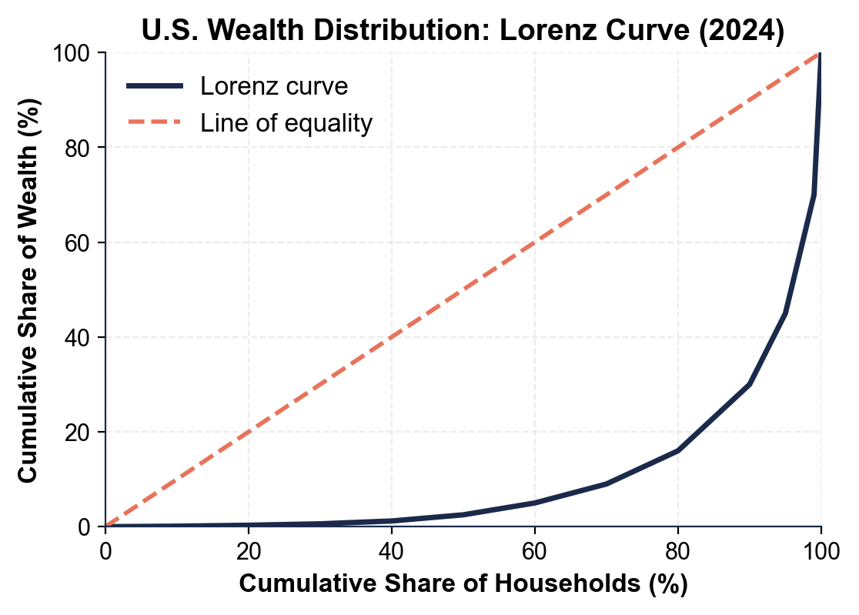

2. Use the WEALTH GINI BY COUNTRY chart, inserted below and shown in the slide deck.
(a) Identify the country with the HIGHEST wealth Gini and its value, and the country with the LOWEST and its value.

(b) Calculate the gap between the highest country and the lowest.

(c) Calculate the gap between the U.S. and France, then explain in one sentence what a larger Gini gap means in plain English. (Chart: chart_gini_by_country)
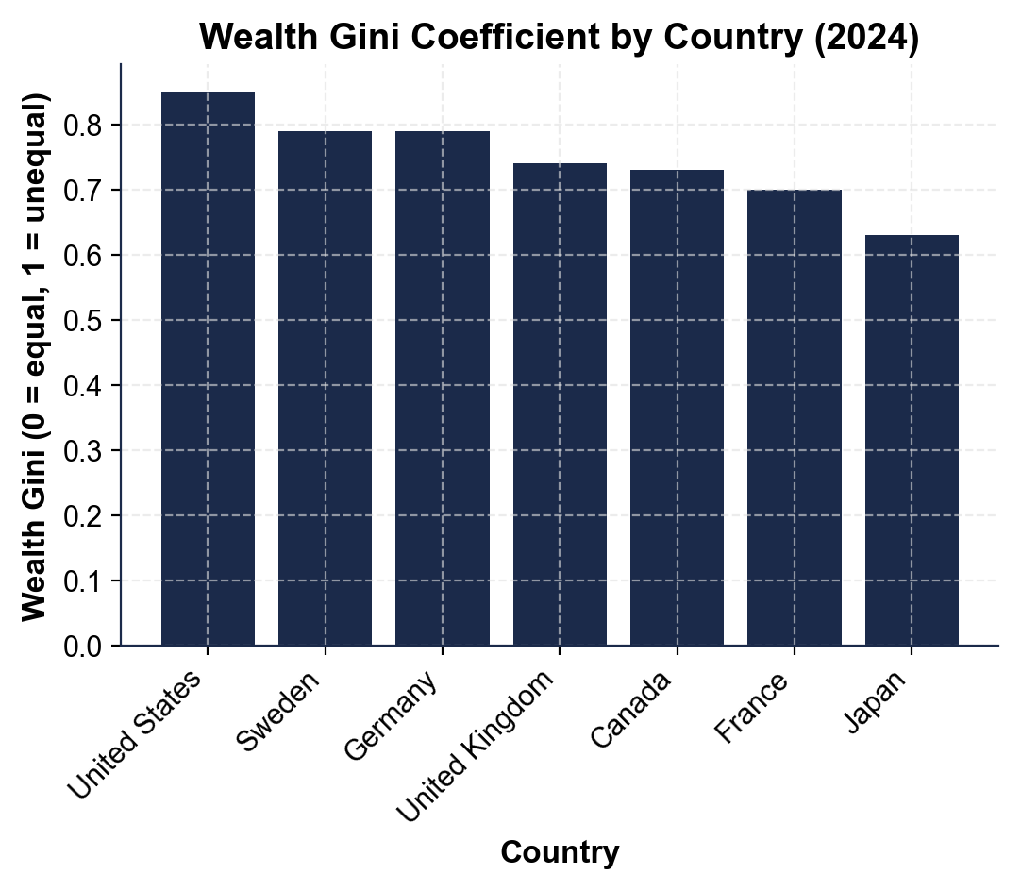

3. Use the RACIAL WEALTH GAP OVER TIME chart, inserted below and shown in the slide deck.
(a) Read the 2022 median wealth for WHITE, BLACK, and HISPANIC households off the chart.

(b) Calculate the DOLLAR GAP between median white and median Black household wealth in 2022.

(c) Calculate the RATIO of white to Black median wealth, and state what that ratio means for a Black family compared to a white family. (Chart: chart_racial_wealth_gap_over_time)
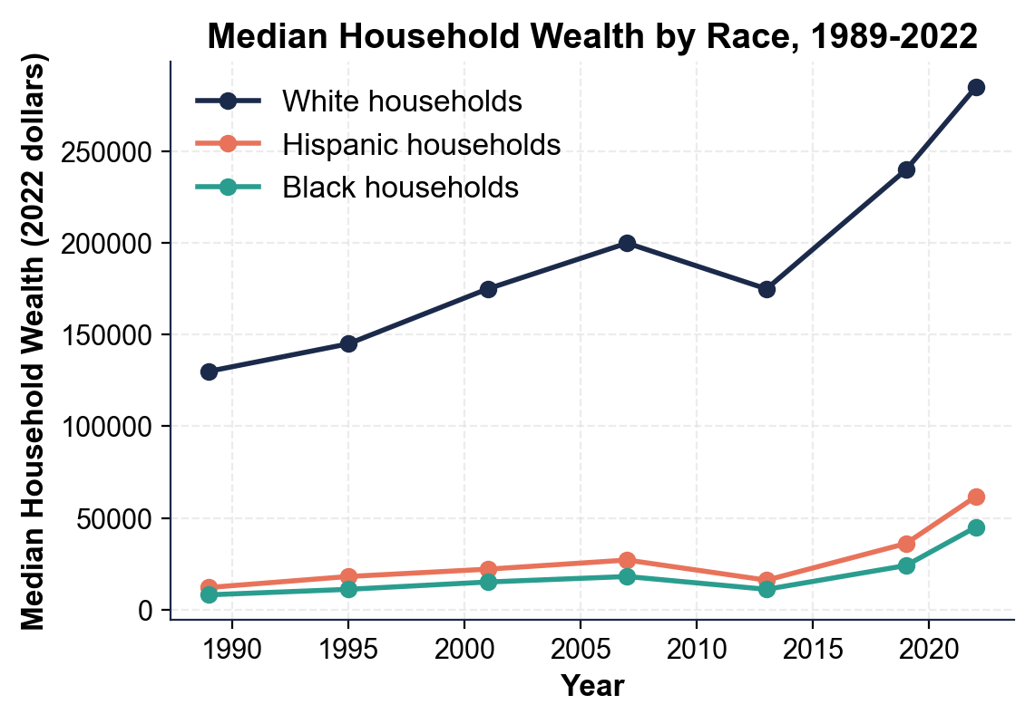

4. COMPOUNDING MATH (no chart). Using FV = PV x (1 + r)^n, the same 7% annual return for 40 years turns $10,000 into about $149,745 but turns $100,000 into about $1,497,446.
(a) Calculate the dollar DIFFERENCE in ending balance between the two.

(b) Calculate the RATIO of the two ending balances.

(c) Explain in one sentence why the same 7% rate produces such different total dollars, and what that says about the importance of starting balances (and therefore inheritance). Show your work.

5. SHARES AND INHERITANCE MATH (no chart).
(a) The top 1% of U.S. households holds about 30% of all wealth. Using the bottom-50% wealth share you read off the Lorenz curve back in A4-Q1, calculate how many TIMES more TOTAL wealth the top 1% holds than the entire bottom 50% combined.

(b) Total U.S. household wealth is roughly $150 trillion. Using 35% as the midpoint of the "30 to 40 percent from inheritance" range, calculate the dollar amount of inherited wealth.

(c) In one sentence, explain why inheritance is so important for understanding wealth inequality. Show your work.

PART 5

Policy Memo - Which Fix Comes First?
POLICY MEMO
1. POLICY MEMO. You are advising a U.S. senator on wealth inequality and she votes soon. Write an 8-12 sentence memo (about 250-350 words) recommending ONE policy to push FIRST. Options: a wealth tax on net worth above $50 million; a stronger estate tax on large inheritances; broader first-time homeownership programs; broader retirement-savings (baby-bond or auto-IRA) programs; or raising capital-gains tax rates closer to wage tax rates. Use the memo header below and check off each required element as you include it. (Sentence starter you may use: "I recommend the senator push ___ first because ___.")
YOUR RESPONSE MUST:
☐ CLEAR RECOMMENDATION - name ONE policy in the first sentence. Do not hedge across multiple options.
☐ TWO LESSON NUMBERS - cite at least TWO specific facts or figures from the lesson or charts (for example: the top 1% holds about 30% of wealth, the median white household holds about 6x the median Black household, about 30-40% of U.S. wealth comes from inheritance, the $10K-vs-$100K compounding example, or any of the chart values you extracted in Part 4 such as a country Gini gap or the racial-wealth dollar gap).
☐ WINNERS AND LOSERS - name WHO benefits and WHO might lose under your recommendation.
☐ ONE REALISTIC OBJECTION - acknowledge one credible objection an opponent would raise.
☐ ONE TRADE-OFF - state one trade-off you accept by choosing this policy over the others.
MEMO
To: U.S. Senator (Your State)
From: Wealth Policy Analyst
Date:
Re: Which Wealth-Inequality Fix to Champion First

