ECONOMICS

WEALTH INEQUALITY: THE TOP 1% EXPLAINED
ANSWER KEY ACTIVITY

PART 1

Wealth-Inequality Reference Guide - Complete the Missing Terms

Term | Definition
Wealth | What a household owns (home, savings, retirement accounts, stocks, a business) minus what they owe in debt; a stock that carries forward across years and lifetimes
Income | The money a household earns each year from wages, business profits, or investments; measured before taxes; a flow that resets each paycheck
Gini coefficient | A single number from 0 to 1 that measures inequality; 0 means perfect equality and 1 means total inequality where one household owns everything
Lorenz curve | A graph that plots the cumulative share of wealth against the cumulative share of population; the further it drops below the diagonal line of equality, the more unequal the country
Compounding | When investment returns earn returns on top of past returns, so wealth grows faster and faster over time; the main reason wealth concentrates at the top
Median wealth | The middle household's wealth, where half of families have more and half have less; less skewed by billionaires than the average
Redlining | The 20th-century practice of denying home loans to Black neighborhoods; one of the biggest historical drivers of the racial wealth gap
Racial wealth gap | The gap in median wealth between white households and Black or Hispanic households; one of the largest and most persistent gaps in U.S. economics
Inherited wealth | Money or assets passed down from parents or grandparents; a large share of U.S. wealth comes from inheritance rather than the owner's own earnings
Top 1% wealth share | The share of all national wealth owned by the wealthiest 1 percent of households; the headline measure of wealth concentration at the very top

PART 2

Apply the Terms - Wealth-Inequality Vocabulary in Context
WORD BANK Wealth · Compounding · Redlining · Gini coefficient · Inherited wealth
1. What a household OWNS (home, savings, retirement accounts, stocks, a business) minus what they owe in debt - a stock that carries forward across years and lifetimes - is a household's Wealth.
Wealth
2. The single number from 0 to 1 that measures inequality, where 0 means perfect equality and 1 means total inequality, is the Gini coefficient.
Gini coefficient
3. When investment returns earn returns on top of past returns, so wealth grows faster and faster over time, that is Compounding.
Compounding
4. The 20th-century practice of denying home loans to Black neighborhoods, a major historical driver of the racial wealth gap, is Redlining.
Redlining
5. Money or assets passed down from parents or grandparents, which a large share of U.S. wealth comes from rather than the owner's own earnings, is Inherited wealth.
Inherited wealth

PART 3

Explain Wealth vs Income, the Gini Coefficient, and Compounding
1. In your own words, explain the difference between WEALTH and INCOME. Then state which is more concentrated at the top in the U.S., and explain WHY that one is more concentrated.
WEALTH is what a household OWNS minus what they owe - home equity, savings, retirement accounts, stocks, and businesses, MINUS debts. It is a STOCK: it carries forward across years and across lifetimes. INCOME is what a household EARNS each year - wages, business profits, and investment returns. It is a FLOW: it resets every paycheck and every year. WEALTH is far more concentrated at the top than income in the U.S. The reason is COMPOUNDING and INHERITANCE: past savings earn returns, those returns earn more returns, and wealth gets passed down to the next generation - so it piles up across years and lifetimes. Income just resets each year, so it cannot stack up the same way. That is why the gap looks much larger when you measure what families OWN (wealth) than when you measure what they EARN (income).
2. Explain in 2-3 sentences what the GINI COEFFICIENT measures. Include what scores of 0 and 1 mean, and describe how the LORENZ CURVE shows the same information visually.
GINI COEFFICIENT: a single number from 0 to 1 that measures how unevenly wealth or income is distributed across households. ZERO MEANS: a Gini of 0 is PERFECT EQUALITY - every household has the same wealth. ONE MEANS: a Gini of 1 is TOTAL INEQUALITY - one household owns everything and everyone else owns nothing. LORENZ CURVE: the visual version of the same measure - it plots cumulative wealth share (y-axis) against cumulative population share (x-axis), and the further the curve drops below the diagonal line of perfect equality, the higher the Gini and the more unequal the country. A perfectly equal country would have a Lorenz curve sitting right on the diagonal line.
3. Explain in 3-4 sentences why WEALTH COMPOUNDS, and connect compounding to TWO other lesson ideas: inheritance and the racial wealth gap.
Why does the gap persist across generations?
COMPOUNDING: wealth grows because investment returns earn returns on top of past returns - the gains from one year become part of the balance that earns gains the next year, so wealth grows faster and faster (multiplicatively, not additively), and larger STARTING BALANCES therefore compound into far larger ending balances at the same rate over the same years. INHERITANCE: a large share of U.S. wealth is passed down rather than earned, and inheritance sets the starting balances that then compound for decades, so a child who inherits even a modest amount gets a head start. RACIAL WEALTH GAP: redlining blocked Black families from building home equity - the largest source of wealth for most middle-income families - for decades, so that equity was never built, never compounded, and never inherited. PERSISTENCE: the missing equity of one generation becomes the missing inheritance of the next, which is why the gap carries forward across generations instead of closing on its own.

PART 4

Read the Charts and Run the Numbers
1. Use the U.S. WEALTH LORENZ CURVE chart, inserted below and shown in the slide deck. Read the curve at the 50% population mark, then at the 90% mark, and
(a) state the share of total wealth held by the BOTTOM 50% of households
BOTTOM 50% wealth share = about 2.5% (read the y-axis at x = 50%; accept 2-3%). The entire bottom HALF of U.S. households together owns only about 2.5 cents of every wealth dollar.
(b) state the share held by the BOTTOM 90%
BOTTOM 90% wealth share = about 30% (read the y-axis at x = 90%; accept 28-32%).
(c) calculate what the TOP 10% must therefore hold (shares add to 100%). (Chart: chart_lorenz_us_wealth)
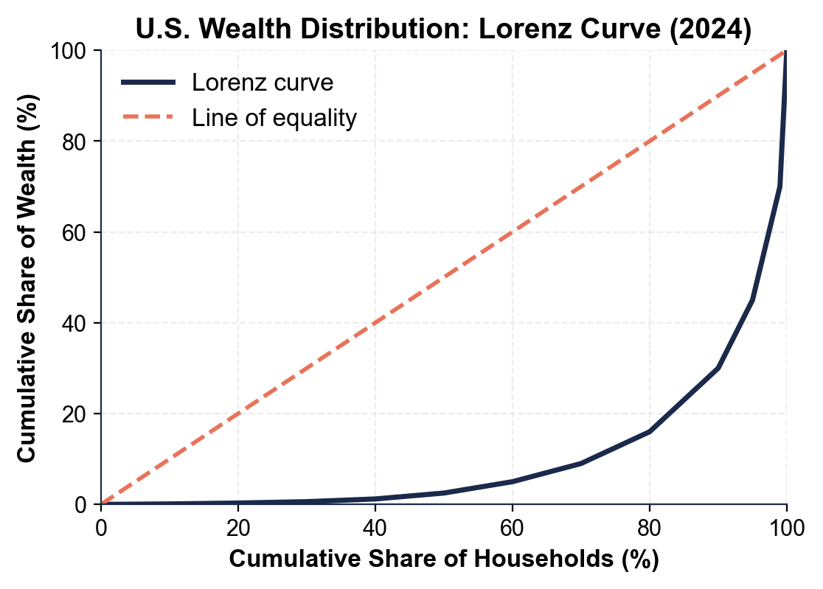
TOP 10% = 100% - 30% = about 70% (accept 68-72%). So the wealthiest 10% of households own roughly 70% of all U.S. wealth while the other 90% of households together own about 30%. The big gap between the curve and the diagonal line is the visual measure of that inequality.
2. Use the WEALTH GINI BY COUNTRY chart, inserted below and shown in the slide deck.
(a) Identify the country with the HIGHEST wealth Gini and its value, and the country with the LOWEST and its value.
HIGHEST = the UNITED STATES at about 0.85; LOWEST = JAPAN at about 0.63 (accept within 0.02).
(b) Calculate the gap between the highest country and the lowest.
GAP (U.S. - Japan) = 0.85 - 0.63 = about 0.22 Gini points.
(c) Calculate the gap between the U.S. and France, then explain in one sentence what a larger Gini gap means in plain English. (Chart: chart_gini_by_country)
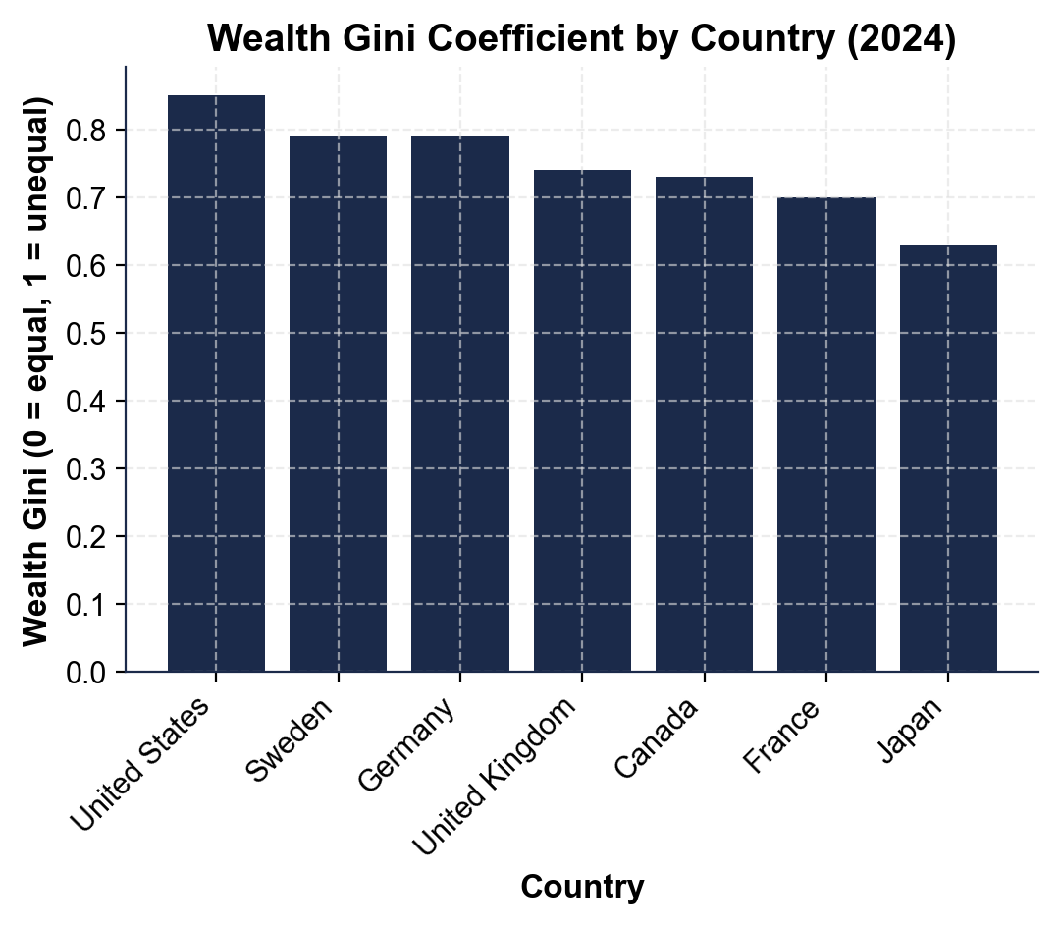
GAP (U.S. - France, ~0.70) = 0.85 - 0.70 = about 0.15 Gini points. PLAIN ENGLISH: a larger Gini gap means wealth is far more concentrated at the top in the higher-Gini country - Japan's and France's wealth is spread much more evenly across households than U.S. wealth, even though all three are wealthy capitalist economies with similar GDP per person. The difference is about how the wealth is distributed, not how much there is.
3. Use the RACIAL WEALTH GAP OVER TIME chart, inserted below and shown in the slide deck.
(a) Read the 2022 median wealth for WHITE, BLACK, and HISPANIC households off the chart.
WHITE median (2022) = about $285,000; HISPANIC median = about $61,600; BLACK median = about $44,900 (accept within $10K). White is the top line, Black the bottom line, Hispanic in between.
(b) Calculate the DOLLAR GAP between median white and median Black household wealth in 2022.
DOLLAR GAP = $285,000 - $44,900 = about $240,100.
(c) Calculate the RATIO of white to Black median wealth, and state what that ratio means for a Black family compared to a white family. (Chart: chart_racial_wealth_gap_over_time)
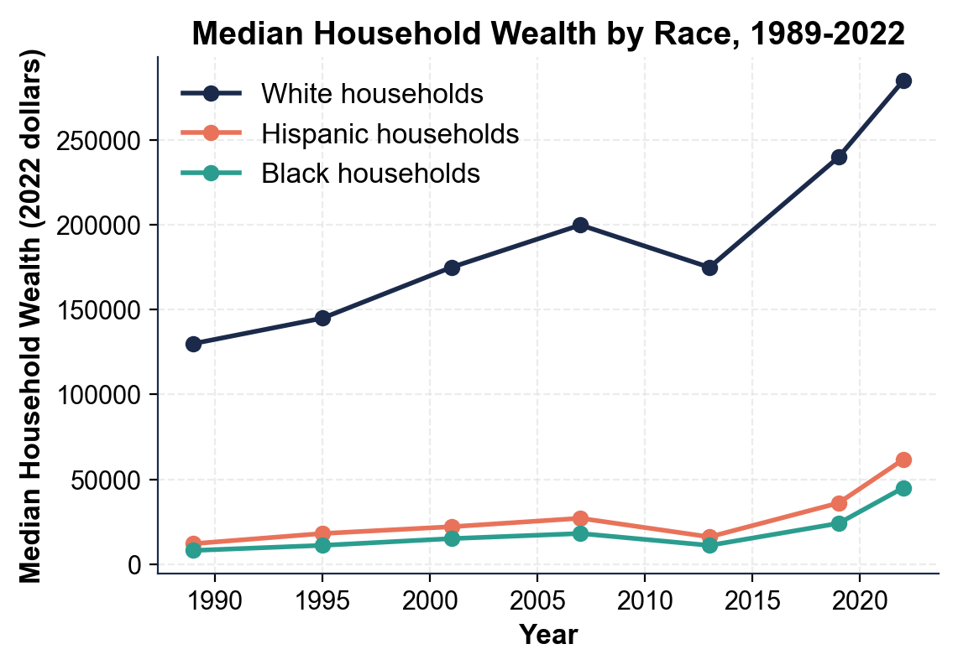
RATIO = $285,000 / $44,900 = about 6.3 to 1 (consistent with the lesson's ~6x figure). MEANING: for every $1 of wealth a median Black family holds, a median white family holds roughly $6. That gap shows up as differences in housing security, college affordability, retirement readiness, and the cushion to absorb a job loss or medical bill - and it has widened in dollar terms since 1989 because the white line has risen faster. Accept ratios of 5.5-7 and gaps of $230K-$250K.
4. COMPOUNDING MATH (no chart). Using FV = PV x (1 + r)^n, the same 7% annual return for 40 years turns $10,000 into about $149,745 but turns $100,000 into about $1,497,446.
(a) Calculate the dollar DIFFERENCE in ending balance between the two.
DIFFERENCE = $1,497,446 - $149,745 = about $1,347,701 MORE for the family that started with $100,000.
(b) Calculate the RATIO of the two ending balances.
RATIO = $1,497,446 / $149,745 = about 10 to 1 - exactly the 10x ratio of the starting balances ($100,000 / $10,000).
(c) Explain in one sentence why the same 7% rate produces such different total dollars, and what that says about the importance of starting balances (and therefore inheritance). Show your work.
WHY: compounding is MULTIPLICATIVE, not additive - a 10x larger starting balance grows to a 10x larger ending balance at the same rate over the same years, so the family that started 10x ahead ended up about $1.35 MILLION ahead in absolute dollars.
5. SHARES AND INHERITANCE MATH (no chart).
(a) The top 1% of U.S. households holds about 30% of all wealth. Using the bottom-50% wealth share you read off the Lorenz curve back in A4-Q1, calculate how many TIMES more TOTAL wealth the top 1% holds than the entire bottom 50% combined.
RATIO = 30% / 2.5% = 12 TIMES more TOTAL wealth for the top 1% than for the entire bottom 50% combined - and because the top 1% is just 1% of households while the bottom 50% is 50% of households, the PER-HOUSEHOLD gap is far larger still (about 600 times per household: (30/1) / (2.5/50)).
(b) Total U.S. household wealth is roughly $150 trillion. Using 35% as the midpoint of the "30 to 40 percent from inheritance" range, calculate the dollar amount of inherited wealth.
INHERITED WEALTH = 35% x $150 trillion = about $52.5 TRILLION.
(c) In one sentence, explain why inheritance is so important for understanding wealth inequality. Show your work.
Inheritance matters because it sets the STARTING balances that compounding then multiplies for decades, so wealth gaps PERSIST across generations - families that already have wealth pass on more wealth, which is exactly why the redlining-driven racial wealth gap still shows up today.

PART 5

Policy Memo - Which Fix Comes First?
POLICY MEMO
1. POLICY MEMO. You are advising a U.S. senator on wealth inequality and she votes soon. Write an 8-12 sentence memo (about 250-350 words) recommending ONE policy to push FIRST. Options: a wealth tax on net worth above $50 million; a stronger estate tax on large inheritances; broader first-time homeownership programs; broader retirement-savings (baby-bond or auto-IRA) programs; or raising capital-gains tax rates closer to wage tax rates. Use the memo header below and check off each required element as you include it. (Sentence starter you may use: "I recommend the senator push ___ first because ___.")
YOUR RESPONSE MUST:
☐ CLEAR RECOMMENDATION - name ONE policy in the first sentence. Do not hedge across multiple options.
☐ TWO LESSON NUMBERS - cite at least TWO specific facts or figures from the lesson or charts (for example: the top 1% holds about 30% of wealth, the median white household holds about 6x the median Black household, about 30-40% of U.S. wealth comes from inheritance, the $10K-vs-$100K compounding example, or any of the chart values you extracted in Part 4 such as a country Gini gap or the racial-wealth dollar gap).
☐ WINNERS AND LOSERS - name WHO benefits and WHO might lose under your recommendation.
☐ ONE REALISTIC OBJECTION - acknowledge one credible objection an opponent would raise.
☐ ONE TRADE-OFF - state one trade-off you accept by choosing this policy over the others.
MEMO
To: U.S. Senator (Your State)
From: Wealth Policy Analyst
Date: [student completes]
Re: Which Wealth-Inequality Fix to Champion First
GRADING RUBRIC
Grade the evidence and reasoning, not the conclusion — any defensible position is valid. Score against the 5 requirements above.
FULL CREDIT — clear position; meets all 5 requirements with accurate, specific numbers and evidence from the lesson.
PARTIAL — position stated, but misses 1-2 requirements or uses vague / incorrect numbers.
MINIMAL — no clear position, or missing most requirements and numbers.
WHAT TO LOOK FOR IN THIS LESSON
Sample full-credit memo (STRONGER ESTATE TAX):
To: U.S. Senator (Your State)
From: Wealth Policy Analyst
Date: [today's date - leave bracketed]
Re: Which Wealth-Inequality Fix to Champion First
[1] RECOMMENDATION: push a STRONGER FEDERAL ESTATE TAX first - lower the exemption from about $13 million per person toward about $3 million and raise the rate on the very largest estates. [2] TWO LESSON NUMBERS: (i) about 30 to 40 percent of U.S. wealth comes from INHERITANCE, so inheritance is the single biggest channel concentrating wealth across generations; (ii) the U.S. wealth Gini is about 0.85, the highest of any major developed economy. The estate tax acts directly on the inheritance channel that produces both. [3] WINNERS: future generations and society broadly, because estate-tax revenue can fund baby bonds, first-time-homebuyer help, or college aid that broadens ownership; LOSERS: the wealthiest roughly 1% of estates, which would owe more. [4] OBJECTION: opponents call it "double taxation" (the wealth was taxed when earned) and warn it hits family farms and small businesses. [5] TRADE-OFF: I accept that estate-tax reform takes years to bite (estates settle when long-lived owners die) and may push families toward trusts, so it must be paired with closing trust loopholes.
REQUIRED-ELEMENT CHECKLIST (award credit per item): [1] ONE policy named in sentence 1. [2] at least TWO specific lesson numbers. [3] winners AND losers named. [4] one realistic objection. [5] one trade-off. ACCEPTABLE ALTERNATES: WEALTH TAX (defend with the 30%-top-1% and 0.85-Gini numbers), BROADER HOMEOWNERSHIP (defend with the racial wealth gap / redlining), BROADER RETIREMENT SAVINGS (defend with the bottom-50% 2.5% share), or EQUAL CAPITAL-GAINS RATES (defend with the compounding example). Grade on the QUALITY of the reasoning, not the choice.
MORE LESSONS LESS PLANNING
Thank You!
If you enjoyed this product, please do not forget to rate and review to assist other teachers.

Looking for future discounts? Earn TPT credits by reviewing purchased products.

Please contact me if you have any issues with this product. Just like our students, I am always looking for opportunities to grow.

