Universal Basic Income: Free Money for Everyone?
STUDENT ACTIVITY
Name: | Date: | Period:
ESSENTIAL QUESTION
What is universal basic income, what did the Yang, Alaska, Stockton, and Finland precedents actually show, and which of the three bills - the Yang $1,000/month Freedom Dividend, the $400/month hybrid, or the federal Alaska-style sovereign wealth fund - should the senator champion?
THE SCENARIO
It is October 2024. You are MAYA CHEN, a UBI policy advisor on the Senate Finance Committee staff.
BY THE END, YOU CAN:
✓ Define universal basic income (UBI) and identify recent U.S. proposals and pilot programs
✓ Evaluate the Stockton SEED ($500/month) and Finland (2017-2018) UBI experiments and what they found
✓ Compare UBI to the existing safety net and analyze the funding debate using cost-of-program math
HOW IT WORKS (do Parts 1–5 in order)
Part 1 — The UBI Reference Guide - Complete the Missing Terms
Part 2 — Apply the Terms - UBI Vocabulary in Context
Part 3 — Trace the Mechanics - Defining Features, the Four Precedents, the Cost Math, and UBI vs the Safety Net
Part 4 — Read the Charts - UBI Cost by Proposal and Alaska PFD Payouts
Part 5 — Final Policy Memo to Your Senator
TIME about 45 minutes YOU’LL NEED the lesson slides and your Guided Notes.

PART 1

The UBI Reference Guide - Complete the Missing Terms
Fill in the missing term for each blank row — the definition is your clue. Your Guided Notes and the lesson slides have every term.

Term | Definition
___________ | A government cash payment given to every adult, no strings attached, regardless of income or employment status
Means-tested benefit | A safety-net program that requires income or asset verification (SNAP, Medicaid, Section 8); the opposite of UBI
___________ | The economic concern that giving people unconditional cash reduces their incentive to take a paid job; the central UBI critique
Value-added tax (VAT) | A consumption tax charged at each stage of production; Yang proposed a 10 percent rate to fund the Freedom Dividend
___________ | A government-owned investment fund (Norway $1.6T, Alaska $80B); the Alaska Permanent Fund Dividend pays from one of these
Alaska Permanent Fund Dividend | Annual cash payment to every Alaska resident from oil-revenue investments; the closest thing to a real UBI in U.S. history (since 1982)
___________ | When a benefit gets reduced as income rises (SNAP cuts off above 130 percent of the poverty line); UBI eliminates these by giving cash to everyone
Negative income tax | A 1960s economist proposal (Milton Friedman) to give cash to households below an income threshold; the intellectual ancestor of modern UBI
___________ | The concern that AI and robots will replace human workers faster than new jobs are created; a key driver of Yang's UBI argument
Earned income tax credit (EITC) | A refundable U.S. tax credit for low-income workers; the closest existing program to a partial UBI for working households

PART 2

Apply the Terms - UBI Vocabulary in Context
WORD BANK Phase-out · Work disincentive · Universal basic income · Automation displacement · Sovereign wealth fund
1. A government cash payment given to every adult with no income test and no work requirement, regardless of how much they earn, is called a (UBI).

2. The central economic concern that giving people unconditional cash reduces their incentive to take a paid job is called the .

3. A government-owned investment fund (like Norway's $1.6 trillion fund or Alaska's $80 billion fund) that the Alaska Permanent Fund Dividend pays out from is a .

4. When a benefit gets reduced or cut off as income rises - the way SNAP ends above 130% of the poverty line - economists call it a .

5. The concern that AI and robots will replace human workers faster than new jobs are created, a key driver of Yang's UBI argument, is called .

PART 3

Trace the Mechanics - Defining Features, the Four Precedents, the Cost Math, and UBI vs the Safety Net
1. In your own words, explain what UNIVERSAL BASIC INCOME (UBI) means by naming its three defining features. Then state which of the three bills on your senator's desk (Yang-style $1,000/month Freedom Dividend, $400/month hybrid UBI, federal Alaska-style sovereign wealth fund) is the closest match to a TRUE universal basic income, and explain why.

2. Explain the WORK DISINCENTIVE critique of UBI in your own words. Then state what the STOCKTON SEED and FINLAND 2017-2018 pilots actually found about whether UBI recipients work less, and be honest about the limits of that evidence.

3. The senator needs to know which real-world precedent each of her three bills most resembles. As Maya, apply the THREE UBI PROPOSALS on her desk to the four real-world precedents from the lesson (Yang, Alaska, Stockton, Finland). For each of the three bills, name
(a) which precedent it most resembles

(b) one strength and one weakness of that precedent for predicting how the bill would work nationwide.

4. The senator needs Maya to do the cost math she will be asked about in committee. Calculate the cost math for the three bills she is voting on.
(a) Yang $1,000/month for 235M adults = ?

(b) $400/month hybrid for 235M adults = ?

(c) Compare both to the entire 2024 federal budget of about $6.8 trillion. What share of the federal budget does each plan consume?

5. The senator wants Maya to answer the opposition's favorite question: "Won't paying people not to work mean they stop working?" Apply the WORK DISINCENTIVE CRITIQUE to her three bills. For each bill, predict whether you expect a SMALL, MEDIUM, or LARGE work-disincentive effect. Use evidence from the Stockton SEED (Phase 1 employment gain; Phase 2 confounded by COVID; small sample of 125 treatment), Finland 2017-2018, or both - and be honest about the limits of the pilot evidence.

6. Compare UBI to the EXISTING SAFETY NET (SNAP, Medicaid, Section 8). As Maya, pick one of the three bills on her senator's desk and write a 6-8 sentence rationale explaining why the senator might prefer it for political or economic reasons. Walk through (1) the funding math, (2) at least one phase-out / safety-net mechanic, and (3) at least one piece of pilot evidence. Use specific examples from the lesson (the 130 percent SNAP gross-income limit, the Stockton 28-to-40-percent Phase 1 finding, the $2.82T Yang annual cost, the $1.128T hybrid annual cost, the $80B Alaska fund size, or the $6.8T federal budget).

PART 4

Read the Charts - UBI Cost by Proposal and Alaska PFD Payouts
1. As Maya, you need to brief the senator on what the Yang-style bill would actually cost compared to a cheaper alternative.
Use the UBI COST BY PROPOSAL bar chart, inserted below and shown in the slide deck. Read directly off the chart: roughly how much would Yang's $1,000/month Freedom Dividend cost per year? How much would a $500/month Stockton-scale national UBI cost per year? Calculate the DIFFERENCE between the two. (Chart unit note: the bar chart is labeled in $Billions per year - to brief the senator in $Trillions, divide by 1,000.) (Chart: chart_ubi_cost_by_proposal)
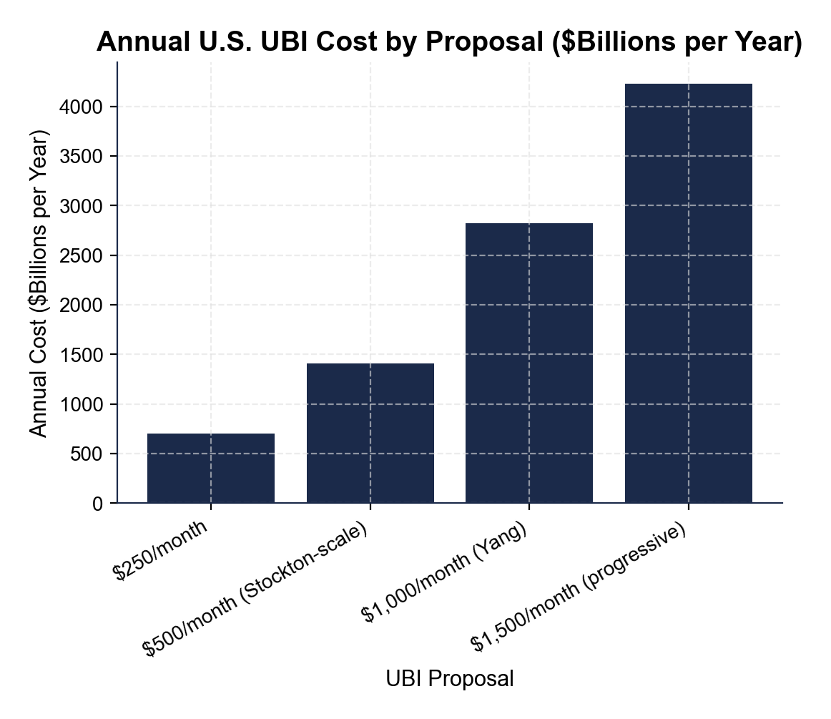

2. The senator wants to understand how scaling the monthly amount affects the price tag - cheaper to start small? Use the same UBI cost chart.
Compare the smallest proposal ($250/month) to the largest ($1,500/month). Read off both annual costs. Then write 2-3 sentences Maya could use to explain to the senator the relationship between monthly UBI amount and total annual cost (does it scale linearly, exponentially, or stay flat?).

3. The senator is considering the Alaska-style sovereign wealth fund bill and wants to know: how stable is the payout, really? Use the ALASKA PERMANENT FUND DIVIDEND chart, inserted below and shown in the slide deck.
Read directly off the chart: roughly what was the LOWEST annual payout (around 1984) and the HIGHEST annual payout (around 2022)? Calculate the GAP between them. Decide what you would tell the senator about whether households can count on a fixed amount each year. (Chart: chart_alaska_pfd_payouts)
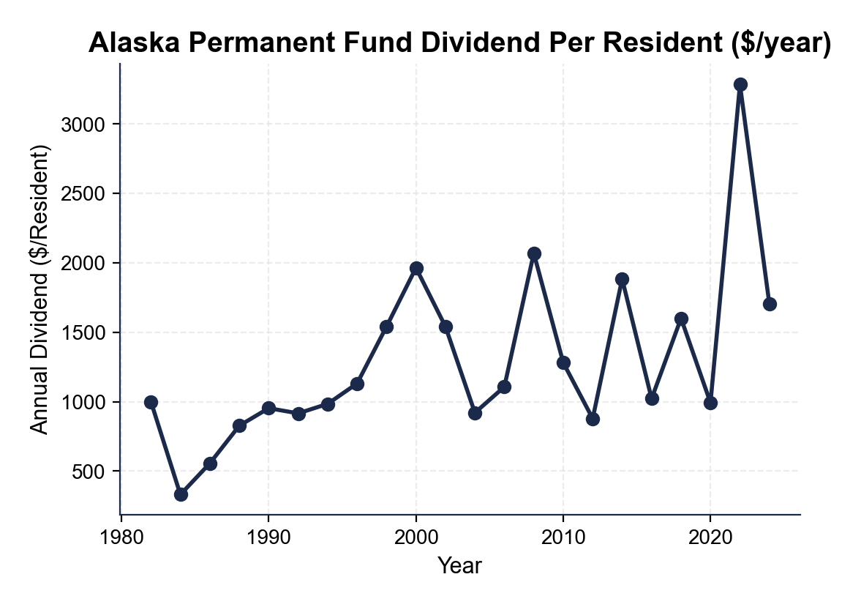

4. The senator asks Maya: "Why are these payouts so unpredictable?" Using the same Alaska PFD chart, identify ONE year where the payout was around $1,000 (close to the 1982 starting value) and ONE year where it climbed above $2,000. Then explain in 2-3 sentences what drives the year-to-year variation in PFD payouts.

PART 5

Final Policy Memo to Your Senator
FINAL POLICY MEMO
1. FINAL POLICY MEMO. Write a 7-9 sentence memo to your senator. Pick ONE of the three bills (Yang $1,000/month Freedom Dividend, $400/month hybrid UBI, or federal Alaska-style sovereign wealth fund) and recommend it for her campaign. Use the memo header below and check off each required element as you include it. (Sentence starter you may use: "I recommend the senator champion ___ because ___.")
YOUR RESPONSE MUST:
☐ RECOMMENDATION - name ONE bill (Yang $1,000/month Freedom Dividend, $400/month hybrid UBI, or federal Alaska-style sovereign wealth fund) clearly in your first sentence. Do not hedge.
☐ THREE SPECIFIC FACTS - cite at least THREE specific numbers or facts from the lesson to defend your choice (the $2.82T Yang cost, the $705B / $1.41T / $4.23T bar-chart values, the Stockton 28-to-40-percent Phase 1 finding, the Finland 6-extra-days finding, the Alaska PFD chart values, the $80B Alaska fund, or the 130-percent SNAP cliff).
☐ WINNERS AND LOSERS - name WHO benefits and WHO might lose under your recommendation.
☐ ONE OBJECTION - acknowledge ONE realistic objection an opponent (or a skeptical economist) might raise.
☐ ONE TRADE-OFF - state ONE trade-off you accept by choosing this policy.
MEMO
To: Senator (Senate Finance Committee)
From: Maya Chen, UBI Policy Advisor
Date:
Re: UBI Vote Recommendation

