ECONOMICS

UNIVERSAL BASIC INCOME: FREE MONEY FOR EVERYONE?
ANSWER KEY ACTIVITY

PART 1

The UBI Reference Guide - Complete the Missing Terms

Term | Definition
Universal basic income (UBI) | A government cash payment given to every adult, no strings attached, regardless of income or employment status
Means-tested benefit | A safety-net program that requires income or asset verification (SNAP, Medicaid, Section 8); the opposite of UBI
Work disincentive | The economic concern that giving people unconditional cash reduces their incentive to take a paid job; the central UBI critique
Value-added tax (VAT) | A consumption tax charged at each stage of production; Yang proposed a 10 percent rate to fund the Freedom Dividend
Sovereign wealth fund | A government-owned investment fund (Norway $1.6T, Alaska $80B); the Alaska Permanent Fund Dividend pays from one of these
Alaska Permanent Fund Dividend | Annual cash payment to every Alaska resident from oil-revenue investments; the closest thing to a real UBI in U.S. history (since 1982)
Phase-out | When a benefit gets reduced as income rises (SNAP cuts off above 130 percent of the poverty line); UBI eliminates these by giving cash to everyone
Negative income tax | A 1960s economist proposal (Milton Friedman) to give cash to households below an income threshold; the intellectual ancestor of modern UBI
Automation displacement | The concern that AI and robots will replace human workers faster than new jobs are created; a key driver of Yang's UBI argument
Earned income tax credit (EITC) | A refundable U.S. tax credit for low-income workers; the closest existing program to a partial UBI for working households

PART 2

Apply the Terms - UBI Vocabulary in Context
WORD BANK Phase-out · Work disincentive · Universal basic income · Automation displacement · Sovereign wealth fund
1. A government cash payment given to every adult with no income test and no work requirement, regardless of how much they earn, is called a Universal basic income (UBI).
Universal basic income
2. The central economic concern that giving people unconditional cash reduces their incentive to take a paid job is called the Work disincentive.
Work disincentive
3. A government-owned investment fund (like Norway's $1.6 trillion fund or Alaska's $80 billion fund) that the Alaska Permanent Fund Dividend pays out from is a Sovereign wealth fund.
Sovereign wealth fund
4. When a benefit gets reduced or cut off as income rises - the way SNAP ends above 130% of the poverty line - economists call it a Phase-out.
Phase-out
5. The concern that AI and robots will replace human workers faster than new jobs are created, a key driver of Yang's UBI argument, is called Automation displacement.
Automation displacement

PART 3

Trace the Mechanics - Defining Features, the Four Precedents, the Cost Math, and UBI vs the Safety Net
1. In your own words, explain what UNIVERSAL BASIC INCOME (UBI) means by naming its three defining features. Then state which of the three bills on your senator's desk (Yang-style $1,000/month Freedom Dividend, $400/month hybrid UBI, federal Alaska-style sovereign wealth fund) is the closest match to a TRUE universal basic income, and explain why.
UBI has three defining features: (1) UNIVERSAL - every adult citizen gets it, no exceptions; your billionaire neighbor and your unemployed neighbor get the same check. (2) BASIC - enough to cover the basics like food and rent (most proposals are $500-$1,500/month). (3) UNCONDITIONAL - no work requirement, no income test, no means-testing, no phase-out as you earn more. This is the opposite of how the U.S. safety net works: SNAP requires income below ~130% of the federal poverty line, unemployment requires you lost a job, Medicaid requires income verification. Of the three bills: the YANG-STYLE $1,000/MONTH FEDERAL FREEDOM DIVIDEND is the closest match to a TRUE UBI because it gives every adult the same amount with no income test and no work requirement - it satisfies all three defining features. The $400/MONTH HYBRID is universal and unconditional but is too small to be "basic" and is layered on means-tested programs (Medicaid, SNAP) that ARE income-tested - so the program package overall is mixed. The FEDERAL SOVEREIGN WEALTH FUND modeled on Alaska is universal and unconditional but the payment varies year to year with fund returns - usually too small to count as "basic" - so it is a partial UBI like the Alaska PFD itself.
2. Explain the WORK DISINCENTIVE critique of UBI in your own words. Then state what the STOCKTON SEED and FINLAND 2017-2018 pilots actually found about whether UBI recipients work less, and be honest about the limits of that evidence.
(1) THE CRITIQUE: the work-disincentive critique is the central economic concern - if the government gives every adult $500 or $1,000 per month with no strings attached, why take an unpleasant low-wage job? Critics predict recipients reduce hours, leave the labor force, and shrink the tax base that funds the UBI itself. (2) STOCKTON: Phase 1 of the Stockton SEED ($500/month for 24 months, 2019-2021) found the OPPOSITE - full-time employment among recipients rose from 28 percent to 40 percent, versus a roughly flat 32-to-37 percent in the n=200 control group. (3) CAVEATS: Phase 2 (Year 2) overlapped with the COVID shock and the Phase 1 gains did not replicate cleanly; the treatment sample was only 125 people; the pilot was privately funded with a close evaluator relationship. (4) FINLAND: the Finland 2017-2018 experiment (560 euros/month for two years, 2,000 unemployed Finns) found a tiny POSITIVE effect of about 6 extra days of work per year vs control. (5) TAKEAWAY: neither pilot found the labor-force collapse critics predicted, but skeptical economists (Hoynes & Rothstein, Mankiw, AEI, Mercatus) argue 125 people for 24 months cannot tell us what a permanent national $1,000/month UBI would do - the short-pilot evidence is suggestive against the worst case, not settled.
3. The senator needs to know which real-world precedent each of her three bills most resembles. As Maya, apply the THREE UBI PROPOSALS on her desk to the four real-world precedents from the lesson (Yang, Alaska, Stockton, Finland). For each of the three bills, name
(a) which precedent it most resembles
(b) one strength and one weakness of that precedent for predicting how the bill would work nationwide.
BILL 1 - YANG-STYLE FEDERAL FREEDOM DIVIDEND ($1,000/month for every adult). PRECEDENT = Yang's 2020 campaign proposal itself - the only large-scale national UBI proposal ever scored by a major U.S. politician. STRENGTH = the most ambitious and economically pure UBI; satisfies all three defining features (universal, basic, unconditional). WEAKNESS = the funding math has never closed under independent scoring - $2.82 trillion/year is roughly 41 percent of the federal budget; Yang's VAT only raises ~$800B; welfare consolidation is scored by independent groups at $200-400B (not Yang's claimed $500-600B) because the plan was opt-in; the stack leaves a hole of $1 trillion or more per year. BILL 2 - $400/MONTH HYBRID UBI (on top of existing welfare). PRECEDENT = Stockton SEED ($500/month for 24 months, n=125 treatment, n=200 control). STRENGTH = the only U.S. precedent that directly tested an unconditional cash transfer at roughly this size; Phase 1 employment rose 28-to-40 percent and mental health improved. WEAKNESS = the pilot is small (n=125 treatment); the Phase 1 gains did NOT replicate cleanly in Phase 2 (COVID confound); the program was privately funded with a close evaluator relationship; scaling to 235 million adults permanently could produce work-disincentive effects that small short pilots may not detect (the critique Hoynes & Rothstein, Mankiw, AEI, Mercatus raise). BILL 3 - FEDERAL SOVEREIGN WEALTH FUND (Alaska-style). PRECEDENT = Alaska Permanent Fund Dividend (since 1982, $300-$3,300 per resident per year). STRENGTH = 40+ years of bipartisan political durability; proves a universal payment can be administered for decades. WEAKNESS = the Alaska model only works because Alaska has a giant resource (oil) to extract and invest; the U.S. federal government has no equivalent natural-resource trust to capitalize an $80B-equivalent fund without raising taxes elsewhere first, and payouts are too volatile to count as "basic."
4. The senator needs Maya to do the cost math she will be asked about in committee. Calculate the cost math for the three bills she is voting on.
(a) Yang $1,000/month for 235M adults = ?
(b) $400/month hybrid for 235M adults = ?
(c) Compare both to the entire 2024 federal budget of about $6.8 trillion. What share of the federal budget does each plan consume?
(a) YANG $1,000/month x 12 months x 235M adults = $1,000 x 12 x 235,000,000 = $2,820,000,000,000 = approximately $2.82 trillion per year. As a share of the $6.8 trillion 2024 federal budget = $2.82T / $6.8T = approximately 41 percent. (b) HYBRID $400/month x 12 months x 235M adults = $400 x 12 x 235,000,000 = $1,128,000,000,000 = approximately $1.128 trillion per year (~$1.1 trillion). As a share of the federal budget = $1.128T / $6.8T = approximately 17 percent. COMPARISON: Yang's plan would consume roughly 41 percent of the federal budget - more than any single existing program (Social Security at ~$1.5T = ~22 percent, Medicare at ~$1T = ~15 percent, defense at ~$0.8T = ~12 percent). The $400/month hybrid is smaller but still ~17 percent of the federal budget - roughly equal to current Medicare spending. Either bill is one of the largest single line items in U.S. fiscal history. Yang's plan plus existing welfare and entitlement spending exceeds total federal revenue.
5. The senator wants Maya to answer the opposition's favorite question: "Won't paying people not to work mean they stop working?" Apply the WORK DISINCENTIVE CRITIQUE to her three bills. For each bill, predict whether you expect a SMALL, MEDIUM, or LARGE work-disincentive effect. Use evidence from the Stockton SEED (Phase 1 employment gain; Phase 2 confounded by COVID; small sample of 125 treatment), Finland 2017-2018, or both - and be honest about the limits of the pilot evidence.
BILL 1 - YANG $1,000/month: predict MEDIUM-to-LARGE work-disincentive effect (acknowledge uncertainty). Stockton Phase 1 ($500/month) found employment rose 12 percentage points and Finland (560 euros) found a tiny positive effect, so at the tested $500-560/month level the short-pilot evidence does not show meaningful disincentive. But (a) $1,000/month is roughly 2x the tested amounts, (b) Yang's plan is permanent national policy not a 2-year pilot, (c) Stockton Phase 2 did NOT replicate Phase 1 cleanly under COVID, and (d) skeptical labor economists (Hoynes & Rothstein, Mankiw, AEI, Mercatus) argue a 125-person pilot cannot answer the national-scale question. Labor-economics estimates of permanent UBI suggest a 1-5 percent reduction in overall labor supply at $1,000/month, concentrated among second earners and marginally-attached workers. BILL 2 - $400/MONTH HYBRID: predict SMALL work-disincentive effect. The amount ($400/month = $4,800/year) is below both Stockton ($500/month = $6,000/year) and Finland (560 euros = ~$7,300/year), and short-pilot evidence at higher amounts shows no large disincentive. Combined with existing welfare programs, $400/month is too small to replace earned income for most working adults. Acknowledge: the same caveats apply (short pilots, COVID confound) but the smaller amount and the existing safety net narrow the risk. BILL 3 - FEDERAL SOVEREIGN WEALTH FUND (Alaska-style, ~$1,000-1,500/year per resident): predict ESSENTIALLY NO work-disincentive effect. The Alaska PFD averages ~$1,200 per resident per year and 40 years of evidence shows no meaningful effect on Alaskan labor supply relative to other states. The amount is far below earned income for any working adult.
6. Compare UBI to the EXISTING SAFETY NET (SNAP, Medicaid, Section 8). As Maya, pick one of the three bills on her senator's desk and write a 6-8 sentence rationale explaining why the senator might prefer it for political or economic reasons. Walk through (1) the funding math, (2) at least one phase-out / safety-net mechanic, and (3) at least one piece of pilot evidence. Use specific examples from the lesson (the 130 percent SNAP gross-income limit, the Stockton 28-to-40-percent Phase 1 finding, the $2.82T Yang annual cost, the $1.128T hybrid annual cost, the $80B Alaska fund size, or the $6.8T federal budget).
Sample answer (HYBRID $400/MONTH UBI preferred): a hybrid UBI is the most politically realistic option for three reasons. (1) FUNDING MATH: at $1.128 trillion per year (17 percent of the federal budget), the hybrid is large but not budget-breaking; Yang's $2.82T plan is 41 percent of the federal budget and every independent score leaves a $1T+ funding hole. (2) PHASE-OUT FIX: the existing safety net creates effective marginal tax rates of 50-90 percent for low-income workers - earn an extra $100, lose SNAP (130 percent gross-income limit), lose Medicaid, lose Section 8 in one cliff. A $400/month UBI does NOT phase out, so working an extra hour means you keep every dollar plus the UBI. (3) PILOT EVIDENCE (honestly framed): the closest tested precedent is Stockton SEED Phase 1 ($500/month for 24 months), which found full-time employment rose from 28 to 40 percent in Year 1. Acknowledge the limits: Phase 2 did not replicate cleanly under COVID, the sample was 125 treatment / 200 control, and Hoynes & Rothstein, Mankiw, AEI, and Mercatus argue that pilot is too small to settle the national-scale question. The hybrid keeps Medicaid and SNAP for the poorest households who need targeted health and food coverage, while adding cash for everyone above. ACCEPTABLE alternate stance: Yang $1,000/month preferred (defend with full-UBI economic purity, Stockton Phase 1 employment finding with caveats, automation argument), or Alaska sovereign wealth fund (defend with 40-year political durability, no funding gap because the fund is self-funding from returns). Required: names ONE plan, cites at least 1 specific lesson number/fact, walks through funding math + phase-out / safety-net mechanic + pilot evidence (with limits), explains political OR economic reasoning.

PART 4

Read the Charts - UBI Cost by Proposal and Alaska PFD Payouts
1. As Maya, you need to brief the senator on what the Yang-style bill would actually cost compared to a cheaper alternative.
Use the UBI COST BY PROPOSAL bar chart, inserted below and shown in the slide deck. Read directly off the chart: roughly how much would Yang's $1,000/month Freedom Dividend cost per year? How much would a $500/month Stockton-scale national UBI cost per year? Calculate the DIFFERENCE between the two. (Chart unit note: the bar chart is labeled in $Billions per year - to brief the senator in $Trillions, divide by 1,000.) (Chart: chart_ubi_cost_by_proposal)
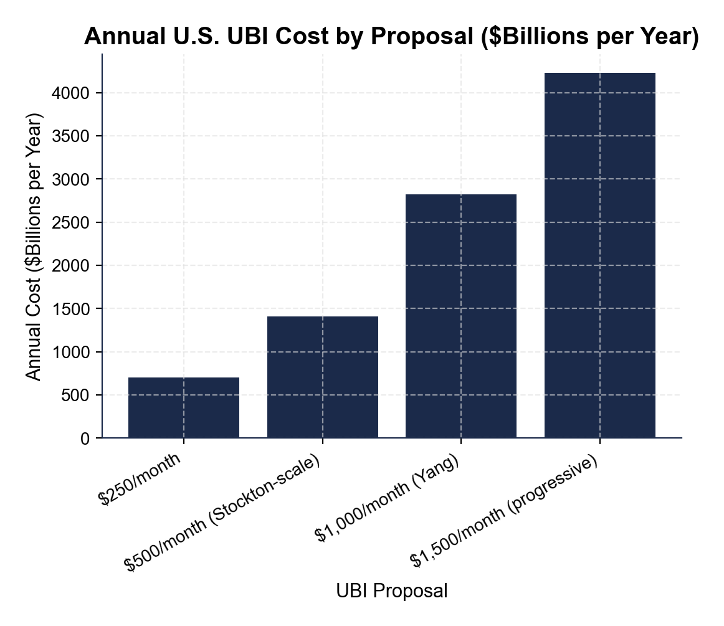
Yang $1,000/month Freedom Dividend = approximately $2,820 billion per year (~$2.8 trillion per year). $500/month Stockton-scale national UBI = approximately $1,410 billion per year (~$1.4 trillion per year). DIFFERENCE = $2,820B - $1,410B = approximately $1,410 billion per year. Accept readings within $50B of each value. Context: Yang's plan costs exactly DOUBLE the Stockton-scale plan because the monthly amount is double - both go to ~235 million U.S. adults. The $1.4 trillion gap is roughly the entire annual federal Social Security budget. Cutting Yang's monthly payment in half halves the annual cost from $2.8T to $1.4T.
2. The senator wants to understand how scaling the monthly amount affects the price tag - cheaper to start small? Use the same UBI cost chart.
Compare the smallest proposal ($250/month) to the largest ($1,500/month). Read off both annual costs. Then write 2-3 sentences Maya could use to explain to the senator the relationship between monthly UBI amount and total annual cost (does it scale linearly, exponentially, or stay flat?).
$250/month proposal = approximately $705 billion per year. $1,500/month proposal = approximately $4,230 billion per year (~$4.2 trillion per year). Accept readings within $50B of each value. RELATIONSHIP: cost scales LINEARLY with the monthly amount, because the recipient population is fixed at ~235 million U.S. adults. Doubling the monthly payment doubles the annual cost; tripling it triples the cost. ($250/month is 1/6 of $1,500/month, and $705B is exactly 1/6 of $4,230B.) The math is simply $monthly x 12 months x 235 million adults. This is why scaling-up the monthly amount is so politically hard: every additional $100/month adds roughly $282 billion per year to the federal cost.
3. The senator is considering the Alaska-style sovereign wealth fund bill and wants to know: how stable is the payout, really? Use the ALASKA PERMANENT FUND DIVIDEND chart, inserted below and shown in the slide deck.
Read directly off the chart: roughly what was the LOWEST annual payout (around 1984) and the HIGHEST annual payout (around 2022)? Calculate the GAP between them. Decide what you would tell the senator about whether households can count on a fixed amount each year. (Chart: chart_alaska_pfd_payouts)
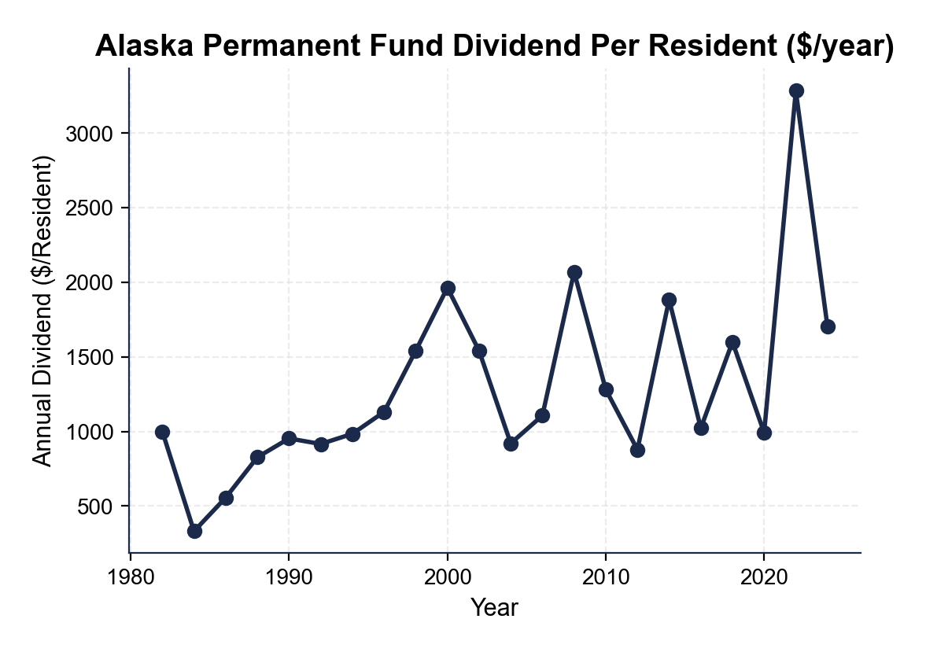
Lowest annual payout in 1984 = approximately $300 per resident (~$330). Highest annual payout in 2022 = approximately $3,300 per resident (~$3,284 with the special legislative bonus). GAP = $3,300 - $300 = approximately $3,000 per resident per year. Accept readings within $200 of each value. Context: the gap reflects the volatility of oil prices and fund returns. The peak in 2022 included a special $662 legislative bonus on top of the regular dividend; without it, the 2022 payout would have been about $2,622. The fund itself has grown from a few billion dollars in 1982 to about $80 billion in 2024, even while paying out tens of billions in dividends over those four decades.
4. The senator asks Maya: "Why are these payouts so unpredictable?" Using the same Alaska PFD chart, identify ONE year where the payout was around $1,000 (close to the 1982 starting value) and ONE year where it climbed above $2,000. Then explain in 2-3 sentences what drives the year-to-year variation in PFD payouts.
Years where the PFD was about $1,000: 1982 ($1,000 starting payment), 1992 (~$916), 2016 (~$1,022), 2020 (~$992), or 2024 (~$1,702 - close enough). Years where it climbed above $2,000: 2000 (~$1,964 - just under), 2008 (~$2,069), or 2022 (~$3,284). Accept any reasonable reading within $200. WHAT DRIVES VARIATION: PFD payouts depend on (1) oil prices - high oil years generate higher fund deposits, which produce bigger dividends; (2) fund investment returns - the $80B fund earns income on stocks and bonds, and a strong-market year boosts the dividend; (3) occasional special legislative bonuses (2008, 2022). The bumpy line shape directly reflects the volatility of oil and capital markets - a UBI funded by a sovereign wealth fund is universal and durable, but the payment amount is not predictable year to year.

PART 5

Final Policy Memo to Your Senator
FINAL POLICY MEMO
1. FINAL POLICY MEMO. Write a 7-9 sentence memo to your senator. Pick ONE of the three bills (Yang $1,000/month Freedom Dividend, $400/month hybrid UBI, or federal Alaska-style sovereign wealth fund) and recommend it for her campaign. Use the memo header below and check off each required element as you include it. (Sentence starter you may use: "I recommend the senator champion ___ because ___.")
YOUR RESPONSE MUST:
☐ RECOMMENDATION - name ONE bill (Yang $1,000/month Freedom Dividend, $400/month hybrid UBI, or federal Alaska-style sovereign wealth fund) clearly in your first sentence. Do not hedge.
☐ THREE SPECIFIC FACTS - cite at least THREE specific numbers or facts from the lesson to defend your choice (the $2.82T Yang cost, the $705B / $1.41T / $4.23T bar-chart values, the Stockton 28-to-40-percent Phase 1 finding, the Finland 6-extra-days finding, the Alaska PFD chart values, the $80B Alaska fund, or the 130-percent SNAP cliff).
☐ WINNERS AND LOSERS - name WHO benefits and WHO might lose under your recommendation.
☐ ONE OBJECTION - acknowledge ONE realistic objection an opponent (or a skeptical economist) might raise.
☐ ONE TRADE-OFF - state ONE trade-off you accept by choosing this policy.
MEMO
To: Senator (Senate Finance Committee)
From: Maya Chen, UBI Policy Advisor
Date: [student completes]
Re: UBI Vote Recommendation
GRADING RUBRIC
Grade the evidence and reasoning, not the conclusion — any defensible position is valid. Score against the 5 requirements above.
FULL CREDIT — clear position; meets all 5 requirements with accurate, specific numbers and evidence from the lesson.
PARTIAL — position stated, but misses 1-2 requirements or uses vague / incorrect numbers.
MINIMAL — no clear position, or missing most requirements and numbers.
WHAT TO LOOK FOR IN THIS LESSON
Sample full-credit memo ($400/MONTH HYBRID UBI recommendation): RECOMMENDATION: champion the $400/MONTH HYBRID UBI layered on top of existing Medicaid and SNAP. THREE FACTS: (1) FUNDING MATH is workable - $400 x 12 x 235M = $1.128 trillion per year, roughly 17 percent of the $6.8 trillion 2024 federal budget, while Yang's $1,000/month plan costs $2.82 trillion (41 percent of the budget) and every independent score leaves a $1T+ hole; (2) the closest tested precedent, STOCKTON SEED Phase 1 ($500/month, n=125 treatment / n=200 control), found full-time employment rose from 28 to 40 percent in Year 1 - the OPPOSITE of what critics predicted; (3) Finland 2017-2018 (560 euros/month, 2,000 unemployed Finns) found a tiny POSITIVE effect of 6 extra days of work per year. WINNERS AND LOSERS: WINNERS = the working poor (the SNAP-cliff households at 130 percent of poverty who lose every benefit when they earn more), single parents, gig and low-wage rural workers; LOSERS = high-income earners (taxes rise to fund it) and safety-net advocates who fear cash weakens the coalition for Medicaid and SNAP. ONE OBJECTION: $1.128 trillion is still the second-largest federal program after Social Security, and skeptical economists (Hoynes & Rothstein, Mankiw, AEI, Mercatus) note the Stockton sample is too small to extrapolate to national scale. ONE TRADE-OFF: by choosing the hybrid over Yang's full $1,000/month I give up the cleanest, most ambitious version of UBI in exchange for a plan whose funding math actually closes. ACCEPTABLE ALTERNATES = YANG $1,000/MONTH (full UBI economic purity + Stockton Phase 1 finding with caveats + automation argument), or ALASKA SOVEREIGN WEALTH FUND (40-year durability + self-funding from returns + $80B fund + 1982-2024 chart range). Grade on the QUALITY of reasoning, not the choice; require ONE bill, 3+ specific facts, winners and losers, one objection, and one trade-off.
MORE LESSONS LESS PLANNING
Thank You!
If you enjoyed this product, please do not forget to rate and review to assist other teachers.

Looking for future discounts? Earn TPT credits by reviewing purchased products.

Please contact me if you have any issues with this product. Just like our students, I am always looking for opportunities to grow.

