Unions: Power in Numbers
STUDENT ACTIVITY
Name: | Date: | Period:
ESSENTIAL QUESTION
If unions are fading, why are Starbucks and Amazon workers fighting to form them?
THE SCENARIO
You are a student aide for DIRECTOR ELLIS, your school's college and career advisor. The principal has asked Director Ellis to brief the staff at next Tuesday's meeting on the recent wave of unionization in retail, warehouse, tech, and entertainment jobs - the same industries many of our students work in.
BY THE END, YOU CAN:
✓ Define a LABOR UNION and explain how COLLECTIVE BARGAINING gives workers more power in setting wages, benefits, and working conditions than they have individually
✓ Trace the rise and decline of U.S. union membership from the 1955 peak (~33%) to today (9.9%) using a line chart, and read state-level differences in union density off a bar chart
✓ Evaluate three recent organizing efforts (Starbucks Workers United, Amazon Labor Union JFK8, the UAW Stand-Up Strike) and present BOTH SIDES of the union pros-and-cons debate
HOW IT WORKS (do Parts 1–5 in order)
Part 1 — Unions Reference Guide - Complete the Missing Terms
Part 2 — Apply the Terms - Union Vocabulary in Context
Part 3 — You Read the Two Union-Density Charts with Director Ellis
Part 4 — Three Recent Organizing Cases - Apply Both Frames
Part 5 — Your Final One-Pager for Director Ellis's Staff Meeting
TIME about 45 minutes YOU’LL NEED the lesson slides and your Guided Notes.

PART 1

Unions Reference Guide - Complete the Missing Terms
Fill in the missing term for each blank row — the definition is your clue. Your Guided Notes and the lesson slides have every term.

Term | Definition
___________ | An organized group of workers that bargains collectively with the employer over wages, benefits, hours, safety, and other working conditions. Once a majority of workers vote yes in an NLRB election, the union becomes the legal representative for everyone in that workplace.
Collective bargaining | The negotiation process between a union (acting for all workers in a bargaining unit) and the employer to set wages, benefits, and rules in a written contract. Under federal law the employer must bargain in good faith - one worker alone has no such right.
___________ | The 1935 National Labor Relations Act - the federal law that gives private-sector workers the right to form unions, bargain collectively, and strike. It created the National Labor Relations Board (NLRB) to run union elections and enforce the rules.
Strike | A coordinated work stoppage by union members to pressure the employer into agreeing to better contract terms. The economic leverage comes from lost production: every day the workers are out, the employer is losing revenue.
___________ | The share of all wage and salary workers in a region or industry who are union members, usually shown as a percent. National U.S. union density was 33.2% in 1955 and 9.9% in 2024.
Right-to-work law | A state law that bans union security clauses - meaning workers in a unionized workplace can choose not to join the union or pay dues, even though the union still has to bargain for them. 26 states are right-to-work (Michigan repealed its RTW law effective Feb 13, 2024); union density is much lower in those states.
___________ | The wage difference between union and non-union workers in similar jobs, holding skills constant. BLS data show union workers earn roughly 10-15% more per hour on average than non-union workers in the same occupation.
NLRB election | A secret-ballot vote run by the National Labor Relations Board to decide whether a group of workers wants to be represented by a union. A simple majority of votes cast wins - if yes, the union is certified as the legal bargaining agent for that workplace.
___________ | The specific group of workers a union represents in negotiations - typically defined by job type and location (e.g., the baristas at one Starbucks store, the warehouse workers at JFK8, the production workers at GM Wentzville). Managers are excluded by law.
Decertification | A vote by workers to REMOVE an existing union. If a majority votes yes, the union loses its legal status as bargaining agent. Decertification petitions have to be filed during a narrow window in the contract cycle.

PART 2

Apply the Terms - Union Vocabulary in Context
WORD BANK density · strike · nlrb election · collective bargaining · right-to-work
1. When the baristas at one Starbucks store negotiate as a group with the employer over wages, benefits, hours, and safety - instead of each worker negotiating alone - they are using the process called .

2. The Amazon warehouse workers at JFK8 became a union only after a majority voted yes in a secret-ballot vote run by the National Labor Relations Board - a vote known as an .

3. When the UAW members at Ford, GM, and Stellantis coordinated a work stoppage in 2023 to pressure the companies into a better contract, their biggest source of economic leverage was the .

4. The line chart shows that the SHARE of U.S. wage and salary workers who belong to a union fell from 33.2% in 1955 to 9.9% in 2024 - this share, usually reported as a percent, is called union .

5. In the 26 states where workers in a unionized workplace can choose not to join the union or pay dues - even though the union must still bargain for them - the reason is a state law.

PART 3

You Read the Two Union-Density Charts with Director Ellis
1. Use Chart Reference 1 (chart_union_membership_rate) - the U.S. union membership rate from 1955 to 2024 line chart shown below - to extract the historical facts.
(a) Read the 1955 peak rate (the leftmost point on the navy line).

(b) Read the 2024 endpoint rate (the rightmost point on the line).

(c) Compute the approximate percentage-point drop from peak to today.

(d) In plain English

2. Still using Chart Reference 1 (the line chart):
(a) The chart marks 1981 specifically with the label '1981: PATCO firings' - briefly explain in one sentence what this marker is and why historians treat 1981 as a turning point in the union story.

(b) Looking at the shape of the line on the chart, identify ONE decade in which the line's drop looks especially steep, and ONE decade in which the drop looks more gradual.

(c) The decline shown on the chart has many causes - name TWO specific causes covered on the slides.

3. Use Chart Reference 2 (chart_union_density_by_state) - the bar chart of top-5 vs bottom-5 state union density shown below - to extract the state-level facts.
(a) Read the rate for HAWAII (highest bar on the chart) off the y-axis.

(b) Read the rate for NORTH CAROLINA (lowest bar on the chart) off the y-axis.

(c) Compute the GAP between highest and lowest state in percentage points.

(d) Looking at the chart, identify whether the top-5 states (the navy bars) are clustered tightly or spread out, and whether the bottom-5 states (the coral bars) are clustered tightly or spread out.

4. Still using Chart Reference 2 (the bar chart): all five lowest-density states (Utah, Arkansas, South Carolina, South Dakota, North Carolina) are RIGHT-TO-WORK states; none of the top-5 (Hawaii, New York, Washington, Alaska, New Jersey) are right-to-work.
(a) In your own words, what does a RIGHT-TO-WORK law actually do? (Hint: it does NOT ban unions.)

(b) Give ONE plausible reason a worker in North Carolina might be FAR less likely to be in a union than a worker in Hawaii, beyond just the RTW law itself.

(c) If your family moved from North Carolina to Hawaii, roughly how many TIMES MORE LIKELY would you be to work a union job, based on the chart?

PART 4

Three Recent Organizing Cases - Apply Both Frames
1. STARBUCKS WORKERS UNITED (Buffalo, NY - December 9, 2021 onward). The first Starbucks store voted yes to unionize on December 9, 2021. By 2024, Starbucks Workers United had organized 400+ stores nationwide. The company contested most of the elections for two years, but in February 2024 finally agreed to bargain a framework agreement covering unionized stores.
(a) Why was Buffalo a SURPRISE? In 1-2 sentences, explain why the conventional wisdom said retail chains like Starbucks were nearly impossible to organize store-by-store. Use the words SERVICE SECTOR and ORGANIZE in your answer.

(b) Make the PRO-UNION CASE for the Buffalo workers in 2 sentences. What concrete things did they hope to gain through a contract?

(c) Make the ANTI-UNION CASE in 2 sentences. What concerns might other Starbucks employees (or the company) raise about store-by-store unionization?

(d) Director Ellis asks: is Starbucks Workers United still going? (Hint: as of 2024, look at how many stores were organized and whether the company started bargaining.)

2. AMAZON LABOR UNION AT JFK8 (Staten Island, NY - April 1, 2022). The Amazon Labor Union (ALU) - an independent worker-led union, NOT initially affiliated with any major federation - won the NLRB election at the JFK8 warehouse on April 1, 2022. The final vote was 2,654 YES to 2,131 NO, in a workforce of about 8,000 (turnout about 58%). It was the first successful Amazon union vote in U.S. history. Amazon contested the result through 2022-2023; the NLRB upheld it. Bargaining has been slow - ALU later affiliated with the Teamsters in mid-2024 to gain resources.
(a) Why was this election a historic FIRST? In 1-2 sentences, explain what other Amazon union attempts had tried before and why they had failed.

(b) Make the PRO-UNION CASE for the JFK8 workers in 2 sentences. Use specific examples of conditions warehouse workers complain about (pace metrics, restroom breaks, injury rates, scheduling).

(c) Make the ANTI-UNION CASE in 2 sentences. Note: 2,131 JFK8 workers voted NO. Why might a warehouse worker vote against their own union?

(d) Director Ellis asks: how much has bargaining accomplished since the April 2022 vote? (Hint: think about why ALU affiliated with the Teamsters in 2024 - what does that tell you about progress?)

3. UAW STAND-UP STRIKE (September 15 - October 30, 2023). The United Auto Workers struck Ford, GM, and Stellantis simultaneously - the first time the UAW has struck all three Detroit automakers at once. The new tactic: instead of pulling EVERY UAW member out on Day 1 (the traditional 'all-out strike' that drains the strike fund fast), UAW President Shawn Fain announced 'STAND-UP' strikes at SELECTED plants and expanded the list as bargaining stalled. The strike ran six weeks. Workers won: 25% cumulative wage hikes over the 4.5-year contract, restored cost-of-living adjustments (COLA) that had been suspended since 2007, and ENDED the tiered pay schedule that paid newer workers less than veterans.
(a) Explain WHY the Stand-Up tactic worked better than an all-out strike. In 2 sentences, use the words STRIKE FUND and UNCERTAINTY in your answer.

(b) Make the PRO-UNION CASE in 2 sentences. Be specific about which group of UAW workers gained the most.

(c) Make the ANTI-UNION CASE in 2 sentences from the EMPLOYER side - what costs did Ford, GM, and Stellantis face, and what longer-term risk does a 25% wage hike create?

(d) Director Ellis asks: did the UAW deal raise the bar for other unions? Use these two facts directly to answer: (i) in August 2023 the Teamsters won a UPS contract that ended two-tier pay and lifted top driver pay above $170,000/year; (ii) in Sept-Nov 2024 Boeing IAM machinists struck for 7 weeks and won a 38% wage hike, citing the UAW pattern. In 2-3 sentences, explain what these two cases tell us about whether the UAW deal had ripple effects across other industries.

PART 5

Your Final One-Pager for Director Ellis's Staff Meeting
STAFF MEETING ONE-PAGER
1. YOUR FINAL ONE-PAGER FOR DIRECTOR ELLIS.
Director Ellis goes to the staff meeting next Tuesday and needs ONE PAGE (8-12 sentences) that explains the union story for staff who have never thought about unions, presents BOTH SIDES of the pros-and-cons debate honestly, names ONE industry where organizing might succeed next, and gives ONE concrete reason for that prediction - using the four required terms (COLLECTIVE BARGAINING, UNION DENSITY, STRIKE, and RIGHT-TO-WORK) at least once each. Using your work from Parts 1-4, what is the final staff-meeting one-pager you would hand Director Ellis?
YOUR RESPONSE MUST:
☐ Defines a labor union and COLLECTIVE BARGAINING in plain language - explains why a union has legal power that one worker alone does not.
☐ Cites specific UNION DENSITY data from the line chart (33% peak in 1955 down to 9.9% in 2024 - a ~23 percentage-point drop).
☐ Presents the PRO-UNION case (the ~10-15% wage premium, better benefits, voice in conditions, safer workplaces).
☐ Presents the ANTI-UNION case (dues cost, less individual flexibility, RIGHT-TO-WORK debate, possible plant closure / automation responses).
☐ Names at least one recent organizing case (Starbucks Buffalo Dec 2021, Amazon JFK8 April 2022, UAW Stand-Up STRIKE Sept-Oct 2023, or Hollywood WGA/SAG-AFTRA 2023) AND uses the word STRIKE in context.
☐ Names ONE INDUSTRY where the student thinks organizing might succeed next (e.g., grocery stores like Trader Joe's/Whole Foods, fast food beyond Starbucks, gig workers like Uber/DoorDash, healthcare aides, video game studios, charter schools, regional tech) AND gives ONE concrete reason tied to the chart, the recent wins, or the pro-union case.
MEMO
To: Tuesday Staff Meeting briefing
From: student aide
Date:
Re: The recent wave of unionization - what staff should know

CHART REFERENCE 1: U.S. UNION MEMBERSHIP RATE (1955-2024)
Use Chart Reference 1 (chart_union_membership_rate) - the U.S. union membership rate from 1955 to 2024 line chart shown below.
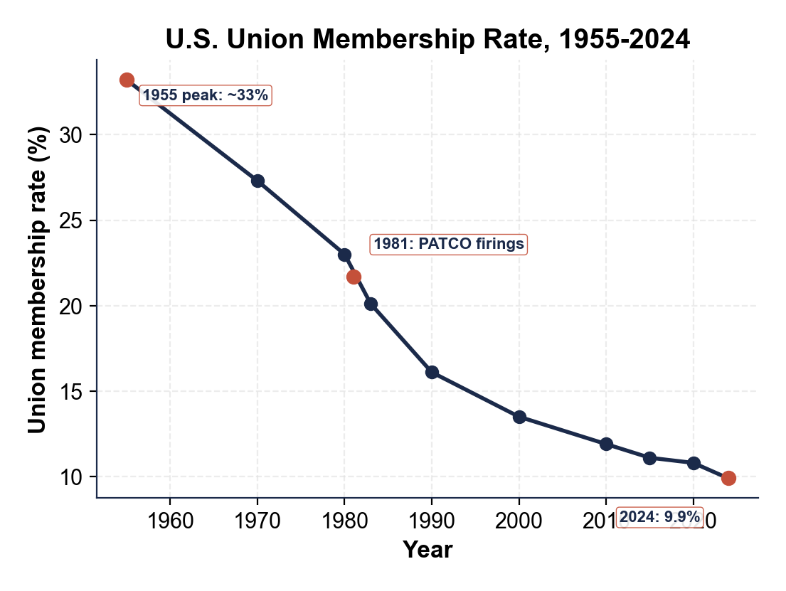
CHART REFERENCE 2: UNION DENSITY BY STATE (TOP 5 VS BOTTOM 5, 2024)
Use Chart Reference 2 (chart_union_density_by_state) - the bar chart of top-5 vs bottom-5 state union density shown below.
