ECONOMICS

UNIONS: POWER IN NUMBERS
ANSWER KEY ACTIVITY - ANSWER KEY

PART 1

Unions Reference Guide - Complete the Missing Terms

Term | Definition
Labor union | An organized group of workers that bargains collectively with the employer over wages, benefits, hours, safety, and other working conditions. Once a majority of workers vote yes in an NLRB election, the union becomes the legal representative for everyone in that workplace.
Collective bargaining | The negotiation process between a union (acting for all workers in a bargaining unit) and the employer to set wages, benefits, and rules in a written contract. Under federal law the employer must bargain in good faith - one worker alone has no such right.
NLRA (Wagner Act) | The 1935 National Labor Relations Act - the federal law that gives private-sector workers the right to form unions, bargain collectively, and strike. It created the National Labor Relations Board (NLRB) to run union elections and enforce the rules.
Strike | A coordinated work stoppage by union members to pressure the employer into agreeing to better contract terms. The economic leverage comes from lost production: every day the workers are out, the employer is losing revenue.
Union density | The share of all wage and salary workers in a region or industry who are union members, usually shown as a percent. National U.S. union density was 33.2% in 1955 and 9.9% in 2024.
Right-to-work law | A state law that bans union security clauses - meaning workers in a unionized workplace can choose not to join the union or pay dues, even though the union still has to bargain for them. 26 states are right-to-work (Michigan repealed its RTW law effective Feb 13, 2024); union density is much lower in those states.
Union premium | The wage difference between union and non-union workers in similar jobs, holding skills constant. BLS data show union workers earn roughly 10-15% more per hour on average than non-union workers in the same occupation.
NLRB election | A secret-ballot vote run by the National Labor Relations Board to decide whether a group of workers wants to be represented by a union. A simple majority of votes cast wins - if yes, the union is certified as the legal bargaining agent for that workplace.
Bargaining unit | The specific group of workers a union represents in negotiations - typically defined by job type and location (e.g., the baristas at one Starbucks store, the warehouse workers at JFK8, the production workers at GM Wentzville). Managers are excluded by law.
Decertification | A vote by workers to REMOVE an existing union. If a majority votes yes, the union loses its legal status as bargaining agent. Decertification petitions have to be filed during a narrow window in the contract cycle.

PART 2

Apply the Terms - Union Vocabulary in Context
WORD BANK density · strike · nlrb election · collective bargaining · right-to-work
1. When the baristas at one Starbucks store negotiate as a group with the employer over wages, benefits, hours, and safety - instead of each worker negotiating alone - they are using the process called collective bargaining.
collective bargaining
2. The Amazon warehouse workers at JFK8 became a union only after a majority voted yes in a secret-ballot vote run by the National Labor Relations Board - a vote known as an NLRB election.
NLRB election
3. When the UAW members at Ford, GM, and Stellantis coordinated a work stoppage in 2023 to pressure the companies into a better contract, their biggest source of economic leverage was the strike.
strike. A coordinated work stoppage by union members pressures the employer because every day workers are out, the employer loses production and revenue.
4. The line chart shows that the SHARE of U.S. wage and salary workers who belong to a union fell from 33.2% in 1955 to 9.9% in 2024 - this share, usually reported as a percent, is called union density.
density. Union density is the share of workers in a region or industry who are union members; the national U.S. rate was 33.2% in 1955 and 9.9% in 2024.
5. In the 26 states where workers in a unionized workplace can choose not to join the union or pay dues - even though the union must still bargain for them - the reason is a state right-to-work law.
right-to-work
PART 3

You Read the Two Union-Density Charts with Director Ellis
1. Use Chart Reference 1 (chart_union_membership_rate) - the U.S. union membership rate from 1955 to 2024 line chart shown below - to extract the historical facts.
(a) Read the 1955 peak rate (the leftmost point on the navy line).
1955 PEAK = 33.2% - the leftmost point on the navy line, labeled by the '1955 peak: ~33%' event marker.
(b) Read the 2024 endpoint rate (the rightmost point on the line).
2024 ENDPOINT = 9.9% - the rightmost point on the line, labeled by the 'Today: 9.9%' event marker.
(c) Compute the approximate percentage-point drop from peak to today.
PERCENTAGE-POINT DROP = 33.2 - 9.9 = 23.3 percentage points. (Accept 'about 23 percentage points' as full credit.)
(d) In plain English
Plain English: at the 1955 peak about 1 in THREE workers was a union member; in 2024 about 1 in TEN is. (33% is ~1/3; 10% is ~1/10.)
2. Still using Chart Reference 1 (the line chart):
(a) The chart marks 1981 specifically with the label '1981: PATCO firings' - briefly explain in one sentence what this marker is and why historians treat 1981 as a turning point in the union story.
PATCO MARKER: In August 1981 President Reagan fired about 11,345 striking PATCO (air-traffic-controller) union workers who had refused his 48-hour return-to-work order.
(b) Looking at the shape of the line on the chart, identify ONE decade in which the line's drop looks especially steep, and ONE decade in which the drop looks more gradual.
STEEP DROP DECADE: 1955-1970 (33% down to 27%) OR 1980-1990 (23% down to 16%) - both decades show roughly 6-7 percentage-point drops. (Accept either; the steeper-looking segments on the chart are early.) MORE GRADUAL DROP DECADE: 2010-2024 (11.9% down to 9.9%) - the line is nearly flat in the most recent decade because the union rate has stabilized at a low level.
(c) The decline shown on the chart has many causes - name TWO specific causes covered on the slides.
TWO SPECIFIC CAUSES (any two): (i) 1981 PATCO firings signaling private-sector employers it was safe to be aggressive; (ii) deindustrialization - U.S. manufacturing jobs fell from ~19.5M in 1979 to ~12.8M today, wiping out the heavy-union manufacturing base; (iii) spread of right-to-work laws to 26 states, letting workers opt out of paying dues even in unionized shops; (iv) growth of the service sector (retail, fast food, gig work) which is structurally harder to organize than concentrated industrial workplaces.

3. Use Chart Reference 2 (chart_union_density_by_state) - the bar chart of top-5 vs bottom-5 state union density shown below - to extract the state-level facts.
(a) Read the rate for HAWAII (highest bar on the chart) off the y-axis.
HAWAII = 26.5% - the tallest navy bar on the far left. (Accept any answer between 26% and 27% as full credit since students are reading visually.)
(b) Read the rate for NORTH CAROLINA (lowest bar on the chart) off the y-axis.
NORTH CAROLINA = 2.4% - the shortest coral bar on the far right. (Accept any answer between 2% and 3% as full credit.)
(c) Compute the GAP between highest and lowest state in percentage points.
GAP = 26.5 - 2.4 = 24.1 percentage points. (Accept 'about 24' as full credit.)
(d) Looking at the chart, identify whether the top-5 states (the navy bars) are clustered tightly or spread out, and whether the bottom-5 states (the coral bars) are clustered tightly or spread out.
TOP-5 CLUSTER: the navy bars (Hawaii, New York, Washington, Alaska, New Jersey) are spread between 17.5% and 26.5% - a range of about 9 percentage points; Hawaii is clearly the outlier at 26.5% while the other four sit in the 17-21% range. BOTTOM-5 CLUSTER: the coral bars (Utah, Arkansas, South Carolina, South Dakota, North Carolina) are tightly clustered between 2.4% and 3.7% - a range of only about 1.3 percentage points; the bottom states all look similar in height, with a small gradient stepping down from Utah at the top of the group to North Carolina at the bottom.
4. Still using Chart Reference 2 (the bar chart): all five lowest-density states (Utah, Arkansas, South Carolina, South Dakota, North Carolina) are RIGHT-TO-WORK states; none of the top-5 (Hawaii, New York, Washington, Alaska, New Jersey) are right-to-work.
(a) In your own words, what does a RIGHT-TO-WORK law actually do? (Hint: it does NOT ban unions.)
RIGHT-TO-WORK LAW: A state law that lets workers in a unionized workplace choose NOT to join the union or pay dues, even though the union still has to bargain on their behalf.
(b) Give ONE plausible reason a worker in North Carolina might be FAR less likely to be in a union than a worker in Hawaii, beyond just the RTW law itself.
ONE OTHER REASON (any one): (i) industry mix - Hawaii has heavily unionized hotel and tourism plus a large public-sector workforce; North Carolina has more non-union manufacturing (textiles, banking back offices, tech); (ii) state political culture and labor history - Hawaii and the other top-5 are historically pro-labor states; the bottom-5 historically organized against unions; (iii) public-sector unionization differences - government workers are more heavily unionized than private, and public-sector union strength varies by state law; (iv) urbanization patterns - Hawaii is geographically small and concentrated; NC has many smaller cities and dispersed workforce.
(c) If your family moved from North Carolina to Hawaii, roughly how many TIMES MORE LIKELY would you be to work a union job, based on the chart?
ABOUT 11 TIMES MORE LIKELY. Math: Hawaii 26.5% / North Carolina 2.4% = 11.04, so roughly 11x. (Accept any answer between 10 and 12 as full credit.)
PART 4

Three Recent Organizing Cases - Apply Both Frames
1. STARBUCKS WORKERS UNITED (Buffalo, NY - December 9, 2021 onward). The first Starbucks store voted yes to unionize on December 9, 2021. By 2024, Starbucks Workers United had organized 400+ stores nationwide. The company contested most of the elections for two years, but in February 2024 finally agreed to bargain a framework agreement covering unionized stores.
(a) Why was Buffalo a SURPRISE? In 1-2 sentences, explain why the conventional wisdom said retail chains like Starbucks were nearly impossible to organize store-by-store. Use the words SERVICE SECTOR and ORGANIZE in your answer.
STARBUCKS WAS A SURPRISE because conventional wisdom said the SERVICE SECTOR was nearly impossible to ORGANIZE store-by-store. Retail chains have thousands of small dispersed locations (Starbucks has roughly 10,000+ U.S. stores), each with 15-25 workers - so organizing means winning hundreds of separate NLRB elections instead of one big election at a single factory of 5,000+ workers. The fact that workers found a way to organize one store at a time, then spread the model to 400+ more, broke a 40-year assumption about service-sector union impossibility.
(b) Make the PRO-UNION CASE for the Buffalo workers in 2 sentences. What concrete things did they hope to gain through a contract?
PRO-UNION CASE for Buffalo workers (any two of): higher and more predictable wages; reliable schedules with advance notice (a huge issue in retail/fast-food); paid sick leave that doesn't punish workers for being sick; better health insurance; a formal grievance process so workers cannot just be fired for…
(c) Make the ANTI-UNION CASE in 2 sentences. What concerns might other Starbucks employees (or the company) raise about store-by-store unionization?
ANTI-UNION CASE (any two of): the union charges dues (usually 1-2% of pay), so individual workers may take home less in the short run; collective bargaining is slow - the Buffalo store voted yes in December 2021 but the framework agreement wasn't reached until February 2024 (more than 2 years of legal fights);…
(d) Director Ellis asks: is Starbucks Workers United still going? (Hint: as of 2024, look at how many stores were organized and whether the company started bargaining.)
YES, STILL GOING. As of 2024, Starbucks Workers United has organized 400+ stores. In February 2024 Starbucks dropped its two-year legal resistance and agreed to bargain a framework agreement covering the unionized stores.

2. AMAZON LABOR UNION AT JFK8 (Staten Island, NY - April 1, 2022). The Amazon Labor Union (ALU) - an independent worker-led union, NOT initially affiliated with any major federation - won the NLRB election at the JFK8 warehouse on April 1, 2022. The final vote was 2,654 YES to 2,131 NO, in a workforce of about 8,000 (turnout about 58%). It was the first successful Amazon union vote in U.S. history. Amazon contested the result through 2022-2023; the NLRB upheld it. Bargaining has been slow - ALU later affiliated with the Teamsters in mid-2024 to gain resources.
(a) Why was this election a historic FIRST? In 1-2 sentences, explain what other Amazon union attempts had tried before and why they had failed.
HISTORIC FIRST: this was the first successful Amazon union vote in U.S. history. Every prior Amazon election - most famously the Bessemer, Alabama warehouse election in March 2021 - had failed; Bessemer voted no by a 2-to-1 margin even after a national organizing campaign.
(b) Make the PRO-UNION CASE for the JFK8 workers in 2 sentences. Use specific examples of conditions warehouse workers complain about (pace metrics, restroom breaks, injury rates, scheduling).
PRO-UNION CASE for JFK8 workers (any two of): predictable break and restroom time (Amazon's pace metrics have been linked to workers skipping bathroom breaks); enforcement of safety rules to reduce the warehouse injury rate (Amazon warehouse injury rates have been documented at roughly 2x the industry average);…
(c) Make the ANTI-UNION CASE in 2 sentences. Note: 2,131 JFK8 workers voted NO. Why might a warehouse worker vote against their own union?
ANTI-UNION CASE (any two of): JFK8 already paid above the local non-union warehouse market (~$22/hour starting in 2022 vs ~$18 at non-union competitors), so some workers thought they didn't need a union; warehouse turnover at Amazon is high (some workers expected to leave before a contract would be signed); dues…
(d) Director Ellis asks: how much has bargaining accomplished since the April 2022 vote? (Hint: think about why ALU affiliated with the Teamsters in 2024 - what does that tell you about progress?)
BARGAINING HAS BEEN SLOW. Amazon contested the NLRB result through 2022-2023 (the NLRB upheld it). As of mid-2024 there was still no JFK8 contract; the ALU affiliated with the Teamsters - a much larger, better-resourced union - in mid-2024 precisely because it didn't have the resources or legal muscle to force…

3. UAW STAND-UP STRIKE (September 15 - October 30, 2023). The United Auto Workers struck Ford, GM, and Stellantis simultaneously - the first time the UAW has struck all three Detroit automakers at once. The new tactic: instead of pulling EVERY UAW member out on Day 1 (the traditional 'all-out strike' that drains the strike fund fast), UAW President Shawn Fain announced 'STAND-UP' strikes at SELECTED plants and expanded the list as bargaining stalled. The strike ran six weeks. Workers won: 25% cumulative wage hikes over the 4.5-year contract, restored cost-of-living adjustments (COLA) that had been suspended since 2007, and ENDED the tiered pay schedule that paid newer workers less than veterans.
(a) Explain WHY the Stand-Up tactic worked better than an all-out strike. In 2 sentences, use the words STRIKE FUND and UNCERTAINTY in your answer.
STAND-UP TACTIC: by striking SELECTED plants instead of all of them at once, UAW workers at non-struck plants kept earning normal wages, which preserved the union's STRIKE FUND much longer than an all-out strike would have. At the same time, the rolling expansion of struck plants created UNCERTAINTY for the Big 3 - they could not predict which plant or product line would be hit next, which made just-in-time supply chain planning impossible and increased the economic pressure to settle.
(b) Make the PRO-UNION CASE in 2 sentences. Be specific about which group of UAW workers gained the most.
PRO-UNION CASE for UAW workers (any two of): existing UAW members got a 25% cumulative wage hike over the 4.5-year contract - the biggest auto wage gain in decades; COLA was restored (after being suspended in the 2007 concessions during the auto crisis), so future inflation will automatically lift wages without…
(c) Make the ANTI-UNION CASE in 2 sentences from the EMPLOYER side - what costs did Ford, GM, and Stellantis face, and what longer-term risk does a 25% wage hike create?
EMPLOYER COSTS (any two of): Ford alone reported about $1.7 billion in direct strike costs across the 6 weeks; production losses across all three companies were estimated at hundreds of thousands of vehicles; the new contract adds ~$8.8 billion in labor cost over its life at GM alone; the higher labor cost could…
(d) Director Ellis asks: did the UAW deal raise the bar for other unions? Use these two facts directly to answer: (i) in August 2023 the Teamsters won a UPS contract that ended two-tier pay and lifted top driver pay above $170,000/year; (ii) in Sept-Nov 2024 Boeing IAM machinists struck for 7 weeks and won a 38% wage hike, citing the UAW pattern. In 2-3 sentences, explain what these two cases tell us about whether the UAW deal had ripple effects across other industries.
UAW INFLUENCE on other 2023-2024 strikes: the UAW deal directly raised the bar for what unions could ask for. The Teamsters' UPS contract (negotiated August 2023, just before UAW) had already won big wage gains and ended a two-tier pay system - the two contracts ran on parallel tracks.
PART 5

Your Final One-Pager for Director Ellis's Staff Meeting
STAFF MEETING ONE-PAGER
1. YOUR FINAL ONE-PAGER FOR DIRECTOR ELLIS.
Director Ellis goes to the staff meeting next Tuesday and needs ONE PAGE (8-12 sentences) that explains the union story for staff who have never thought about unions, presents BOTH SIDES of the pros-and-cons debate honestly, names ONE industry where organizing might succeed next, and gives ONE concrete reason for that prediction - using the four required terms (COLLECTIVE BARGAINING, UNION DENSITY, STRIKE, and RIGHT-TO-WORK) at least once each. Using your work from Parts 1-4, what is the final staff-meeting one-pager you would hand Director Ellis?
YOUR RESPONSE MUST:
☐ Defines a labor union and COLLECTIVE BARGAINING in plain language - explains why a union has legal power that one worker alone does not.
☐ Cites specific UNION DENSITY data from the line chart (33% peak in 1955 down to 9.9% in 2024 - a ~23 percentage-point drop).
☐ Presents the PRO-UNION case (the ~10-15% wage premium, better benefits, voice in conditions, safer workplaces).
☐ Presents the ANTI-UNION case (dues cost, less individual flexibility, RIGHT-TO-WORK debate, possible plant closure / automation responses).
☐ Names at least one recent organizing case (Starbucks Buffalo Dec 2021, Amazon JFK8 April 2022, UAW Stand-Up STRIKE Sept-Oct 2023, or Hollywood WGA/SAG-AFTRA 2023) AND uses the word STRIKE in context.
☐ Names ONE INDUSTRY where the student thinks organizing might succeed next (e.g., grocery stores like Trader Joe's/Whole Foods, fast food beyond Starbucks, gig workers like Uber/DoorDash, healthcare aides, video game studios, charter schools, regional tech) AND gives ONE concrete reason tied to the chart, the recent wins, or the pro-union case.
MEMO
To: Tuesday Staff Meeting briefing
From: student aide
Date: [student completes]
Re: The recent wave of unionization - what staff should know
GRADING RUBRIC
Grade the evidence and reasoning, not the conclusion — any defensible position is valid. Score against the 6 requirements above.
FULL CREDIT — clear position; meets all 6 requirements with accurate, specific numbers and evidence from the lesson.
PARTIAL — position stated, but misses 1-2 requirements or uses vague / incorrect numbers.
MINIMAL — no clear position, or missing most requirements and numbers.
CHART REFERENCE 1: U.S. UNION MEMBERSHIP RATE (1955-2024)
Use Chart Reference 1 (chart_union_membership_rate) - the U.S. union membership rate from 1955 to 2024 line chart shown below.
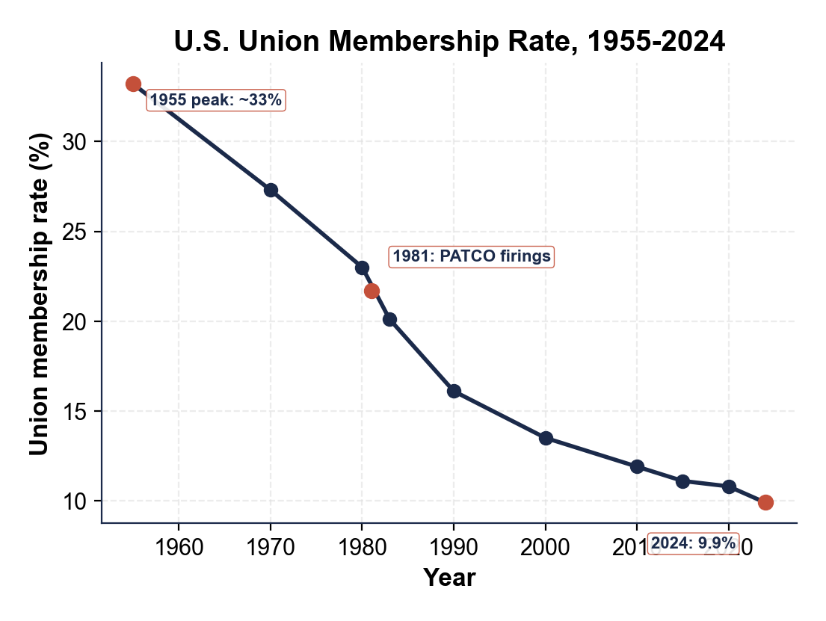
CHART REFERENCE 2: UNION DENSITY BY STATE (TOP 5 VS BOTTOM 5, 2024)
Use Chart Reference 2 (chart_union_density_by_state) - the bar chart of top-5 vs bottom-5 state union density shown below.
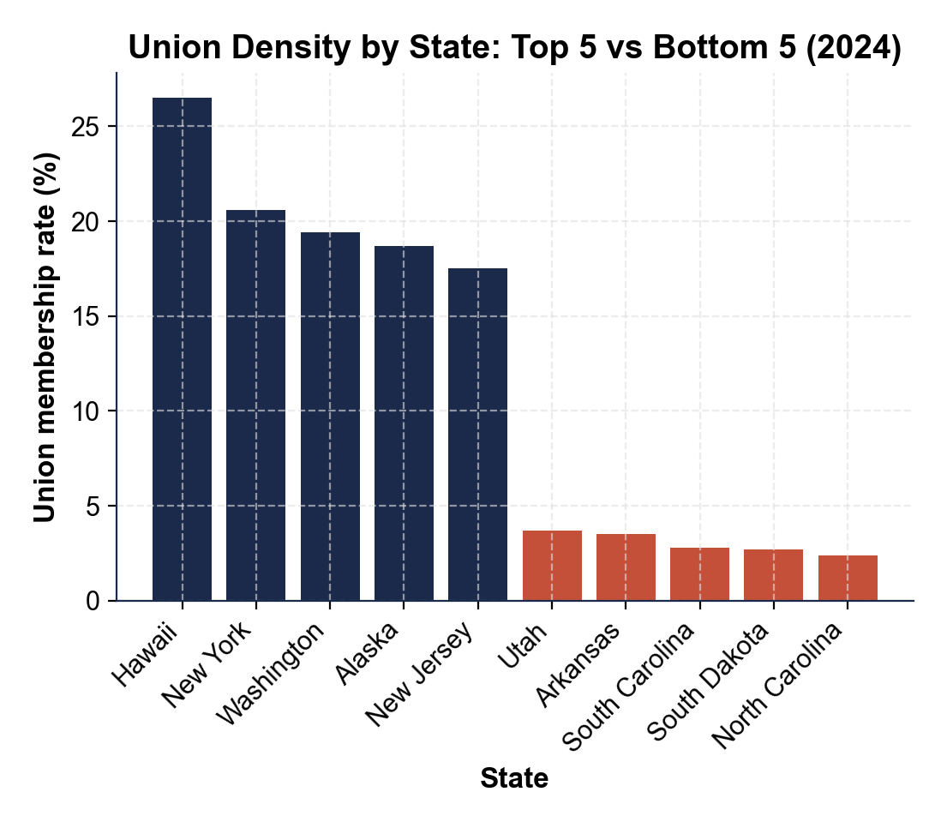

MORE LESSONS LESS PLANNING
Thank You!
If you enjoyed this product, please do not forget to rate and review to assist other teachers.

Looking for future discounts? Earn TPT credits by reviewing purchased products.

Please contact me if you have any issues with this product. Just like our students, I am always looking for opportunities to grow.

