Unemployment Rate: How It's Calculated
STUDENT ACTIVITY
Name: | Date: | Period:
ESSENTIAL QUESTION
How does the BLS decide who counts as unemployed, why can the official U-3 rate look low while the broader U-6 rate stays high, and how do you read the unemployment and monthly-jobs charts to judge the true health of the labor market?
THE SCENARIO
You are Morgan Ellis, a Junior Labor Economist at the U.S. Bureau of Labor Statistics (BLS). The Commissioner asks you to prepare a fact-based briefing on how the official unemployment rate is calculated before the next monthly jobs report.
BY THE END, YOU CAN:
✓ Calculate the unemployment rate from labor force data
✓ Distinguish U-3 (official) from U-6 (broader measure)
✓ Identify who is and isn't counted in the official unemployment rate
HOW IT WORKS (do Parts 1–5 in order)
Part 1 — Unemployment Reference Guide - Complete the Missing Terms
Part 2 — Apply the Terms - Morgan Ellis Builds the Labor-Market Vocabulary
Part 3 — Calculate U-3 and U-6 - Three BLS-Style Scenarios (Morgan Ellis Analysis)
Part 4 — Read the U-3 vs U-6 Line Chart and the Monthly Jobs Bar Chart (Morgan Ellis's BLS Evidence Section)
Part 5 — Final Memo to the BLS Commissioner (Morgan Ellis Synthesis)
TIME about 45 minutes YOU’LL NEED the lesson slides and your Guided Notes.

PART 1

Unemployment Reference Guide - Complete the Missing Terms
Fill in the missing term for each blank row — the definition is your clue. Your Guided Notes and the lesson slides have every term.

Term | Definition
___________ | All people 16 and older who are employed or unemployed; the labor force equals employed plus unemployed and is the denominator of the unemployment rate.
Unemployment rate | The percentage of the labor force that is unemployed; equals unemployed divided by labor force times 100.
___________ | People who want a job and looked in the last year but stopped looking because they believe no jobs are available.
U-3 | The official headline unemployment rate reported in the news; counts only people who are actively looking for work.
___________ | The number of jobs added or lost each month from a survey of about 130,000 businesses; the second main number in the jobs report.
Marginally attached | People who want a job and looked in the last year but did not look in the last 4 weeks; includes discouraged workers, counted in U-6.
___________ | People working part-time who want full-time work but cannot find it; counted as underemployed and included in U-6.
Labor force participation rate | The percentage of the population that is in the labor force; equals labor force divided by population times 100.
___________ | The broader unemployment rate; U-3 plus discouraged workers, marginally attached workers, and involuntary part-time workers.
BLS | Bureau of Labor Statistics; the agency that releases the monthly Employment Situation Report on the first Friday with nonfarm payrolls and the unemployment rate.

PART 2

Apply the Terms - Morgan Ellis Builds the Labor-Market Vocabulary
WORD BANK U-6 · Nonfarm payrolls · Part-time for economic reasons · Labor force · Discouraged workers
1. All people 16 and older who are either working or actively job-hunting - employed plus jobless searchers - together make up the .

2. People who want a job and looked sometime in the last year but stopped searching because they believe no jobs are available for them are called .

3. The monthly count of jobs added or lost, drawn from a survey of about 130,000 businesses and reported as the second main number in the jobs report, is .

4. People who hold a part-time job but would prefer full-time work and cannot find it are counted as .

5. The broader unemployment measure that adds discouraged, marginally attached, and involuntary part-time workers to the headline rate is .

PART 3

Calculate U-3 and U-6 - Three BLS-Style Scenarios (Morgan Ellis Analysis)
1. SCENARIO A - NORMAL ECONOMY (illustrative numbers). As Morgan Ellis, you receive this BLS-style data: Employed = 158 million; Unemployed = 6 million; Marginally attached (includes discouraged workers) = 1.5 million; Part-time for economic reasons (involuntary part-time) = 4.5 million.
(a) Compute the LABOR FORCE.

(b) Compute U-3 (official unemployment rate). Show your math.

(c) Compute U-6 (broader rate). Show your math.

(d) What is the ratio of U-6 to U-3? Show ALL math step by step.

2. SCENARIO B - GREAT RECESSION (2009 STYLE). Now you receive this BLS-style data: Employed = 139 million; Unemployed = 15 million; Marginally attached = 2.5 million; Part-time for economic reasons = 9 million.
(a) Compute the LABOR FORCE.

(b) Compute U-3.

(c) Compute U-6.

(d) What is the U-6 to U-3 GAP in percentage points? Show ALL your math.

3. SCENARIO C - RECOVERY YEAR. Your final packet shows this BLS-style data: Employed = 152 million; Unemployed = 9 million; Marginally attached = 2 million; Part-time for economic reasons = 6 million.
(a) Compute the LABOR FORCE.

(b) Compute U-3.

(c) Compute U-6.

(d) Compare Scenario C to Scenarios A and B: is this economy closer to the normal year or the recession?

PART 4

Read the U-3 vs U-6 Line Chart and the Monthly Jobs Bar Chart (Morgan Ellis's BLS Evidence Section)
1. As Morgan Ellis, study the U.S. U-3 vs U-6 Unemployment Rate 2000-2026 line chart inserted below (also shown in the slide deck). In ONE sentence, describe what the two lines show and which line always sits higher.
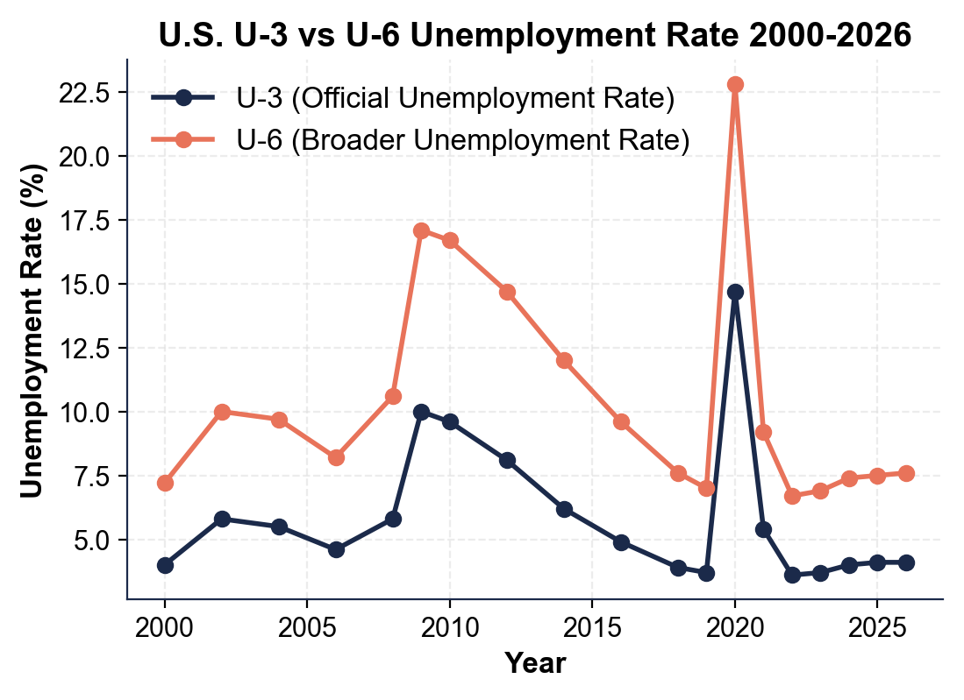

2. Using the line chart above, read directly off the chart: approximately what was U-3 at the 2009 RECESSION PEAK? Approximately what was U-6 at the 2009 PEAK? Approximately what was U-3 in APRIL 2020 (the COVID lockdown month)? Approximately what was U-6 in APRIL 2020?

3. Using the same line chart, read approximate values for 2026: U-3 ___% and U-6 ___%. Compute the U-6 to U-3 RATIO for 2026. In 1-2 sentences, explain what the GAP between U-6 and U-3 represents in real-world terms.

4. Now study the U.S. Monthly Nonfarm Payroll Change 2020-2026 bar chart inserted below (also shown in the slide deck). In ONE sentence, describe what the chart shows and which single bar dominates everything else.
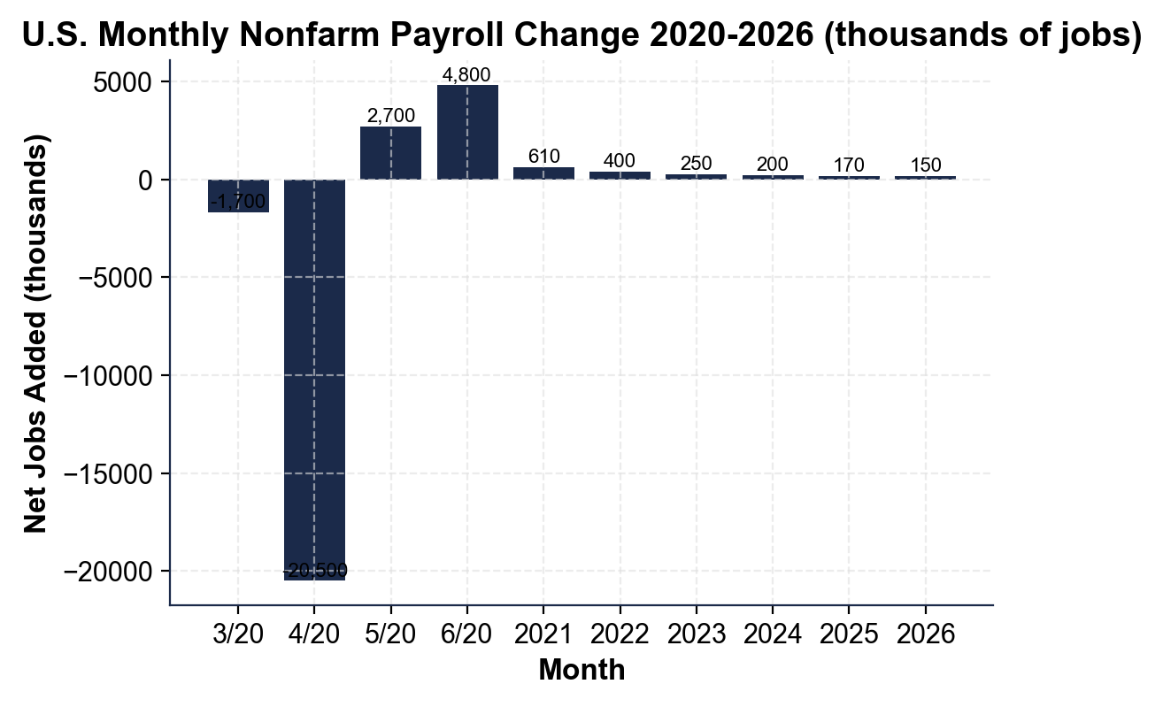

5. Using the bar chart above, read directly off the chart:
(a) In what month did the worst single-month job loss occur, and approximately how many jobs were lost?

(b) Which month started the recovery, and approximately how many jobs were added that month?

6. Using the same bar chart, read the typical 2026 monthly job creation: approximately ___ thousand per month. The BLS says about 150,000-200,000 new jobs per month keeps up with population growth.
(a) Is the typical 2026 month above, below, or in line with the healthy benchmark?

(b) In 1-2 sentences, explain why even a 200,000-job month is NOT a particularly strong month historically - it is just the new baseline for a stable economy.

PART 5

Final Memo to the BLS Commissioner (Morgan Ellis Synthesis)
FINAL POLICY MEMO
1. FINAL POLICY MEMO. As Morgan Ellis, a politician releases this press statement: "U.S. unemployment is at a historic low of 4.1% - the lowest in a generation. My policies created the best job market in decades!" Write a 6-8 sentence memo to the BLS Commissioner evaluating the claim. Use the memo header below and check off each required element as you include it. (Sentence starters you can use: "The 4.1% headline is technically accurate, but..." and "Before endorsing this claim, I would need...")
YOUR RESPONSE MUST:
☐ THE MISLEADING FRAMING - in 1-2 sentences, explain why citing only the 4.1% headline is technically true but MISLEADING, using the U-3 versus U-6 distinction (the headline U-3 leaves out discouraged, marginally attached, and involuntary part-time workers).
☐ TWO DATA NEEDS - name TWO specific data points you would need to evaluate the claim properly (for example the U-6 rate, the labor force participation rate, or the typical monthly nonfarm payroll change).
☐ ONE CHART NUMBER - cite ONE specific number you read off the U-3 vs U-6 line chart in Part 4 (for example the 2026 U-6 you read, the 2009 peak, or the U-6 to U-3 ratio) - use the value YOU read, do not copy it from here.
☐ ONE RECOMMENDATION - name ONE specific change to how the BLS should report unemployment to prevent this kind of misleading framing (for example leading every report with BOTH U-3 and U-6, or publishing the labor force participation rate alongside the headline).
☐ FIVE VOCABULARY TERMS - use at least FIVE lesson vocabulary terms from your Reference Guide (for example labor force, U-3, U-6, discouraged workers, marginally attached, part-time for economic reasons, nonfarm payrolls, labor force participation rate).
MEMO
To: BLS Commissioner
From: Morgan Ellis, Junior Labor Economist, U.S. Bureau of Labor Statistics (BLS)
Date:
Re: Evaluating a "Historically Low Unemployment" Claim

