ECONOMICS

UNEMPLOYMENT RATE: HOW IT'S CALCULATED
ANSWER KEY ACTIVITY

PART 1

Unemployment Reference Guide - Complete the Missing Terms

Term | Definition
Labor force | All people 16 and older who are employed or unemployed; the labor force equals employed plus unemployed and is the denominator of the unemployment rate.
Unemployment rate | The percentage of the labor force that is unemployed; equals unemployed divided by labor force times 100.
Discouraged workers | People who want a job and looked in the last year but stopped looking because they believe no jobs are available.
U-3 | The official headline unemployment rate reported in the news; counts only people who are actively looking for work.
Nonfarm payrolls | The number of jobs added or lost each month from a survey of about 130,000 businesses; the second main number in the jobs report.
Marginally attached | People who want a job and looked in the last year but did not look in the last 4 weeks; includes discouraged workers, counted in U-6.
Part-time for economic reasons | People working part-time who want full-time work but cannot find it; counted as underemployed and included in U-6.
Labor force participation rate | The percentage of the population that is in the labor force; equals labor force divided by population times 100.
U-6 | The broader unemployment rate; U-3 plus discouraged workers, marginally attached workers, and involuntary part-time workers.
BLS | Bureau of Labor Statistics; the agency that releases the monthly Employment Situation Report on the first Friday with nonfarm payrolls and the unemployment rate.

PART 2

Apply the Terms - Morgan Ellis Builds the Labor-Market Vocabulary
WORD BANK U-6 · Nonfarm payrolls · Part-time for economic reasons · Labor force · Discouraged workers
1. All people 16 and older who are either working or actively job-hunting - employed plus jobless searchers - together make up the Labor force.
Labor force
2. People who want a job and looked sometime in the last year but stopped searching because they believe no jobs are available for them are called Discouraged workers.
Discouraged workers
3. The monthly count of jobs added or lost, drawn from a survey of about 130,000 businesses and reported as the second main number in the jobs report, is Nonfarm payrolls.
Nonfarm payrolls
4. People who hold a part-time job but would prefer full-time work and cannot find it are counted as Part-time for economic reasons.
Part-time for economic reasons
5. The broader unemployment measure that adds discouraged, marginally attached, and involuntary part-time workers to the headline rate is U-6.
U-6

PART 3

Calculate U-3 and U-6 - Three BLS-Style Scenarios (Morgan Ellis Analysis)
1. SCENARIO A - NORMAL ECONOMY (illustrative numbers). As Morgan Ellis, you receive this BLS-style data: Employed = 158 million; Unemployed = 6 million; Marginally attached (includes discouraged workers) = 1.5 million; Part-time for economic reasons (involuntary part-time) = 4.5 million.
(a) Compute the LABOR FORCE.
(b) Compute U-3 (official unemployment rate). Show your math.
(c) Compute U-6 (broader rate). Show your math.
(d) What is the ratio of U-6 to U-3? Show ALL math step by step.
Step 1: LABOR FORCE = Employed + Unemployed = 158 + 6 = 164 million. Step 2: U-3 = (Unemployed / Labor Force) x 100 = (6 / 164) x 100. (6 / 164) = 0.0366; x 100 = 3.66, rounds to about 3.7%. So U-3 = 3.7%. Step 3: U-6 NUMERATOR = Unemployed + Marginally attached + Involuntary part-time = 6 + 1.5 + 4.5 = 12 million. U-6 DENOMINATOR = Labor Force + Marginally attached = 164 + 1.5 = 165.5 million. (Note: involuntary part-time workers are ALREADY in the labor force as employed; only marginally attached are added to the denominator since they were not in the labor force originally.) Step 4: U-6 = (12 / 165.5) x 100 = 0.0725 x 100 = 7.25, rounds to about 7.3%. So U-6 = 7.3%. Step 5: RATIO = U-6 / U-3 = 7.3 / 3.7 = approximately 1.97x, roughly 2x. (Accept 1.8x-2.0x.) Required: Labor force = 164M; U-3 = 3.7% with shown math; U-6 = 7.3% with shown math (correct numerator + denominator); ratio approximately 2x.
2. SCENARIO B - GREAT RECESSION (2009 STYLE). Now you receive this BLS-style data: Employed = 139 million; Unemployed = 15 million; Marginally attached = 2.5 million; Part-time for economic reasons = 9 million.
(a) Compute the LABOR FORCE.
(b) Compute U-3.
(c) Compute U-6.
(d) What is the U-6 to U-3 GAP in percentage points? Show ALL your math.
Step 1: LABOR FORCE = Employed + Unemployed = 139 + 15 = 154 million. Step 2: U-3 = (15 / 154) x 100 = 0.0974 x 100 = 9.74, rounds to about 9.7%. (Accept 9.7%-10%.) So U-3 = 9.7%. Step 3: U-6 NUMERATOR = 15 + 2.5 + 9 = 26.5 million. U-6 DENOMINATOR = 154 + 2.5 = 156.5 million. Step 4: U-6 = (26.5 / 156.5) x 100 = 0.1693 x 100 = 16.93, rounds to about 16.9%. (Accept 16.9%-17.1%.) So U-6 = 16.9%. Step 5: GAP = U-6 - U-3 = 16.9 - 9.7 = 7.2 percentage points. In a recession the U-6 to U-3 gap WIDENS - the broader measure picks up the massive surge in discouraged workers and involuntary part-time work that recessions produce. Required: Labor force = 154M; U-3 about 9.7%-10% with shown math; U-6 about 16.9%-17.1% with shown math; gap of about 7 percentage points.
3. SCENARIO C - RECOVERY YEAR. Your final packet shows this BLS-style data: Employed = 152 million; Unemployed = 9 million; Marginally attached = 2 million; Part-time for economic reasons = 6 million.
(a) Compute the LABOR FORCE.
(b) Compute U-3.
(c) Compute U-6.
(d) Compare Scenario C to Scenarios A and B: is this economy closer to the normal year or the recession?
Step 1: LABOR FORCE = 152 + 9 = 161 million. Step 2: U-3 = (9 / 161) x 100 = 0.0559 x 100 = 5.59, rounds to about 5.6%. So U-3 = 5.6%. Step 3: U-6 NUMERATOR = 9 + 2 + 6 = 17 million. U-6 DENOMINATOR = 161 + 2 = 163 million. Step 4: U-6 = (17 / 163) x 100 = 0.1043 x 100 = 10.43, rounds to about 10.4%. So U-6 = 10.4%. Step 5: COMPARISON: U-3 of 5.6% is closer to Scenario A (3.7%) than Scenario B (9.7%) - this economy is in a RECOVERY, mid-way between recession and normal. The U-6 to U-3 ratio is 10.4 / 5.6 = 1.86x, close to the typical 1.8x. Required: Labor force = 161M; U-3 about 5.6% with shown math; U-6 about 10.4% with shown math; correctly identifies the scenario as a recovery (between A and B).

PART 4

Read the U-3 vs U-6 Line Chart and the Monthly Jobs Bar Chart (Morgan Ellis's BLS Evidence Section)
1. As Morgan Ellis, study the U.S. U-3 vs U-6 Unemployment Rate 2000-2026 line chart inserted below (also shown in the slide deck). In ONE sentence, describe what the two lines show and which line always sits higher.
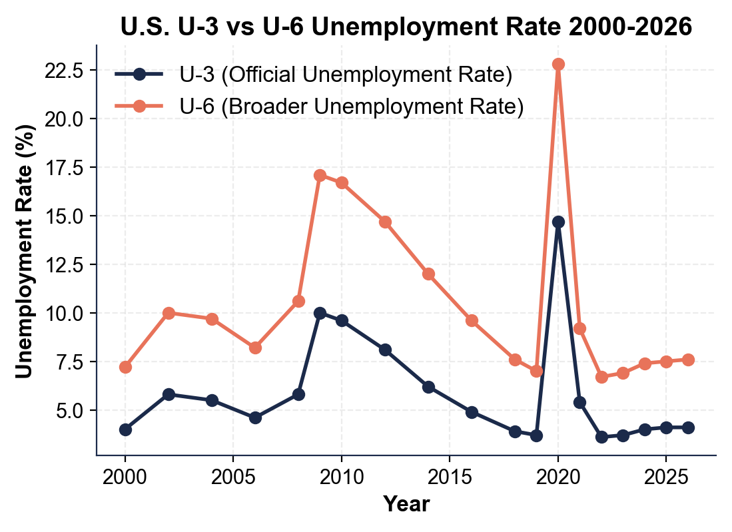
The chart shows two unemployment measures over time - the lower line is U-3 (the official headline rate) and the upper line is U-6 (the broader rate) - and U-6 always sits ABOVE U-3 because it counts more groups of struggling workers.
2. Using the line chart above, read directly off the chart: approximately what was U-3 at the 2009 RECESSION PEAK? Approximately what was U-6 at the 2009 PEAK? Approximately what was U-3 in APRIL 2020 (the COVID lockdown month)? Approximately what was U-6 in APRIL 2020?
Reading the chart: 2009 PEAK U-3 = approximately 10.0% (accept 9.5%-10.5%). 2009 PEAK U-6 = approximately 17.1% (accept 16.5%-17.5%). APRIL 2020 U-3 = approximately 14.7% (accept 14%-15%). APRIL 2020 U-6 = approximately 22.8% (accept 22%-23.5%). The April 2020 spike is the highest single-month value on the entire chart - the COVID labor-market shock has no postwar comparison. Required: 2009 U-3 ~10%; 2009 U-6 ~17%; Apr 2020 U-3 ~15%; Apr 2020 U-6 ~23%.
3. Using the same line chart, read approximate values for 2026: U-3 ___% and U-6 ___%. Compute the U-6 to U-3 RATIO for 2026. In 1-2 sentences, explain what the GAP between U-6 and U-3 represents in real-world terms.
Reading the chart: 2026 U-3 = approximately 4.1% (accept 3.8%-4.5%). 2026 U-6 = approximately 7.6% (accept 7.2%-8.0%). RATIO = 7.6 / 4.1 = approximately 1.85x, roughly 1.8x - close to the typical historical ratio. The GAP between U-6 and U-3 represents three groups U-3 misses entirely: (1) DISCOURAGED WORKERS who want a job but stopped looking because they believe none are available, (2) other MARGINALLY ATTACHED workers who looked in the past year but not the past 4 weeks, and (3) people working PART-TIME who want full-time work but cannot find it. In 2026 the gap of about 3.5 percentage points represents roughly 6 million Americans who are excluded from the official U-3 headline. Required: 2026 U-3 ~4.1%; U-6 ~7.6%; ratio ~1.8x; explains gap = discouraged + marginally attached + involuntary part-time.
4. Now study the U.S. Monthly Nonfarm Payroll Change 2020-2026 bar chart inserted below (also shown in the slide deck). In ONE sentence, describe what the chart shows and which single bar dominates everything else.
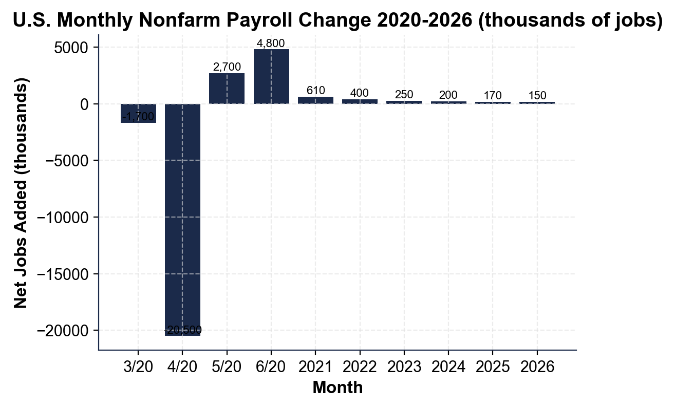
The chart shows the net change in U.S. jobs each period from 2020 to 2026, and a single massive downward bar - April 2020 - dominates the entire chart, far larger than any other bar.
5. Using the bar chart above, read directly off the chart:
(a) In what month did the worst single-month job loss occur, and approximately how many jobs were lost?
APRIL 2020 lost approximately 20.5 million jobs (the chart bar is labeled -20,500 thousand, or -20.5 million). This is the worst single-month job loss in U.S. history (the prior worst single month lost about 800,000 jobs during the 2008-09 recession).
(b) Which month started the recovery, and approximately how many jobs were added that month?
MAY 2020 began the recovery with approximately +2.7 million jobs (the chart bar is labeled +2,700 thousand). June 2020 followed with about +4.8 million. Required: April 2020 = ~-20.5 million (or -20,500 thousand); May 2020 = ~+2.7 million (recovery start).
6. Using the same bar chart, read the typical 2026 monthly job creation: approximately ___ thousand per month. The BLS says about 150,000-200,000 new jobs per month keeps up with population growth.
(a) Is the typical 2026 month above, below, or in line with the healthy benchmark?
The 2026 average sits at the LOW END of the 150,000-200,000 healthy benchmark - in line with population-growth replacement, not above it.
(b) In 1-2 sentences, explain why even a 200,000-job month is NOT a particularly strong month historically - it is just the new baseline for a stable economy.
The 150,000-200,000 monthly range is just enough to keep up with the ~150K-200K new entrants to the labor force each month (population growth + young people aging into 16+).

PART 5

Final Memo to the BLS Commissioner (Morgan Ellis Synthesis)
FINAL POLICY MEMO
1. FINAL POLICY MEMO. As Morgan Ellis, a politician releases this press statement: "U.S. unemployment is at a historic low of 4.1% - the lowest in a generation. My policies created the best job market in decades!" Write a 6-8 sentence memo to the BLS Commissioner evaluating the claim. Use the memo header below and check off each required element as you include it. (Sentence starters you can use: "The 4.1% headline is technically accurate, but..." and "Before endorsing this claim, I would need...")
YOUR RESPONSE MUST:
☐ THE MISLEADING FRAMING - in 1-2 sentences, explain why citing only the 4.1% headline is technically true but MISLEADING, using the U-3 versus U-6 distinction (the headline U-3 leaves out discouraged, marginally attached, and involuntary part-time workers).
☐ TWO DATA NEEDS - name TWO specific data points you would need to evaluate the claim properly (for example the U-6 rate, the labor force participation rate, or the typical monthly nonfarm payroll change).
☐ ONE CHART NUMBER - cite ONE specific number you read off the U-3 vs U-6 line chart in Part 4 (for example the 2026 U-6 you read, the 2009 peak, or the U-6 to U-3 ratio) - use the value YOU read, do not copy it from here.
☐ ONE RECOMMENDATION - name ONE specific change to how the BLS should report unemployment to prevent this kind of misleading framing (for example leading every report with BOTH U-3 and U-6, or publishing the labor force participation rate alongside the headline).
☐ FIVE VOCABULARY TERMS - use at least FIVE lesson vocabulary terms from your Reference Guide (for example labor force, U-3, U-6, discouraged workers, marginally attached, part-time for economic reasons, nonfarm payrolls, labor force participation rate).
MEMO
To: BLS Commissioner
From: Morgan Ellis, Junior Labor Economist, U.S. Bureau of Labor Statistics (BLS)
Date: [student completes]
Re: Evaluating a "Historically Low Unemployment" Claim
GRADING RUBRIC
Grade the evidence and reasoning, not the conclusion — any defensible position is valid. Score against the 5 requirements above.
FULL CREDIT — clear position; meets all 5 requirements with accurate, specific numbers and evidence from the lesson.
PARTIAL — position stated, but misses 1-2 requirements or uses vague / incorrect numbers.
MINIMAL — no clear position, or missing most requirements and numbers.
WHAT TO LOOK FOR IN THIS LESSON
Sample full-credit memo:
TO: BLS Commissioner
FROM: Morgan Ellis, Junior Labor Economist, BLS
RE: Evaluating a "Historically Low Unemployment" Claim
[1] MISLEADING FRAMING: The 4.1% headline is technically accurate, but it cites only U-3 - the narrowest measure - and leaves out about 6 million Americans who are discouraged workers, marginally attached, or working part-time for economic reasons; the broader U-6 rate is nearly double the headline. [2] DATA NEEDS: before endorsing the claim I would need (1) the U-6 rate for the same period and (2) the labor force participation rate, because a falling U-3 paired with a falling participation rate can mean discouraged workers leaving rather than a stronger job market; I would also check the typical monthly nonfarm payrolls. [3] CHART NUMBER: reading the U-3 vs U-6 line chart, 2026 U-6 is about 7.6% versus the 4.1% U-3 headline - a ratio of roughly 1.85x. [4] RECOMMENDATION: every BLS Employment Situation Report should LEAD with BOTH U-3 and U-6 side by side, plus the labor force participation rate, with a one-line explainer of what each measure includes. [5] VOCABULARY: this memo uses labor force, U-3, U-6, discouraged workers, marginally attached, and labor force participation rate.
REQUIRED-ELEMENT CHECKLIST (award credit per item):
[1] Explains the U-3 vs U-6 misleading framing.
[2] Names TWO specific data needs.
[3] One specific chart number (the student's own Part 4 reading).
[4] One specific BLS-reporting recommendation.
[5] At least FIVE Reference-Guide vocabulary terms.
Accept any sound analysis: the memo may agree or disagree with the politician as long as it uses the U-3 vs U-6 distinction, names two data needs, cites the student's own chart number, and recommends one reporting change.
MORE LESSONS LESS PLANNING
Thank You!
If you enjoyed this product, please do not forget to rate and review to assist other teachers.

Looking for future discounts? Earn TPT credits by reviewing purchased products.

Please contact me if you have any issues with this product. Just like our students, I am always looking for opportunities to grow.

