The Trump Tariffs: A Case Study
STUDENT ACTIVITY
Name: | Date: | Period:
ESSENTIAL QUESTION
Did the 2018-2026 U.S. tariff strategy WORK - and given who actually paid (consumers) versus who was protected (a few states' manufacturers), should a Pennsylvania senator vote to extend the 100% Chinese EV and 50% solar tariffs through 2030?
THE SCENARIO
You are a POLICY ANALYST for Senator Marcus Reed, the U.S. Senator from Pennsylvania on the Senate Finance Committee. Next week the senator must vote on a bill to extend the 100% tariff on Chinese electric vehicles and the 50% tariff on Chinese solar panels through 2030.
BY THE END, YOU CAN:
✓ Trace the Trump tariff strategy from 2018 through 2026, naming the key actions (Section 232, Section 301, EU steel, 2024-2025 expansion)
✓ Identify which industries the U.S. targeted and how China and the EU retaliated against U.S. exports
✓ Evaluate evidence on consumer cost vs jobs gained to decide whether the tariff strategy worked
HOW IT WORKS (do Parts 1–5 in order)
Part 1 — Tariff Case Reference Guide - Complete the Missing Terms
Part 2 — Apply the Terms - Tariff Vocabulary in Context
Part 3 — Trace the Case - Tariff Actions, Retaliation, and Geography
Part 4 — Read the Charts - Escalation Timeline and Retail Price Increases
Part 5 — Vote Recommendation Memo to Senator Reed
TIME about 45 minutes YOU’LL NEED the lesson slides and your Guided Notes.

PART 1

Tariff Case Reference Guide - Complete the Missing Terms
Fill in the missing term for each blank row — the definition is your clue. Your Guided Notes and the lesson slides have every term.

Term | Definition
___________ | A trade barrier the 2018 Trump strategy placed on Chinese steel and aluminum, used as both protection and leverage
Section 232 | The 1962 national security trade law the Trump administration used in 2018 for the steel and aluminum tariffs
___________ | The 1974 unfair trade practices law used for the China tariff lists covering 360 billion of Chinese goods
Market Facilitation Program | The Trump farm aid that paid U.S. soybean farmers for losses from Chinese retaliation, replacing the Brazil-lost market
___________ | The share of the tariff that reached U.S. consumers as higher prices, found by the Federal Reserve and NBER to be 95 to 100 percent
EU steel and aluminum dispute | The 2018 steel and aluminum tariffs on the EU that led the EU to retaliate against U.S. bourbon and Harley-Davidson motorcycles
___________ | Taxes China and the EU placed on U.S. soybeans, bourbon, and Harley-Davidson motorcycles in response to the Trump tariffs
Soybeans | The U.S. crop China hit hardest in response to the 2018 Trump tariffs, after which Brazil became the substitute supplier and farmers got Market Facilitation Program aid
___________ | The 2020 China deal that paused escalation but kept most existing tariffs in place
Whirlpool | The U.S. washer factory company that gained market share against Samsung and LG after the 2018 washer tariff

PART 2

Apply the Terms - Tariff Vocabulary in Context
WORD BANK tariff · retaliatory tariffs · pass-through · section 301 · phase one trade deal
1. Q1. A trade barrier a government places on imported goods, used by the 2018 Trump strategy as both protection for U.S. industries and leverage on trading partners, is a .

2. Q2. The 1974 U.S. trade law that authorizes tariffs against unfair foreign trade practices - the legal basis for the 2018-2019 China tariff lists - is .

3. Q3. The share of a tariff that reaches U.S. consumers as higher retail prices - measured by the Federal Reserve and NBER at 95 to 100 percent - is called .

4. Q4. When China and the EU taxed U.S. bourbon and motorcycles in direct response to U.S. tariffs, the taxes they imposed are called .

5. Q5. The January 2020 U.S.-China agreement that paused further escalation but kept most existing tariffs in place is the .

PART 3

Trace the Case - Tariff Actions, Retaliation, and Geography
1. Trace the THREE Trump tariff actions and ONE Biden tariff action that the case walks through. For each action name
(a) the U.S. trade law used

(b) the targeted product or country

(c) the rate. Use complete sentences.

2. As Senator Reed's analyst, explain HOW China and the EU retaliated against the 2018 U.S. tariffs. Name
(a) TWO specific U.S. exports China hit

(b) TWO specific U.S. exports the EU hit, then explain in 2-3 sentences WHY each side picked those products.

3. Use the TARIFF-PROTECTED INDUSTRIES BY STATE chart below.
Read directly off the chart: which TWO states have the LARGEST tariff-protected industry output, and roughly how many BILLIONS of dollars each? Then explain in 2-3 sentences why the GEOGRAPHIC concentration of protection matters for the politics of keeping the tariffs. (Chart: chart_tariff_industries_by_state)
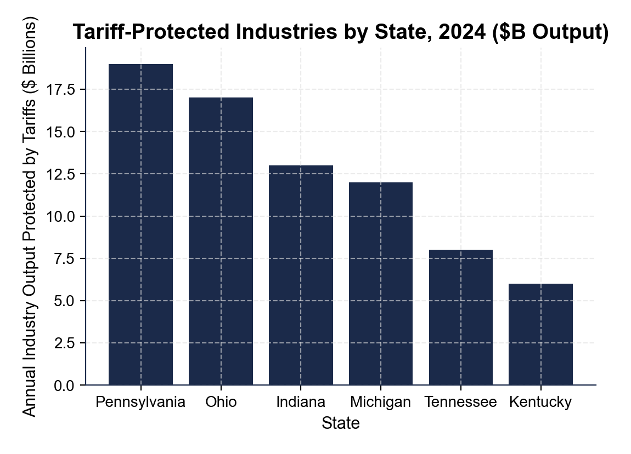

PART 4

Read the Charts - Escalation Timeline and Retail Price Increases
1. Use the U.S.-CHINA TARIFF ESCALATION TIMELINE chart below.
Read directly off the chart: roughly what was the AVERAGE U.S. tariff rate on Chinese goods in 2017, and roughly what was it in 2019? Use those two numbers to tell Senator Reed how big the 2018-2019 escalation was. (Chart: chart_us_china_tariff_escalation)
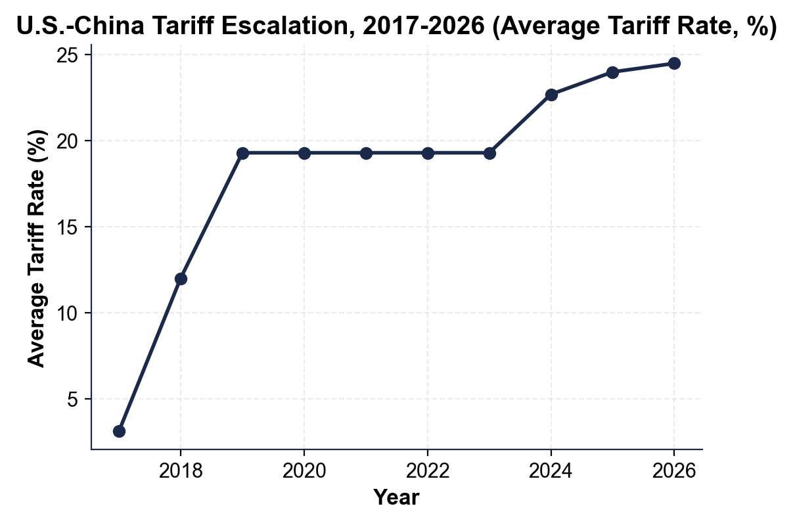

2. Use the same escalation chart.
By 2024-2026 the average U.S. tariff rate on Chinese goods rises again to roughly what percent? Name TWO specific 2024 Biden tariff actions that explain that increase.

3. Use the RETAIL PRICE INCREASES BY CATEGORY chart below. The senator wants concrete consumer-cost numbers for his speech. Read off the chart the approximate PERCENTAGE each price rose after the relevant tariff:
(a) WASHING MACHINES

(b) CONSUMER ELECTRONICS

(c) SOLAR PANELS

(d) CHINESE EVs. (Chart: chart_retail_price_increases_by_category)
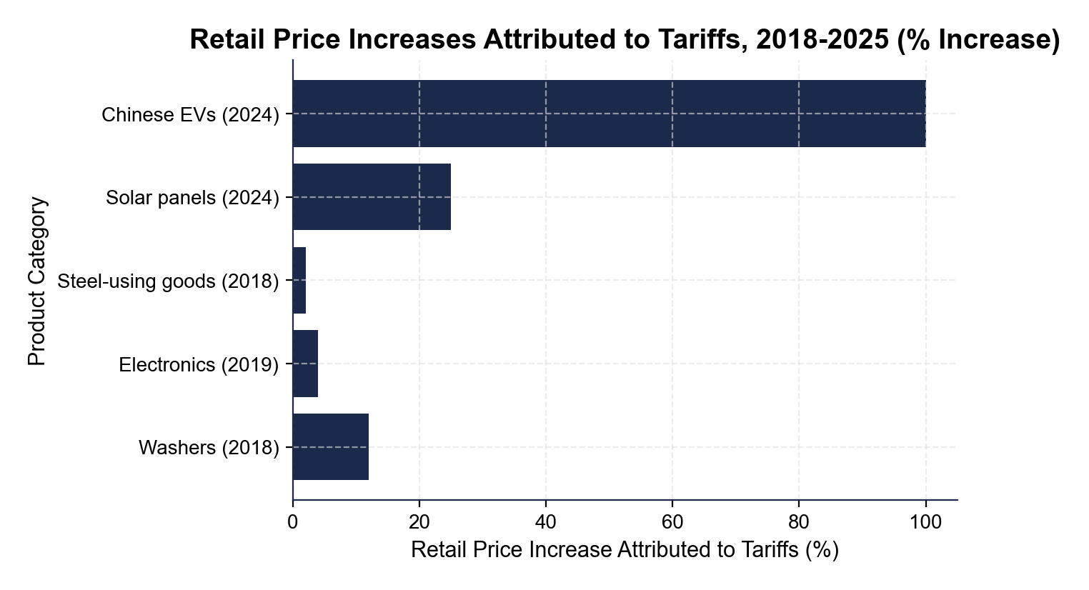

4. Use the same retail-price chart.
Which product category saw the SMALLEST tariff-driven retail price increase, and what does that tell you about how much pass-through varies across products? In 2-3 sentences, explain what factors might cause LOWER pass-through.

PART 5

Vote Recommendation Memo to Senator Reed
VOTE RECOMMENDATION MEMO
1. VOTE RECOMMENDATION MEMO. Write a 6-8 sentence memo (about 200-300 words) to Senator Reed telling him HOW to vote next week on extending the 100% Chinese EV tariff and the 50% Chinese solar tariff through 2030. Use the memo header below and check off each required element as you include it. (Sentence starters you can use: "Senator, the data support a ___ vote because..." and "The strongest argument on the other side is...")
YOUR RESPONSE MUST:
☐ VOTE - a clear YES or NO recommendation on extending the 100% Chinese EV and 50% solar tariffs through 2030.
☐ ONE CONSUMER-COST NUMBER - cite one specific consumer-cost figure from the lesson or the charts (for example a per-household yearly cost, a total annual U.S. cost, a retail price increase you read off the chart, a pass-through rate, or the average tariff rate from the escalation chart).
☐ ONE PROTECTION NUMBER - cite one specific protected-jobs or protected-state figure (for example total U.S. jobs protected, a steel-jobs number, or a protected-output dollar figure you read off the industries-by-state chart).
☐ ONE COUNTER-ARGUMENT - one realistic argument the senator's chief of staff might raise FOR keeping or expanding the tariffs (national security, protecting domestic jobs, or leverage on China).
☐ HOME-STATE TRADE-OFF - reference Pennsylvania's split position: steel and aluminum workers who GAIN from protection AND agricultural exporters who were HURT by China's retaliation.
MEMO
To: Senator Marcus Reed (PA), Senate Finance Committee
From: Policy Analyst, Office of Senator Reed
Date:
Re: Vote Recommendation - Extending the 100% Chinese EV and 50% Solar Tariffs Through 2030

