ECONOMICS

THE TRUMP TARIFFS: A CASE STUDY
ANSWER KEY ACTIVITY - ANSWER KEY

PART 1

Tariff Case Reference Guide - Complete the Missing Terms

Term | Definition
Tariff | A trade barrier the 2018 Trump strategy placed on Chinese steel and aluminum, used as both protection and leverage
Section 232 | The 1962 national security trade law the Trump administration used in 2018 for the steel and aluminum tariffs
Section 301 | The 1974 unfair trade practices law used for the China tariff lists covering 360 billion of Chinese goods
Market Facilitation Program | The Trump farm aid that paid U.S. soybean farmers for losses from Chinese retaliation, replacing the Brazil-lost market
Pass-through | The share of the tariff that reached U.S. consumers as higher prices, found by the Federal Reserve and NBER to be 95 to 100 percent
EU steel and aluminum dispute | The 2018 steel and aluminum tariffs on the EU that led the EU to retaliate against U.S. bourbon and Harley-Davidson motorcycles
Retaliatory tariffs | Taxes China and the EU placed on U.S. soybeans, bourbon, and Harley-Davidson motorcycles in response to the Trump tariffs
Soybeans | The U.S. crop China hit hardest in response to the 2018 Trump tariffs, after which Brazil became the substitute supplier and farmers got Market Facilitation Program aid
Phase One trade deal | The 2020 China deal that paused escalation but kept most existing tariffs in place
Whirlpool | The U.S. washer factory company that gained market share against Samsung and LG after the 2018 washer tariff

PART 2

Apply the Terms - Tariff Vocabulary in Context
WORD BANK tariff · retaliatory tariffs · pass-through · section 301 · phase one trade deal
1. Q1. A trade barrier a government places on imported goods, used by the 2018 Trump strategy as both protection for U.S. industries and leverage on trading partners, is a Tariff.
Tariff
2. Q2. The 1974 U.S. trade law that authorizes tariffs against unfair foreign trade practices - the legal basis for the 2018-2019 China tariff lists - is Section 301.
Section 301
3. Q3. The share of a tariff that reaches U.S. consumers as higher retail prices - measured by the Federal Reserve and NBER at 95 to 100 percent - is called Pass-through.
Pass-through
4. Q4. When China and the EU taxed U.S. bourbon and motorcycles in direct response to U.S. tariffs, the taxes they imposed are called Retaliatory tariffs.
Retaliatory tariffs
5. Q5. The January 2020 U.S.-China agreement that paused further escalation but kept most existing tariffs in place is the Phase One Trade Deal.
Phase One Trade Deal
PART 3

Trace the Case - Tariff Actions, Retaliation, and Geography
1. Trace the THREE Trump tariff actions and ONE Biden tariff action that the case walks through. For each action name
(a) the U.S. trade law used
(b) the targeted product or country
(c) the rate. Use complete sentences.
(1) MARCH 2018 SECTION 232 STEEL AND ALUMINUM: 25% on steel and 10% on aluminum, applied to nearly all U.S. trading partners including China, the EU, Canada, and Mexico, on a national-security justification. (2) 2018 SECTION 301 CHINA LISTS 1-3: 25% on about $250B of Chinese imports (industrial machinery, semiconductors, chemicals, consumer goods), justified by unfair Chinese trade practices including forced technology transfer and IP theft. (3) SEPTEMBER 2019 SECTION 301 LIST 4A: 7.5% on another ~$110B of Chinese consumer goods (clothing, electronics, furniture), bringing total coverage to about $360B of Chinese imports. (4) MAY 2024 BIDEN EXPANSION: 100% on Chinese electric vehicles (quadrupled from 25%), 50% on Chinese solar panels (doubled from 25%), and 25% on Chinese EV batteries (phased through 2026), to protect U.S. clean-energy and EV manufacturing. BOTH ADMINISTRATIONS used the same playbook: protection of U.S. industries plus leverage on China.
2. As Senator Reed's analyst, explain HOW China and the EU retaliated against the 2018 U.S. tariffs. Name
(a) TWO specific U.S. exports China hit
CHINA HIT U.S. SOYBEANS at 25% (plus corn, pork, beef, autos) starting July 2018, and U.S. SOYBEAN EXPORTS TO CHINA DROPPED ABOUT 75% in 2018. China picked these because it was the biggest buyer of U.S. soybeans (~$30B/year before the tariffs), the farm states were politically important, and Brazil could supply substitutes.
(b) TWO specific U.S. exports the EU hit, then explain in 2-3 sentences WHY each side picked those products.
THE EU HIT U.S. BOURBON (Kentucky) and U.S. MOTORCYCLES (Harley-Davidson, Wisconsin) at 25%, plus jeans, peanut butter, and orange juice. The EU picked products that each mapped to a politically important U.S. state, sending the message that tariffs cost U.S. exporters and U.S. workers, not just foreign exporters. THE PATTERN: retaliation is targeted, not random - it aims at the politically sensitive products of the country that started the trade fight.
3. Use the TARIFF-PROTECTED INDUSTRIES BY STATE chart below.
Read directly off the chart: which TWO states have the LARGEST tariff-protected industry output, and roughly how many BILLIONS of dollars each? Then explain in 2-3 sentences why the GEOGRAPHIC concentration of protection matters for the politics of keeping the tariffs. (Chart: chart_tariff_industries_by_state)
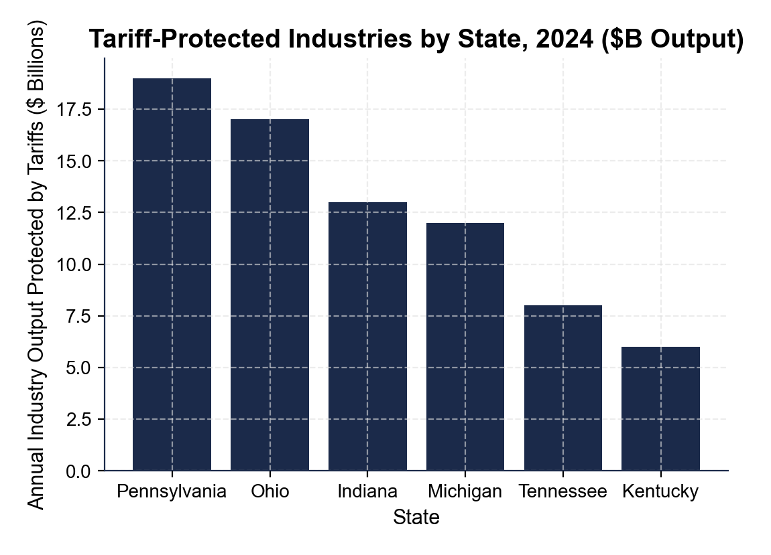
CHART READING: PENNSYLVANIA is the largest at about $19 BILLION in protected industry output (Pittsburgh-area steel and aluminum), and OHIO is second at about $17 BILLION (steel and auto). Together those two states alone account for about $36B of the roughly $75B total across the six charted states. WHY IT MATTERS: tariff BENEFITS are geographically concentrated in a few Midwest manufacturing states (PA, OH, IN, MI, TN, KY) while the consumer-cost BURDEN is spread across all 50 states. THE POLITICS: concentrated benefits create a tight, organized coalition that fights to keep tariffs, while diffuse costs leave millions of households each feeling only a small annual loss - which is exactly why tariffs are politically durable even when total economic costs exceed total economic benefits. Accept chart readings within +/- $2B.
PART 4

Read the Charts - Escalation Timeline and Retail Price Increases
1. Use the U.S.-CHINA TARIFF ESCALATION TIMELINE chart below.
Read directly off the chart: roughly what was the AVERAGE U.S. tariff rate on Chinese goods in 2017, and roughly what was it in 2019? Use those two numbers to tell Senator Reed how big the 2018-2019 escalation was. (Chart: chart_us_china_tariff_escalation)
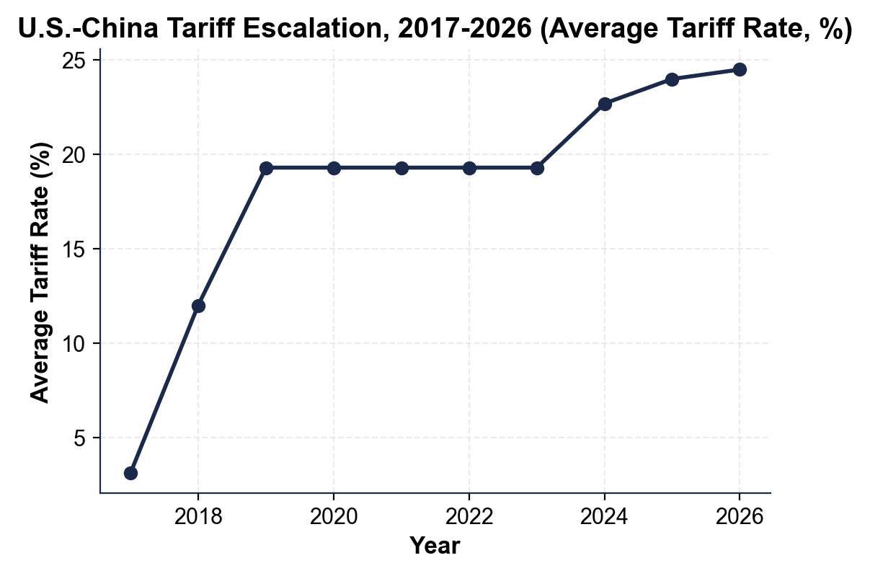
CHART READINGS: the 2017 average rate was approximately 3% (the long-running pre-Trump baseline); the 2019 average rate was approximately 19% (after Section 232 plus Section 301 Lists 1-4 took full effect). THE ESCALATION: roughly a 6x jump - from ~3% to ~19%, about a 16 percentage-point increase - in just two years, the largest U.S. tariff escalation against China in about 90 years. THE SHAPE: the chart shows the rate then stays elevated through 2023 and rises again in 2024, so the change is durable, not a one-year spike. Accept readings within +/- 1 percentage point.
2. Use the same escalation chart.
By 2024-2026 the average U.S. tariff rate on Chinese goods rises again to roughly what percent? Name TWO specific 2024 Biden tariff actions that explain that increase.
CHART READING: by 2024 the average rate climbs to about 23%, and by 2026 to about 24-25% (accept the 22-25% range). TWO 2024 BIDEN ACTIONS: (1) the 100% tariff on Chinese ELECTRIC VEHICLES (quadrupled from 25%); (2) the 50% tariff on Chinese SOLAR PANELS (doubled from 25%). Also accept the 25% tariff on Chinese EV BATTERIES (phased through 2026) or the kept Trump-era Section 232 steel tariffs. THE KEY POINT: the Biden round did NOT replace the Trump tariffs - it KEPT them and ADDED new ones, which is the bipartisan continuity at the heart of the case.
3. Use the RETAIL PRICE INCREASES BY CATEGORY chart below. The senator wants concrete consumer-cost numbers for his speech. Read off the chart the approximate PERCENTAGE each price rose after the relevant tariff:
(a) WASHING MACHINES
WASHING MACHINES rose about 12% after the 2018 safeguard tariff
(b) CONSUMER ELECTRONICS
CONSUMER ELECTRONICS rose about 4% after the 2019 Section 301 List 4A 7.5% tariff
(c) SOLAR PANELS
SOLAR PANELS rose about 25% after the 2024 Biden 50% tariff
(d) CHINESE EVs. (Chart: chart_retail_price_increases_by_category)
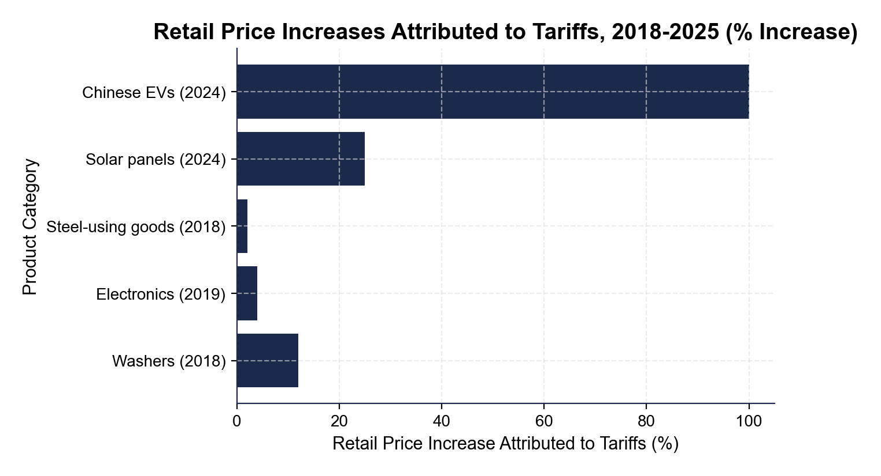
CHINESE EVs: the 100% tariff roughly DOUBLES the would-be sticker price (a 100% jump on what a U.S. buyer would pay), which is exactly why almost no Chinese EVs reach U.S. dealerships - they are priced out of the market entirely.
4. Use the same retail-price chart.
Which product category saw the SMALLEST tariff-driven retail price increase, and what does that tell you about how much pass-through varies across products? In 2-3 sentences, explain what factors might cause LOWER pass-through.
THE SMALLEST INCREASE: STEEL-USING GOODS (canned food, autos, appliances) at about 2% on average - far below the 12% washers, 25% solar, or 100% Chinese-EV increases. WHY LOWER PASS-THROUGH HAPPENS: (a) the tariff hits an INPUT (steel) rather than a finished product, so steel is only a small fraction of the final price; (b) U.S. producers offer a SUBSTITUTE domestic supply that caps how much importers can raise prices; (c) the affected firms have thicker margins and can ABSORB part of the tariff. THE RANGE TO REMEMBER: pass-through runs from about 2% on input-tariff goods to nearly 100% on finished products in competitive markets like solar and EVs; the 95-100% study finding is the AVERAGE across the 2018-2019 China tariffs, and individual products vary widely.
PART 5

Vote Recommendation Memo to Senator Reed
VOTE RECOMMENDATION MEMO
1. VOTE RECOMMENDATION MEMO. Write a 6-8 sentence memo (about 200-300 words) to Senator Reed telling him HOW to vote next week on extending the 100% Chinese EV tariff and the 50% Chinese solar tariff through 2030. Use the memo header below and check off each required element as you include it. (Sentence starters you can use: "Senator, the data support a ___ vote because..." and "The strongest argument on the other side is...")
YOUR RESPONSE MUST:
☐ VOTE - a clear YES or NO recommendation on extending the 100% Chinese EV and 50% solar tariffs through 2030.
☐ ONE CONSUMER-COST NUMBER - cite one specific consumer-cost figure from the lesson or the charts (for example a per-household yearly cost, a total annual U.S. cost, a retail price increase you read off the chart, a pass-through rate, or the average tariff rate from the escalation chart).
☐ ONE PROTECTION NUMBER - cite one specific protected-jobs or protected-state figure (for example total U.S. jobs protected, a steel-jobs number, or a protected-output dollar figure you read off the industries-by-state chart).
☐ ONE COUNTER-ARGUMENT - one realistic argument the senator's chief of staff might raise FOR keeping or expanding the tariffs (national security, protecting domestic jobs, or leverage on China).
☐ HOME-STATE TRADE-OFF - reference Pennsylvania's split position: steel and aluminum workers who GAIN from protection AND agricultural exporters who were HURT by China's retaliation.
MEMO
To: Senator Marcus Reed (PA), Senate Finance Committee
From: Policy Analyst, Office of Senator Reed
Date: [student completes]
Re: Vote Recommendation - Extending the 100% Chinese EV and 50% Solar Tariffs Through 2030
GRADING RUBRIC
Grade the evidence and reasoning, not the conclusion — any defensible position is valid. Score against the 5 requirements above.
FULL CREDIT — clear position; meets all 5 requirements with accurate, specific numbers and evidence from the lesson.
PARTIAL — position stated, but misses 1-2 requirements or uses vague / incorrect numbers.
MINIMAL — no clear position, or missing most requirements and numbers.

MORE LESSONS LESS PLANNING
Thank You!
If you enjoyed this product, please do not forget to rate and review to assist other teachers.

Looking for future discounts? Earn TPT credits by reviewing purchased products.

Please contact me if you have any issues with this product. Just like our students, I am always looking for opportunities to grow.

