The Ticketmaster Monopoly Investigation
STUDENT ACTIVITY
Name: | Date: | Period:
ESSENTIAL QUESTION
When one company owns the band, the arena, AND the only way to buy a ticket, who is really setting the price you pay?
THE SCENARIO
You are a high school senior selected for a paid summer internship at the U.S. Department of Justice Antitrust Division. MARCUS HOLT, a senior antitrust investigator, has assigned you to help him build the case file for the 2024 DOJ v.
BY THE END, YOU CAN:
✓ Apply the four defining features of MONOPOLY from TK 22 (one seller, no close substitutes, high barriers to entry, price-maker firm) to the real Live Nation-Ticketmaster company and explain which features the DOJ argued were present in the 2024 antitrust suit
✓ Define VERTICAL INTEGRATION and explain how Live Nation-Ticketmaster combined four separate businesses (ticketing, concert promotion, venue ownership/management, and artist management) under one roof - and why the DOJ argued that combination foreclosed competition
✓ Read a typical concert-ticket fee breakdown and a Ticketmaster market-share chart to extract real numbers, then write a Final Investigation Memo recommending REMEDY (breakup, conduct restrictions, leave alone) and citing specific evidence from the case
HOW IT WORKS (do Parts 1–5 in order)
Part 1 — Ticketmaster Investigation Reference Guide - Complete the Missing Terms
Part 2 — Apply the Terms - Ticketmaster Monopoly Vocabulary in Context
Part 3 — You Read the Three Investigation Charts with Marcus Holt
Part 4 — Four Real Scenarios with Marcus Holt - Apply the Model
Part 5 — Your Final Investigation Memo to Marcus Holt
TIME about 45 minutes YOU’LL NEED the lesson slides and your Guided Notes.

PART 1

Ticketmaster Investigation Reference Guide - Complete the Missing Terms
Fill in the missing term for each blank row — the definition is your clue. Your Guided Notes and the lesson slides have every term.

Term | Definition
___________ | A market structure with ONE seller, no close substitutes for the product, and high barriers preventing new firms from entering; the single firm is a price-maker with significant market power
Vertical integration | When ONE firm owns multiple stages of the same supply chain - Live Nation owns the concert promoter, the venues, the ticketing platform, and the artist management business under one roof
___________ | An anticompetitive practice where a firm conditions the sale of one product (a popular one) on the buyer also taking another product (a less competitive one) - illegal under Sherman Act Section 1 when the tying firm has market power
Foreclosure | When a vertically integrated firm uses its position in one market to BLOCK competitors from reaching customers in another market - e.g., a venue owner refusing to host any concert not ticketed by its own ticketing platform
___________ | The 1890 federal antitrust statute that bans monopolization (Section 2) and contracts or conspiracies in restraint of trade (Section 1) - the principal law cited in the 2024 DOJ v. Live Nation-Ticketmaster complaint
Consent decree | A court-enforced settlement between the DOJ and a regulated company governing future conduct - the 2010 Live Nation-Ticketmaster merger was approved under a consent decree the DOJ now alleges was repeatedly violated
___________ | A long-term contract between a venue and a ticketing platform requiring ALL tickets to be sold through that platform - the principal legal barrier to entry that locks competing ticketers out of major U.S. arenas
Market share | The percentage of total sales in a market controlled by one firm - the DOJ alleges Ticketmaster controls roughly 75% of the U.S. primary concert-ticketing market for major venues
___________ | An antitrust remedy that forces a firm to sell off PART of its business (a subsidiary, an asset, a contract portfolio) - the principal structural remedy the DOJ is reportedly seeking in the 2024 case
Service fee | A per-ticket charge added by the ticketing platform on top of the face value of a ticket (often $15-$40 per ticket) - the most visible consumer-facing cost of the Ticketmaster monopoly and a major component of Live Nation revenue

PART 2

Apply the Terms - Ticketmaster Monopoly Vocabulary in Context
WORD BANK Tying · Sherman Act · venue exclusivity contract · Divestiture · Monopoly
1. Marcus opens the case file with the core charge. A market structure with ONE dominant seller, no close substitutes for the product, and high barriers that keep new firms out - the structure the DOJ accuses Live Nation-Ticketmaster of holding - is called a .

2. Marcus points to the central allegation about how Live Nation pressures venues. Conditioning the sale of one product the buyer wants (its major tours) on the buyer also taking a separate product (the Ticketmaster platform) is the anticompetitive practice known as .

3. Marcus names the statute the whole case rests on. The 1890 federal antitrust law that bans monopolization in Section 2 and contracts in restraint of trade in Section 1 - the principal law cited in the 2024 complaint - is the .

4. Marcus explains the single biggest barrier to entry in ticketing. The long-term contract that requires a venue to sell ALL of its tickets through one platform, locking competing ticketers out of major arenas, is a .

5. Marcus closes with the remedy the DOJ is reportedly seeking. The structural antitrust remedy that forces a firm to sell off part of its business - here, forcing Live Nation to sell Ticketmaster as a stand-alone company - is called .

PART 3

You Read the Three Investigation Charts with Marcus Holt
1. Use Chart Reference 1 (chart_ticketmaster_market_share) - the bar chart of U.S. primary concert-ticketing market share shown below - to identify Ticketmaster's dominance.
(a) Read Ticketmaster's market share off the chart.

(b) Name the SECOND-largest competitor and read its share.

(c) Compute the ratio of Ticketmaster's share to the second-largest competitor (round to nearest whole number).

(d) In 1-2 sentences, explain why this share counts as monopoly-level concentration under antitrust law.

2. Use Chart Reference 2 (chart_ticket_fee_breakdown) - the bar chart showing how a $100 face-value concert ticket actually costs the consumer about $135 shown below - to compute Ticketmaster's monopoly markup.
(a) Read the FACE VALUE off the chart.

(b) Read each of the three fees (service, processing, facility) and sum them.

(c) Read the TOTAL PAID off the chart.

(d) Compute the FEE MARKUP as a percent of face value.

(e) Identify which single fee is the largest and explain why that fee is the clearest evidence of monopoly pricing power.

3. Use Chart Reference 3 (chart_vertical_integration_stack) - the bar chart showing Live Nation's market share across four connected businesses shown below - to evaluate the vertical integration allegation.
(a) Read the market share or scale figure for each of the four Live Nation businesses (concert promotion, venue ownership/management, ticketing, artist management).

(b) Identify which business has the highest single share.

(c) In 1-2 sentences, explain why vertical integration MULTIPLIES market power even when no single business is at 100%.

(d) Name one specific way Live Nation's ownership of business X reinforces its dominance in business Y - use any pair of the four businesses.

PART 4

Four Real Scenarios with Marcus Holt - Apply the Model
1. THE TYING ALLEGATION - WALK THROUGH A SPECIFIC VENUE. Marcus shows you a hypothetical (but representative) scenario: a mid-sized amphitheater in Texas considers switching from Ticketmaster to a startup ticketer that has lower fees. Three weeks later, Live Nation reportedly tells the venue: "if you drop Ticketmaster, we will pull our major tours from your venue this season."
(a) Identify the SPECIFIC anticompetitive practice being described (tying, foreclosure, predatory pricing, or price discrimination).

(b) Identify which Sherman Act SECTION (1 or 2) this violates.

(c) In 2-3 sentences, explain WHY this is illegal even though Live Nation has the right to choose where its tours play.

2. THE STARTUP COMPETITOR - WHAT WOULD A NEW TICKETING PLATFORM FACE? Suppose you are the founder of a startup ticketing platform with software that is 30% cheaper than Ticketmaster and offers better consumer features.
(a) Name the THREE specific barriers to entry covered in the Feature 3 lesson section that your startup would face.

(b) Of those three, which barrier is the SINGLE biggest obstacle and why?

(c) Apply the term FORECLOSURE to your situation - in 1-2 sentences.

(d) What would the DOJ need to do (as a remedy) to actually open the market for your startup to compete?

3. WHAT WOULD DIVESTITURE ACTUALLY DO? Suppose the DOJ wins the 2024 case and the court orders Live Nation to DIVEST Ticketmaster (sell it off as a separate company).
(a) Name the FOUR Live Nation businesses BEFORE divestiture (from Chart 3).

(b) Name which TWO businesses would be SEPARATED by the divestiture and which TWO would still be combined.

(c) In 2-3 sentences, explain why divestiture would weaken the foreclosure mechanism even though Ticketmaster (now independent) would still be a large firm.

(d) Predict ONE specific way ticket fees might change after divestiture - and ONE reason fees might NOT change.

4. POST-MORTEM ON THE 2022 ERAS TOUR MELTDOWN. In November 2022, the Taylor Swift Eras Tour ticket sale on Ticketmaster collapsed - massive demand, site crashes, fans waiting hours in queues, fees doubling final prices. Critics argued this was monopoly failure; Live Nation argued it was unprecedented demand. Apply the model:
(a) Which feature of monopoly (1-4) was MOST visibly demonstrated by the meltdown?

(b) Argue the OTHER side - in what way could Live Nation be RIGHT that this was just unprecedented demand, not monopoly failure?

(c) In 2-3 sentences, explain how the meltdown moved the political needle toward the 2024 DOJ suit.

(d) Pick whether you think the meltdown SUPPORTS or WEAKENS the DOJ case and give one substantive reason.

PART 5

Your Final Investigation Memo to Marcus Holt
INVESTIGATION RECOMMENDATION MEMO
1. YOUR FINAL INVESTIGATION MEMO.
Marcus closes the internship and hands you the case file. The lead prosecutor will read your recommendation before deciding which remedy to seek: structural DIVESTITURE (force Live Nation to sell Ticketmaster), CONDUCT RULES (ban exclusivity contracts and retaliation but leave the company intact), or DISMISS (drop the suit and let the market work itself out). Write a 6-8 sentence memo to Marcus that uses all four required terms - MONOPOLY, VERTICAL INTEGRATION, FORECLOSURE, and DIVESTITURE - at least once each and addresses every required element listed below. **Based on the case file you built together, which remedy should the DOJ seek, and why?**
YOUR RESPONSE MUST:
☐ Names a SPECIFIC RECOMMENDATION (DIVESTITURE / CONDUCT RULES / DISMISS) AND ties it to the MONOPOLY model from TK 22.
☐ Uses the term VERTICAL INTEGRATION correctly - explains how Live Nation owning four businesses (concert promotion + venues + ticketing + artist management) creates the foreclosure mechanism.
☐ Uses the term FORECLOSURE correctly - identifies which specific market is foreclosed (typically primary ticketing) AND by what mechanism (venue exclusivity contracts).
☐ Uses the term DIVESTITURE correctly - either recommends it (and explains what gets sold off) OR explains why a different remedy is better.
☐ Quotes at least ONE specific value from the chart appendix (Ticketmaster ~75% market share, the $35 fee markup or 35%, the four business-share figures from Chart 3 - 70%/60%/75%/35%, or another specific number) to ground the recommendation in real data.
☐ Closes with a SPECIFIC PROCEDURAL NEXT STEP the Antitrust Division should take in the next 6 months (e.g., subpoena specific venue exclusivity contracts, depose specific Live Nation executives, file a Daubert motion challenging the defense's market-definition expert, file a motion to certify the case for trial).
MEMO
To: Marcus Holt, Senior Antitrust Investigator
From:
Date:
Re: Recommendation on DOJ v. Live Nation-Ticketmaster remedy

CHART REFERENCE 1: TICKETMASTER'S SHARE OF U.S. PRIMARY CONCERT TICKETING (2024)

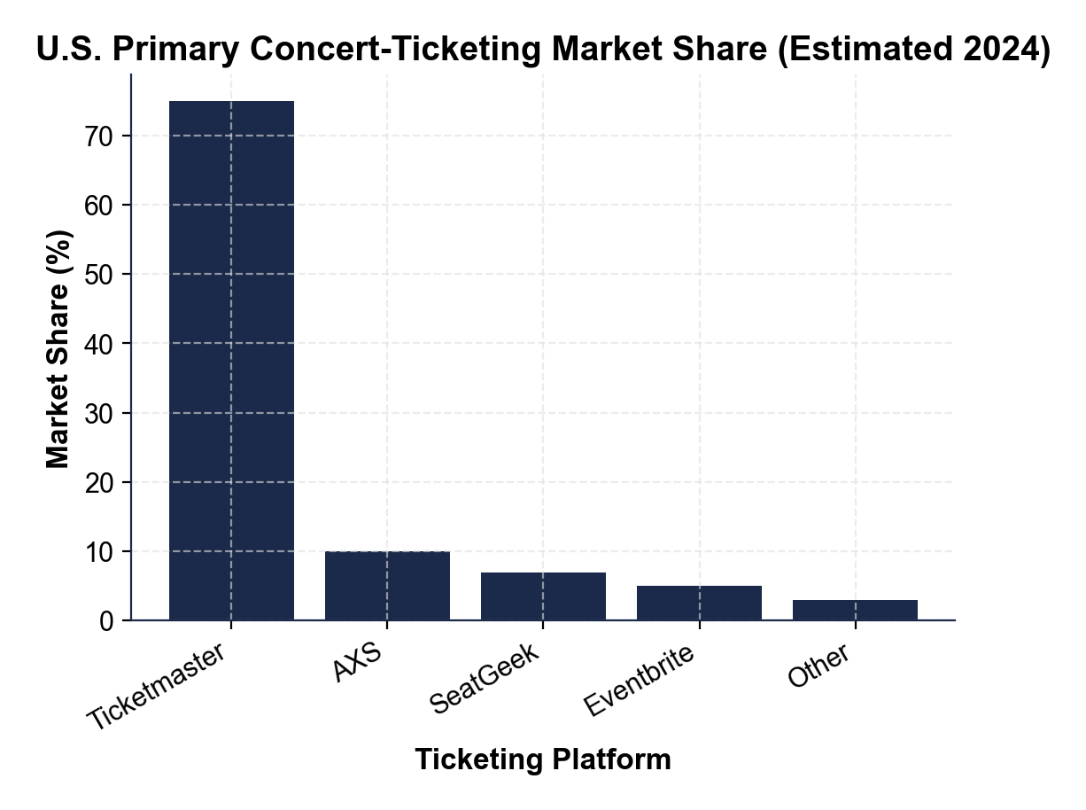

CHART REFERENCE 2: TYPICAL $100 CONCERT TICKET - FEE BREAKDOWN

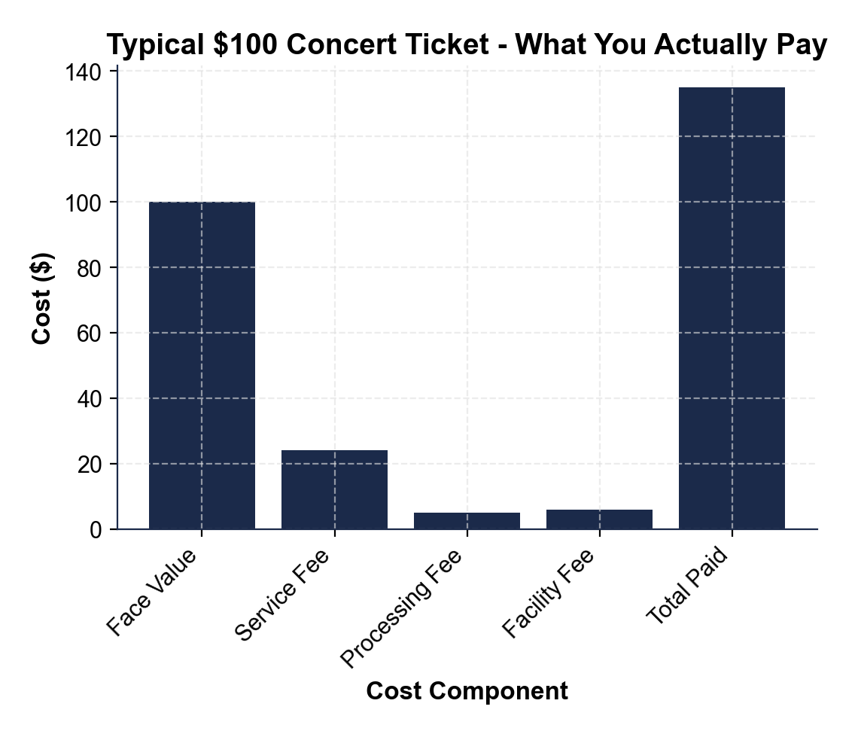

CHART REFERENCE 3: LIVE NATION ENTERTAINMENT - THE VERTICAL INTEGRATION STACK

