ECONOMICS

THE TICKETMASTER MONOPOLY INVESTIGATION
ANSWER KEY ACTIVITY

PART 1

Ticketmaster Investigation Reference Guide - Complete the Missing Terms

Term | Definition
Monopoly | A market structure with ONE seller, no close substitutes for the product, and high barriers preventing new firms from entering; the single firm is a price-maker with significant market power
Vertical integration | When ONE firm owns multiple stages of the same supply chain - Live Nation owns the concert promoter, the venues, the ticketing platform, and the artist management business under one roof
Tying | An anticompetitive practice where a firm conditions the sale of one product (a popular one) on the buyer also taking another product (a less competitive one) - illegal under Sherman Act Section 1 when the tying firm has market power
Foreclosure | When a vertically integrated firm uses its position in one market to BLOCK competitors from reaching customers in another market - e.g., a venue owner refusing to host any concert not ticketed by its own ticketing platform
Sherman Act | The 1890 federal antitrust statute that bans monopolization (Section 2) and contracts or conspiracies in restraint of trade (Section 1) - the principal law cited in the 2024 DOJ v. Live Nation-Ticketmaster complaint
Consent decree | A court-enforced settlement between the DOJ and a regulated company governing future conduct - the 2010 Live Nation-Ticketmaster merger was approved under a consent decree the DOJ now alleges was repeatedly violated
Venue exclusivity contract | A long-term contract between a venue and a ticketing platform requiring ALL tickets to be sold through that platform - the principal legal barrier to entry that locks competing ticketers out of major U.S. arenas
Market share | The percentage of total sales in a market controlled by one firm - the DOJ alleges Ticketmaster controls roughly 75% of the U.S. primary concert-ticketing market for major venues
Divestiture | An antitrust remedy that forces a firm to sell off PART of its business (a subsidiary, an asset, a contract portfolio) - the principal structural remedy the DOJ is reportedly seeking in the 2024 case
Service fee | A per-ticket charge added by the ticketing platform on top of the face value of a ticket (often $15-$40 per ticket) - the most visible consumer-facing cost of the Ticketmaster monopoly and a major component of Live Nation revenue

PART 2

Apply the Terms - Ticketmaster Monopoly Vocabulary in Context
WORD BANK Tying · Sherman Act · venue exclusivity contract · Divestiture · Monopoly
1. Marcus opens the case file with the core charge. A market structure with ONE dominant seller, no close substitutes for the product, and high barriers that keep new firms out - the structure the DOJ accuses Live Nation-Ticketmaster of holding - is called a Monopoly.
Monopoly. A market structure with ONE seller, no close substitutes, and high barriers to entry, in which the single firm is a price-maker; the DOJ filed under Sherman Act Section 2 alleging Live Nation-Ticketmaster holds one.
2. Marcus points to the central allegation about how Live Nation pressures venues. Conditioning the sale of one product the buyer wants (its major tours) on the buyer also taking a separate product (the Ticketmaster platform) is the anticompetitive practice known as Tying.
Tying. Conditioning the sale of a desired product on the buyer also taking a separate product; it is illegal under Sherman Act Section 1 when the tying firm has market power in the first product.
3. Marcus names the statute the whole case rests on. The 1890 federal antitrust law that bans monopolization in Section 2 and contracts in restraint of trade in Section 1 - the principal law cited in the 2024 complaint - is the Sherman Act.
Sherman Act
4. Marcus explains the single biggest barrier to entry in ticketing. The long-term contract that requires a venue to sell ALL of its tickets through one platform, locking competing ticketers out of major arenas, is a venue exclusivity contract.
venue exclusivity contract
5. Marcus closes with the remedy the DOJ is reportedly seeking. The structural antitrust remedy that forces a firm to sell off part of its business - here, forcing Live Nation to sell Ticketmaster as a stand-alone company - is called Divestiture.
Divestiture. The structural antitrust remedy that forces a firm to sell off part of its business; the DOJ is reportedly seeking divestiture of Ticketmaster from Live Nation.

PART 3

You Read the Three Investigation Charts with Marcus Holt
1. Use Chart Reference 1 (chart_ticketmaster_market_share) - the bar chart of U.S. primary concert-ticketing market share shown below - to identify Ticketmaster's dominance.
(a) Read Ticketmaster's market share off the chart.
TICKETMASTER MARKET SHARE: 75% (the tallest bar on the chart).
(b) Name the SECOND-largest competitor and read its share.
SECOND-LARGEST: AXS at 10%.
(c) Compute the ratio of Ticketmaster's share to the second-largest competitor (round to nearest whole number).
RATIO: 75 / 10 = roughly 7.5x - so Ticketmaster is about 7-8 times larger than its nearest competitor.
(d) In 1-2 sentences, explain why this share counts as monopoly-level concentration under antitrust law.
A 75% market share is monopoly-level by any standard antitrust threshold - U.S. courts have routinely treated 70%+ share as evidence of monopoly power under Sherman Section 2.
2. Use Chart Reference 2 (chart_ticket_fee_breakdown) - the bar chart showing how a $100 face-value concert ticket actually costs the consumer about $135 shown below - to compute Ticketmaster's monopoly markup.
(a) Read the FACE VALUE off the chart.
FACE VALUE: $100 (the artist-set price).
(b) Read each of the three fees (service, processing, facility) and sum them.
FEES: $24 service fee + $5 processing fee + $6 facility fee = $35 total fees.
(c) Read the TOTAL PAID off the chart.
TOTAL PAID: $135.
(d) Compute the FEE MARKUP as a percent of face value.
FEE MARKUP: $35 / $100 = 35% markup on top of face value.
(e) Identify which single fee is the largest and explain why that fee is the clearest evidence of monopoly pricing power.
LARGEST FEE: the SERVICE FEE ($24), which is roughly 24% of face value all by itself. The service fee is the clearest evidence of monopoly pricing power because it is set by Ticketmaster (not the artist or the venue), it has no competitive pressure to lower it (the venue is locked into Ticketmaster by exclusivity contract), and the consumer cannot avoid it (no rival ticketing platform serves the venue). In a competitive ticketing market, service fees would have to be much lower to win venue contracts.

3. Use Chart Reference 3 (chart_vertical_integration_stack) - the bar chart showing Live Nation's market share across four connected businesses shown below - to evaluate the vertical integration allegation.
(a) Read the market share or scale figure for each of the four Live Nation businesses (concert promotion, venue ownership/management, ticketing, artist management).
FOUR BUSINESS SHARES: Concert Promotion ~70% of major U.S. tours; Venue Ownership/Management ~60% of top 100 amphitheaters; Ticketing ~75% of primary major-venue concert ticketing; Artist Management ~35% (representative figure).
(b) Identify which business has the highest single share.
HIGHEST SINGLE SHARE: TICKETING at ~75%.
(c) In 1-2 sentences, explain why vertical integration MULTIPLIES market power even when no single business is at 100%.
Vertical integration MULTIPLIES market power because each business reinforces the others. Even without 100% share in any single business, when a firm controls 60-75% of FOUR connected stages of the same supply chain, the cumulative effect is monopoly power across the entire concert ecosystem - and rival firms in any…
(d) Name one specific way Live Nation's ownership of business X reinforces its dominance in business Y - use any pair of the four businesses.
Sample answers (accept any defensible pair): (1) Owning venues (Business 2) reinforces Ticketing (Business 3) because Live Nation venues require Ticketmaster, foreclosing rival ticketers. (2) Owning the concert promoter (Business 1) reinforces venues (Business 2) because Live Nation routes its major tours to Live Nation venues, filling those venues. (3) Owning artist management (Business 4) reinforces concert promotion (Business 1) because Live Nation-managed artists are pushed into Live Nation-promoted tours.

PART 4

Four Real Scenarios with Marcus Holt - Apply the Model
1. THE TYING ALLEGATION - WALK THROUGH A SPECIFIC VENUE. Marcus shows you a hypothetical (but representative) scenario: a mid-sized amphitheater in Texas considers switching from Ticketmaster to a startup ticketer that has lower fees. Three weeks later, Live Nation reportedly tells the venue: "if you drop Ticketmaster, we will pull our major tours from your venue this season."
(a) Identify the SPECIFIC anticompetitive practice being described (tying, foreclosure, predatory pricing, or price discrimination).
PRACTICE: TYING (alternatively, this could be characterized as exclusive dealing - but the DOJ complaint frames it as tying because Live Nation is conditioning concert access on Ticketmaster use).
(b) Identify which Sherman Act SECTION (1 or 2) this violates.
SHERMAN ACT SECTION: Section 1 (contracts in restraint of trade). Tying is illegal under Section 1 when the tying firm has market power - which Live Nation does in concert promotion (~70%).
(c) In 2-3 sentences, explain WHY this is illegal even though Live Nation has the right to choose where its tours play.
Live Nation absolutely has the right to choose where its tours play. What it does NOT have the right to do is condition that choice on the venue using Ticketmaster - that is TYING the sale of one product (concerts, which the venue wants) to the purchase of another (Ticketmaster's platform).
2. THE STARTUP COMPETITOR - WHAT WOULD A NEW TICKETING PLATFORM FACE? Suppose you are the founder of a startup ticketing platform with software that is 30% cheaper than Ticketmaster and offers better consumer features.
(a) Name the THREE specific barriers to entry covered in the Feature 3 lesson section that your startup would face.
(b) Of those three, which barrier is the SINGLE biggest obstacle and why?
(c) Apply the term FORECLOSURE to your situation - in 1-2 sentences.
(d) What would the DOJ need to do (as a remedy) to actually open the market for your startup to compete?
(a) THREE BARRIERS (from the Feature 3 lesson section): (1) VENUE EXCLUSIVITY CONTRACTS - major arenas are signed to Ticketmaster for 5-10 years. (2) INSTALLED SOFTWARE at every major arena (switching costs). (3) NETWORK EFFECTS - artists want venues with the most buyers, venues want platforms with the most artists. (b) SINGLE BIGGEST: VENUE EXCLUSIVITY CONTRACTS. Even with 30% cheaper software, the startup cannot reach customers because the venues are legally locked into Ticketmaster - the contract forbids the venue from using any other platform. Network effects matter but are secondary; the exclusivity contract is the binding constraint. (c) FORECLOSURE: The startup is FORECLOSED from the primary major-venue concert ticketing market because Live Nation's venue exclusivity contracts BLOCK the startup from reaching customers - even though the startup has a better product, no major arena can use it during the contract period. (d) The DOJ would need either (a) a structural remedy (DIVESTITURE - force Live Nation to sell Ticketmaster so it is no longer paired with venue ownership), or (b) a conduct remedy (ban venue exclusivity contracts longer than 1-2 years). The structural remedy is stickier; the conduct remedy is easier to win.
3. WHAT WOULD DIVESTITURE ACTUALLY DO? Suppose the DOJ wins the 2024 case and the court orders Live Nation to DIVEST Ticketmaster (sell it off as a separate company).
(a) Name the FOUR Live Nation businesses BEFORE divestiture (from Chart 3).
BEFORE: (1) Concert Promotion ~70%, (2) Venue Ownership/Management ~60%, (3) Ticketing ~75%, (4) Artist Management.
(b) Name which TWO businesses would be SEPARATED by the divestiture and which TWO would still be combined.
SEPARATED: Ticketing (3) would be split off. STILL COMBINED: Live Nation would keep Concert Promotion (1), Venues (2), and Artist Management (4) - a still-large but less integrated firm.
(c) In 2-3 sentences, explain why divestiture would weaken the foreclosure mechanism even though Ticketmaster (now independent) would still be a large firm.
Divestiture weakens FORECLOSURE because the venue-exclusivity-to-Ticketmaster contracts lose their underlying mechanism: Live Nation venues would no longer have a financial incentive to require Ticketmaster (since Ticketmaster is no longer a Live Nation subsidiary).
(d) Predict ONE specific way ticket fees might change after divestiture - and ONE reason fees might NOT change.
FEES MIGHT FALL: in a more competitive ticketing market, fees would have to drop for platforms to win venue contracts. FEES MIGHT NOT CHANGE MUCH: if Ticketmaster retains its installed software base, network effects, and brand, it could remain dominant in the now-competitive market - structural remedy without behavioral fix may not lower consumer fees fast.
4. POST-MORTEM ON THE 2022 ERAS TOUR MELTDOWN. In November 2022, the Taylor Swift Eras Tour ticket sale on Ticketmaster collapsed - massive demand, site crashes, fans waiting hours in queues, fees doubling final prices. Critics argued this was monopoly failure; Live Nation argued it was unprecedented demand. Apply the model:
(a) Which feature of monopoly (1-4) was MOST visibly demonstrated by the meltdown?
FEATURE MOST VISIBLE: Feature 4 (PRICE-MAKER). The fee structure during the meltdown was set by Ticketmaster with no competitive pressure - fans had no alternative platform to switch to mid-sale.
(b) Argue the OTHER side - in what way could Live Nation be RIGHT that this was just unprecedented demand, not monopoly failure?
LIVE NATION'S DEFENSE (steel-man it): even a competitive market with multiple ticketing platforms would have collapsed under that level of demand for a single artist - the issue was bot traffic + 50x oversubscription, not monopoly power.
(c) In 2-3 sentences, explain how the meltdown moved the political needle toward the 2024 DOJ suit.
The 2022 meltdown moved the political needle by making monopoly pricing visible to millions of consumers simultaneously. Senate hearings followed.
(d) Pick whether you think the meltdown SUPPORTS or WEAKENS the DOJ case and give one substantive reason.
SUPPORTS (most common answer): the meltdown demonstrated that consumers have no alternative when Ticketmaster fails - that IS monopoly. Even if demand was unprecedented, a competitive market would have spread the load across rival platforms.

PART 5

Your Final Investigation Memo to Marcus Holt
INVESTIGATION RECOMMENDATION MEMO
1. YOUR FINAL INVESTIGATION MEMO.
Marcus closes the internship and hands you the case file. The lead prosecutor will read your recommendation before deciding which remedy to seek: structural DIVESTITURE (force Live Nation to sell Ticketmaster), CONDUCT RULES (ban exclusivity contracts and retaliation but leave the company intact), or DISMISS (drop the suit and let the market work itself out). Write a 6-8 sentence memo to Marcus that uses all four required terms - MONOPOLY, VERTICAL INTEGRATION, FORECLOSURE, and DIVESTITURE - at least once each and addresses every required element listed below. **Based on the case file you built together, which remedy should the DOJ seek, and why?**
YOUR RESPONSE MUST:
☐ Names a SPECIFIC RECOMMENDATION (DIVESTITURE / CONDUCT RULES / DISMISS) AND ties it to the MONOPOLY model from TK 22.
☐ Uses the term VERTICAL INTEGRATION correctly - explains how Live Nation owning four businesses (concert promotion + venues + ticketing + artist management) creates the foreclosure mechanism.
☐ Uses the term FORECLOSURE correctly - identifies which specific market is foreclosed (typically primary ticketing) AND by what mechanism (venue exclusivity contracts).
☐ Uses the term DIVESTITURE correctly - either recommends it (and explains what gets sold off) OR explains why a different remedy is better.
☐ Quotes at least ONE specific value from the chart appendix (Ticketmaster ~75% market share, the $35 fee markup or 35%, the four business-share figures from Chart 3 - 70%/60%/75%/35%, or another specific number) to ground the recommendation in real data.
☐ Closes with a SPECIFIC PROCEDURAL NEXT STEP the Antitrust Division should take in the next 6 months (e.g., subpoena specific venue exclusivity contracts, depose specific Live Nation executives, file a Daubert motion challenging the defense's market-definition expert, file a motion to certify the case for trial).
MEMO
To: Marcus Holt, Senior Antitrust Investigator
From: [student completes]
Date: [student completes]
Re: Recommendation on DOJ v. Live Nation-Ticketmaster remedy
GRADING RUBRIC
Grade the evidence and reasoning, not the conclusion — any defensible position is valid. Score against the 6 requirements above.
FULL CREDIT — clear position; meets all 6 requirements with accurate, specific numbers and evidence from the lesson.
PARTIAL — position stated, but misses 1-2 requirements or uses vague / incorrect numbers.
MINIMAL — no clear position, or missing most requirements and numbers.
WHAT TO LOOK FOR IN THIS LESSON
Graded by the six required elements above plus correct use of the four required terms. A full-credit DIVESTITURE memo: recommends structural DIVESTITURE because the 2010 consent decree's conduct rules already failed and the underlying VERTICAL INTEGRATION (concert promotion ~70%, venues ~60%, ticketing ~75%, artist management ~35%) keeps driving the same FORECLOSURE; states Live Nation-Ticketmaster meets all four features of MONOPOLY; cites at least one chart value (Ticketmaster ~75% share, the $35 / 35% fee markup, or the four business-share figures); identifies primary ticketing as the foreclosed market and venue exclusivity contracts as the mechanism; and closes with one concrete next step in the next 6 months (subpoena the top venue exclusivity contracts, depose Live Nation routing executives, or file a motion to certify for trial). ACCEPTABLE ALTERNATES: a CONDUCT-RULES memo (defensible if it acknowledges the 2010 decree failure and proposes stronger enforcement) or a DISMISS memo (harder to defend given the $35 fee markup). The recommendation itself can vary as long as the four terms are used correctly and all six elements are present.

CHART REFERENCE 1: TICKETMASTER'S SHARE OF U.S. PRIMARY CONCERT TICKETING (2024)

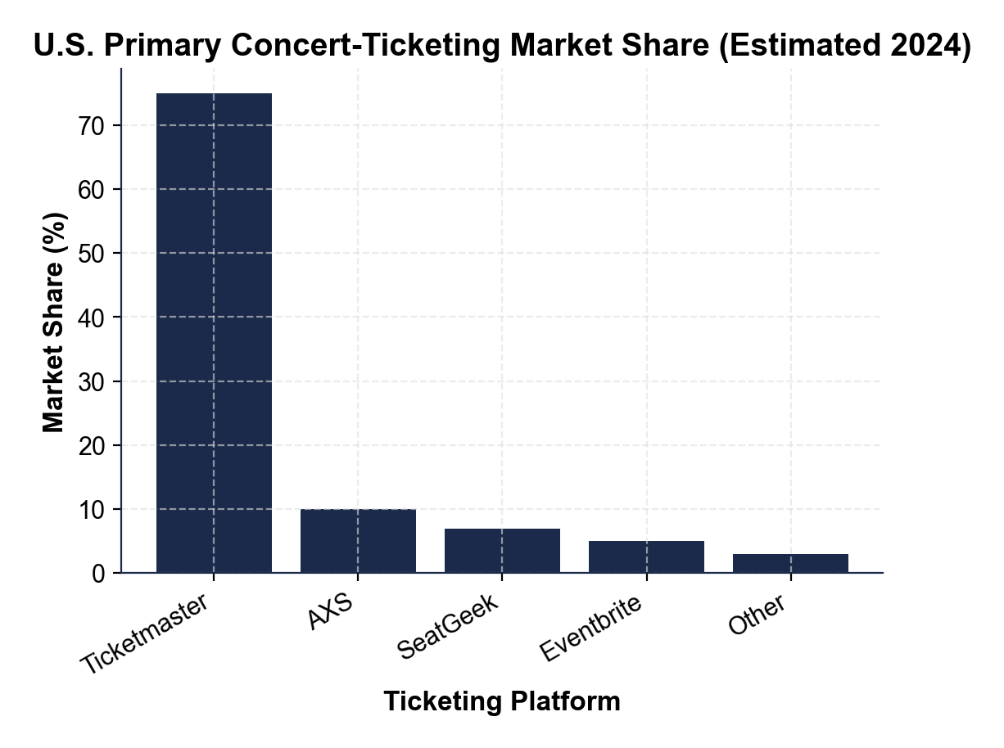

CHART REFERENCE 2: TYPICAL $100 CONCERT TICKET - FEE BREAKDOWN

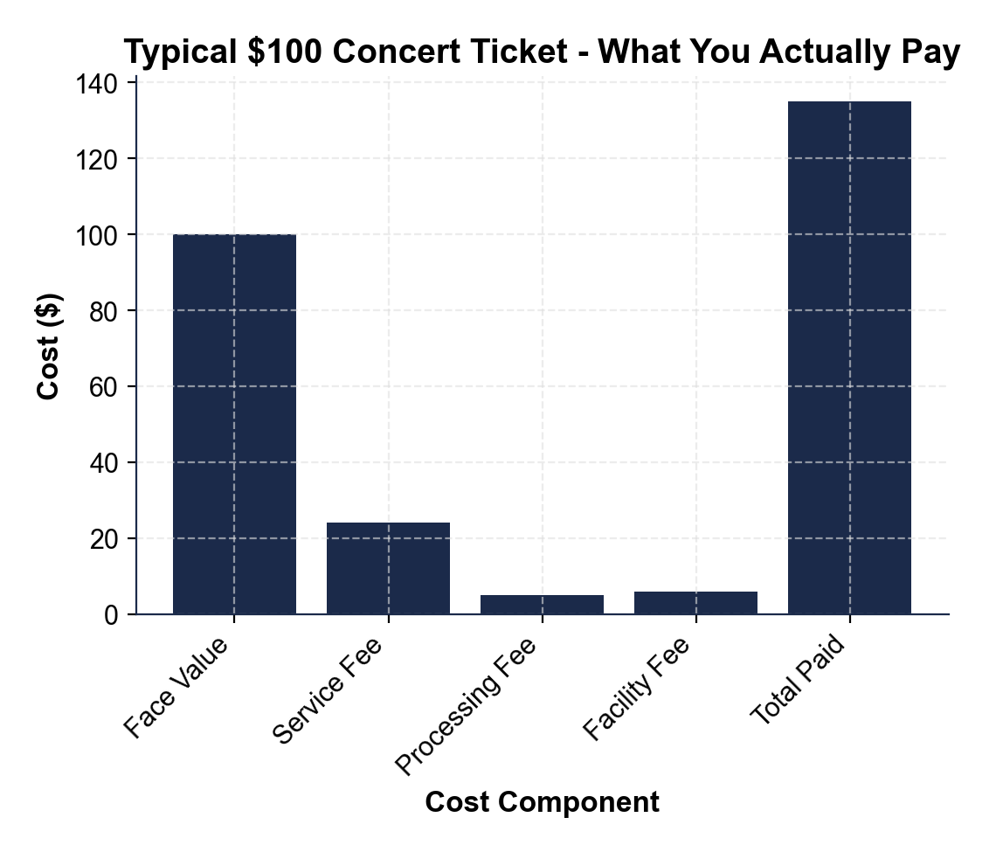

CHART REFERENCE 3: LIVE NATION ENTERTAINMENT - THE VERTICAL INTEGRATION STACK

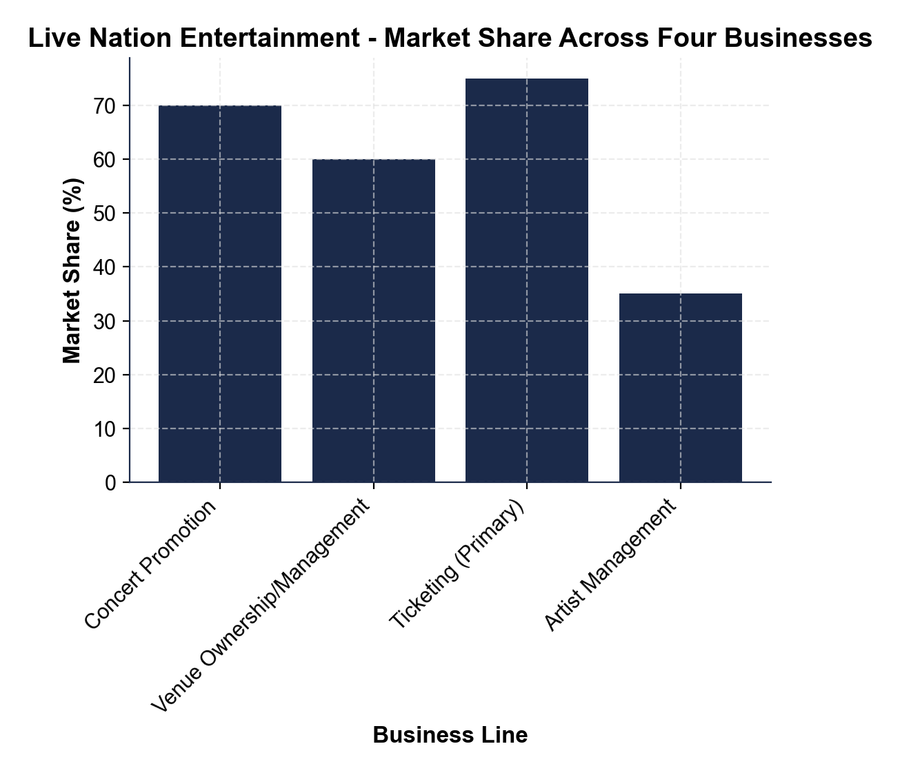
MORE LESSONS LESS PLANNING
Thank You!
If you enjoyed this product, please do not forget to rate and review to assist other teachers.

Looking for future discounts? Earn TPT credits by reviewing purchased products.

Please contact me if you have any issues with this product. Just like our students, I am always looking for opportunities to grow.

