The Stock Market: How It Works & Why It Moves
STUDENT ACTIVITY
Name: | Date: | Period:
ESSENTIAL QUESTION
How does the stock market work as a system - exchanges matching buyers and sellers, supply and demand setting prices, and market indexes tracking the whole market - why do prices move on news and earnings, how does percent change size a move and define bull vs bear markets, and why does staying invested (time in the market) beat panic-selling when the market drops?
THE SCENARIO
You are helping JORDAN REYES, who is 17 and learning to read the stock market for the first time. The STOCK MARKET is the whole system of exchanges, buyers, and sellers where shares of public companies are bought and sold.
BY THE END, YOU CAN:
✓ Explain how stock exchanges (like the NYSE and Nasdaq) work to match buyers and sellers
✓ Explain how supply and demand set stock prices and why prices move on news and earnings
✓ Describe what a market index (like the S&P 500 or the Dow) measures and how bull and bear markets differ
✓ Use percent change ((new - old) / old) x 100 to size a market move, and explain why a long-term investor stays calm when the market drops
HOW IT WORKS (do Parts 1–5 in order)
Part 1 — Stock Market Reference Guide - Complete the Missing Terms
Part 2 — Apply the Terms - Stock Market Vocabulary in Context
Part 3 — Read the Chart - A Broad Market Index Over 25 Years: Bull Runs and Bear Dips
Part 4 — Why Prices Move - Supply and Demand and Percent Change
Part 5 — Bull vs Bear - Make Your Stay-Calm Recommendation
TIME about 45 minutes YOU’LL NEED the lesson slides and your Guided Notes.

PART 1

Stock Market Reference Guide - Complete the Missing Terms
Fill in the missing term for each blank row — the definition is your clue. Your Guided Notes and the lesson slides have every term.

Term | Definition
___________ | The whole system of exchanges, buyers, and sellers where shares of public companies are bought and sold
Stock exchange | An organized marketplace (like the NYSE or Nasdaq) that matches buyers and sellers and lists the price of each trade
___________ | The forces that set a stock's price: more buyers than sellers pushes the price up, more sellers than buyers pushes it down
Market price | The price of the most recent trade, the amount a buyer and seller just agreed on for a share
___________ | A single number that tracks a basket of stocks (like the S&P 500 or the Dow) so you can see how the whole market moved
Earnings | A company's profits; earnings are the biggest regular mover of a stock's price
___________ | How much a price or index moved, figured as ((new value minus old value) divided by old value) times 100
Bull market | A sustained rise in stock prices, about 20% or more off a low, when investors are optimistic
___________ | A sustained fall in stock prices, about 20% or more off a high, when investors are fearful
Time in the market | The idea that staying invested through the ups and downs beats trying to time when to buy and sell

PART 2

Apply the Terms - Stock Market Vocabulary in Context
WORD BANK market index · bear market · stock market · percent change · supply and demand
1. Q1. The whole system of exchanges, buyers, and sellers where shares of public companies are bought and sold is called the .

2. Q2. The forces that set a stock's price - more buyers than sellers push it up, more sellers than buyers push it down - are .

3. Q3. A single number that tracks a basket of stocks, like the S&P 500 or the Dow, so you can see how the whole market moved is a .

4. Q4. The calculation ((new value - old value) / old value) x 100, used to size how far a price or index moved, is the .

5. Q5. A sustained fall in prices of about 20% or more off a high, when investors are fearful and selling, is called a .

PART 3

Read the Chart - A Broad Market Index Over 25 Years: Bull Runs and Bear Dips
1. As you help Jordan Reyes, study the line chart on this page titled "A Broad Market Index Over 25 Years: Bull Runs and Bear Dips." The line tracks one broad market index (500 big U.S. companies) from 2000 to 2025. Read the chart and write:
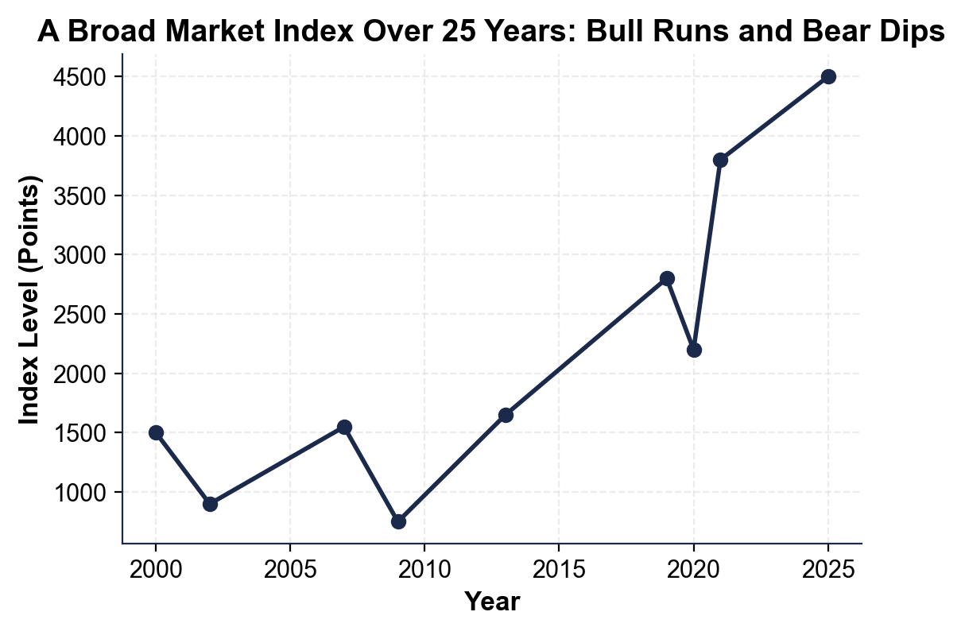
(a) the index level at the very start (2000)

(b) the index level at the very end (2025).

2. As you help Jordan Reyes, use the same chart to find the three big DROPS (bear dips) where the line falls sharply. Read and write the LOW point of each:
(a) the 2002 low

(b) the 2009 low

(c) the 2020 dip.

3. As you help Jordan Reyes, look at what happens AFTER each big drop.
(a) After the 2009 low of about 750, does the line go up or down over the next few years, and roughly what new high does it reach by 2013?

(b) In one sentence, what pattern do you see every time the index crashes?

4. As you help Jordan Reyes, look at the overall pattern. In one or two sentences, explain what the chart shows about the market over 25 years. Start your answer with: "The chart shows that..."

PART 4

Why Prices Move - Supply and Demand and Percent Change
1. As you help Jordan Reyes, explain how SUPPLY AND DEMAND set a price. A company reports great earnings and suddenly many more people want to buy its stock than sell it.
(a) Is there more demand or more supply now?

(b) Which way does the price move - up or down?

(c) Why does the price move that way?

2. As you help Jordan Reyes, use the labeled model PERCENT CHANGE = ((new value - old value) / old value) x 100 on a single stock. A stock is $50.00 before an earnings report and jumps to $58.00 the next day.
(a) Write the formula with the numbers filled in.

(b) Work it out to a percent.

(c) Is this a gain or a drop? Show your math.

3. As you help Jordan Reyes, use the SAME percent-change formula on the chart's deepest crash. The index went from a high of about 1550 in 2007 to a low of about 750 in 2009.
(a) Write the formula with these numbers.

(b) Work it out to a percent (round to one decimal).

(c) A fall of about 20% or more off a high is a bear market - was this a bear market? Show your math.

4. As you help Jordan Reyes, use percent change on the FAST 2020 crash and the whole 25-year run.
(a) The index fell from about 2800 in 2019 to about 2200 in 2020 - what is the percent change (round to one decimal), and was it a bear market?

(b) Over the whole run the index went from about 1500 (2000) to about 4500 (2025) - what is the percent change? Show your math.

5. As you help Jordan Reyes, put your numbers together. From your earlier answers, the index dropped to 900 in 2002, to 750 in 2009, and to 2200 in 2020, then rose from 1500 to 4500 overall.
(a) How many big bear-market crashes did the index have in the 25 years?

(b) Despite those crashes, did the index end higher or lower than it started, and by what percent?

(c) In one sentence, what does that tell a long-term investor?

PART 5

Bull vs Bear - Make Your Stay-Calm Recommendation
1. As you help Jordan Reyes, explain the two big phases.
(a) What is a BULL market (describe it and give the rough percent)?

(b) What is a BEAR market (describe it and give the rough percent)?

(c) How do we use percent change to tell which one the market is in?

2. As you help Jordan Reyes, think about why the market recovers.
(a) Using the chart, what happened to the index after each of its three big crashes?

(b) Why does that make panic-SELLING during a drop a mistake for a long-term investor?

(c) What does TIME IN THE MARKET mean, and why does it beat trying to time the drops?

3. As you help Jordan Reyes, give practical advice. Jordan's index just fell into a bear market and the account is down.
(a) What should Jordan do - sell, or stay invested - and why?

(b) If Jordan is still adding money each month, how can a bear market actually be an opportunity?

(c) Name one thing Jordan should NOT do during the drop.

FINAL RECOMMENDATION
4. FINAL RECOMMENDATION. Jordan asks you to put it in writing. Write a 5-7 sentence note (120-180 words) telling Jordan how the stock market works, why prices move, and why a long-term investor should stay calm when the market drops. Check off each required element as you include it.
YOUR RESPONSE MUST:
☐ DEFINE THE MARKET AND EXCHANGES - state in your own words that the stock market is the system where shares are bought and sold, and that exchanges (the NYSE or Nasdaq) match buyers and sellers.
☐ EXPLAIN WHY PRICES MOVE - explain that supply and demand set prices (more buyers push up, more sellers push down) and that news and earnings move them.
☐ USE A CALCULATED RESULT - state a percent change you calculated yourself in Part 4 (for example, the +16.0% earnings jump, the -51.6% 2009 crash, the -21.4% 2020 dip, or the +200.0% whole-run gain).
☐ DEFINE BULL AND BEAR - explain that a bull market is a sustained rise (about +20% off a low) and a bear market is a sustained fall (about -20% off a high).
☐ GIVE STAY-CALM ADVICE - tell Jordan to stay invested (time in the market) because the market has recovered from every past drop, and name one thing to avoid, such as panic-selling.

