PERSONAL FINANCE

THE STOCK MARKET: HOW IT WORKS & WHY IT MOVES
ANSWER KEY ACTIVITY - ANSWER KEY

PART 1

Stock Market Reference Guide - Complete the Missing Terms

Term | Definition
Stock market | The whole system of exchanges, buyers, and sellers where shares of public companies are bought and sold
Stock exchange | An organized marketplace (like the NYSE or Nasdaq) that matches buyers and sellers and lists the price of each trade
Supply and demand | The forces that set a stock's price: more buyers than sellers pushes the price up, more sellers than buyers pushes it down
Market price | The price of the most recent trade, the amount a buyer and seller just agreed on for a share
Market index | A single number that tracks a basket of stocks (like the S&P 500 or the Dow) so you can see how the whole market moved
Earnings | A company's profits; earnings are the biggest regular mover of a stock's price
Percent change | How much a price or index moved, figured as ((new value minus old value) divided by old value) times 100
Bull market | A sustained rise in stock prices, about 20% or more off a low, when investors are optimistic
Bear market | A sustained fall in stock prices, about 20% or more off a high, when investors are fearful
Time in the market | The idea that staying invested through the ups and downs beats trying to time when to buy and sell

PART 2

Apply the Terms - Stock Market Vocabulary in Context
WORD BANK market index · bear market · stock market · percent change · supply and demand
1. Q1. The whole system of exchanges, buyers, and sellers where shares of public companies are bought and sold is called the Stock market.
Stock market
2. Q2. The forces that set a stock's price - more buyers than sellers push it up, more sellers than buyers push it down - are supply and demand.
supply and demand
3. Q3. A single number that tracks a basket of stocks, like the S&P 500 or the Dow, so you can see how the whole market moved is a market index.
market index
4. Q4. The calculation ((new value - old value) / old value) x 100, used to size how far a price or index moved, is the percent change.
percent change
5. Q5. A sustained fall in prices of about 20% or more off a high, when investors are fearful and selling, is called a bear market.
bear market

PART 3

Read the Chart - A Broad Market Index Over 25 Years: Bull Runs and Bear Dips
1. As you help Jordan Reyes, study the line chart on this page titled "A Broad Market Index Over 25 Years: Bull Runs and Bear Dips." The line tracks one broad market index (500 big U.S. companies) from 2000 to 2025. Read the chart and write:
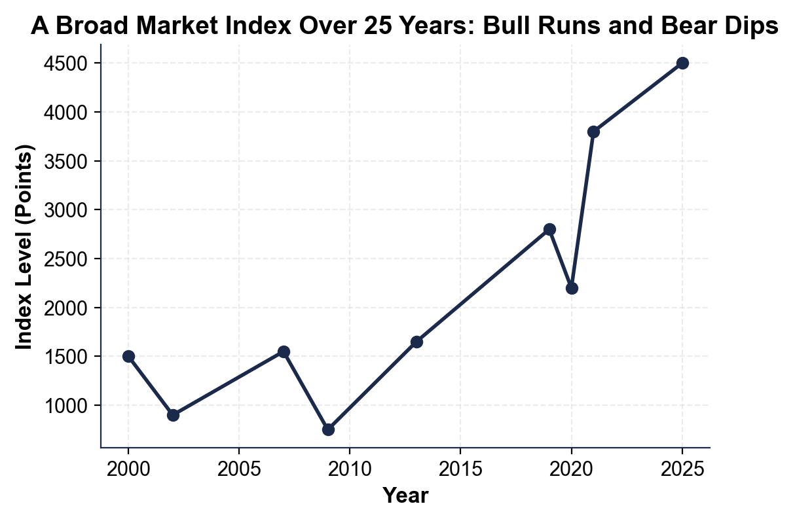
(a) the index level at the very start (2000)
(b) the index level at the very end (2025).
(1) At the start in 2000 the index is about 1500. (2) At the end in 2025 the index is about 4500. Accept 1500 at 2000 and 4500 at 2025.
2. As you help Jordan Reyes, use the same chart to find the three big DROPS (bear dips) where the line falls sharply. Read and write the LOW point of each:
(a) the 2002 low
(b) the 2009 low
(c) the 2020 dip.
(1) The 2002 low (the dot-com bust) is about 900. (2) The 2009 low (the financial crisis) is about 750 - the deepest dip on the chart. (3) The 2020 dip (COVID) is about 2200. Accept about 900, about 750, and about 2200.
3. As you help Jordan Reyes, look at what happens AFTER each big drop.
(a) After the 2009 low of about 750, does the line go up or down over the next few years, and roughly what new high does it reach by 2013?
(b) In one sentence, what pattern do you see every time the index crashes?
(1) After the 2009 low the line goes UP, recovering to a new high of about 1650 by 2013 (and then far higher after that). (2) The pattern is that every time the index crashes it later recovers and climbs back to a NEW high - the drops are temporary and the long-run direction is up. Accept up to about 1650 by 2013, and any answer that says the index recovers to new highs after each crash.
4. As you help Jordan Reyes, look at the overall pattern. In one or two sentences, explain what the chart shows about the market over 25 years. Start your answer with: "The chart shows that..."
The chart shows that the broad market index rose a lot over 25 years - from about 1500 to about 4500 - even though it crashed hard three times (in 2002, 2009, and 2020).

PART 4

Why Prices Move - Supply and Demand and Percent Change
1. As you help Jordan Reyes, explain how SUPPLY AND DEMAND set a price. A company reports great earnings and suddenly many more people want to buy its stock than sell it.
(a) Is there more demand or more supply now?
(b) Which way does the price move - up or down?
(c) Why does the price move that way?
(1) There is more DEMAND (more buyers than sellers). (2) The price moves UP. (3) Because when more people want to buy than sell, buyers compete and bid the price up until a seller agrees - more demand than supply pushes the price up. Accept: more demand, price up, because buyers outnumber sellers and bid the price up.
2. As you help Jordan Reyes, use the labeled model PERCENT CHANGE = ((new value - old value) / old value) x 100 on a single stock. A stock is $50.00 before an earnings report and jumps to $58.00 the next day.
(a) Write the formula with the numbers filled in.
(b) Work it out to a percent.
(c) Is this a gain or a drop? Show your math.
(1) PERCENT CHANGE = ((58 - 50) / 50) x 100. (2) = (8 / 50) x 100 = 0.16 x 100 = +16.0%. (3) It is a GAIN (the percent change is positive). Accept the filled-in formula, +16.0%, and a gain.
3. As you help Jordan Reyes, use the SAME percent-change formula on the chart's deepest crash. The index went from a high of about 1550 in 2007 to a low of about 750 in 2009.
(a) Write the formula with these numbers.
(b) Work it out to a percent (round to one decimal).
(c) A fall of about 20% or more off a high is a bear market - was this a bear market? Show your math.
(1) PERCENT CHANGE = ((750 - 1550) / 1550) x 100. (2) = (-800 / 1550) x 100 = -51.6% (rounded to one decimal). (3) YES - a fall of about 51.6% is far more than 20%, so this was a deep BEAR market. Accept the filled-in formula, about -51.6%, and yes it is a bear market.
4. As you help Jordan Reyes, use percent change on the FAST 2020 crash and the whole 25-year run.
(a) The index fell from about 2800 in 2019 to about 2200 in 2020 - what is the percent change (round to one decimal), and was it a bear market?
(b) Over the whole run the index went from about 1500 (2000) to about 4500 (2025) - what is the percent change? Show your math.
(1) 2020 crash: ((2200 - 2800) / 2800) x 100 = (-600 / 2800) x 100 = -21.4%. A fall of about 21.4% is more than 20%, so YES it was a (fast) bear market. (2) Whole run: ((4500 - 1500) / 1500) x 100 = (3000 / 1500) x 100 = +200.0%. Accept about -21.4% (a bear market) for the 2020 crash and +200.0% for the whole 25-year run.
5. As you help Jordan Reyes, put your numbers together. From your earlier answers, the index dropped to 900 in 2002, to 750 in 2009, and to 2200 in 2020, then rose from 1500 to 4500 overall.
(a) How many big bear-market crashes did the index have in the 25 years?
(b) Despite those crashes, did the index end higher or lower than it started, and by what percent?
(c) In one sentence, what does that tell a long-term investor?
(1) Three big bear-market crashes (the 2002 dot-com low of 900, the 2009 low of 750, and the 2020 dip to 2200). (2) It ended much HIGHER - the index climbed from 1500 to 4500, up +200.0% overall. (3) It tells a long-term investor that crashes are temporary and the market has recovered from every one, so staying invested through the drops (time in the market) beats panic-selling. Accept three crashes, up 200% (1500 to 4500), and any answer that says the market recovers so staying invested beats selling.

PART 5

Bull vs Bear - Make Your Stay-Calm Recommendation
1. As you help Jordan Reyes, explain the two big phases.
(a) What is a BULL market (describe it and give the rough percent)?
A BULL market is a sustained RISE in prices - about +20% or more off a recent low - when investors are optimistic and buying.
(b) What is a BEAR market (describe it and give the rough percent)?
A BEAR market is a sustained FALL in prices - about -20% or more off a recent high - when investors are fearful and selling.
(c) How do we use percent change to tell which one the market is in?
We take the percent change off the recent high or low: a fall of about 20% or more from a high is a bear market, and a rise of about 20% or more off a low is a bull market.
2. As you help Jordan Reyes, think about why the market recovers.
(a) Using the chart, what happened to the index after each of its three big crashes?
After each of the three crashes (2002, 2009, 2020) the index recovered and climbed to a NEW high - it went from about 1500 to about 4500 over the 25 years despite the crashes.
(b) Why does that make panic-SELLING during a drop a mistake for a long-term investor?
Panic-selling during a drop turns a paper loss into a real, locked-in loss and usually misses the fast recovery that follows a bear market, so the investor sells low and misses the rebound.
(c) What does TIME IN THE MARKET mean, and why does it beat trying to time the drops?
TIME IN THE MARKET means staying invested through the ups and downs; it beats trying to time the drops because no one can reliably guess when the market will fall and recover, and the biggest gains often come right after the bottom.
3. As you help Jordan Reyes, give practical advice. Jordan's index just fell into a bear market and the account is down.
(a) What should Jordan do - sell, or stay invested - and why?
Jordan should STAY INVESTED (not sell), because the market has recovered from every past drop and selling would lock in the loss and miss the recovery.
(b) If Jordan is still adding money each month, how can a bear market actually be an opportunity?
If Jordan is still adding money, a bear market is like a sale - lower prices mean buying more shares cheaply that grow when the market recovers.
(c) Name one thing Jordan should NOT do during the drop.
Accept any sound answer: do NOT panic-sell, do NOT try to time the exact bottom, do NOT stop contributing out of fear, do NOT check the account obsessively and react to every dip.
FINAL RECOMMENDATION
4. FINAL RECOMMENDATION. Jordan asks you to put it in writing. Write a 5-7 sentence note (120-180 words) telling Jordan how the stock market works, why prices move, and why a long-term investor should stay calm when the market drops. Check off each required element as you include it.
YOUR RESPONSE MUST:
☐ DEFINE THE MARKET AND EXCHANGES - state in your own words that the stock market is the system where shares are bought and sold, and that exchanges (the NYSE or Nasdaq) match buyers and sellers.
☐ EXPLAIN WHY PRICES MOVE - explain that supply and demand set prices (more buyers push up, more sellers push down) and that news and earnings move them.
☐ USE A CALCULATED RESULT - state a percent change you calculated yourself in Part 4 (for example, the +16.0% earnings jump, the -51.6% 2009 crash, the -21.4% 2020 dip, or the +200.0% whole-run gain).
☐ DEFINE BULL AND BEAR - explain that a bull market is a sustained rise (about +20% off a low) and a bear market is a sustained fall (about -20% off a high).
☐ GIVE STAY-CALM ADVICE - tell Jordan to stay invested (time in the market) because the market has recovered from every past drop, and name one thing to avoid, such as panic-selling.
GRADING RUBRIC
Grade the evidence and reasoning, not the conclusion — any defensible position is valid. Score against the 5 requirements above.
FULL CREDIT — clear position; meets all 5 requirements with accurate, specific numbers and evidence from the lesson.
PARTIAL — position stated, but misses 1-2 requirements or uses vague / incorrect numbers.
MINIMAL — no clear position, or missing most requirements and numbers.

MORE LESSONS LESS PLANNING
Thank You!
If you enjoyed this product, please do not forget to rate and review to assist other teachers.

Looking for future discounts? Earn TPT credits by reviewing purchased products.

Please contact me if you have any issues with this product. Just like our students, I am always looking for opportunities to grow.

