ECONOMICS

THE DUAL MANDATE: JOBS VS PRICES
ANSWER KEY GUIDED NOTES

LEARNING TARGETS
1. State the Fed's dual mandate (maximum employment + stable prices) and explain its statutory origin
2. Explain the Phillips curve - the short-run inflation/unemployment trade-off - and why it broke down in the 1970s
3. Evaluate Fed decisions when jobs and inflation pull in opposite directions, including the 2022 hike cycle

SECTION 1

The Dual Mandate - Maximum Employment + Stable Prices
Mandate 1: Maximum Employment
Maximum employment = the lowest unemployment rate consistent with stable prices.
It is NOT zero unemployment - workers are always between jobs.
The Fed estimates the natural rate (u*) at about 4.0 - 4.5%.
Unemployment BELOW u* pushes inflation up.
Mandate 2: Stable Prices
Stable prices = 2% annual PCE inflation.
PCE = Personal Consumption Expenditures.
The Fed adopted the 2% target formally in January 2012.
Core PCE strips out volatile food and energy.

SECTION 2

The Humphrey-Hawkins Act 1978 - Origin of the Dual Mandate
Timeline
The 1913 Federal Reserve Act did NOT specify dual goals.
The 1977 Federal Reserve Reform Act first wrote dual goals into law.
The 1978 Humphrey-Hawkins Act locked in the dual mandate.
The 1978 law required the Fed Chair to report to Congress twice a year.
The Co-Sponsors and the Rationale
Senator Hubert Humphrey and Rep. Augustus Hawkins co-sponsored the 1978 law.
Both co-sponsors were Democrats focused on 1970s unemployment.
Congress wanted the Fed to care about BOTH unemployment AND inflation.

SECTION 3

The Phillips Curve - Jobs vs Inflation Trade-off
What Phillips Found (1958)
A.W. Phillips studied UK wage inflation vs unemployment 1861 - 1957.
He found: low unemployment came with HIGH wage inflation.
The relationship traced a downward-sloping curve.
Why It Mattered to the Fed
If the trade-off is real, the Fed PICKS a point on the curve.
Pick LOW unemployment -> accept HIGHER inflation.
Pick LOW inflation -> accept HIGHER u-rate.
1960s Fed policy assumed this trade-off was stable.
Chart Reference
See the U.S. Phillips Curve chart, 1961-1980 on the next slide (1961-1980 U.S. data scatter).
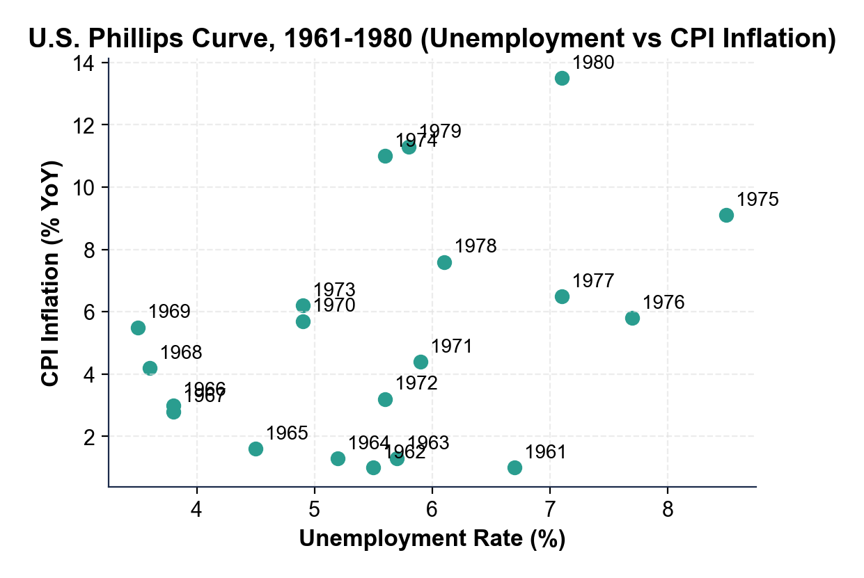

SECTION 4

When Goals Align - 1990s and 2010s
Late 1990s
Unemployment fell from 7.5% (1992) to 3.9% (2000).
Inflation stayed BELOW 3% the entire decade.
A productivity boom kept both goals satisfied.
Fed Chair Alan Greenspan held rates steady.
2010s Recovery
Unemployment fell from 9.9% (2009) to 3.5% (Feb 2020).
Inflation stayed BELOW 2.5% almost every year.
The Fed could keep rates low with both goals OK.

SECTION 5

When Goals Conflict - 1970s Stagflation and 2022 Inflation
1970s Stagflation
OPEC oil shocks 1973 and 1979 were supply-side inflation.
BOTH unemployment AND inflation spiked together.
1980 reading: about 7% u-rate with 13.5% CPI.
Volcker pushed fed funds to 20% to break inflation.
2022 Inflation Surge
CPI peaked at 9.1% in June 2022.
Unemployment at 3.6% - BELOW the natural rate.
The Fed chose to fight inflation - 11 hikes in 16 months.
Chart Reference
See the U.S. Unemployment vs Inflation chart, 2015-2026 on the next slide (2015-2026 U.S. scatter).
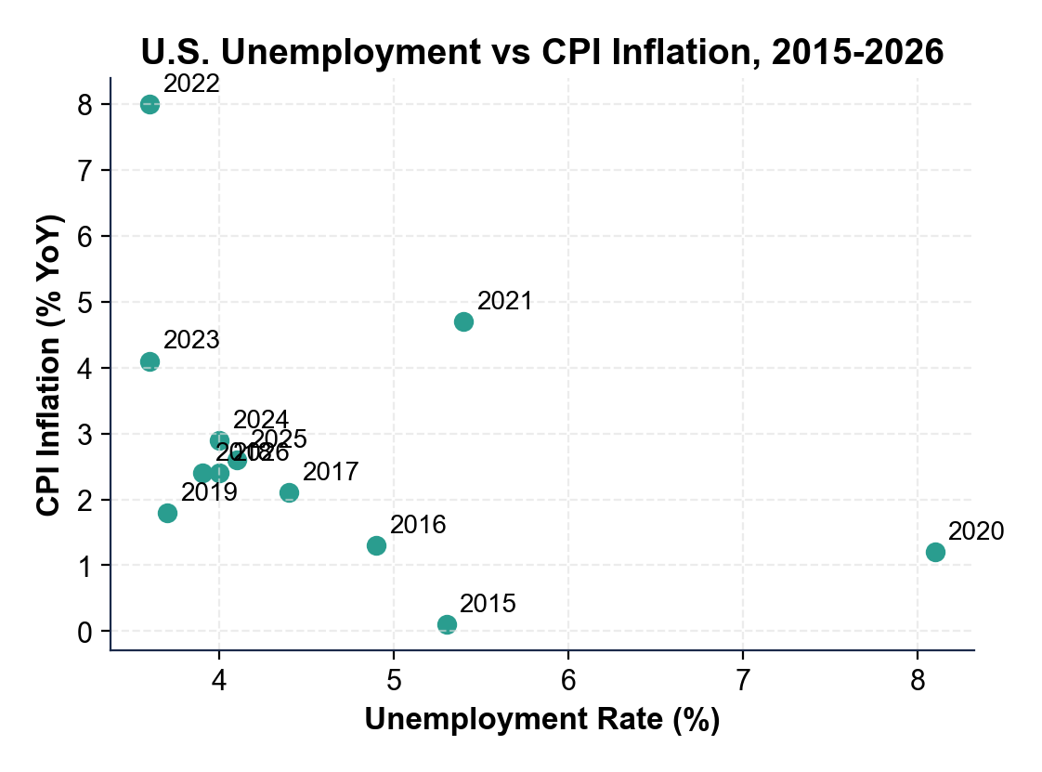

SECTION 6

Modern Fed Framework - Average Inflation Targeting (2020)
Old Rule (1996 - 2020)
Strict 2% inflation ceiling.
The Fed hiked rates BEFORE inflation HIT 2%.
Bias toward preempting inflation.
Critics: cost too many jobs in slow recoveries.
New Rule (Aug 2020)
2% on AVERAGE over time, not a ceiling.
The Fed allows inflation to overshoot 2% briefly.
It makes up for periods of below-2% inflation.
More patience before hiking; jobs-friendly.

SECTION 7

The 2022 Hike Cycle Decision
The Numbers
Peak CPI inflation: 9.1% in June 2022.
Unemployment rate in June 2022: 3.6%.
Total federal funds rate hikes Mar 2022 - Jul 2023: 5.25 pp.
The Decision and Result
March 2022: Fed Funds at 0.00 - 0.25% as inflation hit 8.5%.
FOMC choice: prioritize prices - 11 hikes in 16 months.
Result: CPI down to 3.0% by June 2023 - soft landing so far.
Unemployment rose to only ~4.0% - no recession (yet).
Powell explicitly cited Volcker as the model in Aug 2022.

MORE LESSONS LESS PLANNING
Thank You!
If you enjoyed this product, please do not forget to rate and review to assist other teachers.

Looking for future discounts? Earn TPT credits by reviewing purchased products.

Please contact me if you have any issues with this product. Just like our students, I am always looking for opportunities to grow.

