The Dual Mandate: Jobs vs Prices
STUDENT ACTIVITY
Name: | Date: | Period:
ESSENTIAL QUESTION
What is the Fed's dual mandate, why did the Phillips curve trade-off break down in the 1970s, and when jobs and prices pull opposite ways - as in March 2022 - should the Fed hike or hold?
THE SCENARIO
It is mid-March 2022. You are DANA REYES, a junior research analyst at the Federal Reserve Board in Washington.
BY THE END, YOU CAN:
✓ State the Fed's dual mandate (maximum employment + stable prices) and explain its statutory origin
✓ Explain the Phillips curve - the short-run inflation/unemployment trade-off - and why it broke down in the 1970s
✓ Evaluate Fed decisions when jobs and inflation pull in opposite directions, including the 2022 hike cycle
HOW IT WORKS (do Parts 1–5 in order)
Part 1 — Dual-Mandate Reference Guide - Complete the Missing Terms
Part 2 — Apply the Terms - Dana Reyes Builds Her Dual-Mandate Vocabulary
Part 3 — Read the Chart - U.S. Phillips Curve (1961-1980)
Part 4 — Read the Chart - U.S. Unemployment vs Inflation (2015-2026)
Part 5 — Dana Reyes's FOMC Pre-Meeting Memo (Hike vs Hold)
TIME about 45 minutes YOU’LL NEED the lesson slides and your Guided Notes.

PART 1

Dual-Mandate Reference Guide - Complete the Missing Terms
Fill in the missing term for each blank row — the definition is your clue. Your Guided Notes and the lesson slides have every term.

Term | Definition
___________ | The Fed's two goals, written into law by Congress in 1977-1978: pursue BOTH maximum employment AND stable prices
Humphrey-Hawkins Act | The 1978 law that locked in the Fed's dual mandate after the 1977 Federal Reserve Reform Act
___________ | The Fed's first mandate goal: not zero unemployment, but the lowest unemployment rate consistent with stable prices
Stable prices | The Fed's second mandate goal: 2% annual PCE inflation, the target the Fed adopted in 2012
___________ | A 1958 finding by A.W. Phillips that low unemployment comes with high inflation; the original downward-sloping trade-off curve
Average inflation targeting | The Fed's 2020 framework that targets 2% inflation on AVERAGE over time instead of a strict ceiling, allowing inflation to overshoot to make up for periods below 2%
___________ | When high inflation AND high unemployment rose together; it broke the Phillips curve trade-off in the 1970s
Goals conflict | When the dual mandate's two goals point in opposite directions, as in the 1970s stagflation and the 2022 inflation surge
___________ | The lowest unemployment rate consistent with stable inflation; the Fed estimates the natural rate at about 4.0-4.5%
Trade-off | The Phillips curve's claim that in the SHORT run lower unemployment comes at the cost of higher inflation

PART 2

Apply the Terms - Dana Reyes Builds Her Dual-Mandate Vocabulary
WORD BANK Maximum employment · Phillips curve · Natural rate · Dual mandate · Stagflation
1. The Fed's legal mission - written into law by Congress in 1977-1978 - to pursue BOTH maximum employment AND low, steady inflation at the same time is called the .

2. The Fed's FIRST mandate goal - not zero unemployment, but the LOWEST unemployment rate the economy can sustain without pushing inflation up - is called .

3. The 1958 finding that low unemployment and high inflation tend to occur together - the original short-run trade-off, traced as a downward-sloping line - is the .

4. When high inflation AND high unemployment happen at the SAME time - as in the 1970s, breaking the simple Phillips curve - the economy is suffering from .

5. The lowest unemployment rate consistent with stable inflation - which the Fed estimates at about 4.0-4.5% - is the economy's .

PART 3

Read the Chart - U.S. Phillips Curve (1961-1980)
1. As Dana Reyes, pull up the historical Phillips curve data.
Use the U.S. Phillips Curve scatter (1961-1980), inserted below and shown in the slide deck, to describe the SHAPE traced by the 1961-1973 points. Is the relationship between unemployment and inflation positive (both rising together), negative (one rising while the other falls), or random? Name ONE specific year-pair as evidence.
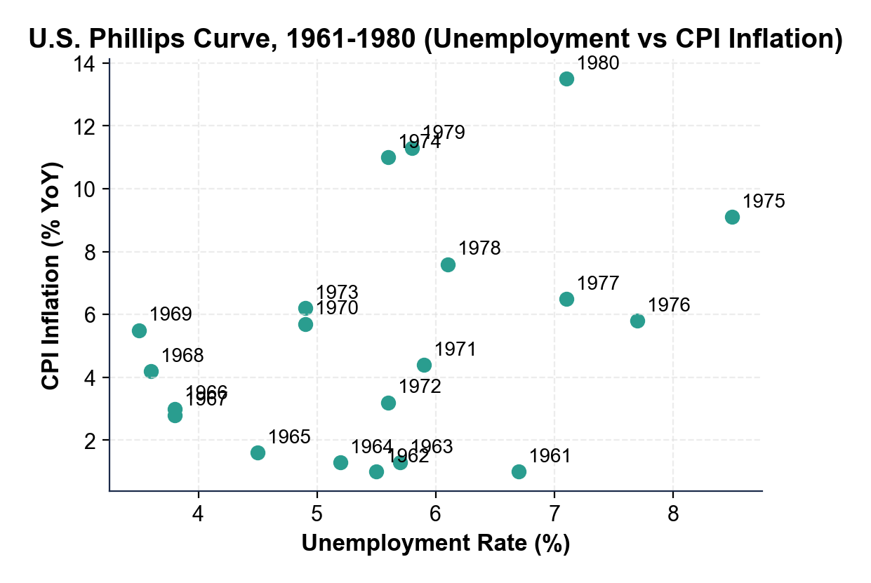

2. As Dana Reyes, use the same Phillips curve chart above to identify what happens to the relationship in the 1974-1980 period.
Where do the 1974-1980 points sit on the chart compared to the 1961-1973 points? Name TWO specific 1974-1980 years and their approximate (unemployment, inflation) coordinates.

3. As Dana Reyes, use the same Phillips curve chart above to identify the most extreme stagflation point. Name the year and approximate coordinates. Then explain in one sentence why this point is so important for understanding the dual mandate.

PART 4

Read the Chart - U.S. Unemployment vs Inflation (2015-2026)
1. As Dana Reyes, use the U.S.
Unemployment vs Inflation scatter (2015-2026), inserted below and shown in the slide deck, to describe the 2015-2019 cluster. What range of unemployment rates and what range of inflation rates do those five years span? In one sentence, characterize whether the dual mandate's goals were ALIGNING or CONFLICTING in 2015-2019.
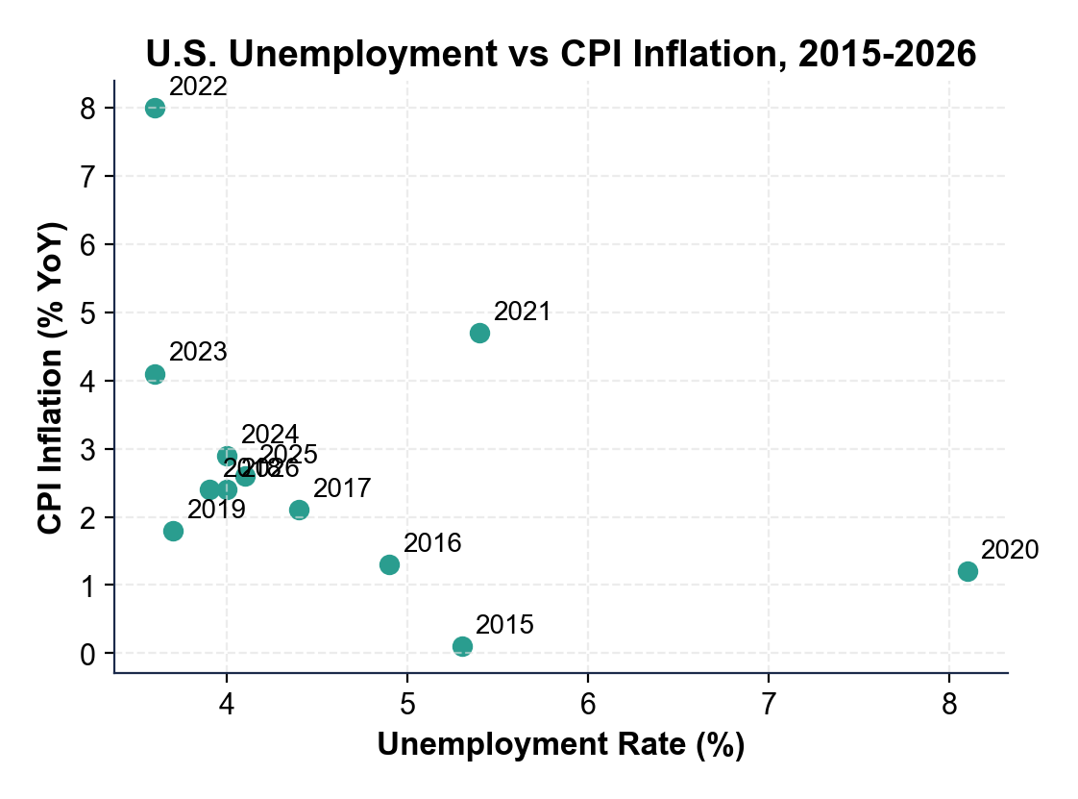

2. As Dana Reyes, use the same 2015-2026 scatter above to locate the 2022 OUTLIER.
What are the approximate (unemployment, inflation) coordinates for 2022? Why is this point an OUTLIER compared to the 2015-2019 cluster, AND how does it contrast with the 2020 pandemic point?

3. HINDSIGHT CHECK - step OUTSIDE the March 2022 moment of your briefing for this question.
The scatter extends through 2026, past the date you are writing. Looking back at the full record after the fact, describe what the chart shows happened to inflation AFTER the Fed's 2022 decision. Name at least TWO specific years and their approximate inflation rates. Did inflation move back toward the 2% target?

PART 5

Dana Reyes's FOMC Pre-Meeting Memo (Hike vs Hold)
FOMC PRE-MEETING MEMO
1. FOMC PRE-MEETING MEMO. It is March 14, 2022 and Chair Powell's office is waiting for your briefing. As Dana Reyes, write a 7-9 sentence memo (250-330 words) recommending a policy path. Use the memo header below and check off each required element as you include it. (Sentence starters you can use: "My recommendation for the March FOMC meeting is..." and "The strongest historical warning for my verdict is... while the main risk is...")
YOUR RESPONSE MUST:
☐ VERDICT - one sentence stating your recommendation (HIKE, HOLD, or SPLIT) and defending it using the dual mandate.
☐ TWO PHILLIPS-CURVE CHART VALUES - cite at least TWO specific numbers you read off the 1961-1980 Phillips curve scatter in Part 3 (for example a stagflation-point coordinate or the 1961-1973 downward-sloping pattern).
☐ TWO 2015-2026 CHART VALUES - cite at least TWO specific numbers you read off the 2015-2026 scatter in Part 4 (for example the 2022 outlier, the 2015-2019 cluster ranges, or the 2020 pandemic point).
☐ HISTORICAL MODEL - name the historical model for your recommendation (the Volcker disinflation, 1979-1982, if you choose HIKE; the patient 2010s approach under Bernanke and Yellen, who held rates low for years to protect the jobs recovery, if you choose HOLD).
☐ ONE RISK - name one specific risk of your recommendation (for example a hard landing if you HIKE, or un-anchored inflation expectations if you HOLD).
☐ FIVE VOCABULARY TERMS - use at least FIVE lesson vocabulary terms in your memo (e.g., dual mandate, maximum employment, stable prices, Phillips curve, stagflation, natural rate, trade-off).
MEMO
To: Chair Powell
From: Dana Reyes, Junior Research Analyst
Date:
Re: Pre-FOMC Recommendation on the March 2022 Dual-Mandate Trade-off

