ECONOMICS

THE DUAL MANDATE: JOBS VS PRICES
ANSWER KEY ACTIVITY

PART 1

Dual-Mandate Reference Guide - Complete the Missing Terms

Term | Definition
Dual mandate | The Fed's two goals, written into law by Congress in 1977-1978: pursue BOTH maximum employment AND stable prices
Humphrey-Hawkins Act | The 1978 law that locked in the Fed's dual mandate after the 1977 Federal Reserve Reform Act
Maximum employment | The Fed's first mandate goal: not zero unemployment, but the lowest unemployment rate consistent with stable prices
Stable prices | The Fed's second mandate goal: 2% annual PCE inflation, the target the Fed adopted in 2012
Phillips curve | A 1958 finding by A.W. Phillips that low unemployment comes with high inflation; the original downward-sloping trade-off curve
Average inflation targeting | The Fed's 2020 framework that targets 2% inflation on AVERAGE over time instead of a strict ceiling, allowing inflation to overshoot to make up for periods below 2%
Stagflation | When high inflation AND high unemployment rose together; it broke the Phillips curve trade-off in the 1970s
Goals conflict | When the dual mandate's two goals point in opposite directions, as in the 1970s stagflation and the 2022 inflation surge
Natural rate | The lowest unemployment rate consistent with stable inflation; the Fed estimates the natural rate at about 4.0-4.5%
Trade-off | The Phillips curve's claim that in the SHORT run lower unemployment comes at the cost of higher inflation

PART 2

Apply the Terms - Dana Reyes Builds Her Dual-Mandate Vocabulary
WORD BANK Maximum employment · Phillips curve · Natural rate · Dual mandate · Stagflation
1. The Fed's legal mission - written into law by Congress in 1977-1978 - to pursue BOTH maximum employment AND low, steady inflation at the same time is called the Dual mandate.
Dual mandate
2. The Fed's FIRST mandate goal - not zero unemployment, but the LOWEST unemployment rate the economy can sustain without pushing inflation up - is called Maximum employment.
Maximum employment
3. The 1958 finding that low unemployment and high inflation tend to occur together - the original short-run trade-off, traced as a downward-sloping line - is the Phillips curve.
Phillips curve
4. When high inflation AND high unemployment happen at the SAME time - as in the 1970s, breaking the simple Phillips curve - the economy is suffering from Stagflation.
Stagflation
5. The lowest unemployment rate consistent with stable inflation - which the Fed estimates at about 4.0-4.5% - is the economy's Natural rate.
Natural rate

PART 3

Read the Chart - U.S. Phillips Curve (1961-1980)
1. As Dana Reyes, pull up the historical Phillips curve data.
Use the U.S. Phillips Curve scatter (1961-1980), inserted below and shown in the slide deck, to describe the SHAPE traced by the 1961-1973 points. Is the relationship between unemployment and inflation positive (both rising together), negative (one rising while the other falls), or random? Name ONE specific year-pair as evidence.
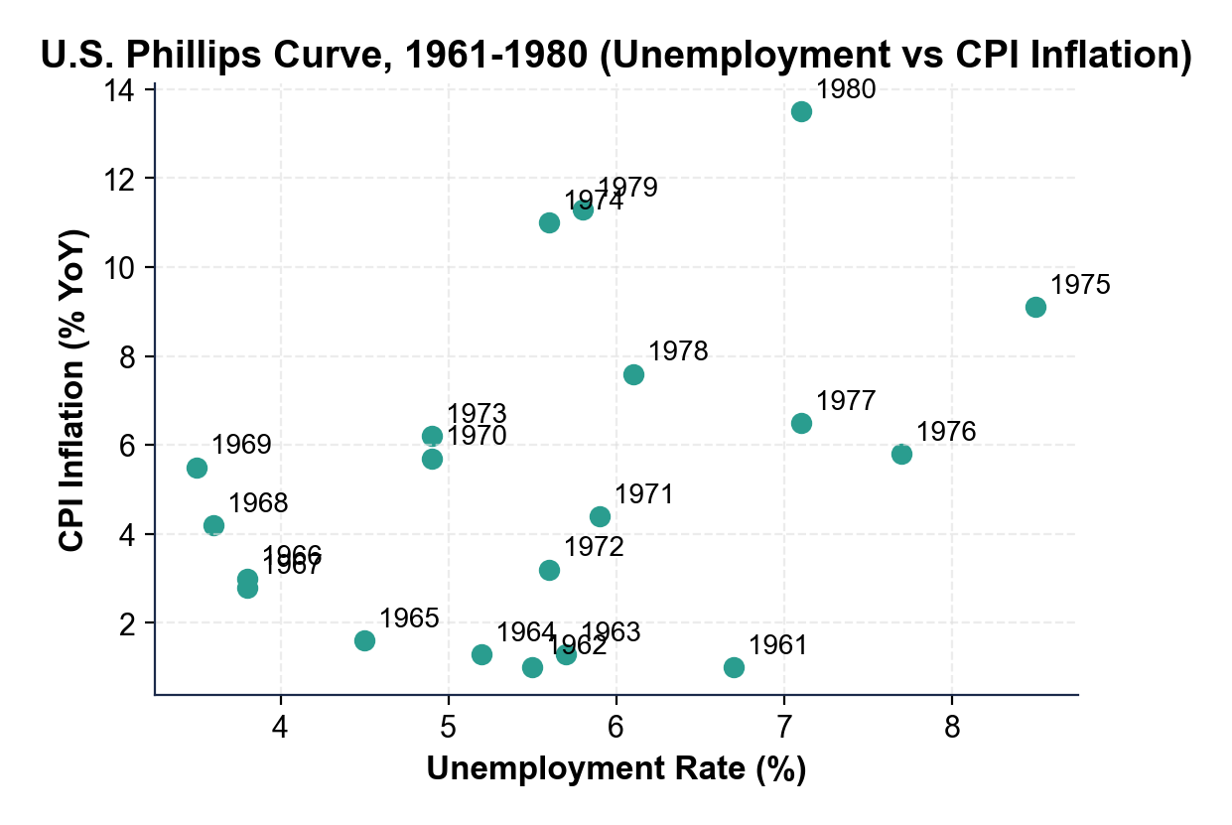
SHAPE: the 1961-1973 points trace a NEGATIVE, downward-sloping relationship - low unemployment came with HIGH inflation and high unemployment with LOW inflation, exactly as Phillips found. EVIDENCE: 1969 (~3.5% unemployment, 5.5% inflation) sits in the low-u-rate / high-inflation corner while 1961 (~6.7% unemployment, 1.0% inflation) sits in the high-u-rate / low-inflation corner; other valid pairs are 1965 (4.5% / 1.6%) vs 1969 (3.5% / 5.5%), or 1967 (3.8% / 2.8%) vs 1971 (5.9% / 4.4%). FULL CREDIT: the student calls the 1961-1973 relationship NEGATIVE or downward-sloping AND names a specific year-pair showing the trade-off.
2. As Dana Reyes, use the same Phillips curve chart above to identify what happens to the relationship in the 1974-1980 period.
Where do the 1974-1980 points sit on the chart compared to the 1961-1973 points? Name TWO specific 1974-1980 years and their approximate (unemployment, inflation) coordinates.
BREAKDOWN: the 1974-1980 points BREAK the Phillips curve - they cluster in the UPPER RIGHT (both high unemployment AND high inflation), which is STAGFLATION, the simultaneous high unemployment and high inflation the simple curve says cannot happen. EXAMPLE YEARS: 1975 sits at about 8.5% unemployment / 9.1% inflation and 1980 sits at about 7.1% unemployment / 13.5% inflation; other valid pairs are 1974 (5.6% / 11.0%), 1979 (5.8% / 11.3%), 1978 (6.1% / 7.6%). FULL CREDIT: the student says the 1974-1980 points sit upper-right, names the pattern STAGFLATION, AND gives TWO specific year-coordinate pairs from the cluster.
3. As Dana Reyes, use the same Phillips curve chart above to identify the most extreme stagflation point. Name the year and approximate coordinates. Then explain in one sentence why this point is so important for understanding the dual mandate.
EXTREME POINT: the most extreme stagflation point is 1980 at approximately 7.1% unemployment and 13.5% inflation (1979 and 1974 are also defensible extremes). WHY IT MATTERS: 1980 shows BOTH mandates failing at once - unemployment far above the Fed's natural-rate estimate AND inflation far above any stable-prices target - a point the simple Phillips curve says should never exist; it is the data point that justified the Volcker disinflation, because runaway inflation expectations threatened to embed permanent high inflation in the economy. FULL CREDIT: the student names 1980 (or 1979/1974), cites approximate coordinates, AND connects the stagflation point to the dual-mandate conflict or the Volcker decision.

PART 4

Read the Chart - U.S. Unemployment vs Inflation (2015-2026)
1. As Dana Reyes, use the U.S.
Unemployment vs Inflation scatter (2015-2026), inserted below and shown in the slide deck, to describe the 2015-2019 cluster. What range of unemployment rates and what range of inflation rates do those five years span? In one sentence, characterize whether the dual mandate's goals were ALIGNING or CONFLICTING in 2015-2019.
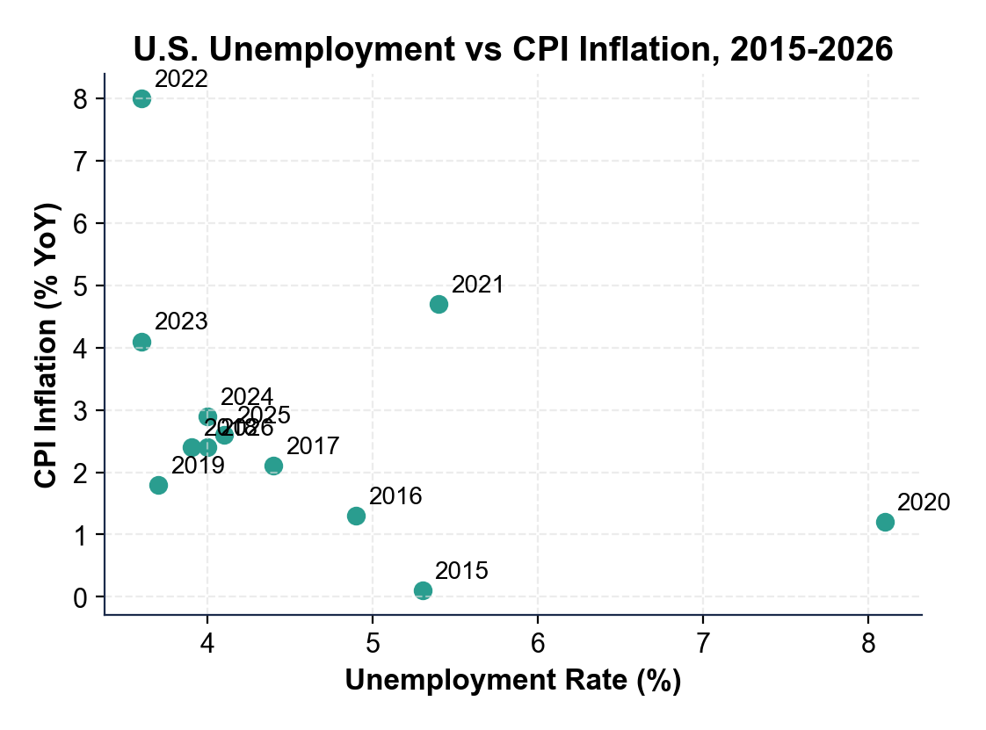
RANGES: the 2015-2019 cluster spans about 3.7% to 5.3% unemployment AND 0.1% to 2.4% inflation - both LOW, low unemployment paired with low inflation. VERDICT: the two mandates were ALIGNING in 2015-2019 - both goals satisfied at once, so the Fed could keep rates low without conflict; this is the 'goals align' pattern of the 2010s expansion, which delivered both maximum employment and stable prices at the same time. FULL CREDIT: the student gives the approximate unemployment range (~3.7-5.3%), the approximate inflation range (~0.1-2.4%), AND says the goals were ALIGNING during these years.
2. As Dana Reyes, use the same 2015-2026 scatter above to locate the 2022 OUTLIER.
What are the approximate (unemployment, inflation) coordinates for 2022? Why is this point an OUTLIER compared to the 2015-2019 cluster, AND how does it contrast with the 2020 pandemic point?
OUTLIER: the 2022 point sits at approximately 3.6% unemployment and 8.0% inflation - an outlier because it sits high on the INFLATION axis (8.0%, far above the 0.1-2.4% range of the 2015-2019 cluster) while unemployment is at the LOW end (3.6%, similar to 2019). CONTRAST: the 2020 pandemic point sits at 8.1% unemployment / 1.2% inflation - the OPPOSITE direction; 2020 was a normal recession (unemployment up, inflation down) while 2022 was the goals-conflict pattern with both mandates demanding opposite responses. FULL CREDIT: the student reads the 2022 coordinates (~3.6%, ~8.0%), calls it an outlier on the inflation axis, AND contrasts it with 2020 (high u-rate, low inflation).
3. HINDSIGHT CHECK - step OUTSIDE the March 2022 moment of your briefing for this question.
The scatter extends through 2026, past the date you are writing. Looking back at the full record after the fact, describe what the chart shows happened to inflation AFTER the Fed's 2022 decision. Name at least TWO specific years and their approximate inflation rates. Did inflation move back toward the 2% target?
DECLINE: inflation fell sharply after 2022 as the Fed's hike cycle took effect - the chart shows 2022 at ~8.0%, 2023 at ~4.1%, 2024 at ~2.9%, 2025 at ~2.6%, and 2026 at ~2.4%, declining every year and moving within striking distance of the 2% target. SOFT LANDING: because the unemployment rate stayed below 4.5% throughout that decline, the chart shows a soft landing rather than a Volcker-style hard landing - inflation came down WITHOUT a recession-level unemployment spike. FULL CREDIT: the student names TWO valid 2023-2026 inflation readings (within 0.5 pp of the chart), describes the declining trajectory, AND concludes inflation moved back toward the 2% target.

PART 5

Dana Reyes's FOMC Pre-Meeting Memo (Hike vs Hold)
FOMC PRE-MEETING MEMO
1. FOMC PRE-MEETING MEMO. It is March 14, 2022 and Chair Powell's office is waiting for your briefing. As Dana Reyes, write a 7-9 sentence memo (250-330 words) recommending a policy path. Use the memo header below and check off each required element as you include it. (Sentence starters you can use: "My recommendation for the March FOMC meeting is..." and "The strongest historical warning for my verdict is... while the main risk is...")
YOUR RESPONSE MUST:
☐ VERDICT - one sentence stating your recommendation (HIKE, HOLD, or SPLIT) and defending it using the dual mandate.
☐ TWO PHILLIPS-CURVE CHART VALUES - cite at least TWO specific numbers you read off the 1961-1980 Phillips curve scatter in Part 3 (for example a stagflation-point coordinate or the 1961-1973 downward-sloping pattern).
☐ TWO 2015-2026 CHART VALUES - cite at least TWO specific numbers you read off the 2015-2026 scatter in Part 4 (for example the 2022 outlier, the 2015-2019 cluster ranges, or the 2020 pandemic point).
☐ HISTORICAL MODEL - name the historical model for your recommendation (the Volcker disinflation, 1979-1982, if you choose HIKE; the patient 2010s approach under Bernanke and Yellen, who held rates low for years to protect the jobs recovery, if you choose HOLD).
☐ ONE RISK - name one specific risk of your recommendation (for example a hard landing if you HIKE, or un-anchored inflation expectations if you HOLD).
☐ FIVE VOCABULARY TERMS - use at least FIVE lesson vocabulary terms in your memo (e.g., dual mandate, maximum employment, stable prices, Phillips curve, stagflation, natural rate, trade-off).
MEMO
To: Chair Powell
From: Dana Reyes, Junior Research Analyst
Date: [student completes]
Re: Pre-FOMC Recommendation on the March 2022 Dual-Mandate Trade-off
GRADING RUBRIC
Grade the evidence and reasoning, not the conclusion — any defensible position is valid. Score against the 6 requirements above.
FULL CREDIT — clear position; meets all 6 requirements with accurate, specific numbers and evidence from the lesson.
PARTIAL — position stated, but misses 1-2 requirements or uses vague / incorrect numbers.
MINIMAL — no clear position, or missing most requirements and numbers.
WHAT TO LOOK FOR IN THIS LESSON
Sample full-credit memo (recommending HIKE):
Memo to: Chair Powell
From: Dana Reyes, Junior Research Analyst
Date: [today's date - leave bracketed]
Subject: Pre-FOMC Recommendation on the March 2022 Dual-Mandate Trade-off
[1] VERDICT: My recommendation is HIKE - the DUAL MANDATE points opposite ways right now, but STABLE PRICES should take priority. [2] PHILLIPS-CURVE EVIDENCE: the 1980 stagflation point (about 7.1% unemployment, 13.5% inflation) is the warning, and the 1975 point (8.5% u-rate, 9.1% inflation) shows the same upper-right STAGFLATION cluster that broke the simple PHILLIPS CURVE. [3] 2015-2026 EVIDENCE: the current 2022 reading is the textbook outlier (3.6% unemployment, 8.0% inflation), far above the calm 2015-2019 cluster (3.7-5.3% unemployment, 0.1-2.4% inflation) when goals aligned. [4] HISTORICAL MODEL: Volcker (1979-1982) chose prices, pushed the federal funds rate to 20%, and accepted high unemployment to break inflation - the lesson is to act EARLY before inflation expectations un-anchor. [5] Because unemployment at 3.6% is below the NATURAL RATE while inflation is far above the 2% target, the labor market can absorb some tightening now. [6] RISK: the danger of HIKE is a hard landing like 1981-82 - if we tighten too fast we could push unemployment to 6-7% and trigger a recession, so I recommend a data-dependent path of 25-50 basis points per meeting rather than a single shock.
REQUIRED-ELEMENT CHECKLIST (award credit per item):
[1] clear VERDICT (HIKE / HOLD / SPLIT) defended with the dual mandate.
[2] TWO specific Phillips-curve chart values (e.g., 1980 ~7.1%/13.5%, 1975 ~8.5%/9.1%, the 1961-1973 downward pattern).
[3] TWO specific 2015-2026 chart values (e.g., 2022 outlier 3.6%/8.0%, 2015-2019 cluster ranges, 2020 point 8.1%/1.2%).
[4] HISTORICAL MODEL named (the Volcker disinflation for HIKE; the patient 2010s Bernanke-Yellen approach for HOLD).
[5] ONE specific risk named.
[6] FIVE lesson vocabulary terms.
Accept any verdict (HIKE, HOLD, or SPLIT) as long as it is defended with the required chart values and the dual-mandate framework.
MORE LESSONS LESS PLANNING
Thank You!
If you enjoyed this product, please do not forget to rate and review to assist other teachers.

Looking for future discounts? Earn TPT credits by reviewing purchased products.

Please contact me if you have any issues with this product. Just like our students, I am always looking for opportunities to grow.

