The Debt Snowball vs Avalanche: Paying It Off
STUDENT ACTIVITY
Name: | Date: | Period:
ESSENTIAL QUESTION
How do the DEBT SNOWBALL (smallest balance first, for motivation) and the DEBT AVALANCHE (highest APR first, for math) differ, and why does choosing the payoff ORDER change the total interest you pay even when the debts and the extra payment are the same?
THE SCENARIO
You are helping TESSA BROOKS decide how to pay off her debts. Tessa owes three things: a STORE CARD with a $1,000 balance at 26% APR, a MEDICAL BILL with a $600 balance at 8% APR, and a CAR LOAN with a $3,000 balance at 14% APR - $4,600 in all - and she has $200 EXTRA a month to throw at her debt beyond the minimum payments.
BY THE END, YOU CAN:
✓ Define the debt snowball, the debt avalanche, payoff order, and motivation
✓ List a set of debts and find the payoff order for the snowball and the avalanche methods
✓ Read a bar chart that compares the total interest paid by the snowball vs the avalanche
✓ Compare motivation vs math and choose the method that is right for a given situation
HOW IT WORKS (do Parts 1–5 in order)
Part 1 — Debt-Payoff Reference Guide - Complete the Missing Terms
Part 2 — Apply the Terms - Debt-Payoff Vocabulary in Context
Part 3 — Read the Chart - Total Interest Paid: Snowball vs Avalanche
Part 4 — Do the Payoff-Order Math - List Tessa's Debts and Find Both Orders
Part 5 — Motivation vs Math - Make Your Recommendation
TIME about 45 minutes YOU’LL NEED the lesson slides and your Guided Notes.

PART 1

Debt-Payoff Reference Guide - Complete the Missing Terms
Fill in the missing term for each blank row — the definition is your clue. Your Guided Notes and the lesson slides have every term.

Term | Definition
___________ | A payoff strategy where you attack your smallest balance first, then roll that payment to the next-smallest debt; it is built for motivation, not for saving the most money.
Minimum payment | The smallest payment a lender will accept each month; in both methods you pay the minimum on every debt and put any extra toward one target debt.
___________ | A payoff strategy where you attack your highest interest rate (APR) first, then roll that payment to the next-highest-rate debt; it saves the most total interest.
APR | The Annual Percentage Rate, the yearly interest rate on a debt; the avalanche targets the highest APR first because that debt costs you the most.
___________ | The sequence in which you pay off your debts; the snowball orders them by balance (smallest first) and the avalanche orders them by APR (highest first).
Balance | The amount you still owe on a debt; the snowball ranks debts by balance (smallest first), while the avalanche ignores balance and ranks by APR.
___________ | The drive to keep going; the snowball pays off a small debt fast to give you an early win that keeps you motivated to finish.
Extra payment | The money beyond the minimums (here $200/month) that you throw at one target debt to pay it off faster; rolling it to the next debt is the snowball or avalanche effect.
___________ | The sum of all the interest you pay until every debt is gone; the method you choose changes the total interest, even when the debts and the extra payment are the same.
Roll the payment | Put the whole extra payment on the smallest debt until it is gone, then roll its freed-up money onto the next-smallest debt - repeating until every debt is paid off; the engine behind both methods.

PART 2

Apply the Terms - Debt-Payoff Vocabulary in Context
WORD BANK debt avalanche · motivation · total interest · payoff order · debt snowball
1. Q1. The payoff strategy where you attack your SMALLEST BALANCE first (Tessa's $600 medical bill), then roll that payment to the next-smallest debt, is the .

2. Q2. The payoff strategy where you attack your HIGHEST INTEREST RATE first (Tessa's 26% store card) to save the most money is the .

3. Q3. The sequence in which you pay off your debts - by balance for the snowball, by APR for the avalanche - is the .

4. Q4. The drive to keep going that the snowball builds by paying off a small debt fast for an early win is .

5. Q5. The sum of all the interest you pay until every debt is gone, which the avalanche keeps lower than the snowball even with the same debts, is the .

PART 3

Read the Chart - Total Interest Paid: Snowball vs Avalanche
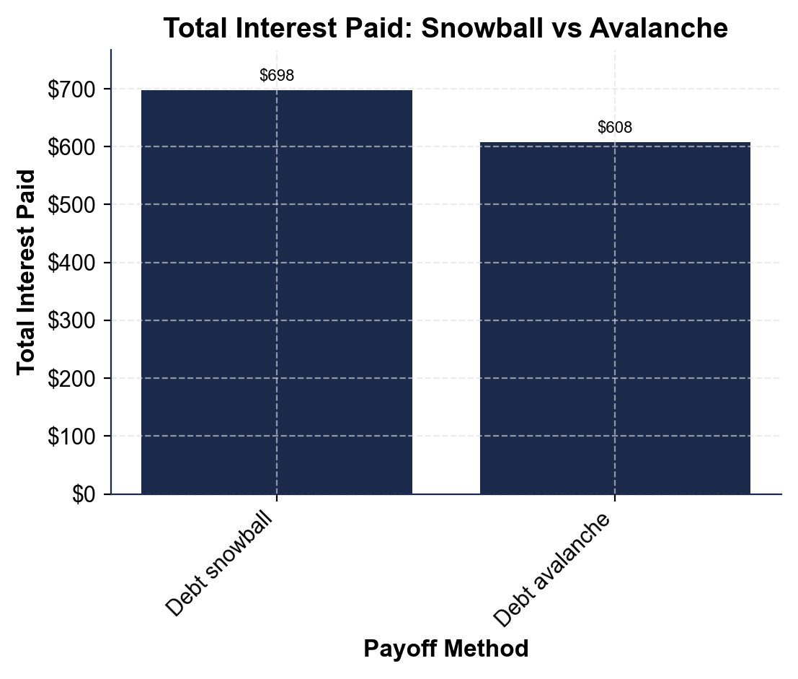
1. As you help Tessa Brooks, study the total-interest bar chart shown above this question, where the x-axis lists the payoff method (debt snowball, debt avalanche) and the y-axis is the total interest paid in dollars.
(a) Read the total interest for each bar: the debt snowball and the debt avalanche.

(b) Which bar is taller?

2. As you help Tessa Brooks, use the total-interest bar chart above to compare the two methods.
(a) Subtract to find how much LESS total interest the avalanche pays than the snowball.

(b) Which method saves money, and about how much? Show your subtraction.

3. As you help Tessa Brooks, look at the total-interest bar chart above. Both bars use Tessa's same three debts and the same $200 extra a month.
(a) Since the debts and the extra payment are identical, what is the ONLY thing that makes the two totals different?

(b) In one sentence, why does the avalanche's order produce the lower bar? (Hint: it kills the highest-APR debt first.)

4. As you help Tessa Brooks, look at the overall pattern of the two bars in the total-interest bar chart above. In one or two sentences, explain what the chart shows about how the payoff order affects total interest. Start your answer with: "The chart shows that..."

PART 4

Do the Payoff-Order Math - List Tessa's Debts and Find Both Orders
1. As you help Tessa Brooks, list her three debts and find the SNOWBALL payoff order (smallest balance first). Tessa owes a store card $1,000 at 26%, a medical bill $600 at 8%, and a car loan $3,000 at 14%.
(a) Write the three debts in snowball order.

(b) Which debt does she attack first, and why?

2. As you help Tessa Brooks, find the AVALANCHE payoff order (highest APR first) for the same three debts.
(a) Write the three debts in avalanche order.

(b) Which debt does she attack first, and why?

(c) How is this order different from the snowball order?

3. As you help Tessa Brooks, use the foundational model MONTHLY INTEREST = balance x (APR / 12) to find how much each debt costs in interest in one month.
(a) Store card ($1,000 at 26%).

(b) Car loan ($3,000 at 14%).

(c) Medical ($600 at 8%). Show your math.

4. As you help Tessa Brooks, connect the monthly interest to the avalanche's choice. Look back at your Part 4 Q3 answers: the car loan actually costs MORE total dollars of interest each month than the store card, even though the store card has the higher rate.
(a) Why does the avalanche still attack the 26% store card FIRST, not the car loan?

(b) What is the avalanche sorting by - the dollar amount of interest, or the rate? Explain in one or two sentences.

5. As you help Tessa Brooks, compare the two methods' results. With the same three debts and the same $200 extra a month, the snowball pays about $698 in total interest and the avalanche about $608.
(a) How much does the avalanche save? Show your subtraction.

(b) What ONE thing did Tessa change to save that money?

(c) What does the snowball give her that the avalanche does not?

PART 5

Motivation vs Math - Make Your Recommendation
1. As you help Tessa Brooks, explain the two methods in your own words.
(a) How does the DEBT SNOWBALL decide which debt to pay first, and what is its strength?

(b) How does the DEBT AVALANCHE decide which debt to pay first, and what is its strength?

2. As you help Tessa Brooks, explain WHY the avalanche saves money even though both methods pay the same debts.
(a) Why does paying the 26% store card first instead of last lower the total interest?

(b) Both methods take the same number of months and pay the same $200 - so what is the ONLY thing that changes the total interest?

3. As you help Tessa Brooks, make the judgment call. Tessa has started and quit two debt-payoff plans before.
(a) Given that history, which method might help her actually FINISH, and why?

(b) What is the honest bottom line about which method is 'better'?

FINAL RECOMMENDATION
4. FINAL RECOMMENDATION. Tessa asks you to put it in writing. Write a 5-7 sentence note (120-180 words) telling Tessa the difference between the two methods, her payoff order both ways, which method saves money and which builds motivation, and the one method you recommend and why. Check off each required element as you include it.
YOUR RESPONSE MUST:
☐ DEFINE BOTH METHODS - state in your own words that the snowball pays the smallest balance first (for motivation) and the avalanche pays the highest APR first (to save money).
☐ GIVE BOTH ORDERS - list Tessa's snowball order (Medical $600 -> Store card $1,000 -> Car loan $3,000) and her avalanche order (Store card 26% -> Car loan 14% -> Medical 8%).
☐ USE A CALCULATED RESULT - state a figure you calculated yourself in Part 4 (for example, the ~$90 the avalanche saves, or the $21.67/month interest on the store card).
☐ NAME THE TRADE-OFF - explain that the avalanche saves about $90 (math) but the snowball gives an early motivating win, and that the only thing that changed is the payoff order.
☐ RECOMMEND ONE METHOD - tell Tessa which ONE method to use and why, using her history of quitting plans to justify the choice.

