PERSONAL FINANCE

THE DEBT SNOWBALL VS AVALANCHE: PAYING IT OFF
ANSWER KEY ACTIVITY - ANSWER KEY

PART 1

Debt-Payoff Reference Guide - Complete the Missing Terms

Term | Definition
Debt snowball | A payoff strategy where you attack your smallest balance first, then roll that payment to the next-smallest debt; it is built for motivation, not for saving the most money.
Minimum payment | The smallest payment a lender will accept each month; in both methods you pay the minimum on every debt and put any extra toward one target debt.
Debt avalanche | A payoff strategy where you attack your highest interest rate (APR) first, then roll that payment to the next-highest-rate debt; it saves the most total interest.
APR | The Annual Percentage Rate, the yearly interest rate on a debt; the avalanche targets the highest APR first because that debt costs you the most.
Payoff order | The sequence in which you pay off your debts; the snowball orders them by balance (smallest first) and the avalanche orders them by APR (highest first).
Balance | The amount you still owe on a debt; the snowball ranks debts by balance (smallest first), while the avalanche ignores balance and ranks by APR.
Motivation | The drive to keep going; the snowball pays off a small debt fast to give you an early win that keeps you motivated to finish.
Extra payment | The money beyond the minimums (here $200/month) that you throw at one target debt to pay it off faster; rolling it to the next debt is the snowball or avalanche effect.
Total interest | The sum of all the interest you pay until every debt is gone; the method you choose changes the total interest, even when the debts and the extra payment are the same.
Roll the payment | Put the whole extra payment on the smallest debt until it is gone, then roll its freed-up money onto the next-smallest debt - repeating until every debt is paid off; the engine behind both methods.

PART 2

Apply the Terms - Debt-Payoff Vocabulary in Context
WORD BANK debt avalanche · motivation · total interest · payoff order · debt snowball
1. Q1. The payoff strategy where you attack your SMALLEST BALANCE first (Tessa's $600 medical bill), then roll that payment to the next-smallest debt, is the Debt snowball.
Debt snowball
2. Q2. The payoff strategy where you attack your HIGHEST INTEREST RATE first (Tessa's 26% store card) to save the most money is the Debt avalanche.
Debt avalanche
3. Q3. The sequence in which you pay off your debts - by balance for the snowball, by APR for the avalanche - is the Payoff order.
Payoff order
4. Q4. The drive to keep going that the snowball builds by paying off a small debt fast for an early win is Motivation.
Motivation
5. Q5. The sum of all the interest you pay until every debt is gone, which the avalanche keeps lower than the snowball even with the same debts, is the Total interest.
Total interest

PART 3

Read the Chart - Total Interest Paid: Snowball vs Avalanche
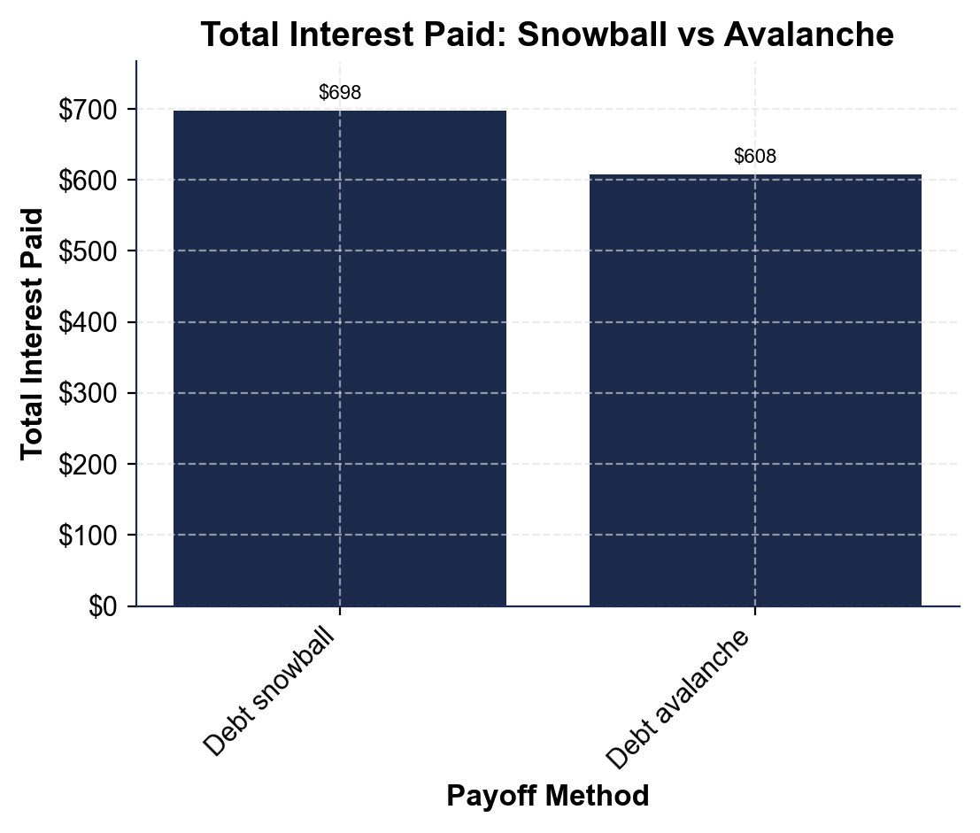
1. As you help Tessa Brooks, study the total-interest bar chart shown above this question, where the x-axis lists the payoff method (debt snowball, debt avalanche) and the y-axis is the total interest paid in dollars.
(a) Read the total interest for each bar: the debt snowball and the debt avalanche.
(b) Which bar is taller?
(1) The DEBT SNOWBALL bar is about $698 in total interest; the DEBT AVALANCHE bar is about $608. (2) The SNOWBALL bar is taller. Accept ~$698 for the snowball, ~$608 for the avalanche, and the snowball as the taller bar.
2. As you help Tessa Brooks, use the total-interest bar chart above to compare the two methods.
(a) Subtract to find how much LESS total interest the avalanche pays than the snowball.
(b) Which method saves money, and about how much? Show your subtraction.
(1) DIFFERENCE = $698 - $608 = about $90. (2) The DEBT AVALANCHE saves money - about $90 less in total interest than the snowball. Accept $698 - $608 = $90 and the avalanche as the money-saving method.
3. As you help Tessa Brooks, look at the total-interest bar chart above. Both bars use Tessa's same three debts and the same $200 extra a month.
(a) Since the debts and the extra payment are identical, what is the ONLY thing that makes the two totals different?
(b) In one sentence, why does the avalanche's order produce the lower bar? (Hint: it kills the highest-APR debt first.)
(1) The only thing that differs is the payoff ORDER - which debt gets the extra $200 first. (2) The avalanche's bar is lower because it kills the highest-APR debt (the 26% store card) first, so the most expensive interest stops soonest, while the snowball pays the small $600 medical bill first and lets the 26% card keep accruing. Accept 'only the payoff order differs' and the point that the avalanche attacks the highest-rate debt first.
4. As you help Tessa Brooks, look at the overall pattern of the two bars in the total-interest bar chart above. In one or two sentences, explain what the chart shows about how the payoff order affects total interest. Start your answer with: "The chart shows that..."
The chart shows that, with the same debts and the same $200 a month, the debt avalanche (~$608) pays less total interest than the debt snowball (~$698) - about $90 less - because attacking the highest-APR debt first stops the most interest soonest.

PART 4

Do the Payoff-Order Math - List Tessa's Debts and Find Both Orders
1. As you help Tessa Brooks, list her three debts and find the SNOWBALL payoff order (smallest balance first). Tessa owes a store card $1,000 at 26%, a medical bill $600 at 8%, and a car loan $3,000 at 14%.
(a) Write the three debts in snowball order.
(b) Which debt does she attack first, and why?
(1) SNOWBALL ORDER (smallest balance first): Medical ($600), then Store card ($1,000), then Car loan ($3,000). (2) She attacks the MEDICAL bill first because it has the smallest balance ($600), so she can clear a whole debt fast for an early motivating win. Accept Medical -> Store card -> Car loan, and the reason that medical is the smallest balance.
2. As you help Tessa Brooks, find the AVALANCHE payoff order (highest APR first) for the same three debts.
(a) Write the three debts in avalanche order.
(b) Which debt does she attack first, and why?
(c) How is this order different from the snowball order?
(1) AVALANCHE ORDER (highest APR first): Store card (26%), then Car loan (14%), then Medical (8%). (2) She attacks the STORE CARD first because it has the highest APR (26%), so it is the most expensive debt and killing it first saves the most interest. (3) The orders are almost reversed: the snowball starts with the small $600 medical bill, while the avalanche starts with the expensive 26% store card. Accept Store card -> Car loan -> Medical, the reason that the store card has the highest APR, and the point that the two orders are nearly reversed.
3. As you help Tessa Brooks, use the foundational model MONTHLY INTEREST = balance x (APR / 12) to find how much each debt costs in interest in one month.
(a) Store card ($1,000 at 26%).
(b) Car loan ($3,000 at 14%).
(c) Medical ($600 at 8%). Show your math.
(1) STORE CARD = $1,000 x (0.26 / 12) = $1,000 x 0.02167 = about $21.67 a month. (2) CAR LOAN = $3,000 x (0.14 / 12) = $3,000 x 0.01167 = about $35.00 a month. (3) MEDICAL = $600 x (0.08 / 12) = $600 x 0.00667 = $4.00 a month. Accept about $21.67 for the store card, $35.00 for the car loan, and $4.00 for the medical bill.
4. As you help Tessa Brooks, connect the monthly interest to the avalanche's choice. Look back at your Part 4 Q3 answers: the car loan actually costs MORE total dollars of interest each month than the store card, even though the store card has the higher rate.
(a) Why does the avalanche still attack the 26% store card FIRST, not the car loan?
(b) What is the avalanche sorting by - the dollar amount of interest, or the rate? Explain in one or two sentences.
(1) The avalanche attacks the 26% store card first because the avalanche sorts by RATE (APR), not by the dollar amount of monthly interest - and 26% is the highest rate. The car loan's monthly interest is larger only because its balance is much bigger ($3,000 vs $1,000); per dollar borrowed, the 26% card is the most expensive. (2) The avalanche sorts by the RATE (the APR), so it targets the highest-APR debt first. Accept the point that the avalanche orders by APR (rate), not by the raw dollar amount of interest, and that the card is the highest-rate debt.
5. As you help Tessa Brooks, compare the two methods' results. With the same three debts and the same $200 extra a month, the snowball pays about $698 in total interest and the avalanche about $608.
(a) How much does the avalanche save? Show your subtraction.
(b) What ONE thing did Tessa change to save that money?
(c) What does the snowball give her that the avalanche does not?
(1) SAVINGS = $698 - $608 = about $90 saved by the avalanche. (2) The only thing she changed is the payoff ORDER - she paid the highest-APR debt first instead of the smallest balance; the debts and the $200 a month are the same. (3) The snowball gives her an early MOTIVATING win (clearing the $600 medical bill fast) that the avalanche does not, which can help her stick with the plan. Accept $90 saved, 'only the payoff order changed,' and the point that the snowball's edge is motivation.

PART 5

Motivation vs Math - Make Your Recommendation
1. As you help Tessa Brooks, explain the two methods in your own words.
(a) How does the DEBT SNOWBALL decide which debt to pay first, and what is its strength?
(b) How does the DEBT AVALANCHE decide which debt to pay first, and what is its strength?
(1) The DEBT SNOWBALL orders debts by BALANCE and pays the SMALLEST first (Tessa's $600 medical bill); its strength is MOTIVATION - clearing a whole debt fast gives an early win that keeps you going. (2) The DEBT AVALANCHE orders debts by APR and pays the HIGHEST RATE first (Tessa's 26% store card); its strength is MATH - killing the most expensive debt first stops the most interest, so it pays the least total interest. Award credit for snowball = smallest balance first for motivation, and avalanche = highest APR first for the lowest total interest.
2. As you help Tessa Brooks, explain WHY the avalanche saves money even though both methods pay the same debts.
(a) Why does paying the 26% store card first instead of last lower the total interest?
(b) Both methods take the same number of months and pay the same $200 - so what is the ONLY thing that changes the total interest?
(1) Paying the 26% store card first stops its high-rate interest soonest; if Tessa pays the small medical bill first instead, the expensive 26% card keeps accruing interest for more months, which adds up to more total interest. (2) The ONLY thing that changes the total interest is the payoff ORDER - which debt gets the extra $200 first; the debts, the $200, and the time are otherwise the same. Award credit for 'killing the high-rate debt first stops the most interest' and 'only the payoff order changes the total interest.'
3. As you help Tessa Brooks, make the judgment call. Tessa has started and quit two debt-payoff plans before.
(a) Given that history, which method might help her actually FINISH, and why?
(b) What is the honest bottom line about which method is 'better'?
(1) Given that she has quit two plans before, the DEBT SNOWBALL might help her finish, because the early win of clearing the $600 medical bill fast builds the motivation she has been missing - and a plan she finishes beats a cheaper plan she quits. (A disciplined case for the avalanche is also acceptable if the student argues she should push for the $90 savings.) (2) The honest bottom line: the avalanche always wins on dollars (it saves ~$90 here), but the best method is the one she will actually FINISH - so the right choice depends on whether motivation or math will keep her going. Award credit for matching the method to her quit-before history and for the point that the best method is the one she will finish.
FINAL RECOMMENDATION
4. FINAL RECOMMENDATION. Tessa asks you to put it in writing. Write a 5-7 sentence note (120-180 words) telling Tessa the difference between the two methods, her payoff order both ways, which method saves money and which builds motivation, and the one method you recommend and why. Check off each required element as you include it.
YOUR RESPONSE MUST:
☐ DEFINE BOTH METHODS - state in your own words that the snowball pays the smallest balance first (for motivation) and the avalanche pays the highest APR first (to save money).
☐ GIVE BOTH ORDERS - list Tessa's snowball order (Medical $600 -> Store card $1,000 -> Car loan $3,000) and her avalanche order (Store card 26% -> Car loan 14% -> Medical 8%).
☐ USE A CALCULATED RESULT - state a figure you calculated yourself in Part 4 (for example, the ~$90 the avalanche saves, or the $21.67/month interest on the store card).
☐ NAME THE TRADE-OFF - explain that the avalanche saves about $90 (math) but the snowball gives an early motivating win, and that the only thing that changed is the payoff order.
☐ RECOMMEND ONE METHOD - tell Tessa which ONE method to use and why, using her history of quitting plans to justify the choice.
GRADING RUBRIC
Grade the evidence and reasoning, not the conclusion — any defensible position is valid. Score against the 5 requirements above.
FULL CREDIT — clear position; meets all 5 requirements with accurate, specific numbers and evidence from the lesson.
PARTIAL — position stated, but misses 1-2 requirements or uses vague / incorrect numbers.
MINIMAL — no clear position, or missing most requirements and numbers.

MORE LESSONS LESS PLANNING
Thank You!
If you enjoyed this product, please do not forget to rate and review to assist other teachers.

Looking for future discounts? Earn TPT credits by reviewing purchased products.

Please contact me if you have any issues with this product. Just like our students, I am always looking for opportunities to grow.

