The Billionaire Tax Debate
STUDENT ACTIVITY
Name: | Date: | Period:
ESSENTIAL QUESTION
Why does an income tax alone miss most billionaire wealth, and which of the four proposals - Warren's wealth tax, Sanders's wealth tax, the Buffett Rule, or the 2024 minimum income tax - should the senator champion?
THE SCENARIO
It is October 2024. You are AVERY CHEN, a Senate policy advisor on the Senate Finance Committee.
BY THE END, YOU CAN:
✓ Identify recent wealth tax and billionaire tax proposals (Warren, Sanders, Buffett rule, 2024 billionaire minimum income tax)
✓ Apply tax incidence analysis to wealth tax debates and explain how billionaires currently avoid taxes
✓ Evaluate practical implementation challenges and the constitutional question around taxing wealth
HOW IT WORKS (do Parts 1–5 in order)
Part 1 — The Billionaire-Tax Reference Guide - Complete the Missing Terms
Part 2 — Apply the Terms - Billionaire-Tax Vocabulary in Context
Part 3 — Trace the Mechanics - Wealth vs Income, Buy-Borrow-Die, and the Constitution
Part 4 — Read the Charts - Billionaires and Effective Tax Rates
Part 5 — Final Policy Memo to Your Senator
TIME about 45 minutes YOU’LL NEED the lesson slides and your Guided Notes.

PART 1

The Billionaire-Tax Reference Guide - Complete the Missing Terms
Fill in the missing term for each blank row — the definition is your clue. Your Guided Notes and the lesson slides have every term.

Term | Definition
___________ | A tax on a household's total net worth (what you own minus what you owe), not on the income earned each year
Income tax | A tax on the wages, profits, and investment returns a household earns each year; the main federal tax most households pay
___________ | The increase in value of an asset you still own (like stock that has gone up) but have not yet sold; under current law these are not taxed
Net worth | The total value of everything you own (home, savings, stocks, businesses) minus everything you owe; the base for a wealth tax
___________ | A legal tax-avoidance strategy: hold appreciating assets, borrow against them tax-free for spending, then pass them on at death with a stepped-up basis that erases the gain
Stepped-up basis | A tax rule that resets an inherited asset's cost basis to its market value at the owner's death, wiping out unrealized gains so heirs never owe capital gains tax
___________ | The percentage of a household's total income that is actually paid in federal tax; at the very top this rate can fall below what middle-income households pay
Capital flight | When wealthy households move themselves or their assets to other countries to avoid a new tax; a main practical objection to wealth taxes
___________ | A proposed 30 percent minimum federal income tax on incomes above $1 million; named for Warren Buffett who paid a lower rate than his secretary
16th Amendment | The 1913 amendment authorizing Congress to tax incomes without apportionment; whether it covers a wealth tax is the central constitutional question

PART 2

Apply the Terms - Billionaire-Tax Vocabulary in Context
WORD BANK wealth tax · effective tax rate · buy borrow die · unrealized capital gains · buffett rule
1. Q1. An annual tax on a household's total accumulated wealth - everything you own minus everything you owe - rather than on the money you earn each year, is a .

2. Q2. The increase in value of an asset you still own (like stock that has gone up) but have not yet sold, which current law does not tax, is called .

3. Q3. The legal strategy of holding appreciating assets, borrowing against them tax-free to spend, and passing them on at death with a stepped-up basis is called , , .

4. Q4. The percentage of a household's total income that is actually paid in federal tax - a figure that can fall surprisingly low at the very top - is the .

5. Q5. A proposed 30% minimum federal income tax on incomes above $1 million, named for an investor's complaint that he paid a lower rate than his secretary, is the .

PART 3

Trace the Mechanics - Wealth vs Income, Buy-Borrow-Die, and the Constitution
1. In your own words, explain the difference between a WEALTH TAX and an INCOME TAX. Then state which of the four proposals on your senator's desk are wealth taxes and which are income taxes.

2. Explain in 2-3 sentences why an income tax alone (no matter how high the rate) misses most billionaire wealth. Use the word UNREALIZED at least once.

3. Trace the BUY-BORROW-DIE strategy for one billionaire. Pick someone from the lesson and walk through how the strategy could let them spend $50 million on personal expenses next year while owing $0 in federal income tax. Use the words BUY, BORROW, and STEPPED-UP BASIS.

4. Calculate the revenue ratio. Saez and Zucman estimated Senator Warren's plan would raise about $2.6 trillion over 10 years; Sanders's plan would raise about $4.4 trillion over 10 years. Calculate
(a) Sanders divided by Warren as a ratio

(b) Sanders MINUS Warren in extra dollars. Then explain in 1-2 sentences why Sanders's plan raises so much more.

5. Twelve European countries had wealth taxes in 1990; only THREE still do (Spain, Norway, Switzerland).
What does this track record tell you about the practical risks of a U.S. wealth tax? Name and briefly explain THREE specific implementation challenges from the lesson.

6. The CONSTITUTIONAL question is the wild card. Explain in your own words why a wealth tax might be unconstitutional even if Congress passes it, and what makes the Buffett Rule and the 2024 billionaire minimum tax LESS legally risky than Warren's and Sanders's plans.

PART 4

Read the Charts - Billionaires and Effective Tax Rates
1. Use the TOP 10 U.S. BILLIONAIRES NET WORTH chart, inserted below and shown in the slide deck. Read directly off the chart: who has the HIGHEST net worth and roughly what is it (in billions)? Who has the LOWEST among the top 10 and roughly what is it? (Chart: chart_top10_billionaires_net_worth)
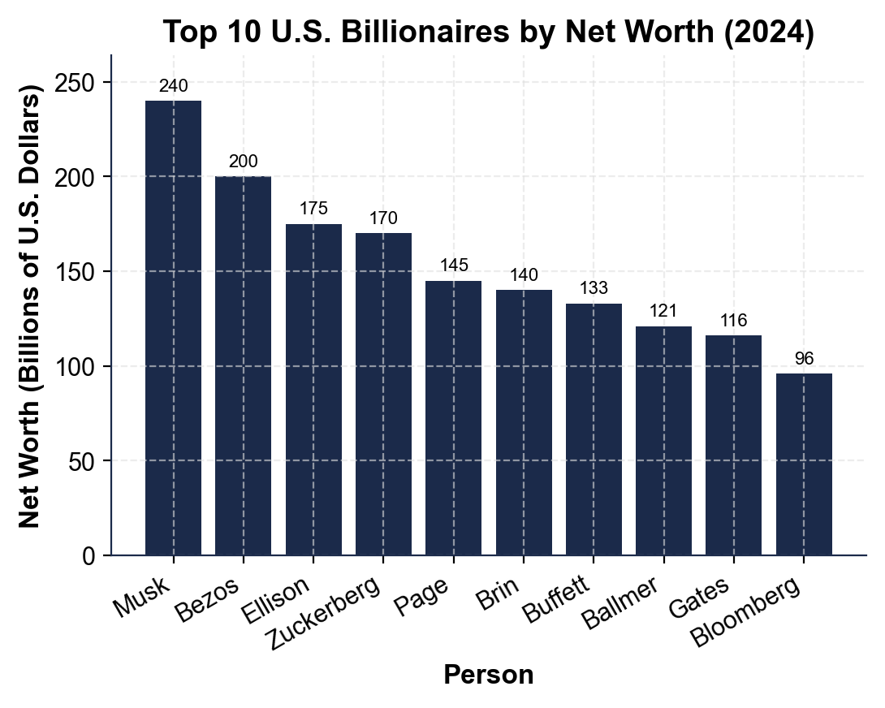

2. Use the same chart. CALCULATE what Senator Warren's wealth tax would owe annually on Elon Musk's net worth. (Reminder: 2% on net worth between $50 million and $1 billion; 6% on net worth above $1 billion.) Show your math.

3. Use the EFFECTIVE FEDERAL TAX RATE BY INCOME DECILE chart, inserted below and shown in the slide deck.
Read directly off the chart: what effective rate does the TOP 10% pay, and what effective rate does the TOP 0.01% pay? (Chart: chart_tax_rate_by_decile)
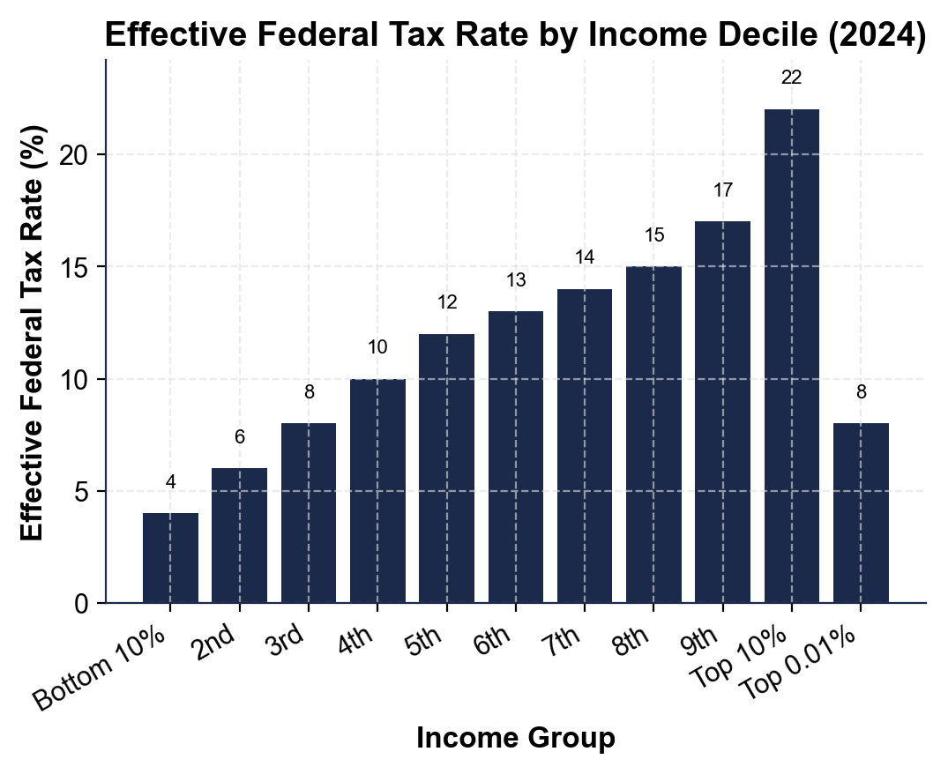

4. Using the same decile chart, calculate the GAP in effective tax rate between the TOP 10% (~22%) and the TOP 0.01% (~8%). Then use lesson concepts to explain in 2-3 sentences WHY the very top pays so much less. (Hint: capital gains rates, buy-borrow-die.)

PART 5

Final Policy Memo to Your Senator
FINAL POLICY MEMO
1. FINAL POLICY MEMO. Write a 7-9 sentence memo to your senator. Pick ONE of the four proposals and recommend it for her town hall. Use the memo header below and check off each required element as you include it. (Sentence starter you may use: "I recommend the senator champion ___ because ___.")
YOUR RESPONSE MUST:
☐ RECOMMENDATION - name ONE proposal (Warren wealth tax, Sanders wealth tax, Buffett Rule, or 2024 billionaire minimum income tax) clearly in your first sentence. Do not hedge.
☐ THREE SPECIFIC FACTS - cite at least THREE specific numbers or facts from the lesson to defend your choice (rates, thresholds, revenue estimates, the ~22% vs ~8% effective-rate gap, the 12-to-3 European track record, etc.).
☐ WINNERS AND LOSERS - name WHO benefits and WHO might lose under your recommendation.
☐ ONE OBJECTION - acknowledge ONE realistic objection an opponent might raise.
☐ ONE TRADE-OFF - state ONE trade-off you accept by choosing this policy.
MEMO
To: Senator (Senate Finance Committee)
From: Avery Chen, Senate Policy Advisor
Date:
Re: Town Hall Recommendation - Billionaire Tax

