ECONOMICS

THE BILLIONAIRE TAX DEBATE
ANSWER KEY ACTIVITY - ANSWER KEY

PART 1

The Billionaire-Tax Reference Guide - Complete the Missing Terms

Term | Definition
Wealth tax | A tax on a household's total net worth (what you own minus what you owe), not on the income earned each year
Income tax | A tax on the wages, profits, and investment returns a household earns each year; the main federal tax most households pay
Unrealized capital gains | The increase in value of an asset you still own (like stock that has gone up) but have not yet sold; under current law these are not taxed
Net worth | The total value of everything you own (home, savings, stocks, businesses) minus everything you owe; the base for a wealth tax
Buy, borrow, die | A legal tax-avoidance strategy: hold appreciating assets, borrow against them tax-free for spending, then pass them on at death with a stepped-up basis that erases the gain
Stepped-up basis | A tax rule that resets an inherited asset's cost basis to its market value at the owner's death, wiping out unrealized gains so heirs never owe capital gains tax
Effective tax rate | The percentage of a household's total income that is actually paid in federal tax; at the very top this rate can fall below what middle-income households pay
Capital flight | When wealthy households move themselves or their assets to other countries to avoid a new tax; a main practical objection to wealth taxes
Buffett Rule | A proposed 30 percent minimum federal income tax on incomes above $1 million; named for Warren Buffett who paid a lower rate than his secretary
16th Amendment | The 1913 amendment authorizing Congress to tax incomes without apportionment; whether it covers a wealth tax is the central constitutional question

PART 2

Apply the Terms - Billionaire-Tax Vocabulary in Context
WORD BANK wealth tax · effective tax rate · buy borrow die · unrealized capital gains · buffett rule
1. Q1. An annual tax on a household's total accumulated wealth - everything you own minus everything you owe - rather than on the money you earn each year, is a Wealth tax.
Wealth tax
2. Q2. The increase in value of an asset you still own (like stock that has gone up) but have not yet sold, which current law does not tax, is called Unrealized capital gains.
Unrealized capital gains
3. Q3. The legal strategy of holding appreciating assets, borrowing against them tax-free to spend, and passing them on at death with a stepped-up basis is called Buy, borrow, die.
Buy borrow die
4. Q4. The percentage of a household's total income that is actually paid in federal tax - a figure that can fall surprisingly low at the very top - is the Effective tax rate.
Effective tax rate
5. Q5. A proposed 30% minimum federal income tax on incomes above $1 million, named for an investor's complaint that he paid a lower rate than his secretary, is the Buffett Rule.
Buffett Rule
PART 3

Trace the Mechanics - Wealth vs Income, Buy-Borrow-Die, and the Constitution
1. In your own words, explain the difference between a WEALTH TAX and an INCOME TAX. Then state which of the four proposals on your senator's desk are wealth taxes and which are income taxes.
(1) WEALTH TAX = an annual tax on a household's NET WORTH (what they own minus what they owe - home, savings, retirement, stocks, businesses, minus debts); it taxes the STOCK of accumulated wealth. (2) INCOME TAX = a tax on money EARNED each year (wages, business profits, capital gains, interest); it taxes the FLOW of new earnings, not the stock. (3) WHY IT MATTERS: most billionaire wealth is in stocks that have NEVER been sold, so income tax misses it but a wealth tax catches it. CLASSIFICATION: Warren (2%/6% on net worth) and Sanders (1%-8% on net worth) are WEALTH TAXES; the Buffett Rule (30% minimum on $1M+ incomes) and the 2024 billionaire minimum (25% minimum on total income, including unrealized gains) are technically INCOME TAXES.
2. Explain in 2-3 sentences why an income tax alone (no matter how high the rate) misses most billionaire wealth. Use the word UNREALIZED at least once.
(1) TRIGGER: income tax only fires when income is REALIZED - wages are paid, a business shows a profit, or an asset is SOLD for a gain. (2) THE GAP: most billionaire wealth is held in stocks and businesses they have NEVER sold, so the gain is UNREALIZED and is not income at all under current tax law. (3) EXAMPLE: a 100% income tax on Elon Musk's reported income (typically a small salary plus dividends) would still miss the bulk of his net worth, because that net worth is unrealized stock appreciation. That is why advocates propose either a wealth tax (taxes the asset directly) or, like the 2024 plan, an income tax expanded to count unrealized gains.
3. Trace the BUY-BORROW-DIE strategy for one billionaire. Pick someone from the lesson and walk through how the strategy could let them spend $50 million on personal expenses next year while owing $0 in federal income tax. Use the words BUY, BORROW, and STEPPED-UP BASIS.
Sample answer (Jeff Bezos, ~$200B in Amazon stock): BUY/HOLD: Bezos already owns roughly $200B in appreciated Amazon stock with tens of billions in unrealized value; he does NOT sell it. BORROW: he arranges a $50M margin loan against his stock at ~4% interest; loans are NOT income under U.S. tax law, so the $50M is NOT taxable, and he spends it. REPEAT: when interest comes due he takes another loan against his still-appreciating stock to pay it, so as long as the stock grows faster than the interest rate the strategy is self-sustaining. STEPPED-UP BASIS: when Bezos dies, his heirs inherit the stock at its CURRENT market value, so decades of unrealized gains are wiped out for tax purposes and the heirs can sell with no capital gains tax owed; the original loan is paid off from the estate. NET RESULT: Bezos spent $50M of real money and legally owed $0 in federal income tax; multiply by hundreds of billionaires and you get the ~8% top-0.01% effective rate.
4. Calculate the revenue ratio. Saez and Zucman estimated Senator Warren's plan would raise about $2.6 trillion over 10 years; Sanders's plan would raise about $4.4 trillion over 10 years. Calculate
(a) Sanders divided by Warren as a ratio
(b) Sanders MINUS Warren in extra dollars. Then explain in 1-2 sentences why Sanders's plan raises so much more.
RATIO = $4.4T / $2.6T = ~1.69 (Sanders raises about 1.7 times what Warren raises). DOLLAR DIFFERENCE = $4.4T - $2.6T = $1.8 trillion MORE under Sanders over 10 years. WHY: Sanders's plan starts taxing at a LOWER threshold ($32M for married couples vs Warren's $50M individual) AND tops out at a HIGHER rate (8% vs Warren's 6%), so it pulls in more households at the bottom of the range AND takes a bigger bite at the top. Both raise far more than the 2024 White House minimum tax (~$500B over 10 years). TRADE-OFF: more aggressive plans face larger capital flight and constitutional risk.
5. Twelve European countries had wealth taxes in 1990; only THREE still do (Spain, Norway, Switzerland).
What does this track record tell you about the practical risks of a U.S. wealth tax? Name and briefly explain THREE specific implementation challenges from the lesson.
TRACK RECORD: the European pattern is the strongest practical argument AGAINST a U.S. wealth tax - in the 9 countries that REPEALED it, revenue came in below estimates, compliance costs ate up much of what came in, and wealthy households shifted themselves or their assets out of the country. Three challenges: (1) VALUATION - private businesses, art, and concentrated stock have to be priced every year, but private businesses have no daily market price, so the IRS would need expensive appraisers and every valuation invites litigation. (2) CAPITAL FLIGHT - households can legally renounce citizenship or move assets abroad; France saw an estimated 60,000 high-net-worth households leave between 2002 and 2017 partly because of its wealth tax (repealed 2018). (3) LIQUIDITY - owing 2% per year on a $50B stock holding means $1B/year in cash, and selling that much stock annually moves prices and can force founders to surrender control.
6. The CONSTITUTIONAL question is the wild card. Explain in your own words why a wealth tax might be unconstitutional even if Congress passes it, and what makes the Buffett Rule and the 2024 billionaire minimum tax LESS legally risky than Warren's and Sanders's plans.
DIRECT-TAX RULE: Article I, Section 9 requires DIRECT TAXES to be APPORTIONED among the states by population, which is impossible for a wealth tax (the wealthy do not live evenly across states). 16TH AMENDMENT: the 1913 amendment cleared this hurdle for INCOME taxes ("incomes, from whatever source derived, without apportionment"), but it talks about INCOME, not WEALTH. THE PROBLEM: a wealth tax is arguably a DIRECT tax on PROPERTY, so the 16th Amendment may not authorize it, and Congress might need a NEW amendment; the 2024 Moore v. United States case touched this but did NOT settle it. WHY SAFER: the Buffett Rule and 2024 minimum are technically INCOME TAXES that ride on the existing 16th-Amendment authority, so they face less constitutional risk (the 2024 minimum is borderline because it taxes unrealized gains, but the Buffett Rule simply sets a floor under the existing income tax).
PART 4

Read the Charts - Billionaires and Effective Tax Rates
1. Use the TOP 10 U.S. BILLIONAIRES NET WORTH chart, inserted below and shown in the slide deck. Read directly off the chart: who has the HIGHEST net worth and roughly what is it (in billions)? Who has the LOWEST among the top 10 and roughly what is it? (Chart: chart_top10_billionaires_net_worth)
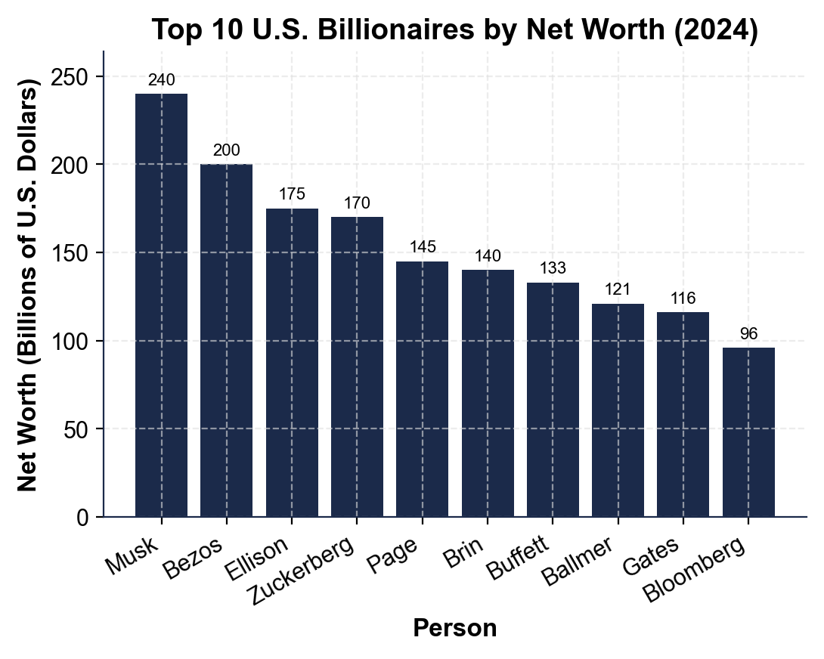
HIGHEST = ELON MUSK at ~$240 billion. LOWEST among the top 10 = MICHAEL BLOOMBERG at ~$96 billion. The chart runs left-to-right: Musk (~$240B), Bezos (~$200B), Ellison (~$175B), Zuckerberg (~$170B), Page (~$145B), Brin (~$140B), Buffett (~$133B), Ballmer (~$121B), Gates (~$116B), Bloomberg (~$96B). Accept readings within $10B of each value.
2. Use the same chart. CALCULATE what Senator Warren's wealth tax would owe annually on Elon Musk's net worth. (Reminder: 2% on net worth between $50 million and $1 billion; 6% on net worth above $1 billion.) Show your math.
Musk's net worth (chart) = ~$240 billion. TIER 1 = 2% on the $50M-$1B band ($0.95B) = $0.019B = ~$19 million. TIER 2 = 6% on everything above $1B = 6% of $239B = $14.34 billion. TOTAL = $14.34B + $0.019B = ~$14.36 BILLION per year. Accept answers in the $14-$15B range. Note: this dwarfs Musk's typical reported INCOME (often near $0 in salary), which is exactly why a wealth tax catches what the income tax misses.
3. Use the EFFECTIVE FEDERAL TAX RATE BY INCOME DECILE chart, inserted below and shown in the slide deck.
Read directly off the chart: what effective rate does the TOP 10% pay, and what effective rate does the TOP 0.01% pay? (Chart: chart_tax_rate_by_decile)
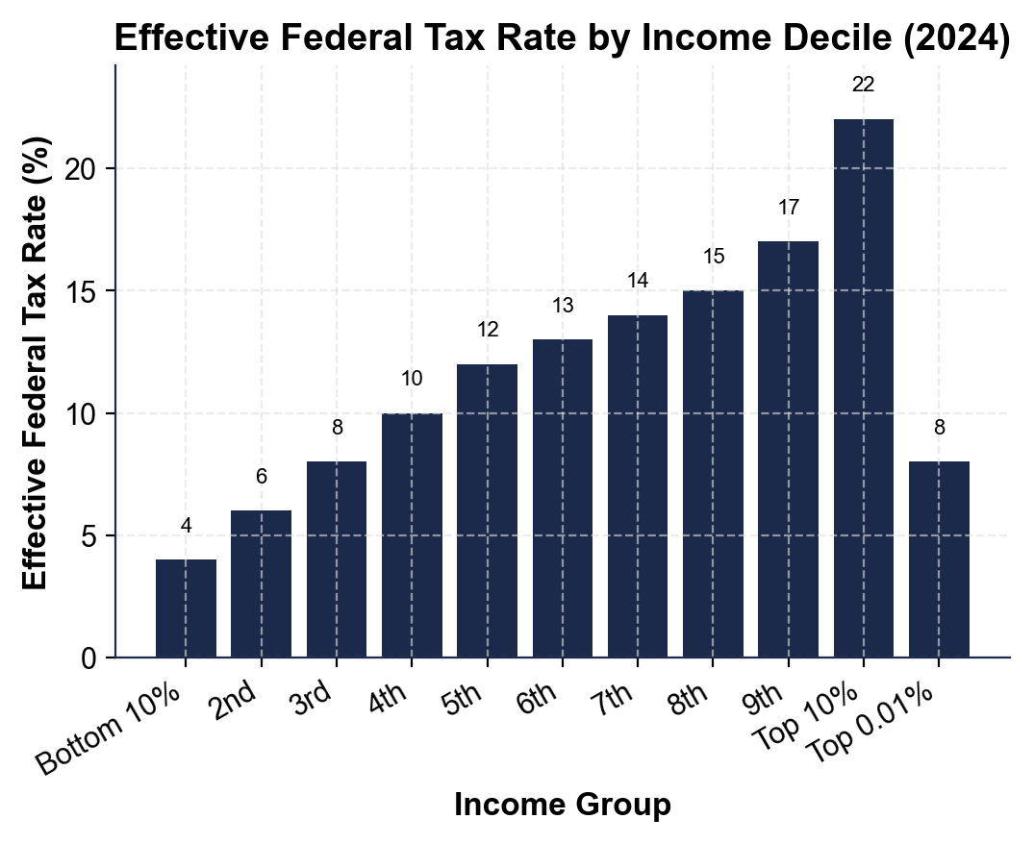
TOP 10% effective tax rate = ~22%. TOP 0.01% effective tax rate = ~8%. Yes - the very richest pay a LOWER effective rate than the merely well-off below them. The chart climbs steadily through the lower deciles, peaks at ~22% for the top 10% block, then drops sharply to ~8% for the top 0.01%. This is exactly what Warren Buffett pointed out - he paid a lower rate than his secretary. Accept 20-24% for the top decile and 7-10% for the top 0.01%.
4. Using the same decile chart, calculate the GAP in effective tax rate between the TOP 10% (~22%) and the TOP 0.01% (~8%). Then use lesson concepts to explain in 2-3 sentences WHY the very top pays so much less. (Hint: capital gains rates, buy-borrow-die.)
GAP = 22% - 8% = 14 percentage points. The very richest pay LESS because: (1) most of their economic income is long-term CAPITAL GAINS (capped at 23.8%) rather than wages (taxed up to 37%), so the legal rate is already lower; (2) they use BUY-BORROW-DIE to avoid realizing those gains at all - hold appreciating stock, borrow against it tax-free, and pass it on at death where stepped-up basis erases the gain; (3) UNREALIZED gains are NOT taxed at all under current law, so even the 23.8% capital-gains rate often never applies. The Buffett Rule and the 2024 minimum tax both target this gap directly.
PART 5

Final Policy Memo to Your Senator
FINAL POLICY MEMO
1. FINAL POLICY MEMO. Write a 7-9 sentence memo to your senator. Pick ONE of the four proposals and recommend it for her town hall. Use the memo header below and check off each required element as you include it. (Sentence starter you may use: "I recommend the senator champion ___ because ___.")
YOUR RESPONSE MUST:
☐ RECOMMENDATION - name ONE proposal (Warren wealth tax, Sanders wealth tax, Buffett Rule, or 2024 billionaire minimum income tax) clearly in your first sentence. Do not hedge.
☐ THREE SPECIFIC FACTS - cite at least THREE specific numbers or facts from the lesson to defend your choice (rates, thresholds, revenue estimates, the ~22% vs ~8% effective-rate gap, the 12-to-3 European track record, etc.).
☐ WINNERS AND LOSERS - name WHO benefits and WHO might lose under your recommendation.
☐ ONE OBJECTION - acknowledge ONE realistic objection an opponent might raise.
☐ ONE TRADE-OFF - state ONE trade-off you accept by choosing this policy.
MEMO
To: Senator (Senate Finance Committee)
From: Avery Chen, Senate Policy Advisor
Date: [student completes]
Re: Town Hall Recommendation - Billionaire Tax
GRADING RUBRIC
Grade the evidence and reasoning, not the conclusion — any defensible position is valid. Score against the 5 requirements above.
FULL CREDIT — clear position; meets all 5 requirements with accurate, specific numbers and evidence from the lesson.
PARTIAL — position stated, but misses 1-2 requirements or uses vague / incorrect numbers.
MINIMAL — no clear position, or missing most requirements and numbers.

MORE LESSONS LESS PLANNING
Thank You!
If you enjoyed this product, please do not forget to rate and review to assist other teachers.

Looking for future discounts? Earn TPT credits by reviewing purchased products.

Please contact me if you have any issues with this product. Just like our students, I am always looking for opportunities to grow.

