The 2022-2024 Inflation Crisis
STUDENT ACTIVITY
Name: | Date: | Period:
ESSENTIAL QUESTION
How did U.S. inflation reach a 40-year high in 2022, what four forces drove it, and did the Fed's rate hikes actually engineer a soft landing by late 2024?
THE SCENARIO
It is December 2024. You are JORDAN CHEN, a junior policy advisor at the Federal Reserve Board in Washington.
BY THE END, YOU CAN:
✓ Trace the 2022-2024 inflation surge from causes through the Fed's response
✓ Identify the four main drivers of the surge: stimulus, supply chains, energy, pent-up demand
✓ Evaluate whether the Fed achieved a soft landing by late 2024
HOW IT WORKS (do Parts 1–5 in order)
Part 1 — Inflation-Crisis Reference Guide - Complete the Missing Terms
Part 2 — Apply the Terms - Inflation-Crisis Vocabulary in Context
Part 3 — Read the Chart - U.S. CPI Inflation Rate (Jan 2020 - Late 2024)
Part 4 — Read the Fed Funds Rate Chart and Diagnose the Four Causes
Part 5 — Jordan Chen's Soft-Landing Verdict Memo for the FOMC
TIME about 45 minutes YOU’LL NEED the lesson slides and your Guided Notes.

PART 1

Inflation-Crisis Reference Guide - Complete the Missing Terms
Fill in the missing term for each blank row — the definition is your clue. Your Guided Notes and the lesson slides have every term.

Term | Definition
___________ | A slowing of the rate of inflation while prices are still rising; the 2023-2024 trend.
Soft landing | Bringing inflation down without causing a recession; the goal of every Fed hiking cycle.
___________ | Federal stimulus checks and direct payments (CARES Act 2020 and American Rescue Plan 2021) that sent money to household budgets and boosted demand.
Supply-chain disruption | Pandemic port and chip-shortage problems - ships waiting at ports while container costs jumped - that made production more expensive (cost-push inflation).
___________ | A sudden spike in oil and gas prices; the 2022 Russia-Ukraine war pushed Brent crude above $120 per barrel.
Pent-up demand | Spending that built up during lockdown and was released all at once when the economy reopened in 2021.
___________ | The rate the Fed raises through rate hikes; it climbed 5.25 percentage points across 11 hikes from March 2022 to July 2023.
Hiking cycle | A sequence of consecutive rate hikes; the 2022-2023 cycle had 11 hikes adding 5.25 percentage points.
___________ | One one-hundredth of a percentage point; a 75 basis-point hike equals 0.75 percentage points.
Recession | A decline in economic activity (falling GDP); the Fed achieved disinflation without a recession - none was officially declared in 2022-2024.

PART 2

Apply the Terms - Inflation-Crisis Vocabulary in Context
WORD BANK energy shock · basis point · disinflation · federal funds rate · covid stimulus
1. Q1. When inflation SLOWS but prices are still rising - so the cost of living keeps climbing, just less quickly than before, as in 2023-2024 - the economy is experiencing .

2. Q2. The 2020-2021 federal checks from the CARES Act and the American Rescue Plan, which put money into household budgets and boosted demand, are an example of .

3. Q3. When the 2022 Russia-Ukraine war pushed Brent crude above $120 a barrel and U.S. gas to $5.02 a gallon, raising the cost of nearly everything that is transported, the U.S. suffered an .

4. Q4. The Fed's main policy interest rate - the overnight rate the FOMC raised again and again across 2022-2023 to cool inflation - is the .

5. Q5. A rate hike of 0.75 percentage points is described as a 75 move; the Fed delivered four of these in a row in 2022.

PART 3

Read the Chart - U.S. CPI Inflation Rate (Jan 2020 - Late 2024)
1. As Jordan Chen, you pull up the official inflation data for your review.
Use the U.S. CPI Inflation Rate line chart (Jan 2020 - late 2024), inserted below and shown in the slide deck, to identify the PEAK inflation rate during the crisis: approximately what was the peak year-over-year rate, and in what month/year did it occur? (Chart: chart_cpi_inflation_2020_2024)
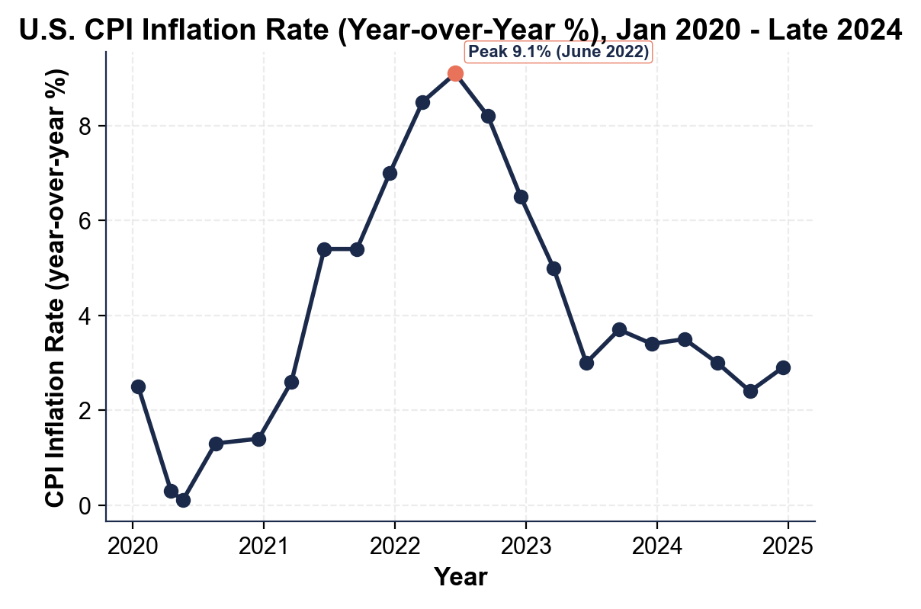

2. As Jordan Chen, use the same CPI chart above to identify what happened to inflation at the start of the COVID pandemic.
Approximately what year-over-year CPI value did the series reach in the spring of 2020, and in what month did this low occur?

3. As Jordan Chen, use the same CPI chart above to describe what happened to inflation between the June 2022 peak and late 2024.
Name at least TWO specific data points (month/year and percent) on the disinflation curve. By late 2024, was inflation above, at, or below the Fed's 2% target? (The 2% target is taught on your slides and Guided Notes - compare your late-2024 chart reading to it.)

PART 4

Read the Fed Funds Rate Chart and Diagnose the Four Causes
1. As Jordan Chen, use the Federal Funds Rate line chart (Mar 2022 - late 2024), inserted below and shown in the slide deck, to describe the Fed's hiking cycle.
What was the starting rate (March 2022)? What was the peak rate (July 2023)? How many percentage points did the Fed add in total, and how many separate rate hikes did this take? (Chart: chart_fed_funds_rate_2022_2024)
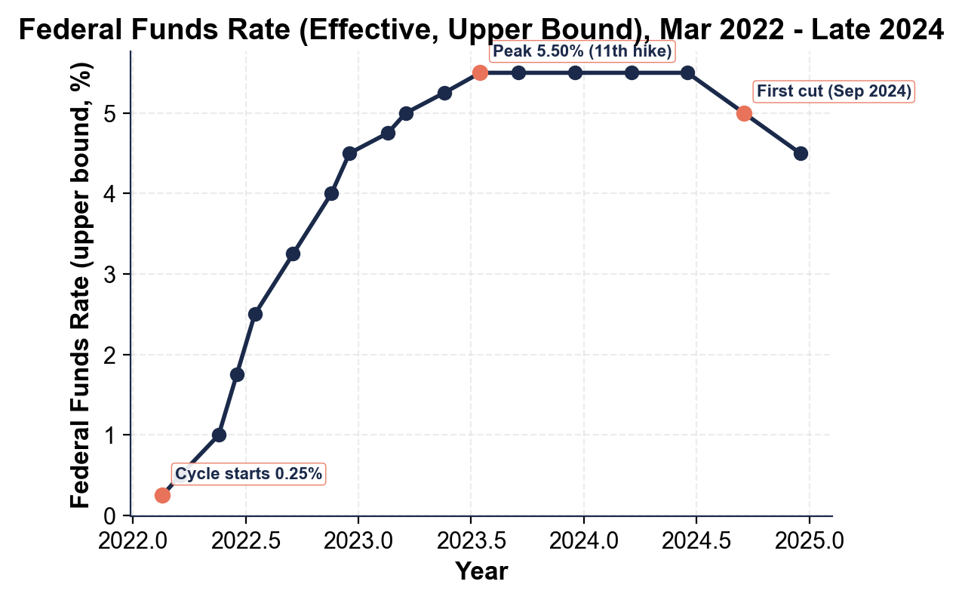

2. As Jordan Chen, use the same federal funds rate chart above to describe what the Fed did between July 2023 and late 2024.
What was the Fed's posture during most of this period, and what changed in September 2024?

3. As Jordan Chen, diagnose the FOUR main causes of the 2022 inflation surge. For EACH cause, write one sentence naming the cause and one sentence explaining specifically how it pushed prices up. Use specific facts from the lesson.

PART 5

Jordan Chen's Soft-Landing Verdict Memo for the FOMC
SOFT-LANDING VERDICT MEMO
1. SOFT-LANDING VERDICT MEMO. Your supervisor is waiting for the written review. As Jordan Chen, write a 7-9 sentence memo (250-330 words) to the FOMC briefing book evaluating the 2022-2024 cycle. Use the memo header below and check off each required element as you include it. (Sentence starters you can use: "After reviewing the 2022-2024 cycle, I grade it as..." and "The strongest evidence for my verdict is... while the strongest evidence against is...")
YOUR RESPONSE MUST:
☐ VERDICT - one sentence stating whether you grade the 2022-2024 cycle as a soft landing (YES, MOSTLY, or NO), with a clear defense.
☐ TWO CPI CHART VALUES - cite at least TWO specific numbers you read off the CPI inflation chart in Part 3 (for example a peak or trough rate and the year it happened, or the late-2024 reading).
☐ TWO FEDERAL-FUNDS CHART VALUES - cite at least TWO specific numbers you read off the federal funds rate chart in Part 4 (for example the starting rate, the peak rate, the total increase, the number of hikes, or the first cut).
☐ TWO CAUSES - name TWO of the four causes (stimulus, supply chains, energy/Ukraine, pent-up demand) and say which one(s) you think the Fed handled well or poorly, and why.
☐ EVIDENCE FOR AND AGAINST - give ONE piece of evidence FOR your verdict AND ONE piece of evidence AGAINST it.
☐ FIVE VOCABULARY TERMS - use at least FIVE lesson vocabulary terms in your memo (e.g., disinflation, federal funds rate, hiking cycle, basis point, soft landing, recession).
MEMO
To: FOMC Briefing Book
From: Jordan Chen, Policy Advisor
Date:
Re: Soft-Landing Verdict on the 2022-2024 Inflation Cycle

