ECONOMICS

THE 2022-2024 INFLATION CRISIS
ANSWER KEY ACTIVITY - ANSWER KEY

PART 1

Inflation-Crisis Reference Guide - Complete the Missing Terms

Term | Definition
Disinflation | A slowing of the rate of inflation while prices are still rising; the 2023-2024 trend.
Soft landing | Bringing inflation down without causing a recession; the goal of every Fed hiking cycle.
COVID stimulus | Federal stimulus checks and direct payments (CARES Act 2020 and American Rescue Plan 2021) that sent money to household budgets and boosted demand.
Supply-chain disruption | Pandemic port and chip-shortage problems - ships waiting at ports while container costs jumped - that made production more expensive (cost-push inflation).
Energy shock | A sudden spike in oil and gas prices; the 2022 Russia-Ukraine war pushed Brent crude above $120 per barrel.
Pent-up demand | Spending that built up during lockdown and was released all at once when the economy reopened in 2021.
Federal funds rate | The rate the Fed raises through rate hikes; it climbed 5.25 percentage points across 11 hikes from March 2022 to July 2023.
Hiking cycle | A sequence of consecutive rate hikes; the 2022-2023 cycle had 11 hikes adding 5.25 percentage points.
Basis point | One one-hundredth of a percentage point; a 75 basis-point hike equals 0.75 percentage points.
Recession | A decline in economic activity (falling GDP); the Fed achieved disinflation without a recession - none was officially declared in 2022-2024.

PART 2

Apply the Terms - Inflation-Crisis Vocabulary in Context
WORD BANK energy shock · basis point · disinflation · federal funds rate · covid stimulus
1. Q1. When inflation SLOWS but prices are still rising - so the cost of living keeps climbing, just less quickly than before, as in 2023-2024 - the economy is experiencing Disinflation.
Disinflation
2. Q2. The 2020-2021 federal checks from the CARES Act and the American Rescue Plan, which put money into household budgets and boosted demand, are an example of COVID stimulus.
COVID stimulus
3. Q3. When the 2022 Russia-Ukraine war pushed Brent crude above $120 a barrel and U.S. gas to $5.02 a gallon, raising the cost of nearly everything that is transported, the U.S. suffered an Energy shock.
Energy shock
4. Q4. The Fed's main policy interest rate - the overnight rate the FOMC raised again and again across 2022-2023 to cool inflation - is the Federal funds rate.
Federal funds rate
5. Q5. A rate hike of 0.75 percentage points is described as a 75 Basis point move; the Fed delivered four of these in a row in 2022.
Basis point
PART 3

Read the Chart - U.S. CPI Inflation Rate (Jan 2020 - Late 2024)
1. As Jordan Chen, you pull up the official inflation data for your review.
Use the U.S. CPI Inflation Rate line chart (Jan 2020 - late 2024), inserted below and shown in the slide deck, to identify the PEAK inflation rate during the crisis: approximately what was the peak year-over-year rate, and in what month/year did it occur? (Chart: chart_cpi_inflation_2020_2024)
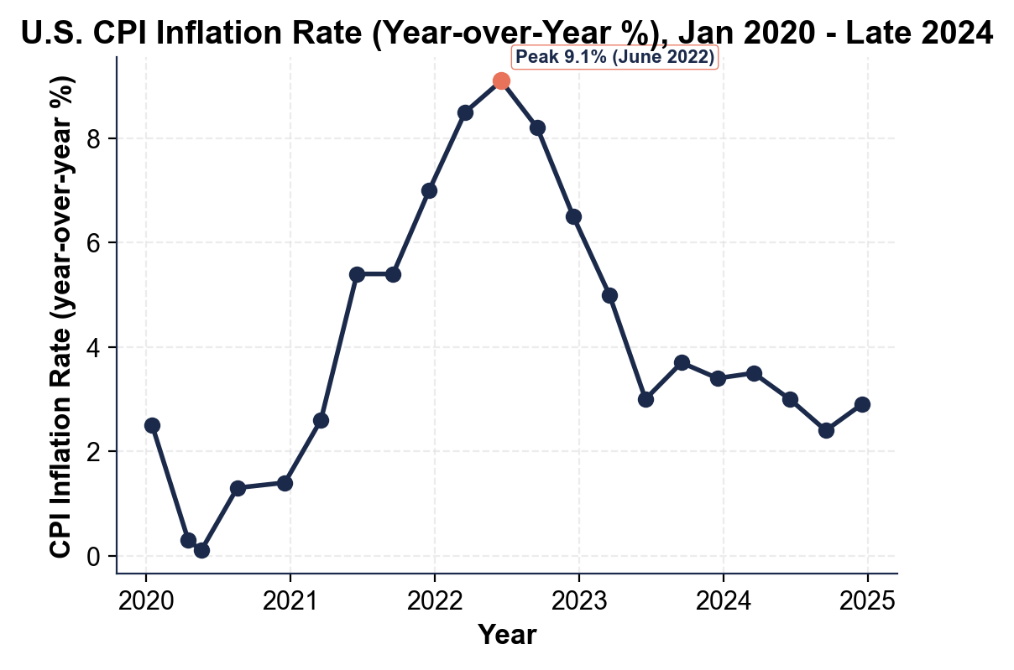
PEAK VALUE: approximately 9.1% year-over-year CPI, reached in JUNE 2022 - the highest annual U.S. inflation rate since November 1981 (a 41-year span). ACCEPTABLE: any reading in the 8.8-9.3% range and any answer naming June 2022 or 'mid-2022.' FULL CREDIT requires BOTH the value (~9.1%) AND the month/year (June 2022); partial credit for naming 2022 without the month.
2. As Jordan Chen, use the same CPI chart above to identify what happened to inflation at the start of the COVID pandemic.
Approximately what year-over-year CPI value did the series reach in the spring of 2020, and in what month did this low occur?
COVID LOW: in MAY 2020, CPI inflation fell to approximately 0.1% year over year - an unusual low driven by the COVID lockdown that crashed consumer demand (gasoline demand collapsed when nobody was driving). ACCEPTABLE: readings of 0.0% to 0.5% and a spring/May 2020 timeframe. WHY IT MATTERS: the surge started from an extremely LOW base, so the climb from 0.1% (May 2020) to 9.1% (June 2022) was about 9 percentage points in 25 months.
3. As Jordan Chen, use the same CPI chart above to describe what happened to inflation between the June 2022 peak and late 2024.
Name at least TWO specific data points (month/year and percent) on the disinflation curve. By late 2024, was inflation above, at, or below the Fed's 2% target? (The 2% target is taught on your slides and Guided Notes - compare your late-2024 chart reading to it.)
DISINFLATION CURVE: from the 9.1% June 2022 peak, CPI fell to about 3.0% by June 2023 (a 6-point drop in 12 months, the fastest since 1982), sat near 3.4% in December 2023, and reached about 2.9% by late 2024. VERSUS TARGET: by late 2024 inflation was still ABOVE the Fed's 2% target, though close. ACCEPTABLE: any TWO valid curve points (e.g., September 2022 ~8.2%, December 2022 ~6.5%, June 2023 ~3.0%, late 2024 ~2.9%) PLUS the verdict that late-2024 inflation was ABOVE the 2% target.
PART 4

Read the Fed Funds Rate Chart and Diagnose the Four Causes
1. As Jordan Chen, use the Federal Funds Rate line chart (Mar 2022 - late 2024), inserted below and shown in the slide deck, to describe the Fed's hiking cycle.
What was the starting rate (March 2022)? What was the peak rate (July 2023)? How many percentage points did the Fed add in total, and how many separate rate hikes did this take? (Chart: chart_fed_funds_rate_2022_2024)
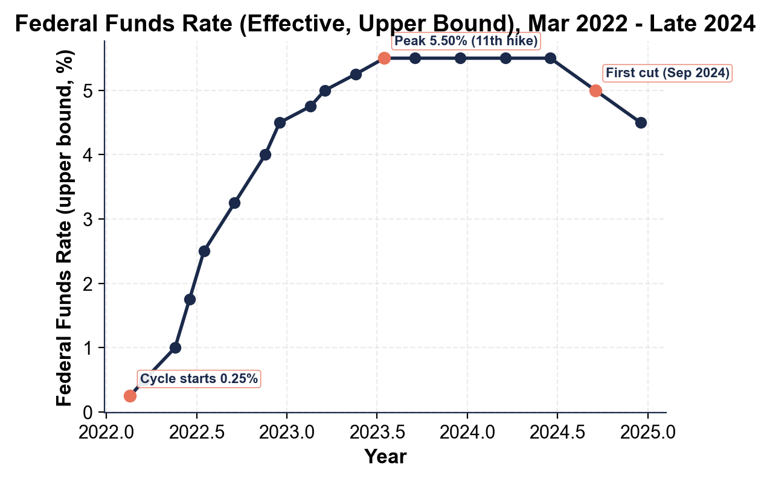
(a) starting rate of 0.25% (b) peak of 5.50% (c) total increase of 5.25 pp, AND (d) 11 hikes. Full credit requires all four numbers.
2. As Jordan Chen, use the same federal funds rate chart above to describe what the Fed did between July 2023 and late 2024.
What was the Fed's posture during most of this period, and what changed in September 2024?
(a) the rate held flat from mid-2023 into mid-2024 (b) the first cut occurred in September 2024, AND (c) the cut signaled the Fed believed inflation had cooled enough to start easing.
3. As Jordan Chen, diagnose the FOUR main causes of the 2022 inflation surge. For EACH cause, write one sentence naming the cause and one sentence explaining specifically how it pushed prices up. Use specific facts from the lesson.
CAUSE 1 - COVID STIMULUS: three rounds of federal direct payments (CARES Act $1,200; Dec 2020 $600; ARP $1,400) injected roughly $931 billion into household pockets while M2 money supply grew 40% in two years - that excess cash showed up as demand-pull inflation in 2021-2022. CAUSE 2 - SUPPLY-CHAIN DISRUPTION: pandemic-era port congestion, factory closures, and the global chip shortage (which idled auto plants) made production more expensive; container costs jumped roughly 7x in 18 months and producers passed costs on as cost-push inflation. CAUSE 3 - ENERGY SHOCK + RUSSIA-UKRAINE WAR: Russia's February 24, 2022 invasion of Ukraine sent Brent crude oil above $120/barrel and pushed U.S. national gasoline to $5.02/gallon in June 2022; because energy is in every supply chain, that spike cascaded through trucking, manufacturing, food, and fertilizer. CAUSE 4 - PENT-UP DEMAND: households built up about $2 trillion in excess savings during lockdown; when vaccines rolled out in spring 2021 the economy reopened and that money flooded back into services ('revenge spending'), overwhelming a supply still constrained by cause 2. FULL CREDIT: names all 4 causes AND gives one specific data point or mechanism per cause; partial credit per cause.
PART 5

Jordan Chen's Soft-Landing Verdict Memo for the FOMC
SOFT-LANDING VERDICT MEMO
1. SOFT-LANDING VERDICT MEMO. Your supervisor is waiting for the written review. As Jordan Chen, write a 7-9 sentence memo (250-330 words) to the FOMC briefing book evaluating the 2022-2024 cycle. Use the memo header below and check off each required element as you include it. (Sentence starters you can use: "After reviewing the 2022-2024 cycle, I grade it as..." and "The strongest evidence for my verdict is... while the strongest evidence against is...")
YOUR RESPONSE MUST:
☐ VERDICT - one sentence stating whether you grade the 2022-2024 cycle as a soft landing (YES, MOSTLY, or NO), with a clear defense.
☐ TWO CPI CHART VALUES - cite at least TWO specific numbers you read off the CPI inflation chart in Part 3 (for example a peak or trough rate and the year it happened, or the late-2024 reading).
☐ TWO FEDERAL-FUNDS CHART VALUES - cite at least TWO specific numbers you read off the federal funds rate chart in Part 4 (for example the starting rate, the peak rate, the total increase, the number of hikes, or the first cut).
☐ TWO CAUSES - name TWO of the four causes (stimulus, supply chains, energy/Ukraine, pent-up demand) and say which one(s) you think the Fed handled well or poorly, and why.
☐ EVIDENCE FOR AND AGAINST - give ONE piece of evidence FOR your verdict AND ONE piece of evidence AGAINST it.
☐ FIVE VOCABULARY TERMS - use at least FIVE lesson vocabulary terms in your memo (e.g., disinflation, federal funds rate, hiking cycle, basis point, soft landing, recession).
MEMO
To: FOMC Briefing Book
From: Jordan Chen, Policy Advisor
Date: [student completes]
Re: Soft-Landing Verdict on the 2022-2024 Inflation Cycle
GRADING RUBRIC
Grade the evidence and reasoning, not the conclusion — any defensible position is valid. Score against the 6 requirements above.
FULL CREDIT — clear position; meets all 6 requirements with accurate, specific numbers and evidence from the lesson.
PARTIAL — position stated, but misses 1-2 requirements or uses vague / incorrect numbers.
MINIMAL — no clear position, or missing most requirements and numbers.

MORE LESSONS LESS PLANNING
Thank You!
If you enjoyed this product, please do not forget to rate and review to assist other teachers.

Looking for future discounts? Earn TPT credits by reviewing purchased products.

Please contact me if you have any issues with this product. Just like our students, I am always looking for opportunities to grow.

