ECONOMICS

TAYLOR SWIFT ECONOMICS: CONCERT TICKET PRICING
ACTIVITY

Name: | Date: | Period:

CASE FILE

Confidential Investigation
CASE FILE - Riley Carter, consumer-affairs market analyst investigating the Eras Tour ticket meltdown (you are a student investigator on Riley Carter's consumer-affairs team, opening the case file on why millions of fans could not buy Taylor Swift Eras Tour tickets at face value in 2022, why the show sold out in minutes, why prices on resale sites skyrocketed, and how dynamic 'surge' pricing fits in - using Unit 2 supply and demand to explain what really happened)
STATUS: ACTIVE INVESTIGATION

DIRECTIONS

Instructions
START HERE: This is a CASE FILE. Read the cover, then work the three Evidence Items and the Analyst's Worksheet using the four Chart References at the end of the packet, and finish with Riley Carter's Final Report. The lettered steps below give the full work order.

A. READ THE CASE FILE COVER first so you know what Riley Carter is investigating: why the Eras Tour show sold out in minutes and then exploded on resale.
B. WORK THROUGH THE THREE EVIDENCE ITEMS in order. Each Evidence Item tells you which Chart Reference (1, 2, or 3) to use - all charts are at the END of this packet. Evidence 1 = the shortage chart; Evidence 2 = the surge-pricing chart; Evidence 3 = the resale-markup bar chart. Read the values off the charts before you answer.
C. COMPLETE THE ANALYST'S WORKSHEET with Riley Carter using Chart Reference 4 (the Eras-announcement demand-shift chart) - read the old and new equilibrium and explain the demand shift against fixed supply.
D. WRITE Riley Carter'S FINAL REPORT (6-8 sentences). Check off the 6 required elements and use all four required terms (shortage, equilibrium price, fixed supply, secondary market) at least once each.
E. USE THE CASE GLOSSARY at the bottom of the packet as your reference for the key supply-and-demand terms. Five of the ten terms are blanked - fill them in using your Guided Notes and the Slides.

EVIDENCE ITEM 1

Why a Sold-Out Show Is a Shortage - Riley Carter Opens the Case
1. WHY A SOLD-OUT SHOW IS A SHORTAGE. Riley Carter hands you the first chart. Use Chart Reference 1 (chart_face_value_shortage) - the face-value shortage chart shown below.
(a) Read the equilibrium off the chart: what is the equilibrium PRICE and the quantity of seats?

(b) Why is the SUPPLY curve nearly vertical in this market?

(c) What is the FACE VALUE price, and is it above or below the equilibrium price?

2. READ THE GAP. Staying with Chart Reference 1, help Riley Carter explain the meltdown.
(a) At the $90 face value, is the quantity DEMANDED larger or smaller than the 50,000 fixed seats?

(b) What do we call it when quantity demanded is greater than quantity supplied?

(c) In plain English, what does this shortage look like to a fan trying to buy a ticket?

EVIDENCE ITEM 2

Dynamic ('Surge') Pricing - Riley Carter Tests a Fix
1. DYNAMIC ("SURGE") PRICING. Riley Carter wants to know what happens if the listed price is allowed to rise. Use Chart Reference 2 (chart_surge_pricing) - the surge-pricing chart shown below.
(a) Read the two coral points on the demand curve: what is the price at the FACE-VALUE point, and what is the price at the SURGE/clearing point?

(b) Do both points sit on the SAME demand curve, or on two different curves?

(c) What single thing changed to move from the first point to the second?

2. MOVEMENT OR SHIFT, AND WHAT IT DOES TO THE SHORTAGE. Staying with Chart Reference 2, finish the analysis for Riley Carter.
(a) Because only the ticket's OWN price changed, is the slide from $90 to $450 a MOVEMENT along the curve or a SHIFT of the curve?

(b) As the listed price rises toward equilibrium, what happens to the quantity demanded?

(c) What does surge pricing do to the SHORTAGE?

EVIDENCE ITEM 3

The Resale (Secondary) Market - Riley Carter Follows the Money
1. THE RESALE (SECONDARY) MARKET. Riley Carter pulls the resale data. Use Chart Reference 3 (chart_resale_markup) - the resale-markup bar chart shown below.
(a) For EACH of the four seat tiers, read the FACE VALUE and the RESALE price off the bars (Nosebleed, Upper Level, Lower Level, Floor).

(b) Which tier shows the BIGGEST gap between face value and resale price?

2. WHY DOES RESALE EXIST? Staying with Chart Reference 3, explain the secondary market to Riley Carter.
(a) In every tier the resale price is far ABOVE face value. Why does that happen when face value is held below the equilibrium price?

(b) What is it called when someone buys a ticket at the low face value and resells it for more?

(c) If the face value had been set AT the equilibrium price instead, what would happen to the resale markup?

ANALYST'S WORKSHEET

The Tour Announcement and the Demand Shift - Riley Carter Connects the Dots
1. AW-Q1. THE TOUR ANNOUNCEMENT - A DEMAND SHIFT. Riley Carter connects the meltdown to the announcement. Use Chart Reference 4 (chart_demand_shift_eras) - the Eras-announcement demand-shift chart shown below.
(a) What non-price factor caused the change shown on this chart?

(b) Did the WHOLE demand curve move to a new position, or did one point slide along the old curve?

(c) Which DIRECTION did the demand curve move?

2. AW-Q2. READ THE NEW EQUILIBRIUM. Staying with Chart Reference 4, finish the worksheet for Riley Carter.
(a) Read the OLD equilibrium (before the announcement) and the NEW equilibrium (after the announcement): what price and quantity does each show?

(b) Why does the QUANTITY stay the same even though demand shifted right?

(c) What happened to the equilibrium PRICE, and why is the price effect so large in this market?

FINAL REPORT

Riley Carter's Final Report on the Ticket Meltdown
To: Lead Investigator
From: ___________________________
Re: Riley Carter's case
FINAL REPORT
1. FR-Q1. Riley Carter'S FINAL REPORT. Close the case for Riley Carter, the consumer-affairs market analyst leading this investigation. Write a 6-8 sentence FINAL REPORT to the Lead Investigator that ties all four pieces of evidence together and answers: 'Why did the Eras Tour show sell out in minutes and then explode on resale - and what would change the outcome?' You MUST use the four required terms - SHORTAGE, EQUILIBRIUM PRICE, FIXED SUPPLY, and SECONDARY MARKET - at least once each. The report MUST address each required element below.
FINAL REPORT FORMAT (the header is filled in for you on the worksheet):
To: Lead Investigator
From: [Your name - leave bracketed]
Re: Riley Carter's case - the Eras Tour ticket meltdown
YOUR RESPONSE MUST:
☐ States that a sold-out show is a SHORTAGE: the FACE VALUE was set BELOW the EQUILIBRIUM PRICE.
☐ Explains FIXED SUPPLY - the venue has a set number of seats, so the supply curve is nearly vertical and the price cannot add seats.
☐ Explains the SECONDARY MARKET / scalping: a below-equilibrium face value lets resellers capture the gap, so resale prices climb far above face value (cite the Floor tier $450 -> about $1,900 if you can).
☐ Explains dynamic/surge pricing as a MOVEMENT along the demand curve that raises the listed price toward equilibrium and shrinks the shortage.
☐ Explains that the tour announcement was a non-price popularity surge that SHIFTED demand right, raising the equilibrium price (about $300 -> $450) while quantity stayed at the fixed seat count.
☐ Closes with one clear recommendation or takeaway (for example, setting face value closer to equilibrium would shrink both the shortage and the resale market).

Case Glossary

Term | Definition
___________ | When quantity demanded is greater than quantity supplied; it happens when the price is set BELOW the equilibrium price (a sold-out show is a shortage you can see)
Equilibrium price | The price where quantity demanded equals quantity supplied; the market-clearing price (about $450 for these tickets)
___________ | A supply that cannot change with price; a venue has a set number of seats, so its supply curve is nearly vertical
Face value | The original price printed on the ticket, set by the seller; here it was held BELOW equilibrium ($90)
___________ | Also called surge pricing; letting the listed price rise and fall with demand so it moves toward the equilibrium price and shrinks the shortage
Secondary market | The RESALE market where fans buy and sell tickets after the original sale; when face value is below equilibrium, resale prices rise far above face value
___________ | Buying tickets at the low face value and reselling them at a higher price; profitable only when face value is set below the equilibrium price
Movement along the curve | A slide from one point to another on the SAME curve, caused only by a change in the good's OWN price (a change in quantity demanded)
___________ | The WHOLE curve moves left or right, caused by a NON-PRICE factor such as a surge in popularity (a change in demand)
Demand | How much buyers are willing and able to buy at each price; for a hot tour, demand is huge and the demand curve is far to the right

CHART REFERENCE 1: WHY A SOLD-OUT SHOW MEANS A SHORTAGE (FACE VALUE BELOW EQUILIBRIUM)

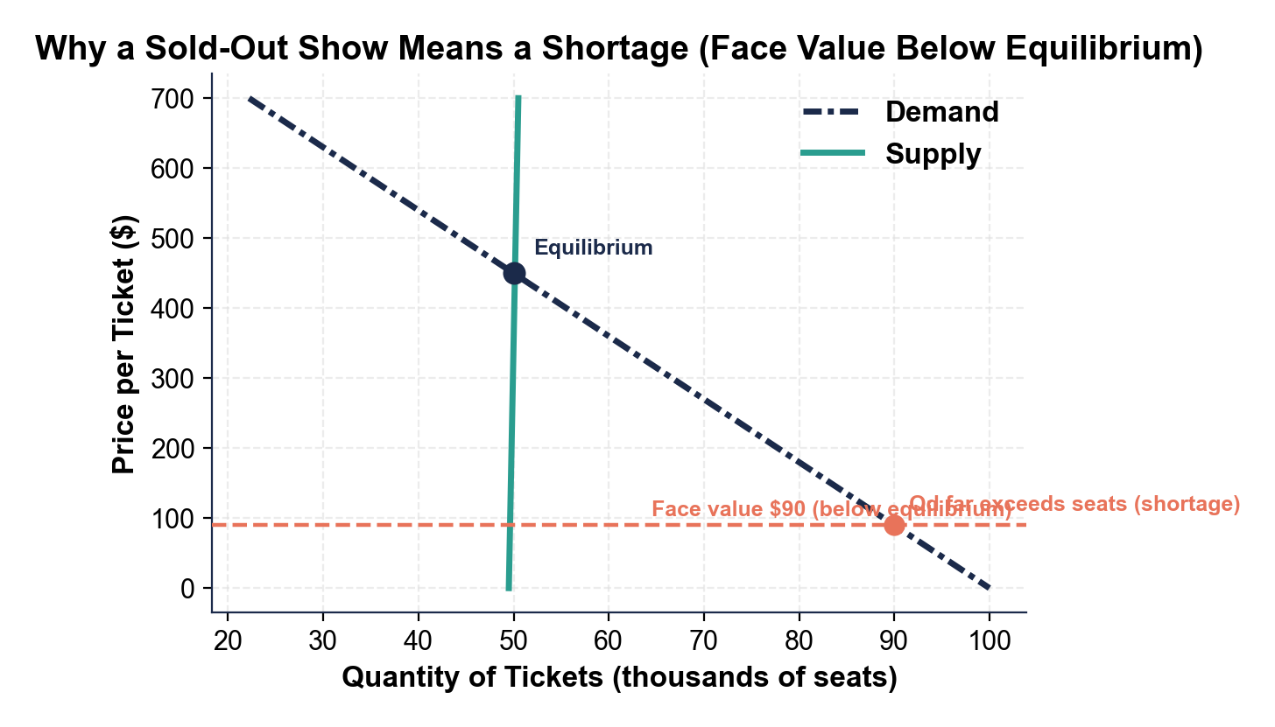

CHART REFERENCE 2: DYNAMIC ('SURGE') PRICING MOVES PRICE TOWARD EQUILIBRIUM

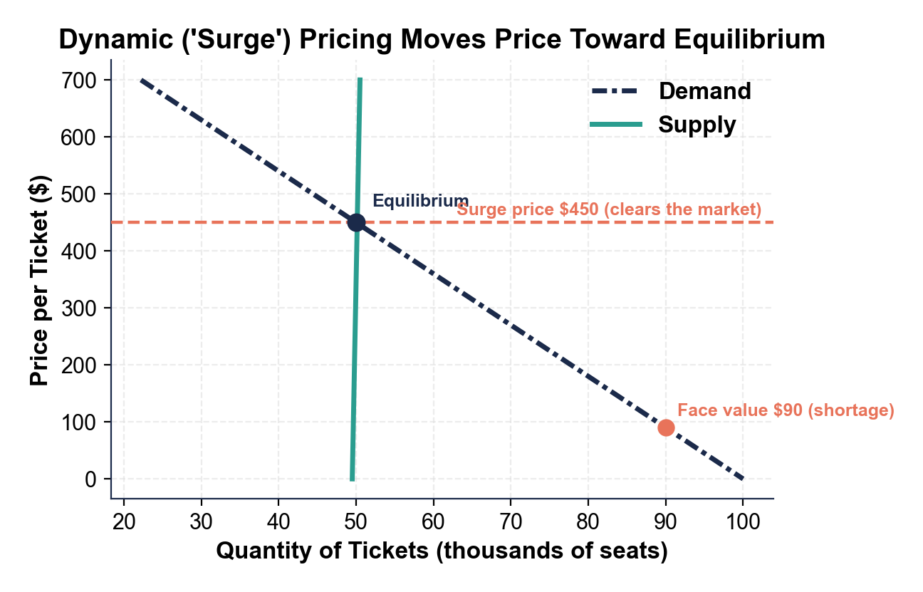

CHART REFERENCE 3: FACE VALUE VS RESALE PRICE BY SEAT TIER (SECONDARY MARKET)

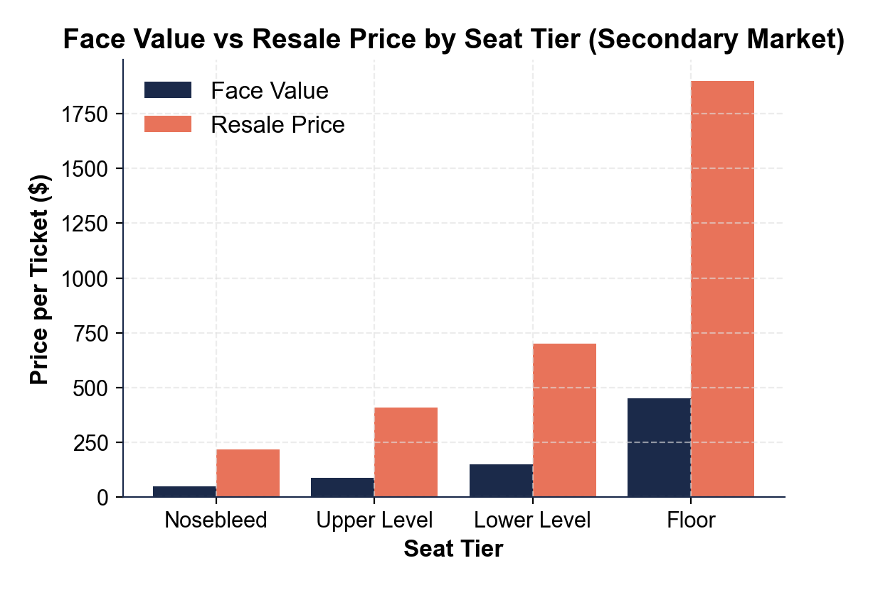

CHART REFERENCE 4: A DEMAND SHIFT - THE ERAS TOUR ANNOUNCEMENT

