ECONOMICS

TAYLOR SWIFT ECONOMICS: CONCERT TICKET PRICING
ANSWER KEY ACTIVITY

CASE FILE

Confidential Investigation
CASE FILE - Riley Carter, consumer-affairs market analyst investigating the Eras Tour ticket meltdown (you are a student investigator on Riley Carter's consumer-affairs team, opening the case file on why millions of fans could not buy Taylor Swift Eras Tour tickets at face value in 2022, why the show sold out in minutes, why prices on resale sites skyrocketed, and how dynamic 'surge' pricing fits in - using Unit 2 supply and demand to explain what really happened)
STATUS: ACTIVE INVESTIGATION

DIRECTIONS

Instructions
START HERE: This is a CASE FILE. Read the cover, then work the three Evidence Items and the Analyst's Worksheet using the four Chart References at the end of the packet, and finish with Riley Carter's Final Report. The lettered steps below give the full work order.

A. READ THE CASE FILE COVER first so you know what Riley Carter is investigating: why the Eras Tour show sold out in minutes and then exploded on resale.
B. WORK THROUGH THE THREE EVIDENCE ITEMS in order. Each Evidence Item tells you which Chart Reference (1, 2, or 3) to use - all charts are at the END of this packet. Evidence 1 = the shortage chart; Evidence 2 = the surge-pricing chart; Evidence 3 = the resale-markup bar chart. Read the values off the charts before you answer.
C. COMPLETE THE ANALYST'S WORKSHEET with Riley Carter using Chart Reference 4 (the Eras-announcement demand-shift chart) - read the old and new equilibrium and explain the demand shift against fixed supply.
D. WRITE Riley Carter'S FINAL REPORT (6-8 sentences). Check off the 6 required elements and use all four required terms (shortage, equilibrium price, fixed supply, secondary market) at least once each.
E. USE THE CASE GLOSSARY at the bottom of the packet as your reference for the key supply-and-demand terms. Five of the ten terms are blanked - fill them in using your Guided Notes and the Slides.

EVIDENCE ITEM 1

Why a Sold-Out Show Is a Shortage - Riley Carter Opens the Case
1. WHY A SOLD-OUT SHOW IS A SHORTAGE. Riley Carter hands you the first chart. Use Chart Reference 1 (chart_face_value_shortage) - the face-value shortage chart shown below.
(a) Read the equilibrium off the chart: what is the equilibrium PRICE and the quantity of seats?
The equilibrium price is about $450 and the quantity is the fixed seat count, about 50 thousand seats.
(b) Why is the SUPPLY curve nearly vertical in this market?
The supply curve is nearly vertical because the venue has a FIXED number of seats - raising the price cannot add more seats, so quantity supplied stays at about 50 thousand no matter the price.
(c) What is the FACE VALUE price, and is it above or below the equilibrium price?
The face value is $90, which is far BELOW the $450 equilibrium price (shown by the coral dashed line low on the chart). Riley Carter notes that a price set below equilibrium is the setup for a shortage.
2. READ THE GAP. Staying with Chart Reference 1, help Riley Carter explain the meltdown.
(a) At the $90 face value, is the quantity DEMANDED larger or smaller than the 50,000 fixed seats?
At the $90 face value the quantity demanded is FAR LARGER than the 50,000 fixed seats - many more fans want a ticket than there are seats.
(b) What do we call it when quantity demanded is greater than quantity supplied?
When quantity demanded is greater than quantity supplied, it is a SHORTAGE.
(c) In plain English, what does this shortage look like to a fan trying to buy a ticket?
To a fan, the shortage looks like the show 'selling out in minutes' - the website crashes, the seats are gone almost instantly, and most fans who wanted a ticket at $90 cannot get one.

EVIDENCE ITEM 2

Dynamic ('Surge') Pricing - Riley Carter Tests a Fix
1. DYNAMIC ("SURGE") PRICING. Riley Carter wants to know what happens if the listed price is allowed to rise. Use Chart Reference 2 (chart_surge_pricing) - the surge-pricing chart shown below.
(a) Read the two coral points on the demand curve: what is the price at the FACE-VALUE point, and what is the price at the SURGE/clearing point?
The face-value point is at $90 and the surge/clearing point is at $450 (the equilibrium price).
(b) Do both points sit on the SAME demand curve, or on two different curves?
Both points sit on the SAME demand curve.
(c) What single thing changed to move from the first point to the second?
The only thing that changed is the ticket's OWN listed price - it rose from $90 toward $450. Riley Carter notes that nothing else changed: same fans, same tour, same fixed seats.
2. MOVEMENT OR SHIFT, AND WHAT IT DOES TO THE SHORTAGE. Staying with Chart Reference 2, finish the analysis for Riley Carter.
(a) Because only the ticket's OWN price changed, is the slide from $90 to $450 a MOVEMENT along the curve or a SHIFT of the curve?
It is a MOVEMENT along the demand curve (a change in quantity demanded) because only the ticket's own price changed - buyers slide up the same curve.
(b) As the listed price rises toward equilibrium, what happens to the quantity demanded?
As the listed price rises toward $450, the quantity demanded FALLS until it meets the 50,000 fixed seats.
(c) What does surge pricing do to the SHORTAGE?
Surge pricing SHRINKS the shortage: by raising the price to the clearing price ($450), quantity demanded drops to exactly the number of seats, so the shortage disappears.

EVIDENCE ITEM 3

The Resale (Secondary) Market - Riley Carter Follows the Money
1. THE RESALE (SECONDARY) MARKET. Riley Carter pulls the resale data. Use Chart Reference 3 (chart_resale_markup) - the resale-markup bar chart shown below.
(a) For EACH of the four seat tiers, read the FACE VALUE and the RESALE price off the bars (Nosebleed, Upper Level, Lower Level, Floor).
NOSEBLEED: face value $50, resale $220. UPPER LEVEL: face value $90, resale $410. LOWER LEVEL: face value $150, resale $700. FLOOR: face value $450, resale about $1,900.
(b) Which tier shows the BIGGEST gap between face value and resale price?
The FLOOR tier shows the biggest gap - $450 face value up to about $1,900 resale. Riley Carter circles the Floor row as the clearest example of the resale markup.
2. WHY DOES RESALE EXIST? Staying with Chart Reference 3, explain the secondary market to Riley Carter.
(a) In every tier the resale price is far ABOVE face value. Why does that happen when face value is held below the equilibrium price?
Because face value was held BELOW the equilibrium price, anyone who buys at face value gets a ticket worth far more than they paid. The resale (secondary) market lets them sell it for what fans will actually pay - close to the equilibrium price - so resale prices climb far above face value.
(b) What is it called when someone buys a ticket at the low face value and resells it for more?
Buying at the low face value and reselling higher is called SCALPING.
(c) If the face value had been set AT the equilibrium price instead, what would happen to the resale markup?
If the face value had been set AT the equilibrium price, there would be little or no gap to capture, so the resale markup would mostly disappear. Riley Carter concludes the resale boom is driven by the below-equilibrium face value.

ANALYST'S WORKSHEET

The Tour Announcement and the Demand Shift - Riley Carter Connects the Dots
1. AW-Q1. THE TOUR ANNOUNCEMENT - A DEMAND SHIFT. Riley Carter connects the meltdown to the announcement. Use Chart Reference 4 (chart_demand_shift_eras) - the Eras-announcement demand-shift chart shown below.
(a) What non-price factor caused the change shown on this chart?
The non-price factor is a huge surge in POPULARITY (tastes) caused by the blockbuster tour announcement - fans suddenly want tickets much more.
(b) Did the WHOLE demand curve move to a new position, or did one point slide along the old curve?
The WHOLE demand curve moved to a new position - this is a SHIFT, not a movement.
(c) Which DIRECTION did the demand curve move?
The demand curve shifted to the RIGHT, because fans want tickets at every price. Riley Carter notes that the ticket's own price did not cause this - the announcement did.
2. AW-Q2. READ THE NEW EQUILIBRIUM. Staying with Chart Reference 4, finish the worksheet for Riley Carter.
(a) Read the OLD equilibrium (before the announcement) and the NEW equilibrium (after the announcement): what price and quantity does each show?
The OLD equilibrium (before the announcement) was about $300 and 50 thousand seats. The NEW equilibrium (after the announcement) is about $450 and the same 50 thousand seats.
(b) Why does the QUANTITY stay the same even though demand shifted right?
The quantity stays the same because SUPPLY is FIXED - the venue still has only about 50,000 seats no matter how far demand shifts.
(c) What happened to the equilibrium PRICE, and why is the price effect so large in this market?
The equilibrium price jumped sharply, from about $300 to $450. The price effect is so large because supply is fixed (nearly vertical): when demand shifts right against a fixed supply, almost the entire effect shows up as a higher price rather than more seats.

FINAL REPORT

Riley Carter's Final Report on the Ticket Meltdown
To: Lead Investigator
From: [Student investigator]
Re: Riley Carter's case
FINAL REPORT
1. FR-Q1. Riley Carter'S FINAL REPORT. Close the case for Riley Carter, the consumer-affairs market analyst leading this investigation. Write a 6-8 sentence FINAL REPORT to the Lead Investigator that ties all four pieces of evidence together and answers: 'Why did the Eras Tour show sell out in minutes and then explode on resale - and what would change the outcome?' You MUST use the four required terms - SHORTAGE, EQUILIBRIUM PRICE, FIXED SUPPLY, and SECONDARY MARKET - at least once each. The report MUST address each required element below.
FINAL REPORT FORMAT (the header is filled in for you on the worksheet):
To: Lead Investigator
From: [Your name - leave bracketed]
Re: Riley Carter's case - the Eras Tour ticket meltdown
YOUR RESPONSE MUST:
☐ States that a sold-out show is a SHORTAGE: the FACE VALUE was set BELOW the EQUILIBRIUM PRICE.
☐ Explains FIXED SUPPLY - the venue has a set number of seats, so the supply curve is nearly vertical and the price cannot add seats.
☐ Explains the SECONDARY MARKET / scalping: a below-equilibrium face value lets resellers capture the gap, so resale prices climb far above face value (cite the Floor tier $450 -> about $1,900 if you can).
☐ Explains dynamic/surge pricing as a MOVEMENT along the demand curve that raises the listed price toward equilibrium and shrinks the shortage.
☐ Explains that the tour announcement was a non-price popularity surge that SHIFTED demand right, raising the equilibrium price (about $300 -> $450) while quantity stayed at the fixed seat count.
☐ Closes with one clear recommendation or takeaway (for example, setting face value closer to equilibrium would shrink both the shortage and the resale market).
GRADING RUBRIC
Grade the evidence and reasoning, not the conclusion — any defensible position is valid. Score against the 6 requirements above.
FULL CREDIT — clear position; meets all 6 requirements with accurate, specific numbers and evidence from the lesson.
PARTIAL — position stated, but misses 1-2 requirements or uses vague / incorrect numbers.
MINIMAL — no clear position, or missing most requirements and numbers.
WHAT TO LOOK FOR IN THIS LESSON
Sample full-credit FINAL REPORT (ties all four findings together):
To: Lead Investigator
From: [Student investigator]
Re: Riley Carter's case - the Eras Tour ticket meltdown
[1] Riley Carter and I conclude that the 'sold-out in minutes' meltdown was a textbook SHORTAGE: the $90 FACE VALUE was set far below the roughly $450 EQUILIBRIUM PRICE, so at $90 far more fans wanted a ticket than there were seats. [2] The shortage was guaranteed by FIXED SUPPLY - the venue has about 50,000 seats and the supply curve is nearly vertical, so raising the price cannot add seats. [3] Because face value sat below equilibrium, a huge SECONDARY MARKET appeared: resellers bought at the low face value and resold for what fans would really pay, with Floor seats jumping from $450 face value to about $1,900 on resale (scalping). [4] Dynamic ('surge') pricing is one response - letting the listed price rise from $90 toward $450 is a MOVEMENT along the demand curve (only the ticket's own price changed), and it shrinks the shortage because quantity demanded falls to meet the fixed seats. [5] The meltdown got worse because the tour announcement was a non-price popularity surge that SHIFTED the whole demand curve to the right, pushing the equilibrium price from about $300 to $450 while quantity stayed pinned at 50,000 seats. [6] Recommendation: setting the face value closer to the equilibrium price would shrink both the shortage and the resale market, though it would make tickets more expensive for fans up front.
REQUIRED-ELEMENT CHECKLIST (award credit per item):
[1] Sold-out = SHORTAGE; face value below EQUILIBRIUM PRICE.
[2] FIXED SUPPLY = nearly vertical supply; price cannot add seats.
[3] SECONDARY MARKET / scalping driven by below-equilibrium face value (Floor $450 -> ~$1,900).
[4] Surge pricing = MOVEMENT along the demand curve that shrinks the shortage.
[5] Tour announcement = non-price demand SHIFT right; price $300 -> $450, quantity fixed.
[6] One clear recommendation or takeaway.
ACCEPTABLE ALTERNATES: Any report that correctly identifies the sold-out show as a shortage from a below-equilibrium face value, explains fixed supply, explains the secondary market, and connects either surge pricing (movement) or the announcement (shift) is fully acceptable, even if the recommendation differs.
Case Glossary

Term | Definition
Shortage | When quantity demanded is greater than quantity supplied; it happens when the price is set BELOW the equilibrium price (a sold-out show is a shortage you can see)
Equilibrium price | The price where quantity demanded equals quantity supplied; the market-clearing price (about $450 for these tickets)
Fixed supply | A supply that cannot change with price; a venue has a set number of seats, so its supply curve is nearly vertical
Face value | The original price printed on the ticket, set by the seller; here it was held BELOW equilibrium ($90)
Dynamic pricing | Also called surge pricing; letting the listed price rise and fall with demand so it moves toward the equilibrium price and shrinks the shortage
Secondary market | The RESALE market where fans buy and sell tickets after the original sale; when face value is below equilibrium, resale prices rise far above face value
Scalping | Buying tickets at the low face value and reselling them at a higher price; profitable only when face value is set below the equilibrium price
Movement along the curve | A slide from one point to another on the SAME curve, caused only by a change in the good's OWN price (a change in quantity demanded)
Shift of the curve | The WHOLE curve moves left or right, caused by a NON-PRICE factor such as a surge in popularity (a change in demand)
Demand | How much buyers are willing and able to buy at each price; for a hot tour, demand is huge and the demand curve is far to the right

CHART REFERENCE 1: WHY A SOLD-OUT SHOW MEANS A SHORTAGE (FACE VALUE BELOW EQUILIBRIUM)

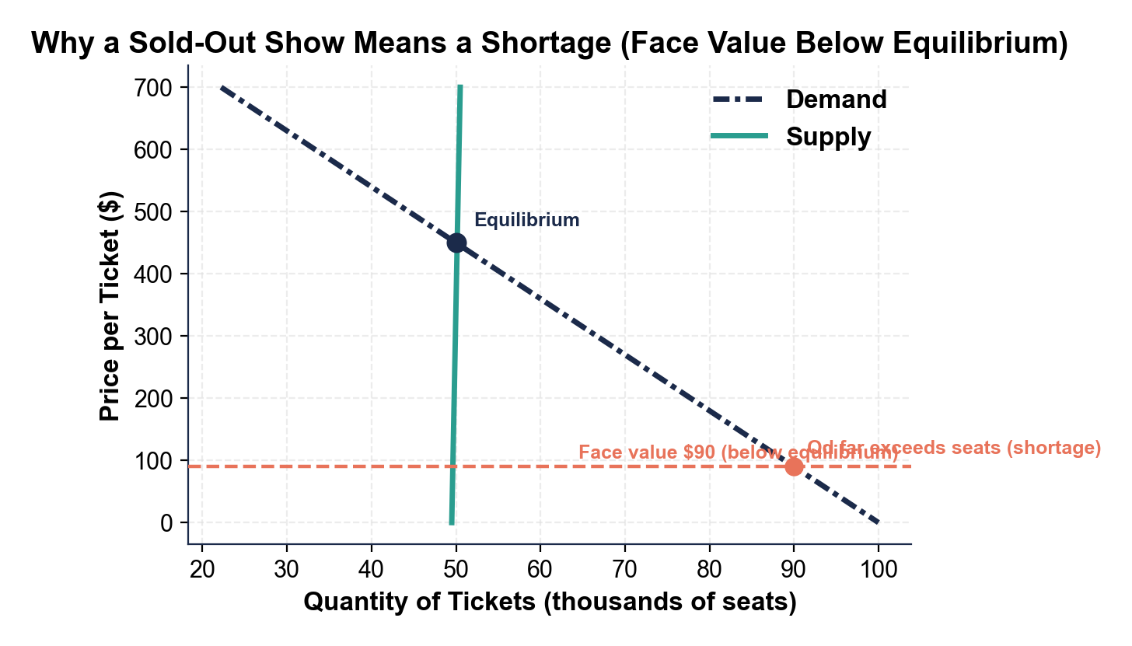

CHART REFERENCE 2: DYNAMIC ('SURGE') PRICING MOVES PRICE TOWARD EQUILIBRIUM

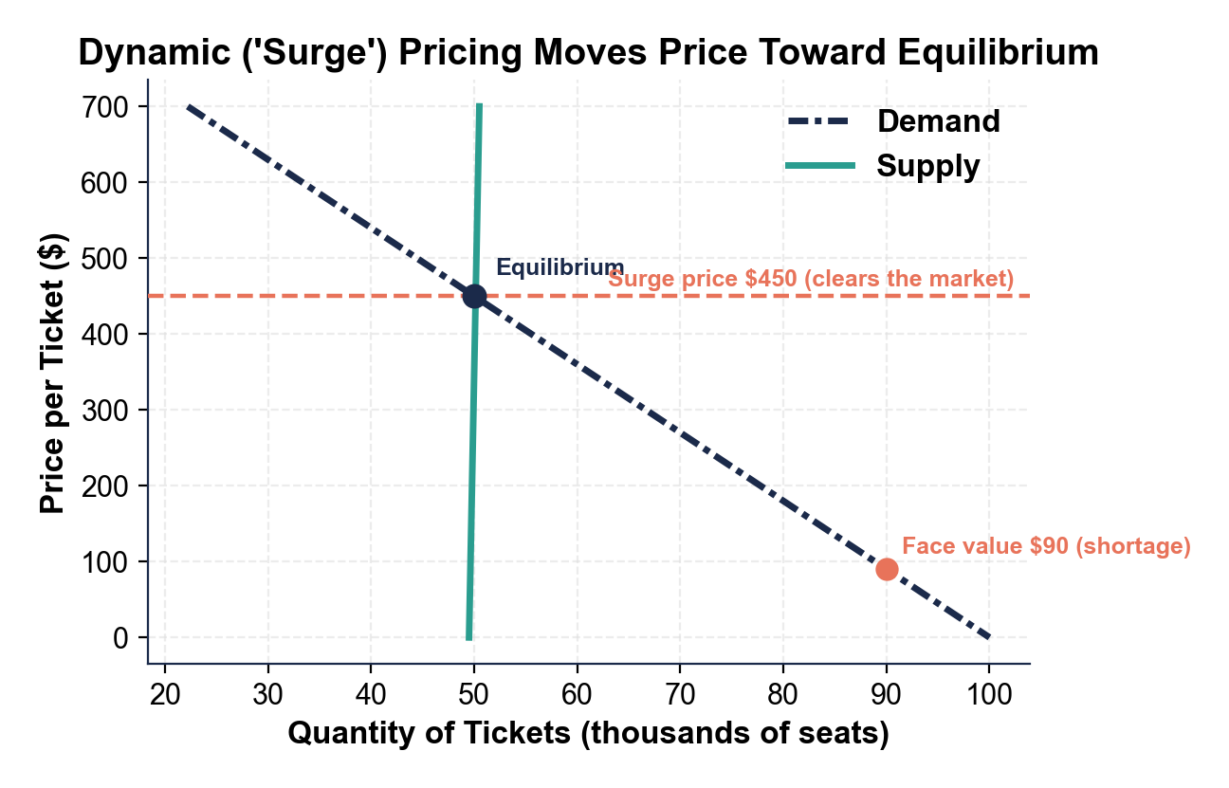

CHART REFERENCE 3: FACE VALUE VS RESALE PRICE BY SEAT TIER (SECONDARY MARKET)

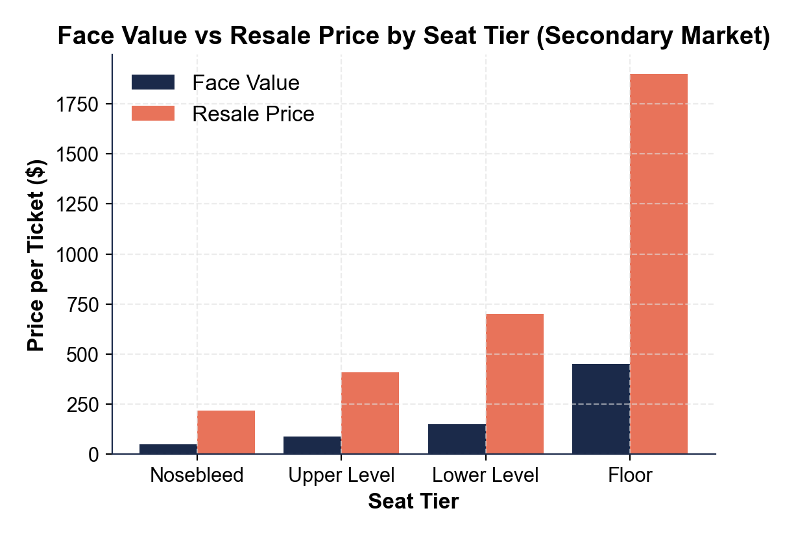

CHART REFERENCE 4: A DEMAND SHIFT - THE ERAS TOUR ANNOUNCEMENT

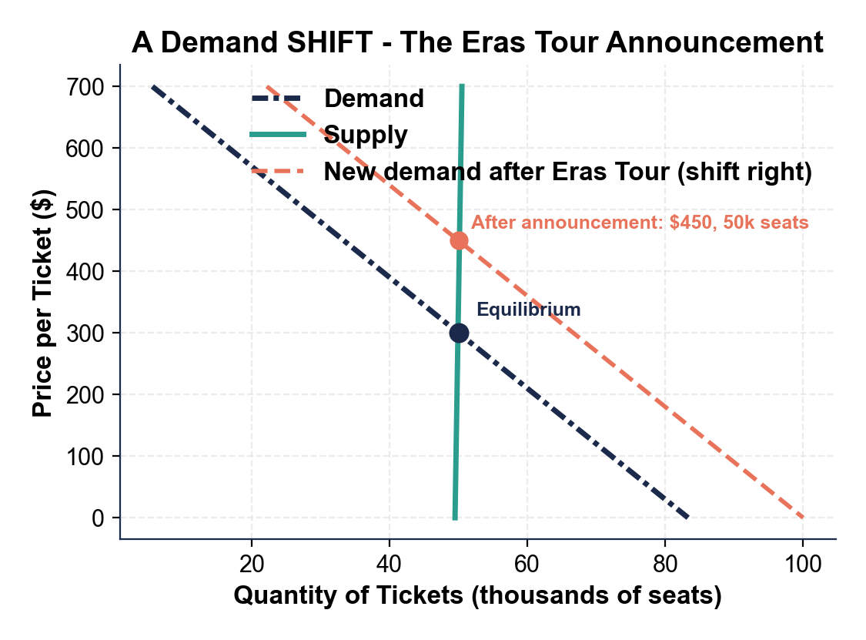
MORE LESSONS LESS PLANNING
Thank You!
If you enjoyed this product, please do not forget to rate and review to assist other teachers.

Looking for future discounts? Earn TPT credits by reviewing purchased products.

Please contact me if you have any issues with this product. Just like our students, I am always looking for opportunities to grow.

