Tax Refunds: Why a Big One Isn't a Win
STUDENT ACTIVITY
Name: | Date: | Period:
ESSENTIAL QUESTION
Why does a big tax refund actually mean you overpaid all year, and how does adjusting your W-4 toward accurate withholding put that money back into every paycheck instead of lending it to the IRS interest-free?
THE SCENARIO
You are MORGAN LEE, a peer financial mentor running a first-job money workshop for new W-2 employees. ALEX just filed taxes for the first time and got a big refund - and is thrilled, treating it like free money or a bonus.
BY THE END, YOU CAN:
✓ Explain why a large tax refund means too much was withheld from your paychecks
✓ Apply the LABELED refund model (Refund = total tax withheld - actual tax owed) and the balance-due model (Balance due = actual tax owed - total tax withheld)
✓ Explain why over-withholding is an interest-free loan to the IRS with a real opportunity cost
✓ Calculate the monthly cost of over-withholding (refund / 12) and explain how adjusting your W-4 puts that money back in each paycheck
HOW IT WORKS (do Parts 1–5 in order)
Part 1 — Tax Refund Reference Guide - Complete the Missing Terms
Part 2 — Apply the Terms - Tax Refund Vocabulary in Context
Part 3 — Calculate Refunds and Their Monthly Cost - Use the Labeled Models
Part 4 — Read the Chart and Work the Numbers - Refund vs. Take-Home Pay: The Over-Withholding Tradeoff
Part 5 — Advise Alex - Adjust the W-4 Toward Accurate Withholding
TIME about 45 minutes YOU’LL NEED the lesson slides and your Guided Notes.

PART 1

Tax Refund Reference Guide - Complete the Missing Terms
Fill in the missing term for each blank row — the definition is your clue. Your Guided Notes and the lesson slides have every term.

Term | Definition
___________ | Money the IRS returns to a filer when MORE tax was withheld from their paychecks than they actually owed; it is the filer's own over-withheld money, not a bonus
Withholding | The tax an employer takes out of each paycheck and sends to the IRS on the employee's behalf, based on the employee's W-4
___________ | Having MORE tax taken out of your paychecks all year than you actually owe, which produces a large refund but smaller monthly paychecks
W-4 form | The form an employee gives their employer that tells the employer how much tax to withhold from each paycheck; adjusting it changes the size of your refund and your take-home pay
___________ | What over-withholding really is: the government holds your extra money all year at 0% interest, money you could have had in each paycheck to spend, save, or earn interest on
Take-home pay | The amount of a paycheck an employee actually keeps after withholding is subtracted; over-withholding lowers take-home pay
___________ | Money a filer OWES the IRS at tax time, which happens when LESS tax was withheld than they actually owed (the opposite of a refund)
Actual tax owed | The real amount of tax a person owes for the year based on their income
___________ | Setting your W-4 so about the right amount of tax comes out of each paycheck, producing a refund close to $0 and the largest legal take-home pay
Opportunity cost | The value of what you give up by choosing one option over another; the opportunity cost of a big refund is the spending, saving, or interest that money could have provided during the year

PART 2

Apply the Terms - Tax Refund Vocabulary in Context
WORD BANK tax refund · balance due · over-withholding · accurate withholding · interest free
1. Q1. Your own money the IRS returns because more tax was withheld from your paychecks than you actually owed is a .

2. Q2. Having MORE tax taken out of every paycheck all year than you actually owe - which creates a big refund but smaller monthly pay - is called .

3. Q3. Letting the government hold your extra money all year at 0% interest, when you could have kept it in each paycheck, is really an - loan to the IRS.

4. Q4. Money you OWE the IRS at tax time because too little was withheld - the opposite of a refund - is a .

5. Q5. Setting your W-4 so about the right amount of tax comes out - producing a refund close to $0 and the biggest legal paycheck - is .

PART 3

Calculate Refunds and Their Monthly Cost - Use the Labeled Models
1. As Morgan Lee, warm up the refund model with Alex on a simple case. A filer had $4,200 withheld from their paychecks all year but actually owed $3,000 in tax.
(a) Using REFUND = total tax withheld - actual tax owed, what is their refund?

(b) In one sentence, what does that refund tell you about how much they overpaid?

2. As Morgan Lee, now work Alex's real numbers. Alex had $5,400 withheld all year but actually owed only $3,600.
(a) What is Alex's refund (REFUND = total withheld - actual owed)?

(b) Using the monthly-cost model (MONTHLY COST = refund / 12), how much smaller was each of Alex's 12 monthly paychecks?

(c) In one sentence, explain what that $150 means for Alex.

3. As Morgan Lee, use Alex's $1,800 refund to bust the 'free money' idea.
(a) When Alex calls the $1,800 refund 'free money the government gave me,' is that accurate - yes or no?

(b) In one to two sentences, explain where the $1,800 actually came from, using the word 'over-withholding.'

PART 4

Read the Chart and Work the Numbers - Refund vs. Take-Home Pay: The Over-Withholding Tradeoff
As Morgan Lee, study the bar chart titled "Refund vs. Take-Home Pay: The Over-Withholding Tradeoff" (it appears with A4-Q1). Both workers earn the SAME salary and file as single - the ONLY difference is how they filled out their W-4. For each worker there are two bars: monthly take-home pay and year-end refund. The same values are listed in the data table below. Use the chart and table to answer A4-Q1 to A4-Q3, then work the balance-due math in A4-Q4.

Worker (same salary, single filing status) | Monthly take-home pay | Year-end refund
Worker A (over-withholds) | $2,300 | $2,400
Worker B (accurate W-4) | $2,500 | $0
Difference (B keeps more each month) | $200 more/month | x 12 = $2,400 = A’s refund

Analysis
1. A4-Q1. As Morgan Lee, study the bar chart on this page titled "Refund vs. Take-Home Pay: The Over-Withholding Tradeoff." Both workers earn the SAME salary and file as single; only their W-4 differs. Read the chart and write, for each worker, both (a) their monthly take-home pay and (b) their year-end refund. Label your answers Worker A and Worker B.
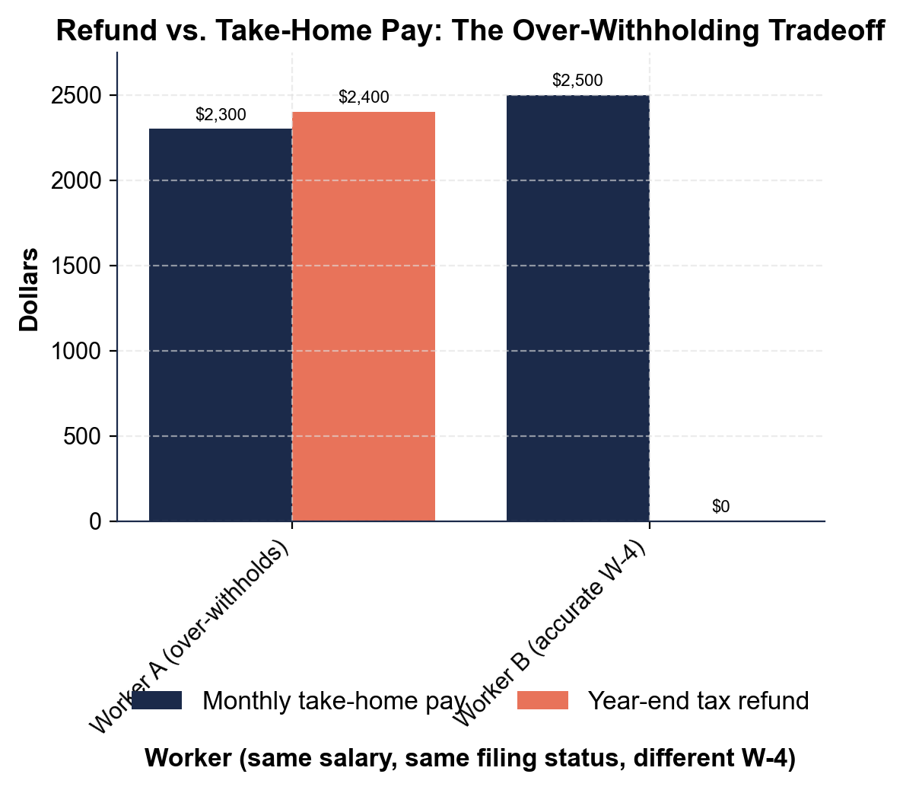

2. A4-Q2. As Morgan Lee, use the same chart to make the key point to Alex. (a) How much MORE take-home pay does Worker B keep each month than Worker A? (b) Multiply that monthly difference by 12 months. (c) In one sentence, what do you notice about your answer to (b) compared to Worker A's refund?

3. A4-Q3. As Morgan Lee, use the chart to help Alex choose. (a) Which worker has the bigger year-end refund? (b) Which worker has the bigger monthly paycheck? (c) In one sentence, state the tradeoff the chart shows between a big refund and a big monthly paycheck.

4. A4-Q4. As Morgan Lee, show Alex the OTHER outcome at tax time so they see the full picture. A different filer, Sam, actually owed $3,600 in tax but only had $3,000 withheld from their paychecks. (a) Using BALANCE DUE = actual tax owed - total tax withheld, how much does Sam OWE at tax time? (b) Did Sam over-withhold or under-withhold? (c) In one sentence, explain why accurate withholding (aiming for a refund near $0) protects a filer from BOTH a big interest-free loan to the IRS AND a surprise balance due.

PART 5

Advise Alex - Adjust the W-4 Toward Accurate Withholding
1. As Morgan Lee, help Alex picture the fix. Alex's $1,800 refund came from over-withholding, at a monthly cost of $150 per paycheck.
(a) If Alex adjusts their W-4 to withhold about $3,600 for the year (matching what they actually owe), roughly what will next year's refund be?

(b) About how much MORE will land in each of Alex's 12 monthly paychecks?

(c) In one sentence, why might Alex prefer that even though the big refund 'felt good'?

2. As Morgan Lee, make sure Alex understands the mirror risk of overcorrecting. Suppose Alex slashes their withholding too far and ends up having only $2,900 withheld while actually owing $3,600.
(a) Using BALANCE DUE = actual tax owed - total tax withheld, what would Alex owe at tax time?

(b) In one sentence, what is the sensible target Alex should aim for instead of either extreme?

3. As Morgan Lee, handle Alex's honest pushback. Alex says, 'But I like the big refund - it's the only way I ever save money.'
(a) Name what Alex is really using the refund as.

(b) In one to two sentences, give Alex a fair, balanced response: acknowledge why that can make sense for some people, but name the real cost and suggest a better plan.

FINAL NOTE TO ALEX
4. FINAL NOTE TO ALEX. As Morgan Lee, put your advice in writing for Alex. Write a 5-7 sentence note (120-180 words) that explains why a big refund is not free money, uses at least one calculated result from this activity, explains the interest-free-loan idea, and tells Alex the concrete fix (adjust the W-4 toward accurate withholding, aiming for a refund near $0). Check off each required element as you include it.
YOUR RESPONSE MUST:
☐ EXPLAIN WHY A BIG REFUND IS NOT FREE MONEY - say that a refund is Alex's OWN over-withheld money coming back, because more was withheld from every paycheck than Alex actually owed (REFUND = withheld - owed).
☐ USE A CALCULATED RESULT - include a figure from this activity (for example: Alex's $1,800 refund, or the $150 smaller each monthly paycheck was; or the chart's $200/month x 12 = $2,400 = Worker A's refund).
☐ EXPLAIN THE INTEREST-FREE LOAN - tell Alex that over-withholding lets the IRS hold that money all year at 0% interest, giving up the interest and use of it (the opportunity cost).
☐ GIVE THE CONCRETE FIX - tell Alex to adjust their W-4 toward accurate withholding so less is withheld and more lands in each paycheck.
☐ NAME THE TARGET - tell Alex to aim for a refund close to $0 (break about even), not a big refund and not a surprise balance due.

