PERSONAL FINANCE

TAX REFUNDS: WHY A BIG ONE ISN'T A WIN
ANSWER KEY ACTIVITY - ANSWER KEY

PART 1

Tax Refund Reference Guide - Complete the Missing Terms

Term | Definition
Tax refund | Money the IRS returns to a filer when MORE tax was withheld from their paychecks than they actually owed; it is the filer's own over-withheld money, not a bonus
Withholding | The tax an employer takes out of each paycheck and sends to the IRS on the employee's behalf, based on the employee's W-4
Over-withholding | Having MORE tax taken out of your paychecks all year than you actually owe, which produces a large refund but smaller monthly paychecks
W-4 form | The form an employee gives their employer that tells the employer how much tax to withhold from each paycheck; adjusting it changes the size of your refund and your take-home pay
Interest-free loan to the IRS | What over-withholding really is: the government holds your extra money all year at 0% interest, money you could have had in each paycheck to spend, save, or earn interest on
Take-home pay | The amount of a paycheck an employee actually keeps after withholding is subtracted; over-withholding lowers take-home pay
Balance due | Money a filer OWES the IRS at tax time, which happens when LESS tax was withheld than they actually owed (the opposite of a refund)
Actual tax owed | The real amount of tax a person owes for the year based on their income
Accurate withholding | Setting your W-4 so about the right amount of tax comes out of each paycheck, producing a refund close to $0 and the largest legal take-home pay
Opportunity cost | The value of what you give up by choosing one option over another; the opportunity cost of a big refund is the spending, saving, or interest that money could have provided during the year

PART 2

Apply the Terms - Tax Refund Vocabulary in Context
WORD BANK tax refund · balance due · over-withholding · accurate withholding · interest free
1. Q1. Your own money the IRS returns because more tax was withheld from your paychecks than you actually owed is a tax refund.
tax refund
2. Q2. Having MORE tax taken out of every paycheck all year than you actually owe - which creates a big refund but smaller monthly pay - is called over-withholding.
over-withholding
3. Q3. Letting the government hold your extra money all year at 0% interest, when you could have kept it in each paycheck, is really an interest-free loan to the IRS.
interest free
4. Q4. Money you OWE the IRS at tax time because too little was withheld - the opposite of a refund - is a balance due.
balance due
5. Q5. Setting your W-4 so about the right amount of tax comes out - producing a refund close to $0 and the biggest legal paycheck - is accurate withholding.
accurate withholding

PART 3

Calculate Refunds and Their Monthly Cost - Use the Labeled Models
1. As Morgan Lee, warm up the refund model with Alex on a simple case. A filer had $4,200 withheld from their paychecks all year but actually owed $3,000 in tax.
(a) Using REFUND = total tax withheld - actual tax owed, what is their refund?
(b) In one sentence, what does that refund tell you about how much they overpaid?
(1) REFUND = $4,200 withheld - $3,000 owed = $1,200.00. (2) The $1,200 refund tells you they OVERPAID by exactly $1,200 - too much was withheld from their paychecks all year, and the IRS is simply returning the overpayment. Accept a $1,200 refund and an overpaid-by-$1,200 explanation.
2. As Morgan Lee, now work Alex's real numbers. Alex had $5,400 withheld all year but actually owed only $3,600.
(a) What is Alex's refund (REFUND = total withheld - actual owed)?
(b) Using the monthly-cost model (MONTHLY COST = refund / 12), how much smaller was each of Alex's 12 monthly paychecks?
(c) In one sentence, explain what that $150 means for Alex.
(1) REFUND = $5,400 - $3,600 = $1,800.00. (2) MONTHLY COST = $1,800 / 12 = $150.00. (3) It means every one of Alex's monthly paychecks was $150 smaller than it needed to be all year - Alex went without $150 a month just to get it back in one lump as a refund. Accept a $1,800 refund, $150 monthly cost, and a smaller-paycheck explanation.
3. As Morgan Lee, use Alex's $1,800 refund to bust the 'free money' idea.
(a) When Alex calls the $1,800 refund 'free money the government gave me,' is that accurate - yes or no?
(b) In one to two sentences, explain where the $1,800 actually came from, using the word 'over-withholding.'
(1) No - it is not free money. (2) The $1,800 was Alex's OWN money all along: through over-withholding, $1,800 too much was taken out of Alex's paychecks over the year and sent to the IRS, and the refund is simply that over-withheld money being returned. The government did not give Alex anything extra. Accept 'no' plus an it-was-Alex's-own-over-withheld-money explanation.

PART 4

Read the Chart and Work the Numbers - Refund vs. Take-Home Pay: The Over-Withholding Tradeoff
As Morgan Lee, study the bar chart titled "Refund vs. Take-Home Pay: The Over-Withholding Tradeoff" (it appears with A4-Q1). Both workers earn the SAME salary and file as single - the ONLY difference is how they filled out their W-4. For each worker there are two bars: monthly take-home pay and year-end refund. The same values are listed in the data table below. Use the chart and table to answer A4-Q1 to A4-Q3, then work the balance-due math in A4-Q4.

Worker (same salary, single filing status) | Monthly take-home pay | Year-end refund
Worker A (over-withholds) | $2,300 | $2,400
Worker B (accurate W-4) | $2,500 | $0
Difference (B keeps more each month) | $200 more/month | x 12 = $2,400 = A’s refund

Analysis

1. A4-Q1. As Morgan Lee, study the bar chart on this page titled "Refund vs. Take-Home Pay: The Over-Withholding Tradeoff." Both workers earn the SAME salary and file as single; only their W-4 differs. Read the chart and write, for each worker, both (a) their monthly take-home pay and (b) their year-end refund. Label your answers Worker A and Worker B.
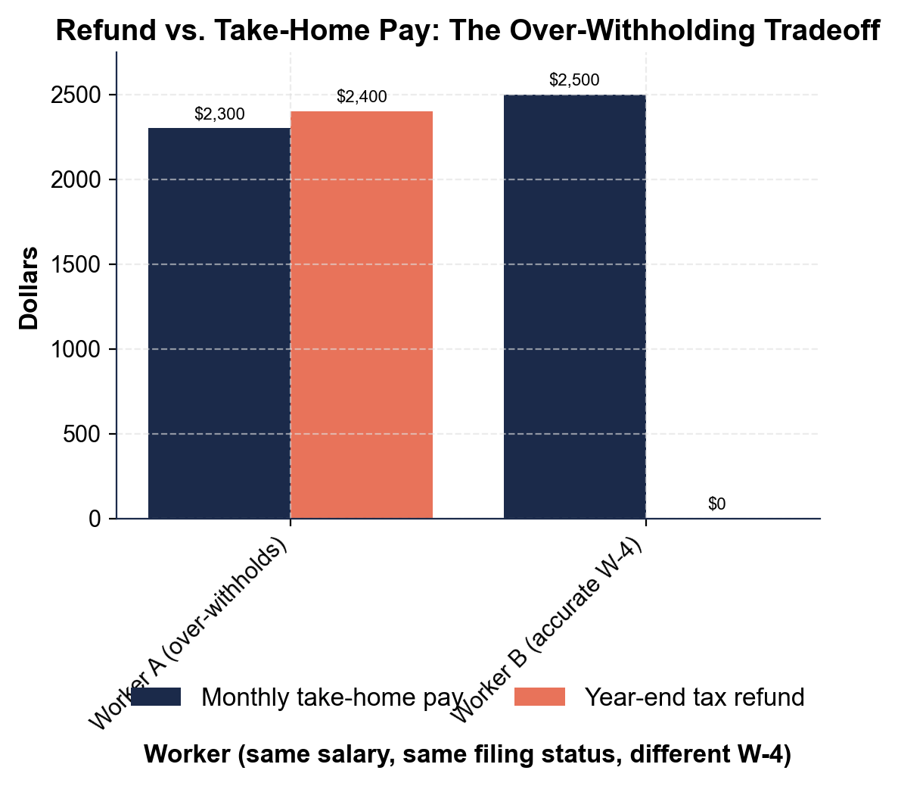
Worker A (over-withholds): monthly take-home = $2,300; year-end refund = $2,400. Worker B (accurate W-4): monthly take-home = $2,500; year-end refund = $0. Accept these four values read directly off the chart.

2. A4-Q2. As Morgan Lee, use the same chart to make the key point to Alex. (a) How much MORE take-home pay does Worker B keep each month than Worker A? (b) Multiply that monthly difference by 12 months. (c) In one sentence, what do you notice about your answer to (b) compared to Worker A's refund?
(1) Worker B keeps $2,500 - $2,300 = $200 more each month. (2) $200 x 12 = $2,400. (3) The $2,400 is EXACTLY Worker A's year-end refund - which proves Worker A's refund was just the $200 a month quietly taken out of every paycheck and handed back at the end; it was Worker A's own money all along. Accept $200/month, $2,400, and an it-equals-the-refund observation.

3. A4-Q3. As Morgan Lee, use the chart to help Alex choose. (a) Which worker has the bigger year-end refund? (b) Which worker has the bigger monthly paycheck? (c) In one sentence, state the tradeoff the chart shows between a big refund and a big monthly paycheck.
(1) Worker A has the bigger refund ($2,400 vs $0). (2) Worker B has the bigger monthly paycheck ($2,500 vs $2,300). (3) The tradeoff: a big refund and a big monthly paycheck are not both available at once - choosing a bigger refund (over-withholding) means giving up money in every monthly paycheck, and keeping more in each paycheck (accurate withholding) means giving up the big refund. Accept Worker A for refund, Worker B for paycheck, and a can't-have-both tradeoff explanation.

4. A4-Q4. As Morgan Lee, show Alex the OTHER outcome at tax time so they see the full picture. A different filer, Sam, actually owed $3,600 in tax but only had $3,000 withheld from their paychecks. (a) Using BALANCE DUE = actual tax owed - total tax withheld, how much does Sam OWE at tax time? (b) Did Sam over-withhold or under-withhold? (c) In one sentence, explain why accurate withholding (aiming for a refund near $0) protects a filer from BOTH a big interest-free loan to the IRS AND a surprise balance due.
(1) BALANCE DUE = $3,600 owed - $3,000 withheld = $600.00. Sam owes $600 at tax time. (2) Sam UNDER-withheld - too little tax came out of their paychecks. (3) Accurate withholding aims for the middle, landing a filer near $0 either way: withhold too much and you hand the IRS a big 0% loan (a large refund); withhold too little and you get hit with a surprise bill (a balance due) - accurate withholding avoids both. Accept a $600 balance due, under-withheld, and a protects-against-both explanation.

PART 5

Advise Alex - Adjust the W-4 Toward Accurate Withholding
1. As Morgan Lee, help Alex picture the fix. Alex's $1,800 refund came from over-withholding, at a monthly cost of $150 per paycheck.
(a) If Alex adjusts their W-4 to withhold about $3,600 for the year (matching what they actually owe), roughly what will next year's refund be?
(b) About how much MORE will land in each of Alex's 12 monthly paychecks?
(c) In one sentence, why might Alex prefer that even though the big refund 'felt good'?
(1) About $0 - if Alex withholds roughly what they actually owe ($3,600), the refund drops toward $0. (2) About $150 more per monthly paycheck (the $1,800 no longer over-withheld, spread over 12 months). (3) Alex might prefer it because they get to keep and use their own $150 every month - to spend on needs, pay down debt, or save and earn interest - instead of lending it to the IRS at 0% all year for one lump-sum return. Accept about $0 refund, about $150 more per paycheck, and a keep-and-use-my-money explanation.
2. As Morgan Lee, make sure Alex understands the mirror risk of overcorrecting. Suppose Alex slashes their withholding too far and ends up having only $2,900 withheld while actually owing $3,600.
(a) Using BALANCE DUE = actual tax owed - total tax withheld, what would Alex owe at tax time?
(b) In one sentence, what is the sensible target Alex should aim for instead of either extreme?
(1) BALANCE DUE = $3,600 owed - $2,900 withheld = $700.00 - Alex would OWE $700 at filing. (2) The sensible target is ACCURATE WITHHOLDING: set the W-4 so about the right amount comes out and the refund lands close to $0 - not a big refund (over-withholding) and not a surprise balance due (under-withholding), but breaking about even. Accept a $700 balance due and an aim-for-accurate-withholding/near-$0 answer.
3. As Morgan Lee, handle Alex's honest pushback. Alex says, 'But I like the big refund - it's the only way I ever save money.'
(a) Name what Alex is really using the refund as.
(b) In one to two sentences, give Alex a fair, balanced response: acknowledge why that can make sense for some people, but name the real cost and suggest a better plan.
(1) Alex is using the big refund as FORCED SAVINGS - a way to save money they fear they would otherwise spend. (2) Fair response: for someone who truly cannot save any other way, a guaranteed refund might beat saving nothing - but it is still an interest-free loan to the IRS with a real opportunity cost (lost interest and use of the money), so a better plan is accurate withholding PLUS an automatic transfer to a savings account, so Alex keeps AND saves their own money. Accept 'forced savings' and a balanced acknowledge-the-cost-suggest-a-savings-plan response.
FINAL NOTE TO ALEX
4. FINAL NOTE TO ALEX. As Morgan Lee, put your advice in writing for Alex. Write a 5-7 sentence note (120-180 words) that explains why a big refund is not free money, uses at least one calculated result from this activity, explains the interest-free-loan idea, and tells Alex the concrete fix (adjust the W-4 toward accurate withholding, aiming for a refund near $0). Check off each required element as you include it.
YOUR RESPONSE MUST:
☐ EXPLAIN WHY A BIG REFUND IS NOT FREE MONEY - say that a refund is Alex's OWN over-withheld money coming back, because more was withheld from every paycheck than Alex actually owed (REFUND = withheld - owed).
☐ USE A CALCULATED RESULT - include a figure from this activity (for example: Alex's $1,800 refund, or the $150 smaller each monthly paycheck was; or the chart's $200/month x 12 = $2,400 = Worker A's refund).
☐ EXPLAIN THE INTEREST-FREE LOAN - tell Alex that over-withholding lets the IRS hold that money all year at 0% interest, giving up the interest and use of it (the opportunity cost).
☐ GIVE THE CONCRETE FIX - tell Alex to adjust their W-4 toward accurate withholding so less is withheld and more lands in each paycheck.
☐ NAME THE TARGET - tell Alex to aim for a refund close to $0 (break about even), not a big refund and not a surprise balance due.
GRADING RUBRIC
Grade the evidence and reasoning, not the conclusion — any defensible position is valid. Score against the 5 requirements above.
FULL CREDIT — clear position; meets all 5 requirements with accurate, specific numbers and evidence from the lesson.
PARTIAL — position stated, but misses 1-2 requirements or uses vague / incorrect numbers.
MINIMAL — no clear position, or missing most requirements and numbers.

MORE LESSONS LESS PLANNING
Thank You!
If you enjoyed this product, please do not forget to rate and review to assist other teachers.

Looking for future discounts? Earn TPT credits by reviewing purchased products.

Please contact me if you have any issues with this product. Just like our students, I am always looking for opportunities to grow.

