ECONOMICS

SURGE PRICING: UBER, HOTELS & HURRICANE PLYWOOD
ACTIVITY

Name: | Date: | Period:

CASE FILE

Confidential Investigation
CASE FILE - Jordan Reyes, state consumer-protection economist ruling on whether three reported price spikes were illegal gouging or normal market behavior (you are a student investigator on Jordan Reyes's consumer-protection team, using Unit 2 supply and demand to rule on each reported spike)
STATUS: ACTIVE INVESTIGATION

DIRECTIONS

Instructions
A. READ THE CASE FILE COVER first so you know what Jordan Reyes is investigating: three reported price spikes (an Uber fare, hotel rooms in an evacuation, and plywood before a hurricane) and whether each was illegal gouging or normal market behavior.
B. WORK THROUGH THE THREE EVIDENCE ITEMS in order. Each Evidence Item tells you which Chart Reference (1, 2, or 3) to use - all charts are at the END of this packet. Read the values off the charts before you answer.
C. COMPLETE THE ANALYST'S WORKSHEET with Jordan Reyes using Chart Reference 4 (the three-market comparison bar chart) - read the normal-vs-surge prices and find the common pattern across all three markets.
D. WRITE Jordan Reyes'S FINAL REPORT (6-8 sentences). Take a clear position on the gouging-vs-signal debate, check off the 6 required elements, and use all four required terms (surge pricing, demand spike, shortage, price signal) at least once each.
E. USE THE CASE GLOSSARY at the bottom of the packet as your reference for the key supply-and-demand terms. Five of the ten terms are blanked - fill them in using your Guided Notes and the Slides.
EVIDENCE ITEM 1

The Uber Demand Spike - Jordan Reyes Opens the Case
1. WHY THE UBER FARE JUMPED. Jordan Reyes hands you the first report. Use Chart Reference 1 (chart_uber_surge) - the Uber demand-spike chart shown below.
(a) Read the OLD equilibrium fare (before the concert) and the NEW surge fare (after the concert) off the chart.

(b) What non-price event caused the change?

(c) Did the WHOLE demand curve move, or did one point slide along the old curve?

2. WHY THE PRICE EFFECT IS SO BIG. Staying with Chart Reference 1, finish the analysis for Jordan Reyes.
(a) The supply curve in this chart is steep. Why is the short-run supply of drivers nearly fixed?

(b) Because supply is slow to grow, what happens to the fare when demand spikes against it?

(c) Was this Uber spike caused by an emergency essential, or by a normal demand surge for a non-essential ride?

EVIDENCE ITEM 2

The Hotel Price Cap and the Shortage - Jordan Reyes Reviews the Cap
1. THE HOTEL PRICE CAP. Jordan Reyes pulls the second report: a wildfire evacuation and a law capping room prices. Use Chart Reference 2 (chart_hotel_shortage) - the hotel shortage chart shown below.
(a) Read the equilibrium price and the fixed number of rooms off the chart.

(b) What is the CAPPED price, and is it above or below the equilibrium price?

(c) Why is the supply of rooms shown as nearly vertical?

2. THE SHORTAGE AND WHAT IT COSTS. Staying with Chart Reference 2, help Jordan Reyes explain the fallout.
(a) At the $120 capped price, is the quantity DEMANDED larger or smaller than the 400 fixed rooms?

(b) What do we call it when quantity demanded is greater than quantity supplied?

(c) In plain English, what does this shortage look like to an evacuating family - and what would letting the price rise to $260 do?

EVIDENCE ITEM 3

The Plywood Price Signal - Jordan Reyes Follows the Supply
1. THE PLYWOOD PRICE SIGNAL. Jordan Reyes opens the third report: plywood before a hurricane. Use Chart Reference 3 (chart_plywood_signal) - the plywood price-signal chart shown below.
(a) Read the TWO points on the supply curve: what is the price and the quantity supplied at the LOW point and at the HIGHER point?

(b) As the price rises, does the quantity supplied go up or down?

(c) Did the whole supply curve move, or did one point slide along the same curve?

2. MOVEMENT OR SHIFT, AND WHY MORE PLYWOOD APPEARED. Staying with Chart Reference 3, finish the analysis for Jordan Reyes.
(a) Because only the price changed and the point slid up the same curve, is this a MOVEMENT along the supply curve or a SHIFT of supply?

(b) WHY did more plywood appear when the price rose?

(c) What is the name for the job the high price is doing here?

ANALYST'S WORKSHEET

The Same Pattern in Three Markets - Jordan Reyes Connects the Dots
1. AW-Q1. THE SAME PATTERN IN THREE MARKETS. Jordan Reyes wants to see whether all three spikes share a pattern. Use Chart Reference 4 (chart_surge_compare) - the three-market comparison bar chart shown below.
(a) For EACH market, read the NORMAL price and the SURGE price off the bars (Uber ride, hotel room per night, plywood sheet).

(b) In how many of the three markets is the surge price ABOVE the normal price?

(c) Which market shows the biggest DOLLAR jump from normal to surge?

2. AW-Q2. WHY THE PATTERN REPEATS. Staying with Chart Reference 4, finish the worksheet for Jordan Reyes.
(a) The same surge pattern appears in three very different markets. What do all three situations have in common that makes the price spike?

(b) In which TWO of the three markets is the good an emergency essential (the kind anti-gouging laws usually cover)?

(c) Why does that distinction matter for whether Jordan Reyes would call a spike gouging?

FINAL REPORT

Jordan Reyes's Final Report and Ruling on the Three Price Spikes
To: Lead Investigator
From: ___________________________
Re: Jordan Reyes's case
FINAL REPORT
1. FR-Q1. Jordan Reyes'S FINAL REPORT AND RULING. Close the case for Jordan Reyes, the state consumer-protection economist leading this investigation. Write a 6-8 sentence FINAL REPORT to the Lead Investigator that ties all four pieces of evidence together and answers: 'Why did each of the three prices spike - and was any of it illegal gouging or just the market doing its job?' You MUST use the four required terms - SURGE PRICING, DEMAND SPIKE, SHORTAGE, and PRICE SIGNAL - at least once each. You must take a clear POSITION on the gouging-vs-signal debate. The report MUST address each required element below.
FINAL REPORT FORMAT (the header is filled in for you on the worksheet):
To: Lead Investigator
From: [Your name - leave bracketed]
Re: Jordan Reyes's case - the three reported price spikes
YOUR RESPONSE MUST:
☐ Explains the Uber spike as a DEMAND SPIKE (the concert) that shifted demand right against a fixed short-run supply of drivers, raising the equilibrium fare from about $12 to $30 - an example of SURGE PRICING.
☐ Explains that capping the hotel price at $120 (below the $260 equilibrium) during the evacuation caused a SHORTAGE - rooms sold out and families were stranded.
☐ Explains the plywood case as a PRICE SIGNAL: letting the price rise drew quantity supplied from about 2,000 to 5,000 sheets as out-of-town sellers shipped plywood in (a movement up the supply curve).
☐ Notes the common pattern across all three markets: a demand spike hitting a fixed or slow-to-grow supply pushes the surge price far above the normal price.
☐ Takes a CLEAR POSITION on the ethics debate (gouging vs efficient signal) and gives at least one correct supporting reason (for example: a cap causes a shortage and removes the signal that brings in more supply; OR a sharp spike on emergency essentials prices out the people who need them most).
☐ Closes with one clear recommendation or ruling (for example, allow the Uber and plywood spikes as normal signals but watch hotel pricing during a declared emergency).

Case Glossary

Term | Definition
___________ | Also called dynamic pricing; letting a price rise and fall automatically as demand changes so the market clears (Uber, hotels, airlines)
Demand spike | A sudden jump in how much buyers want something at a given moment (a concert lets out, a storm is coming), pushing the demand curve right
___________ | Using the higher price to decide WHO gets the scarce supply - those willing and able to pay the most get it first
Price signal | A high price acts as a message that tells sellers to bring more supply here and tells buyers to use less - it coordinates the market
___________ | The negative term for sharply raising prices on essentials during an emergency; many states have laws against it
Equilibrium price | The price where quantity demanded equals quantity supplied; surge pricing pushes the listed price toward this clearing price
___________ | When quantity demanded is greater than quantity supplied; happens when a price is held BELOW equilibrium during a demand spike
Fixed supply | A supply that cannot grow quickly with price in the short run (rooms in a town tonight, plywood on shelves today)
___________ | A slide from one point to another on the SAME curve, caused only by a change in the good's OWN price (a change in quantity demanded or supplied)
Shift of the curve | The WHOLE curve moves left or right, caused by a NON-PRICE factor such as an approaching storm raising demand for plywood
CHART REFERENCE 1: THE UBER DEMAND SPIKE (FARE $12 TO $30)
Use Chart Reference 1 (chart_uber_surge) - the Uber demand-spike chart shown below.
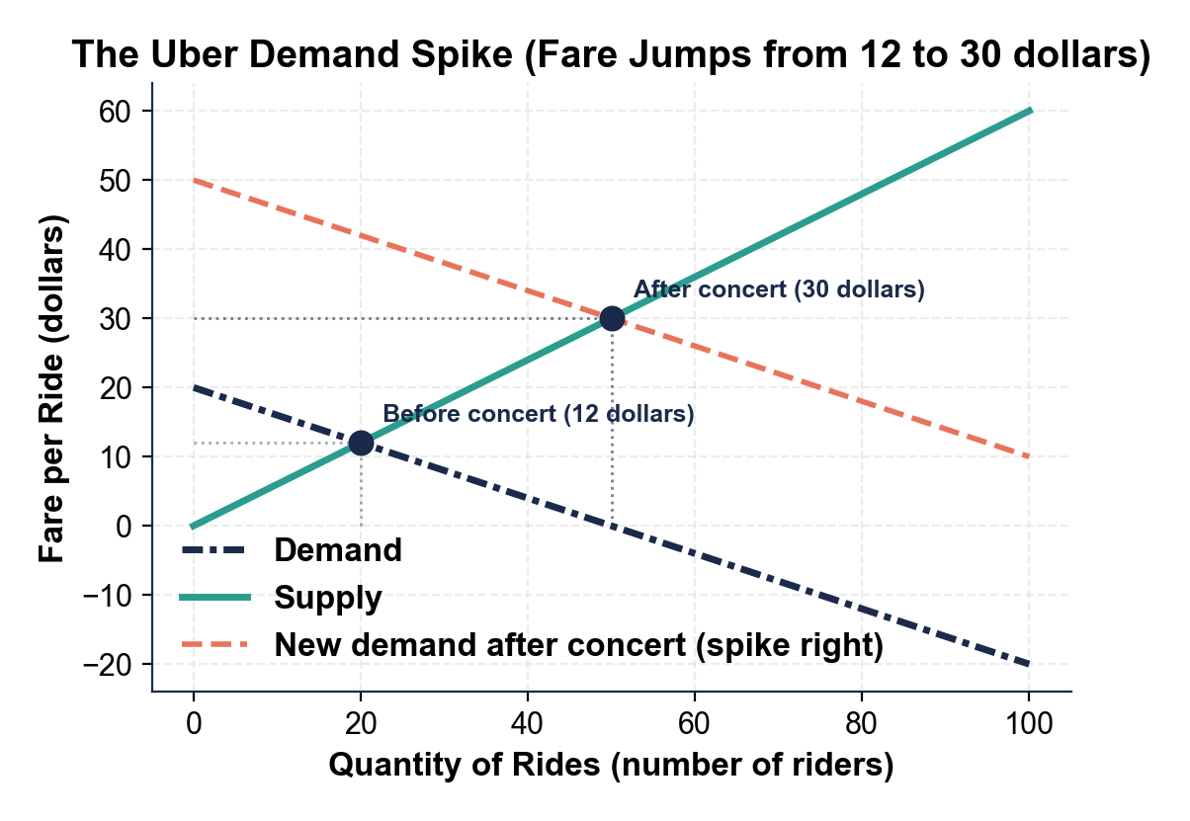
CHART REFERENCE 2: A PRICE CAP BELOW EQUILIBRIUM LEAVES A SHORTAGE (HOTEL ROOMS)
Use Chart Reference 2 (chart_hotel_shortage) - the hotel shortage chart shown below.
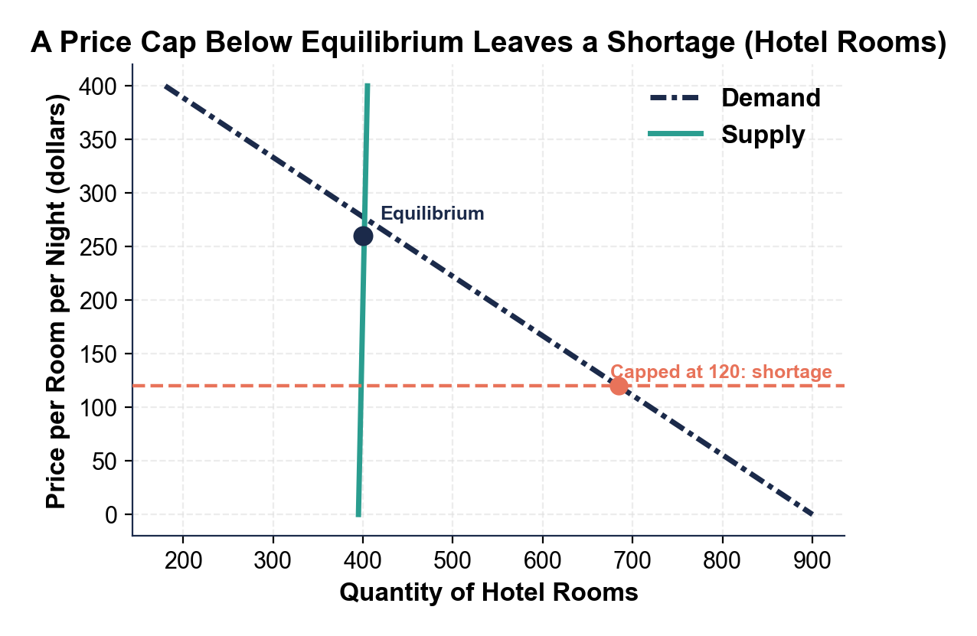
CHART REFERENCE 3: THE PRICE SIGNAL - A HIGHER PRICE DRAWS OUT MORE PLYWOOD
Use Chart Reference 3 (chart_plywood_signal) - the plywood price-signal chart shown below.
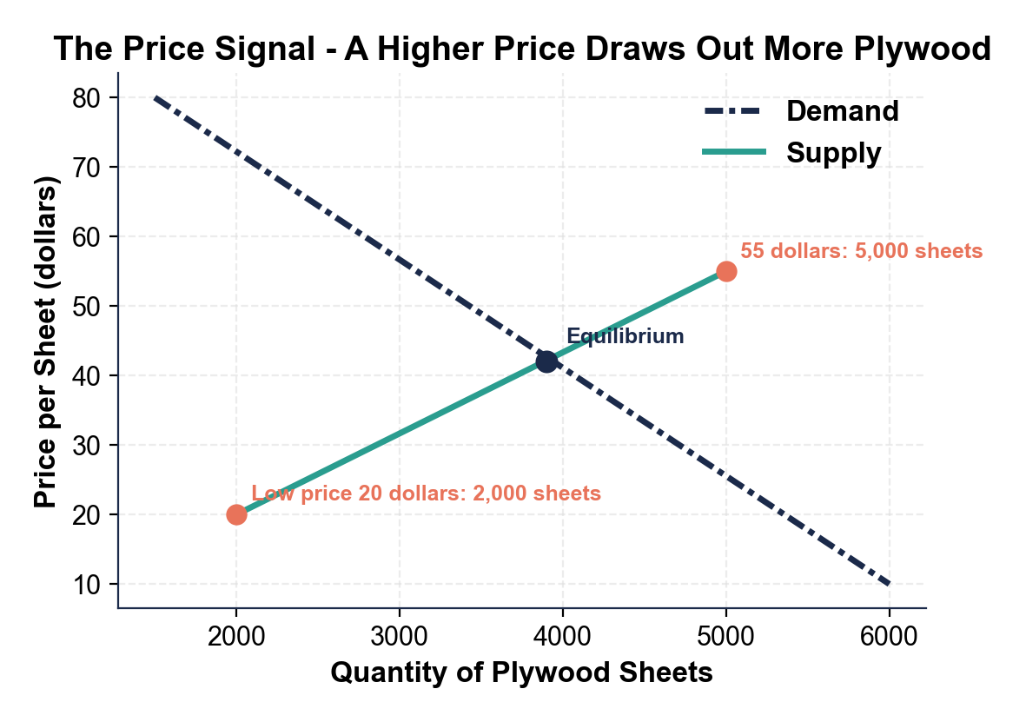
CHART REFERENCE 4: NORMAL PRICE VS SURGE PRICE IN THREE MARKETS
Use Chart Reference 4 (chart_surge_compare) - the three-market comparison bar chart shown below.
