ECONOMICS

SUBSIDIES: FARM BILLS, EVS & SOLAR
GUIDED NOTES

Name: | Date: | Period:

LEARNING TARGETS
1. Define a subsidy and identify three major federal subsidy programs (the Farm Bill, the EV tax credit, the solar Investment Tax Credit) by their dollar size and policy goal.
2. Apply supply-and-demand analysis to a subsidy: show how it shifts the supply curve right, lowers the price consumers pay, and raises the quantity bought.
3. Evaluate the winners and losers of each subsidy: who collects the dollars, who pays through higher taxes or higher prices, and what market distortions the subsidy creates.

SECTION 1

What Is a Subsidy?
Definition and Two Delivery Methods
A SUBSIDY is a government to producers (or sometimes buyers) that lowers cost.
The two main delivery methods are a CASH PAYMENT or a TAX .
Both methods lower the producer's per unit.
Both methods shift the curve to the right.
SECTION 2

The Supply-Shift Mechanic
How a Subsidy Shifts Supply
A subsidy lowers the cost for every producer, so the supply curve shifts DOWN and to the .
At the new equilibrium, the CONSUMER PRICE is than before.
At the new equilibrium, the quantity sold is .
The vertical gap between the two supply curves equals the per-unit .
The subsidy SPLITS between consumer and - the split depends on elasticities.
SECTION 3

The Farm Bill
Three Buckets of Farm Bill Spending
The largest line is CROP , ~$80B over 10 years; the feds pay ~62% of premiums.
Commodity supports include PLC (Price Loss Coverage) and (Agriculture Risk Coverage).
SNAP is the largest single program: ~$1.1T over 10 years and pays ~42 million per month.
SNAP is politically BUNDLED with crop subsidies to build a durable coalition.
About two-thirds of crop insurance and commodity payments go to four crops: corn, soybeans, wheat, and .
SECTION 4

EV Tax Credit Under the IRA
EV Credit Structure
The 2022 IRA created an EV tax credit of up to $ per new electric vehicle.
The used-EV version of the credit is up to $ per vehicle.
The household income cap is $300K joint / $ single.
The sourcing rule requires FINAL ASSEMBLY in America.
In 2024 the credit became transferable to the at point of sale.
SECTION 5

Solar Investment Tax Credit
Solar ITC Mechanics
The residential Solar ITC is a federal tax credit equal to percent of the installed system cost.
The 30 percent rate steps down to 22 percent in .
The commercial ITC adds a 10 percent bonus for domestic .
Total commercial ITC can stack to 40-50 percent with low-income and labor .
The IRA also includes a Production Tax Credit (PTC) for wind, hydrogen, and clean .
SECTION 6

Top 5 Federal Subsidies
Federal Subsidy Sizes
The IRA Clean-Energy Credits are about $ billion per year (blended decade average).
The Farm Bill commodity supports and crop insurance total about $ billion per year.
The Solar ITC costs about $ billion per year.
The EV Tax Credit costs about $ billion per year at full ramp.
The CHIPS Act semiconductor subsidies total about $ billion per year average.
SECTION 7

Who Benefits, Who Pays
Subsidy Incidence
Direct beneficiaries include subsidy recipients (farmers, EV buyers, solar ).
Direct payers are federal through forgone tax revenue.
Hidden costs include consumers of unsubsidized substitutes and consumers of sugar (because of the sugar ).
About 40 percent of Farm Bill payments are captured by owners through higher land rents.
Research shows ~30-50% of the pre-IRA EV credit was captured by manufacturers through higher .
SECTION 8

Farm Subsidies Are Concentrated
Concentration Pattern
The top 5 farm states are Iowa, Illinois, Texas, Nebraska, and .
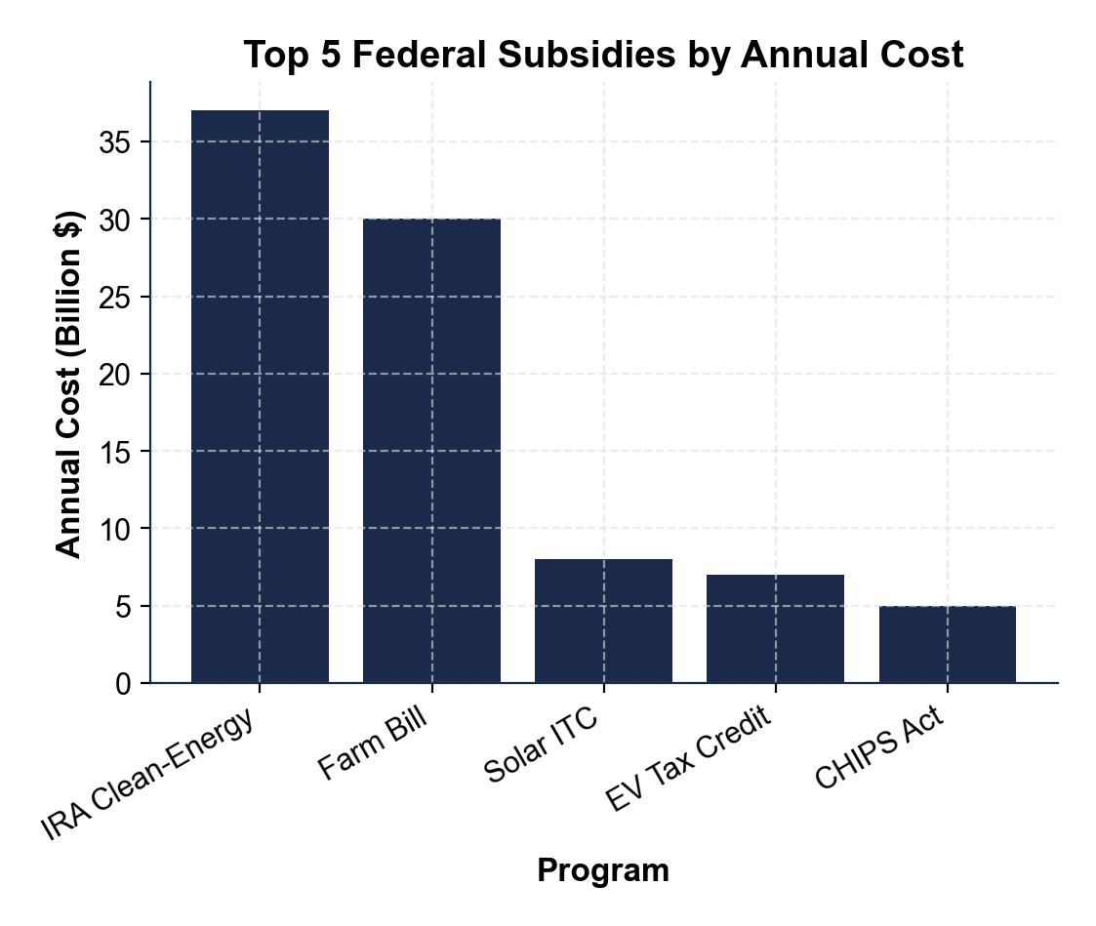
Iowa receives about $ billion per year, the largest single state.
About 10% of states get more than percent of all farm subsidy dollars.
The top 10% of farms receive about percent of all federal farm payments.
Concentration was locked in by the 1996 Freedom to Act, which tied payments to historical acreage.
SECTION 9

Why Politicians Love Subsidies
The Political-Economy Logic
CONCENTRATED : a few recipients each collect a large per-person check.
DIFFUSE : ~300 million Americans share $87B - roughly $290 per person per year, too small to organize against.
Every Farm Bill subsidy goes to a specific congressional - legislators trade votes for local money.
A bipartisan COALITION (urban SNAP + rural commodity supports) makes the bill nearly impossible to .
SECTION 10

The Distortions Subsidies Create
Six Distortions
DEADWEIGHT : subsidized goods are produced beyond their social value.
CROWDING OUT: corn ethanol subsidies raise prices for livestock farmers.
INPUT INFLATION: the pre-IRA solar ITC and EV credit raised input prices by about percent.
PICKING WINNERS: government bets on specific that may underperform unsubsidized rivals.
RENT : industries spend political resources on lobbying to keep subsidies instead of producing new value.
SECTION 11

Key Takeaways
Lesson Wrap Up Review
A SUBSIDY is a government payment that lowers producer cost; supply shifts to the .
Three big federal programs: the Farm Bill, the EV tax credit, and the Solar .
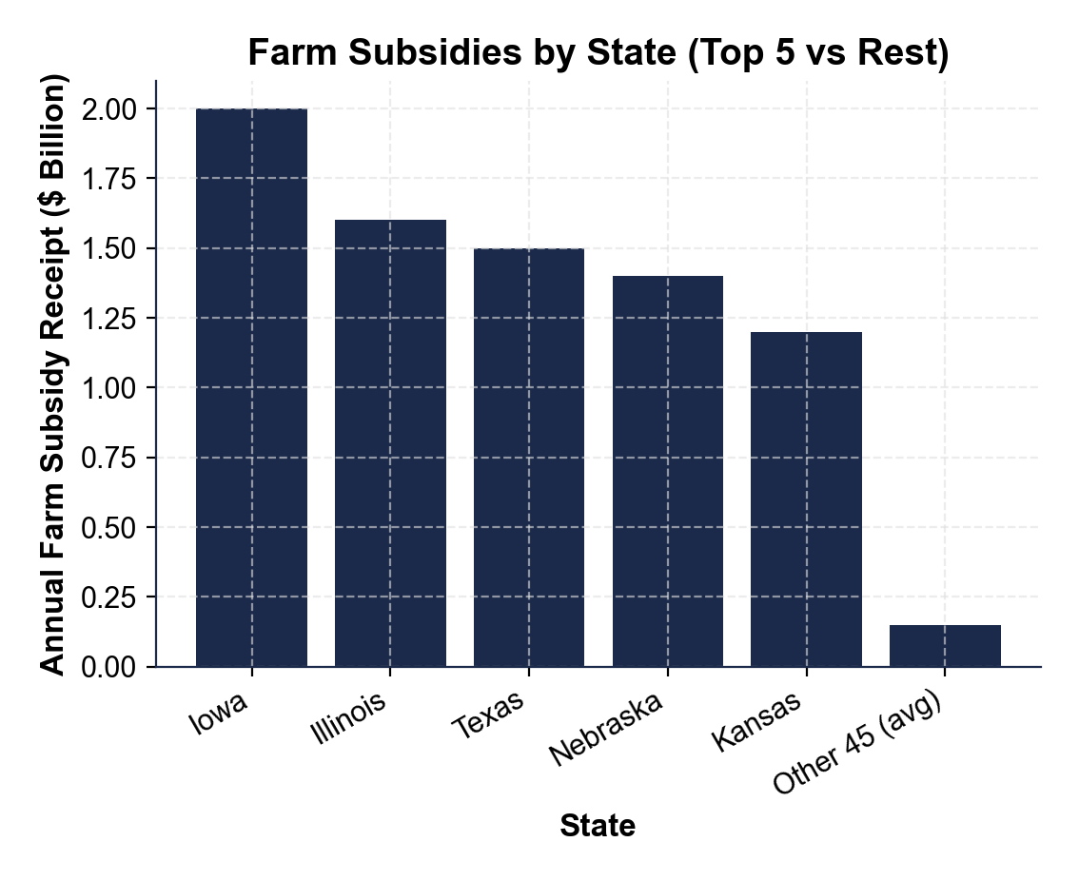
Subsidies are durable because of CONCENTRATED BENEFIT and DIFFUSE .
Every subsidy has DISTORTIONS: deadweight loss, crowding out, rent .
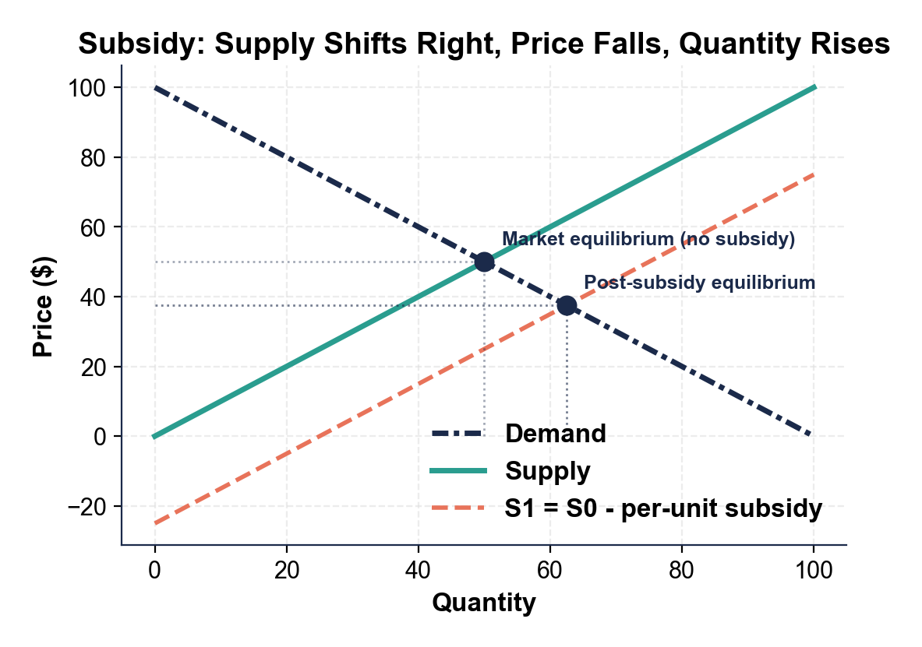

MORE LESSONS LESS PLANNING
Thank You!
If you enjoyed this product, please do not forget to rate and review to assist other teachers.

Looking for future discounts? Earn TPT credits by reviewing purchased products.

Please contact me if you have any issues with this product. Just like our students, I am always looking for opportunities to grow.

