PERSONAL FINANCE

STUDENT LOANS AND FINANCIAL AID
ANSWER KEY ACTIVITY - ANSWER KEY

PART 1

Student-Loan Reference Guide - Complete the Missing Terms

Term | Definition
Principal | The original amount of money borrowed before any interest is added
Interest rate | The percentage charged annually on the outstanding loan balance
Loan term | The total length of time you have to repay a loan in full
Grace period | The time after graduation before your first loan payment is due
APR | Annual Percentage Rate - the true yearly cost of borrowing, including fees
Subsidized loan | A federal loan on which the government pays the interest while you are enrolled in school
Unsubsidized loan | A loan on which interest accrues immediately, even while you are still in school
FAFSA | The Free Application for Federal Student Aid, the first step to grants, work-study, and federal loans
Refinancing | Combining one or more loans into a single new loan, usually at a lower interest rate
Income-driven repayment | A federal repayment plan that sets your monthly payment based on your income and family size

PART 2

Apply the Terms - Student-Loan Vocabulary in Context
WORD BANK apr · refinancing · loan term · principal · unsubsidized loan
1. Q1. The original amount of money you borrow, before any interest is added, is the Principal of the loan.
Principal
2. Q2. The total length of time you have to repay a loan in full is the Loan term, measured in years.
Loan term
3. Q3. The Annual Percentage Rate - the true yearly cost of borrowing, including fees - is abbreviated APR on loan paperwork.
APR
4. Q4. An Unsubsidized loan is a loan on which interest accrues immediately, even while you are still enrolled in school.
Unsubsidized loan
5. Q5. Combining one or more loans into a single new loan, usually at a lower interest rate, is called Refinancing the debt.
Refinancing

PART 3

Loan Cost Analysis - Maria, James, and Aisha
As the financial aid counselor, review Maria, James, and Aisha below. For each loan, use SIMPLE INTEREST to find the Total Interest (Principal x Rate x Years) and the Total Repayment (Principal x (1 + Rate x Years)), then add the rows to fill in each student's TOTAL. Federal loans are at 6.53% (0.0653); the private loan is at 9.50% (0.095); every term is 10 years. Example: $10,000 x (1 + 0.0653 x 10) = $16,530, so the interest is $6,530.

Student 1 - Maria: State University (4-year public) - Reference Data

Item | Detail
College | State University (4 years, public)
Total Cost | $120,000
Scholarships / Grants | $32,000
Loans | Federal Subsidized $14,000 + Federal Unsubsidized $8,000
Remaining | $66,000 covered by work-study, family, and savings

Maria's Loan Costs - Fill in Total Interest and Total Repayment

Loan Type | Principal | Rate | Term (Yrs) | Total Interest | Total Repayment
Federal Subsidized | $14,000.00 | 6.53% | 10 | $9,142.00 | $23,142.00
Federal Unsubsidized | $8,000.00 | 6.53% | 10 | $5,224.00 | $13,224.00
TOTAL | - | - | - | $14,366.00 | $36,366.00

Student 2 - James: Community College then State University Transfer - Reference Data

Item | Detail
College | Community College (2 years) then State University (2 years transfer)
Total Cost | $60,000
Scholarships / Grants | $20,000
Loans | Federal Subsidized $10,000 + Federal Unsubsidized $5,000
Remaining | $25,000 covered by part-time work and family

James's Loan Costs - Fill in Total Interest and Total Repayment

Loan Type | Principal | Rate | Term (Yrs) | Total Interest | Total Repayment
Federal Subsidized | $10,000.00 | 6.53% | 10 | $6,530.00 | $16,530.00
Federal Unsubsidized | $5,000.00 | 6.53% | 10 | $3,265.00 | $8,265.00
TOTAL | - | - | - | $9,795.00 | $24,795.00

Student 3 - Aisha: Private University (4-year) - Reference Data

Item | Detail
College | Private University (4 years)
Total Cost | $200,000
Scholarships / Grants | $108,000
Loans | Federal Subsidized $14,000 + Federal Unsubsidized $9,000 + Private Loan $35,000
Remaining | $34,000 covered by family

Aisha's Loan Costs - Fill in Total Interest and Total Repayment

Loan Type | Principal | Rate | Term (Yrs) | Total Interest | Total Repayment
Federal Subsidized | $14,000.00 | 6.53% | 10 | $9,142.00 | $23,142.00
Federal Unsubsidized | $9,000.00 | 6.53% | 10 | $5,877.00 | $14,877.00
Private Loan | $35,000.00 | 9.50% | 10 | $33,250.00 | $68,250.00
TOTAL | - | - | - | $48,269.00 | $106,269.00

PART 4

Read the Charts - Monthly Payment by Repayment Term and Interest Accrual
1. Study the bar chart titled "Monthly Payment by Repayment Term (on a $30,000 Loan at 6.53%)" printed on this page.
(a) What is the monthly payment at the 10-year (Standard) term?
The monthly payment at the 10-year term is $413.25.
(b) What is the monthly payment at the 25-year term?
At the 25-year term it is $263.25.
(c) In one sentence, what happens to the monthly payment as the repayment term gets longer?
The monthly payment gets SMALLER as the repayment term gets longer, because the same $30,000 loan is spread over more months. Accept $413.25 at 10 years, $263.25 at 25 years, and a lower payment for a longer term.
2. Use the same "Monthly Payment by Repayment Term" chart.
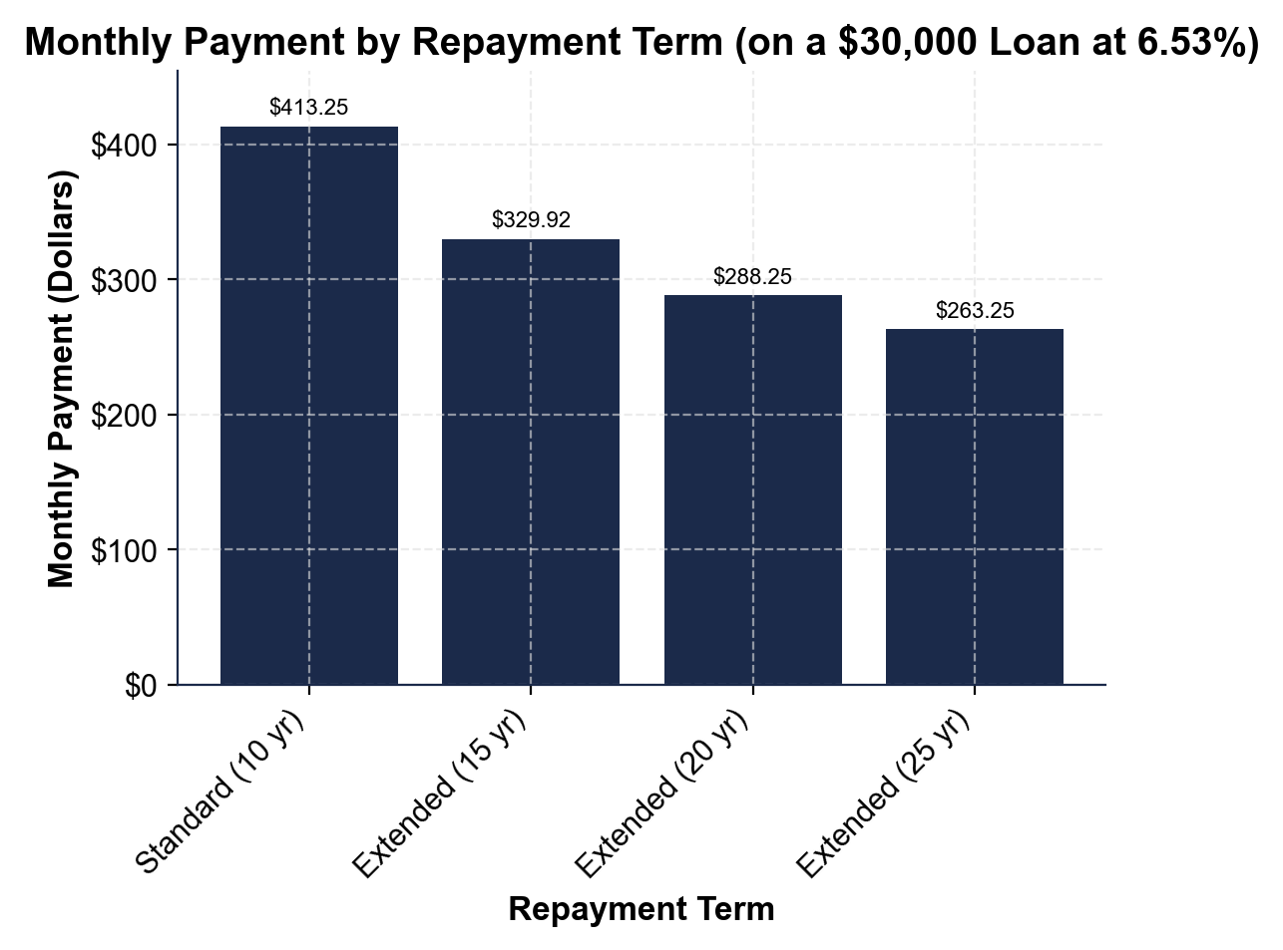
The 10-year term costs $49,590 in total repayment and the 20-year term costs $69,180. Even though the 25-year term has the lowest monthly payment, why is a longer term NOT the cheapest option overall?
A longer term is not cheapest overall because a lower monthly payment is spread over many more months, so you pay interest for far longer - the same $30,000 loan costs $49,590 over 10 years but $69,180 over 20 years, which is $19,590 more in interest.
3. Study the line chart titled "Loan Balance With vs Without Interest Accrual (While in School)" on this page.
(a) What is the SUBSIDIZED balance at graduation (year 4)?
The subsidized balance at graduation is $10,000.
(b) What is the UNSUBSIDIZED balance at graduation?
The unsubsidized balance at graduation is $12,612.
(c) Subtract to find the difference.
The difference is $12,612 - $10,000 = $2,612. Accept $10,000 subsidized, $12,612 unsubsidized, and a $2,612 difference.
4. Use the same "Loan Balance With vs Without Interest Accrual" chart. In one or two sentences, explain why the UNSUBSIDIZED balance grows during school while the SUBSIDIZED balance stays flat. Start your answer with: "The unsubsidized balance grows because..."
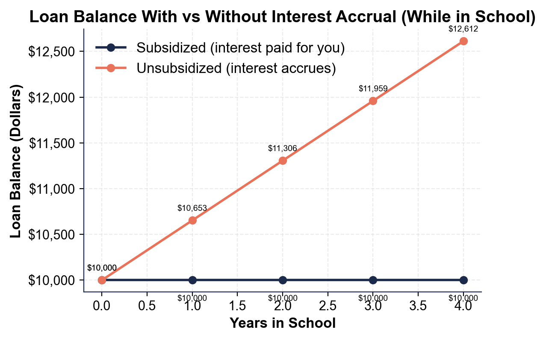
The unsubsidized balance grows because interest accrues immediately - it is charged from the day the loan is taken, even while the student is still enrolled, so $653 is added each year to the $10,000 loan.

PART 5

Compare the Graduates - Analysis and Recommendation
1. Which graduate will pay the LEAST in total interest, and why? (Use the TOTAL Interest you calculated for each student in Part 3.)
James pays the least in total interest, $9,795, because he borrowed the least - he started at community college and had only two federal loans ($10,000 subsidized + $5,000 unsubsidized) and no private loan.
2. Which graduate will pay the MOST in total interest? What TYPE of loan contributes the most to their total, and by how much?
Aisha pays the most in total interest, $48,269. Her PRIVATE loan contributes the most: the $35,000 private loan at 9.50% alone costs $33,250 in interest - more than her two federal loans combined.
3. If Maria switched her Federal Subsidized loan to a 20-year repayment term, the total interest would be $18,284.00.
How much MORE interest would she pay compared to the 10-year term? Show your math.
(1) Maria's 10-year Federal Subsidized interest = $9,142.00. (2) The 20-year interest = $18,284.00. (3) The extra interest = $18,284.00 - $9,142.00 = $9,142.00 MORE for the 20-year term - she would pay double the interest for the same loan. Accept a $9,142.00 difference and the point that doubling the term doubles the simple interest.
4. James chose to start at community college.
How much did this decision save him compared to attending State University for all 4 years? (Hint: Use Maria's total cost of $120,000 as your State University benchmark.) Show your math.
(1) State University benchmark (Maria's total cost) = $120,000. (2) James's total cost = $60,000. (3) Savings = $120,000 - $60,000 = $60,000 saved by starting at community college and transferring. Accept $60,000 in savings using the $120,000 State benchmark minus James's $60,000 cost.
5. Calculate Aisha's monthly payment on her PRIVATE loan alone (Total Repayment / 120 months).
Financial experts recommend student loan payments should not exceed 10% of gross monthly income ($3,333/month on a $40,000 salary). Would this payment be affordable? Explain.
(1) Aisha's private-loan total repayment = $68,250.00, so the monthly payment = $68,250.00 / 120 = $568.75 per month. (2) The 10% affordability limit on a $40,000 salary is 10% of $3,333 = about $333 per month. (3) $568.75 is about 17% of her $3,333 gross monthly income - well above the 10% rule - so on that private loan alone it is NOT affordable by the standard; she would need a higher income or a lower loan balance. Accept a $568.75 monthly payment, ~17% of gross income, and the conclusion that it exceeds the 10% affordability rule.
FINAL RECOMMENDATION
6. FINAL RECOMMENDATION. As the financial aid counselor, put your advice in writing. Write a 5-7 sentence note (120-180 words) to a high school senior about borrowing wisely for college, using what you found analyzing Maria, James, and Aisha. Check off each required element as you include it.
YOUR RESPONSE MUST:
☐ USE THE FAFSA AND FREE MONEY FIRST - tell the student to complete the FAFSA and take grants and scholarships (free money) before any loan.
☐ FEDERAL BEFORE PRIVATE - explain that federal loans have lower fixed rates and protections (income-driven repayment, forgiveness), and reference Aisha's costly $35,000 private loan at 9.50% ($33,250 interest).
☐ USE A CALCULATED RESULT - state a total you calculated yourself in Part 3 (for example, James's $24,795 total repayment or Aisha's $106,269) to show the difference borrowing choices make.
☐ EXPLAIN THE TERM TRADE-OFF - explain that a longer repayment term lowers the monthly payment but raises the total interest (for example, $30,000 at 6.53% costs $19,590 more over 20 years than 10 years).
☐ GIVE CLEAR ADVICE - give one concrete recommendation, such as starting at community college like James (saving $60,000) or borrowing as little as possible on the shortest term they can afford.
GRADING RUBRIC
Grade the evidence and reasoning, not the conclusion — any defensible position is valid. Score against the 5 requirements above.
FULL CREDIT — clear position; meets all 5 requirements with accurate, specific numbers and evidence from the lesson.
PARTIAL — position stated, but misses 1-2 requirements or uses vague / incorrect numbers.
MINIMAL — no clear position, or missing most requirements and numbers.

MORE LESSONS LESS PLANNING
Thank You!
If you enjoyed this product, please do not forget to rate and review to assist other teachers.

Looking for future discounts? Earn TPT credits by reviewing purchased products.

Please contact me if you have any issues with this product. Just like our students, I am always looking for opportunities to grow.

