Stimulus Checks: Did They Actually Work?
STUDENT ACTIVITY
Name: | Date: | Period:
ESSENTIAL QUESTION
Did the 2008, 2020, and 2021 stimulus checks actually work - did the multiplier amplify them into a real boost to aggregate demand, or did households save the cash and feed inflation instead?
THE SCENARIO
You are JORDAN PARK, a junior Economist at the Council of Economic Advisers (CEA). CEA senior staff have asked you to prepare a retrospective briefing on whether the 2008, 2020, and 2021 federal stimulus checks actually WORKED.
BY THE END, YOU CAN:
✓ Identify the three major U.S. stimulus-check episodes (2008 Bush rebate, 2020 CARES Act, 2021 American Rescue Plan) by size, eligibility, total federal cost, and economic context.
✓ Explain the MULTIPLIER EFFECT - how marginal propensity to consume (MPC) turns $1 of federal stimulus into more than $1 of total economic activity across spending rounds.
✓ Calculate the aggregate-demand impact of a stimulus check at given MPC values using the multiplier formula 1 / (1 - MPC), and predict how saving versus spending changes the result.
✓ Evaluate the two-sided 'did stimulus work' debate - the Keynesian multiplier defense vs the saved-not-spent + 2021-22 inflation critique - and judge which side the evidence supports.
HOW IT WORKS (do Parts 1–5 in order)
Part 1 — Stimulus Reference Guide - Complete the Missing Terms
Part 2 — Apply the Terms - Jordan Park Builds the Stimulus Vocabulary
Part 3 — Calculate the Multiplier, ARP Aggregate-Demand Impact, and Family Check Totals (Jordan Park CEA Cost Analysis)
Part 4 — Read the Stimulus Check Sizes and Multiplier Charts (Jordan Park CEA Evidence Section)
Part 5 — Final Policy Briefing to CEA Senior Staff (Jordan Park Synthesis)
TIME about 45 minutes YOU’LL NEED the lesson slides and your Guided Notes.

PART 1

Stimulus Reference Guide - Complete the Missing Terms
Fill in the missing term for each blank row — the definition is your clue. Your Guided Notes and the lesson slides have every term.

Term | Definition
___________ | A cash payment the federal government gives households to boost spending and aggregate demand.
Economic Stimulus Act | The 2008 stimulus under President Bush that sent rebate checks to households to boost spending.
___________ | The 2020 pandemic stimulus that sent checks plus expanded unemployment to households during the COVID downturn.
American Rescue Plan | The 2021 stimulus signed by President Biden that sent the largest checks and expanded the Child Tax Credit.
___________ | How one dollar of stimulus spending amplifies into more total spending across the rounds; the multiplier depends on the MPC.
Inflation | When the 2021 American Rescue Plan stimulus may have contributed to CPI inflation, which peaked at 9.1% in 2022.
___________ | Total spending that stimulus checks boost; aggregate demand goes up when households and consumers spend more.
Personal Savings Rate | The share of household income that is saved rather than spent; savings spiked to 33% in April 2020.
___________ | The fraction of an extra dollar of income a household will spend rather than save; lower-income households have a higher MPC.
Child Tax Credit | A per-child tax credit the 2021 American Rescue Plan expanded, which helped cut child poverty roughly in half.

PART 2

Apply the Terms - Jordan Park Builds the Stimulus Vocabulary
WORD BANK Multiplier Effect · CARES Act · Aggregate Demand · Marginal Propensity to Consume · Stimulus Check
1. A direct cash payment the federal government sends straight to households to boost consumer spending and aggregate demand during a downturn is a .

2. The March 2020 coronavirus relief law that sent stimulus checks plus expanded unemployment benefits to households during the COVID lockdown downturn is the .

3. The amplification of an initial dollar of spending as it ripples through round after round of the economy - calculated as 1 / (1 - MPC) - is the .

4. The total demand for goods and services in the economy (C + I + G + NX) that stimulus checks try to raise by lifting the consumer-spending component is .

5. The fraction of an extra dollar of income a household spends rather than saves - higher for lower-income households - is the (abbreviated MPC).

PART 3

Calculate the Multiplier, ARP Aggregate-Demand Impact, and Family Check Totals (Jordan Park CEA Cost Analysis)
1. THE MULTIPLIER AT THREE DIFFERENT MPC VALUES. The simple multiplier formula is MULTIPLIER = 1 / (1 - MPC).
(a) Compute the multiplier at MPC = 0.4.

(b) Compute the multiplier at MPC = 0.6.

(c) Compute the multiplier at MPC = 0.8.

(d) Explain in ONE SENTENCE the relationship between MPC and the multiplier - what happens to the multiplier as MPC rises?

2. AGGREGATE-DEMAND IMPACT OF THE 2021 ARP CHECKS. The 2021 American Rescue Plan stimulus checks totaled ~$402 billion. FORMULA: AGGREGATE-DEMAND IMPACT = (STIMULUS DOLLARS) x (MULTIPLIER). Compute the implied aggregate-demand boost from the 2021 ARP checks under three assumptions:
(a) MPC = 0.4 (low-spend scenario, much saved).

(b) MPC = 0.6 (baseline scenario).

(c) MPC = 0.8 (high-spend scenario, low savings).

3. PER-FAMILY CHECK TOTAL ACROSS THE THREE EPISODES. A typical family of four (two adults + two children) received different total amounts in each episode. Compute the per-family-of-four check total for:
(a) 2008 ESA ($600/adult, $300/child).

(b) 2020 CARES ($1,200/adult, $500/child).

(c) 2021 ARP ($1,400/adult, $1,400/child).

(d) Compute the COMBINED total a family of four received across all three episodes if they qualified each time.

4. SAVED VS SPENT - APPLYING THE APRIL 2020 SAVINGS RATE. The U.S. personal savings rate in April 2020 was about 33% (vs the ~7% pre-pandemic baseline). The 2020 CARES checks totaled ~$292B.
(a) Estimate the dollar amount of the 2020 CARES checks that was SAVED (using 33% as the savings rate).

(b) Estimate the dollar amount that was SPENT (using 67% as the consumption rate).

(c) Now use 7% (pre-pandemic baseline savings rate) for a counterfactual. How many MORE dollars would have been SPENT if households had saved at the pre-pandemic rate?

(d) Connect this to MPC: what is the implied MPC for 2020 CARES using the 67%/33% one-month split, and then explain in ONE sentence why this single-month figure can be HIGHER than the ~0.3 realized MPC the lesson reports for the 2020 checks?

5. PROJECTING A HYPOTHETICAL 2026 STIMULUS CHECK ROUND. Suppose CEA proposes a 2026 stimulus round of $1,200 per adult + $1,200 per child, costing ~$350B. Use these assumptions:
(a) MPC = 0.5 (a middle estimate between the 2008 ~0.4 and the 2020 ~0.3)

(b) inflation context: assume inflation is still running ABOVE the Fed's 2% target and the economy is near full employment (so additional demand may push inflation up). Compute (i) the multiplier at MPC = 0.5, (ii) the projected aggregate-demand boost of the $350B round, and (iii) write ONE SENTENCE identifying the BIGGEST RISK of sending stimulus when the economy is already at full employment.

PART 4

Read the Stimulus Check Sizes and Multiplier Charts (Jordan Park CEA Evidence Section)
1. As Jordan Park, study the Stimulus Check Sizes by Episode bar chart inserted below (also shown in the slide deck).
The lesson already taught these per-adult amounts; the chart lets you confirm them visually. In ONE sentence, describe the overall pattern: which episode's per-adult bar is the TALLEST, which is the SHORTEST, and does the chart show per-adult check sizes growing over time? (Chart: chart_stimulus_comparison)
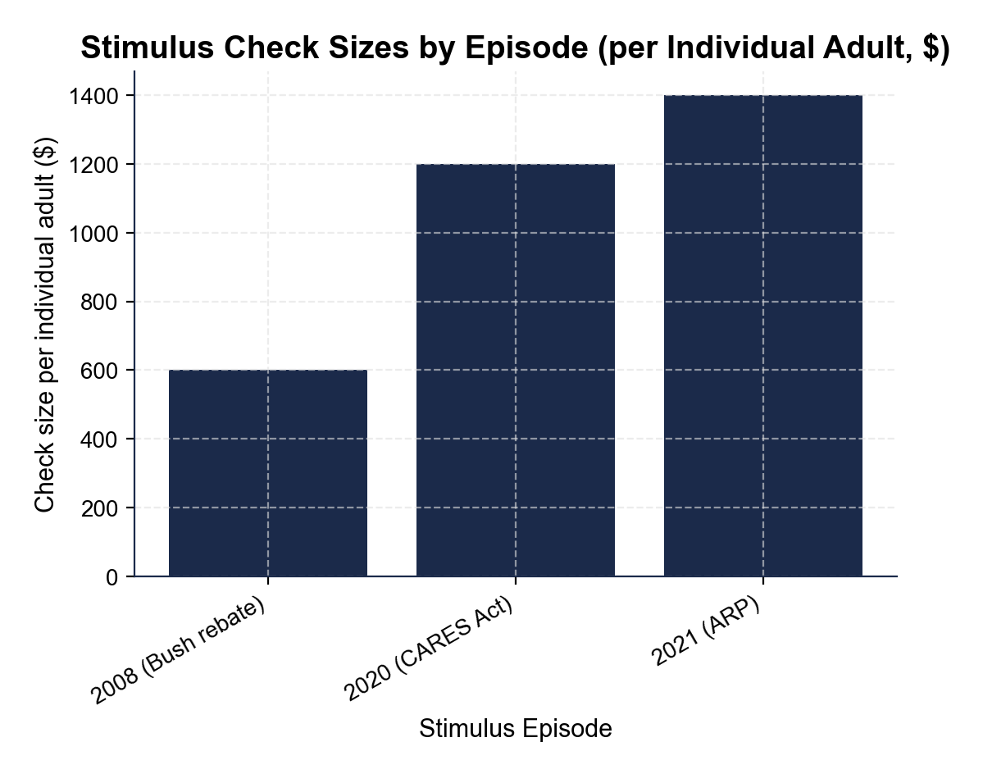

2. Using the chart above, CONFIRM the per-adult amounts against the chart.
(a) Read the per-individual-adult check size for the 2008 episode, the 2020 episode, and the 2021 episode off the chart and check that each matches the amount you used in Part 3.

(b) Which episode produced the LARGEST per-adult check?

(c) How many TIMES larger is the largest per-adult check than the smallest per-adult check on the chart?

3. Still using the Stimulus Check Sizes chart above.
(a) Compute the DOLLAR DIFFERENCE between the 2021 ARP per-adult check and the 2020 CARES per-adult check.

(b) Compute the PERCENT INCREASE from the 2020 check to the 2021 check.

(c) Write ONE SENTENCE describing the trend in per-adult check size from 2008 through 2021.

4. Now study the $1,000 Stimulus Check Multiplier bar chart inserted below (MPC = 0.6, also shown in the slide deck).
In ONE sentence, describe the pattern: which round is the TALLEST, and what happens to the spending amount in each successive round? (Chart: chart_multiplier_effect)
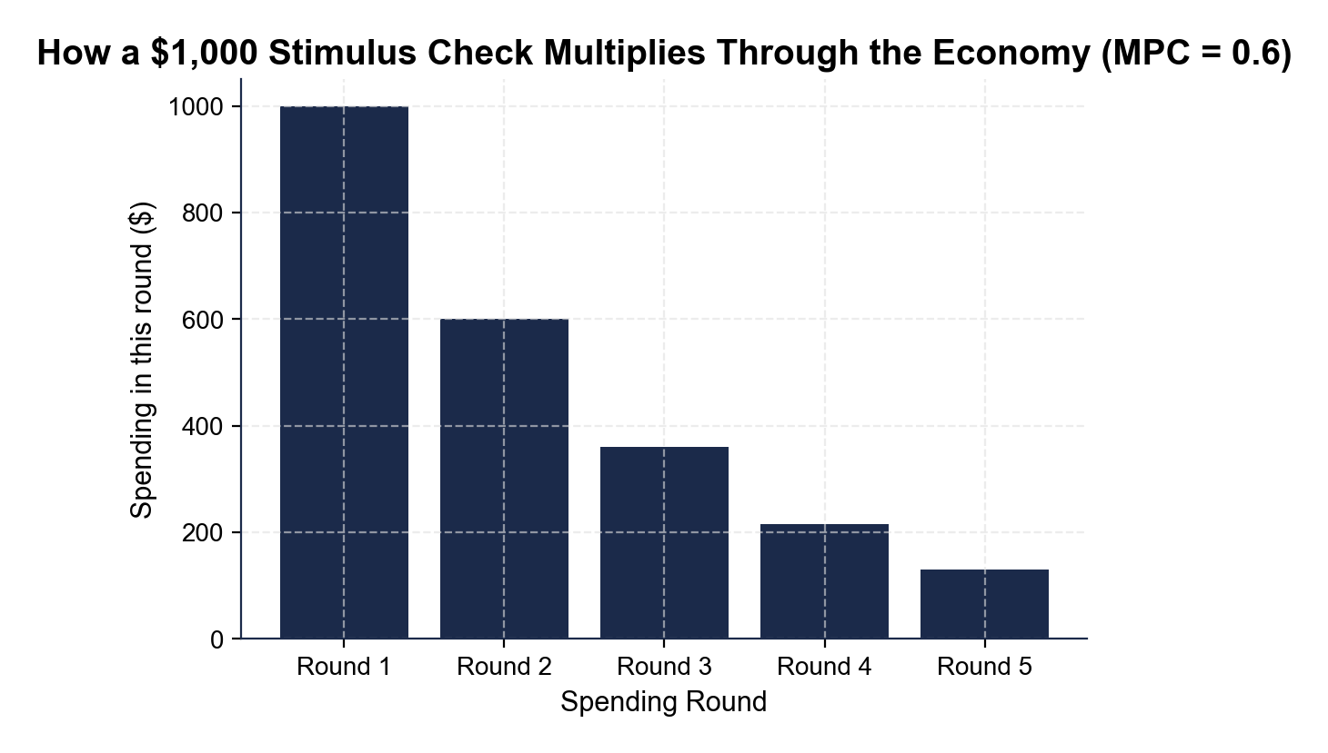

5. Using the Multiplier chart above, read directly off it.
(a) What is the Round 1 spending amount? Round 2? Round 3? Round 4? Round 5?

(b) Verify the 60% relationship between consecutive rounds: Round 2 / Round 1 = ___, Round 3 / Round 2 = ___.

(c) Compute the SUM of just the first five rounds visible on the chart.

6. CONNECT BACK TO PART 3 (NO CHART NEEDED). Connect the Multiplier chart to your Part 3 Q1 calculations.
(a) What is the infinite-rounds TOTAL spending across all rounds at MPC = 0.6 (using the formula 1 / (1 - MPC))?

(b) Redo the chart for $1,000 at MPC = 0.4: compute the first three rounds.

(c) What is the infinite-rounds total at MPC = 0.4?

(d) Write ONE SENTENCE explaining why a HIGHER MPC produces a LARGER multiplier effect, using the math you just computed.

PART 5

Final Policy Briefing to CEA Senior Staff (Jordan Park Synthesis)
POLICY BRIEFING MEMO
1. POLICY BRIEFING MEMO TO CEA SENIOR STAFF. As Jordan Park, write a 6-8 sentence policy briefing memo (about 200-300 words) to CEA senior staff TAKING A POSITION on whether the 2020 CARES Act stimulus checks were WORTH IT given the ~$292 billion fiscal cost. Use the memo header below and check off each required element as you include it. (Sentence starters you can use: "My briefing finds that the 2020 CARES checks were..." and "The strongest evidence FOR is... but a critic could object that...")
YOUR RESPONSE MUST:
☐ FACT PATTERN - one or two sentences stating the 2020 CARES per-adult and per-child check amounts, the total cost, and the timing, using the specific numbers you used in Part 3 and saw in the slides.
☐ KEYNESIAN EVIDENCE FOR - cite ONE specific piece of pro-stimulus evidence from the lesson (the realized multiplier of about 1.5-2.0, the fast 2020 Q3 GDP rebound, the child-poverty cut, or the within-week spending spikes).
☐ SAVED-NOT-SPENT EVIDENCE AGAINST - cite ONE specific piece of critique evidence from the lesson (the personal savings rate spiking to about 33% in April 2020, the realized MPC of about 0.3, or imperfect targeting).
☐ YOUR JUDGMENT - state clearly whether the 2020 CARES checks were worth it (worth it / not worth it / mixed-with-caveats) and defend the judgment in one sentence with at least one specific number.
☐ ONE REALISTIC OBJECTION - name one realistic objection a critic could raise to your judgment (for example, that targeted unemployment insurance has a higher MPC than untargeted checks).
☐ FIVE VOCABULARY TERMS - use at least FIVE lesson vocabulary terms from your Reference Guide (e.g., stimulus check, CARES Act, marginal propensity to consume, multiplier effect, aggregate demand, inflation).
MEMO
To: CEA Senior Staff
From: Jordan Park, Junior Economist, Council of Economic Advisers (CEA)
Date:
Re: Retrospective on the 2020 CARES Act Stimulus Checks - Were They Worth It?

