ECONOMICS

STIMULUS CHECKS: DID THEY ACTUALLY WORK?
ANSWER KEY ACTIVITY

PART 1

Stimulus Reference Guide - Complete the Missing Terms

Term | Definition
Stimulus Check | A cash payment the federal government gives households to boost spending and aggregate demand.
Economic Stimulus Act | The 2008 stimulus under President Bush that sent rebate checks to households to boost spending.
CARES Act | The 2020 pandemic stimulus that sent checks plus expanded unemployment to households during the COVID downturn.
American Rescue Plan | The 2021 stimulus signed by President Biden that sent the largest checks and expanded the Child Tax Credit.
Multiplier Effect | How one dollar of stimulus spending amplifies into more total spending across the rounds; the multiplier depends on the MPC.
Inflation | When the 2021 American Rescue Plan stimulus may have contributed to CPI inflation, which peaked at 9.1% in 2022.
Aggregate Demand | Total spending that stimulus checks boost; aggregate demand goes up when households and consumers spend more.
Personal Savings Rate | The share of household income that is saved rather than spent; savings spiked to 33% in April 2020.
Marginal Propensity to Consume (MPC) | The fraction of an extra dollar of income a household will spend rather than save; lower-income households have a higher MPC.
Child Tax Credit | A per-child tax credit the 2021 American Rescue Plan expanded, which helped cut child poverty roughly in half.

PART 2

Apply the Terms - Jordan Park Builds the Stimulus Vocabulary
WORD BANK Multiplier Effect · CARES Act · Aggregate Demand · Marginal Propensity to Consume · Stimulus Check
1. A direct cash payment the federal government sends straight to households to boost consumer spending and aggregate demand during a downturn is a Stimulus Check.
Stimulus Check
2. The March 2020 coronavirus relief law that sent stimulus checks plus expanded unemployment benefits to households during the COVID lockdown downturn is the CARES Act.
CARES Act
3. The amplification of an initial dollar of spending as it ripples through round after round of the economy - calculated as 1 / (1 - MPC) - is the Multiplier Effect.
Multiplier Effect
4. The total demand for goods and services in the economy (C + I + G + NX) that stimulus checks try to raise by lifting the consumer-spending component is Aggregate Demand.
Aggregate Demand
5. The fraction of an extra dollar of income a household spends rather than saves - higher for lower-income households - is the Marginal Propensity to Consume (abbreviated MPC).
Marginal Propensity to Consume

PART 3

Calculate the Multiplier, ARP Aggregate-Demand Impact, and Family Check Totals (Jordan Park CEA Cost Analysis)
1. THE MULTIPLIER AT THREE DIFFERENT MPC VALUES. The simple multiplier formula is MULTIPLIER = 1 / (1 - MPC).
(a) Compute the multiplier at MPC = 0.4.
AT MPC = 0.4: multiplier = 1 / (1 - 0.4) = 1 / 0.6 = ~1.67.
(b) Compute the multiplier at MPC = 0.6.
AT MPC = 0.6: multiplier = 1 / (1 - 0.6) = 1 / 0.4 = 2.5.
(c) Compute the multiplier at MPC = 0.8.
AT MPC = 0.8: multiplier = 1 / (1 - 0.8) = 1 / 0.2 = 5.0.
(d) Explain in ONE SENTENCE the relationship between MPC and the multiplier - what happens to the multiplier as MPC rises?
RELATIONSHIP: As MPC RISES, the multiplier RISES - and it rises NONLINEARLY. Going from MPC 0.4 to 0.6 (a 50% increase) raises the multiplier from 1.67 to 2.5 (a 50% increase).
2. AGGREGATE-DEMAND IMPACT OF THE 2021 ARP CHECKS. The 2021 American Rescue Plan stimulus checks totaled ~$402 billion. FORMULA: AGGREGATE-DEMAND IMPACT = (STIMULUS DOLLARS) x (MULTIPLIER). Compute the implied aggregate-demand boost from the 2021 ARP checks under three assumptions:
(a) MPC = 0.4 (low-spend scenario, much saved).
AT MPC = 0.4: multiplier = 1.67. ARP aggregate-demand boost = $402B x 1.67 = ~$671 BILLION. About $0.67 TRILLION.
(b) MPC = 0.6 (baseline scenario).
AT MPC = 0.6: multiplier = 2.5. ARP aggregate-demand boost = $402B x 2.5 = $1,005 BILLION. About $1.0 TRILLION.
(c) MPC = 0.8 (high-spend scenario, low savings).
AT MPC = 0.8: multiplier = 5.0. ARP aggregate-demand boost = $402B x 5.0 = $2,010 BILLION. About $2.0 TRILLION. INTERPRETATION: the realized impact depends heavily on the assumed MPC. The realized 2020-21 MPC was probably closer to 0.3 (per research) than to 0.6 (the textbook benchmark), meaning the ACTUAL aggregate-demand boost from $402B was probably closer to $570B than to $1T or $2T. This wide range explains why economists disagree about whether the ARP did enough good to justify its inflationary risk.
3. PER-FAMILY CHECK TOTAL ACROSS THE THREE EPISODES. A typical family of four (two adults + two children) received different total amounts in each episode. Compute the per-family-of-four check total for:
(a) 2008 ESA ($600/adult, $300/child).
2008 ESA family of four: 2 x $600 + 2 x $300 = $1,200 + $600 = $1,800.
(b) 2020 CARES ($1,200/adult, $500/child).
2020 CARES family of four: 2 x $1,200 + 2 x $500 = $2,400 + $1,000 = $3,400.
(c) 2021 ARP ($1,400/adult, $1,400/child).
2021 ARP family of four: 2 x $1,400 + 2 x $1,400 = $2,800 + $2,800 = $5,600.
(d) Compute the COMBINED total a family of four received across all three episodes if they qualified each time.
COMBINED across all three: $1,800 + $3,400 + $5,600 = $10,800. So an eligible family of four received about $10,800 in stimulus checks across the three federal episodes from 2008 through 2021.
4. SAVED VS SPENT - APPLYING THE APRIL 2020 SAVINGS RATE. The U.S. personal savings rate in April 2020 was about 33% (vs the ~7% pre-pandemic baseline). The 2020 CARES checks totaled ~$292B.
(a) Estimate the dollar amount of the 2020 CARES checks that was SAVED (using 33% as the savings rate).
AMOUNT SAVED (33%): $292B x 0.33 = $96.4 BILLION. About $96B of the 2020 CARES checks was saved during April 2020.
(b) Estimate the dollar amount that was SPENT (using 67% as the consumption rate).
AMOUNT SPENT (67%): $292B x 0.67 = $195.6 BILLION. About $196B was spent.
(c) Now use 7% (pre-pandemic baseline savings rate) for a counterfactual. How many MORE dollars would have been SPENT if households had saved at the pre-pandemic rate?
COUNTERFACTUAL AT 7% SAVINGS RATE: $292B x 0.93 (consumption rate) = $271.6B SPENT. The additional spending if households had behaved at the pre-pandemic baseline = $271.6B - $195.6B = $76 BILLION extra in spending.
(d) Connect this to MPC: what is the implied MPC for 2020 CARES using the 67%/33% one-month split, and then explain in ONE sentence why this single-month figure can be HIGHER than the ~0.3 realized MPC the lesson reports for the 2020 checks?
IMPLIED MPC: if the savings rate is 33%, the consumption rate is 67%, so MPC = 0.67. However, research found realized MPC on 2020 CARES checks was lower (~0.3) because much of the 67% was spent on essentials (rent, groceries) that did NOT cycle into additional rounds of spending.
5. PROJECTING A HYPOTHETICAL 2026 STIMULUS CHECK ROUND. Suppose CEA proposes a 2026 stimulus round of $1,200 per adult + $1,200 per child, costing ~$350B. Use these assumptions:
(a) MPC = 0.5 (a middle estimate between the 2008 ~0.4 and the 2020 ~0.3)
(b) inflation context: assume inflation is still running ABOVE the Fed's 2% target and the economy is near full employment (so additional demand may push inflation up). Compute (i) the multiplier at MPC = 0.5, (ii) the projected aggregate-demand boost of the $350B round, and (iii) write ONE SENTENCE identifying the BIGGEST RISK of sending stimulus when the economy is already at full employment.
(i) MULTIPLIER AT MPC = 0.5: 1 / (1 - 0.5) = 1 / 0.5 = 2.0. (ii) PROJECTED AGGREGATE-DEMAND BOOST: $350B x 2.0 = $700 BILLION. (iii) BIGGEST RISK SENTENCE: The biggest risk of sending stimulus when the economy is already at full employment is INFLATION - if aggregate demand is pushed above aggregate supply capacity, the additional spending pulls prices up rather than pulling more workers into employment, exactly the dynamic critics (Summers, Blanchard) attribute to the 2021 ARP's contribution to the 2022 inflation peak of 9.1%. Accept answers identifying inflation as the chief risk PLUS naming a specific connection (full employment, no slack capacity, demand exceeds supply).

PART 4

Read the Stimulus Check Sizes and Multiplier Charts (Jordan Park CEA Evidence Section)
1. As Jordan Park, study the Stimulus Check Sizes by Episode bar chart inserted below (also shown in the slide deck).
The lesson already taught these per-adult amounts; the chart lets you confirm them visually. In ONE sentence, describe the overall pattern: which episode's per-adult bar is the TALLEST, which is the SHORTEST, and does the chart show per-adult check sizes growing over time? (Chart: chart_stimulus_comparison)
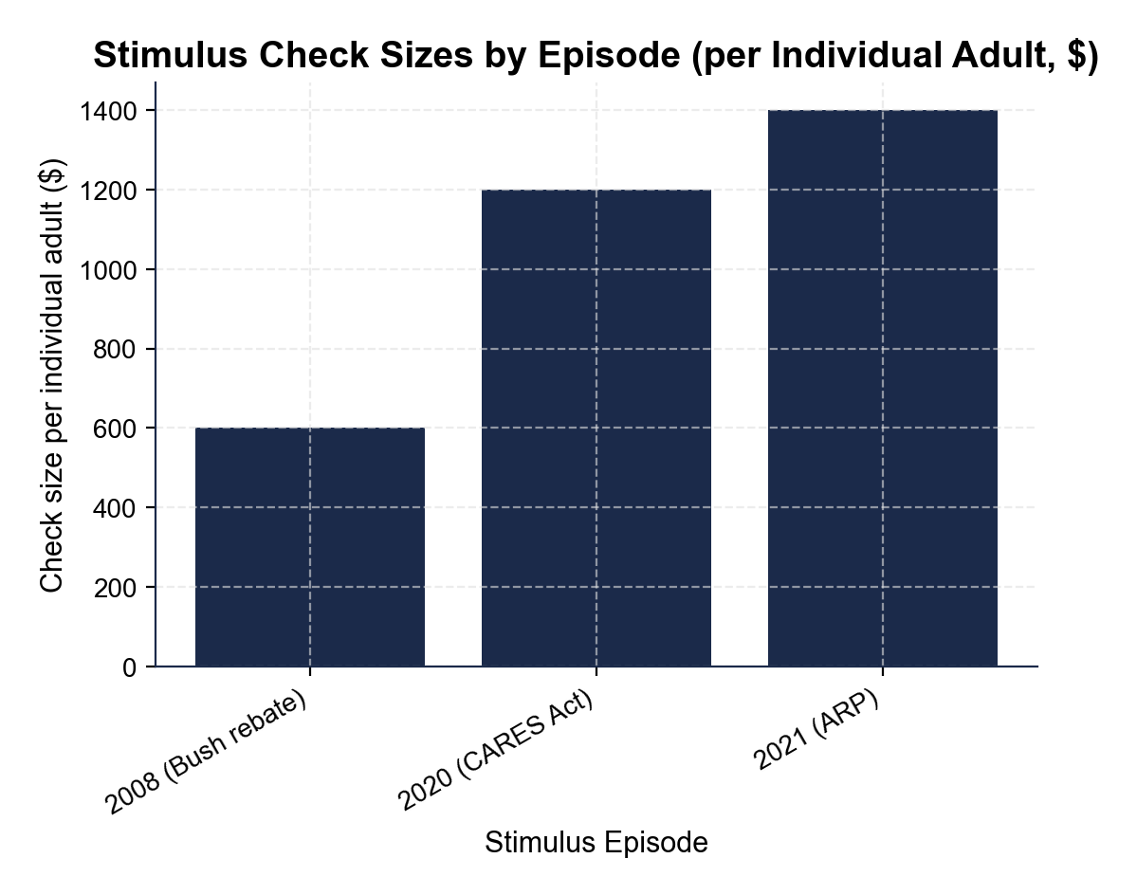
The 2021 ARP bar is the TALLEST and the 2008 Economic Stimulus Act (Bush rebate) bar is the SHORTEST; the chart shows per-adult stimulus check sizes GROWING over time, rising across the 2008, 2020, and 2021 episodes.
2. Using the chart above, CONFIRM the per-adult amounts against the chart.
(a) Read the per-individual-adult check size for the 2008 episode, the 2020 episode, and the 2021 episode off the chart and check that each matches the amount you used in Part 3.
Reading the bar chart at each label: 2008 (Bush rebate) = $600. 2020 (CARES Act) = $1,200. 2021 (ARP) = $1,400.
(b) Which episode produced the LARGEST per-adult check?
LARGEST = 2021 ARP at $1,400 - the tallest bar on the chart.
(c) How many TIMES larger is the largest per-adult check than the smallest per-adult check on the chart?
RATIO: $1,400 / $600 = ~2.33 times larger. The 2021 ARP per-adult check was roughly TWO AND A THIRD TIMES the 2008 Bush rebate per-adult check. Accept readings within +/- $50.
3. Still using the Stimulus Check Sizes chart above.
(a) Compute the DOLLAR DIFFERENCE between the 2021 ARP per-adult check and the 2020 CARES per-adult check.
DOLLAR DIFFERENCE: $1,400 - $1,200 = $200 more per adult in 2021 vs 2020.
(b) Compute the PERCENT INCREASE from the 2020 check to the 2021 check.
PERCENT INCREASE: $200 / $1,200 = 16.67% (round to ~17%). The 2021 ARP per-adult check was about 17% larger than the 2020 CARES check.
(c) Write ONE SENTENCE describing the trend in per-adult check size from 2008 through 2021.
TREND SENTENCE: Per-adult stimulus check sizes have GROWN over the three episodes - $600 in 2008, $1,200 in 2020 (a 100% increase), and $1,400 in 2021 (another ~17% increase).
4. Now study the $1,000 Stimulus Check Multiplier bar chart inserted below (MPC = 0.6, also shown in the slide deck).
In ONE sentence, describe the pattern: which round is the TALLEST, and what happens to the spending amount in each successive round? (Chart: chart_multiplier_effect)
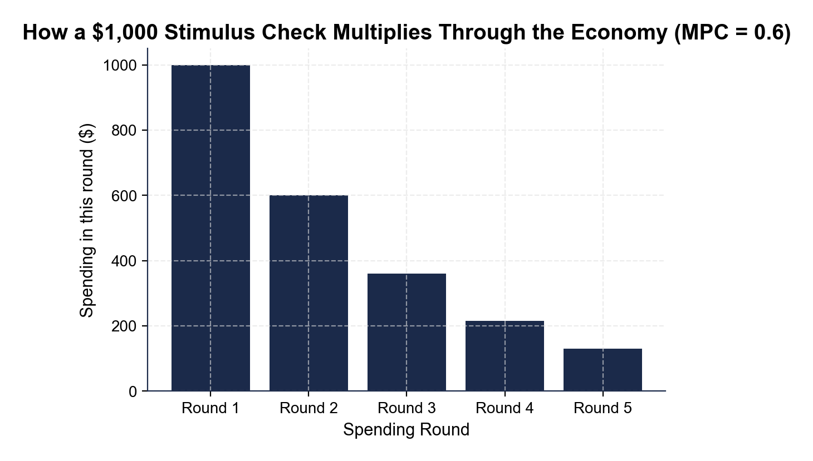
Round 1 is the TALLEST bar and each successive round is SHORTER - every round is 60% of the round before it (because MPC = 0.6), so the bars shrink steadily from left to right toward zero.
5. Using the Multiplier chart above, read directly off it.
(a) What is the Round 1 spending amount? Round 2? Round 3? Round 4? Round 5?
Reading the bar chart at each label: Round 1 = $1,000. Round 2 = $600. Round 3 = $360. Round 4 = $216. Round 5 = ~$130.
(b) Verify the 60% relationship between consecutive rounds: Round 2 / Round 1 = ___, Round 3 / Round 2 = ___.
VERIFY 60% RELATIONSHIP: Round 2 / Round 1 = $600 / $1,000 = 0.60 = 60%. Round 3 / Round 2 = $360 / $600 = 0.60 = 60%. Confirmed - each round is 60% of the prior round, which IS the MPC of 0.6.
(c) Compute the SUM of just the first five rounds visible on the chart.
SUM OF FIRST FIVE ROUNDS: $1,000 + $600 + $360 + $216 + $130 = $2,306. The infinite sum (all rounds) is $2,500 - so the first five rounds capture ~92% of the total multiplier effect.
6. CONNECT BACK TO PART 3 (NO CHART NEEDED). Connect the Multiplier chart to your Part 3 Q1 calculations.
(a) What is the infinite-rounds TOTAL spending across all rounds at MPC = 0.6 (using the formula 1 / (1 - MPC))?
INFINITE SUM AT MPC = 0.6: $1,000 / (1 - 0.6) = $1,000 / 0.4 = $2,500. The chart visualizes the first 5 rounds; the geometric series sums to $2,500 across all rounds.
(b) Redo the chart for $1,000 at MPC = 0.4: compute the first three rounds.
ROUNDS AT MPC = 0.4: Round 1 = $1,000. Round 2 = $1,000 x 0.4 = $400. Round 3 = $400 x 0.4 = $160.
(c) What is the infinite-rounds total at MPC = 0.4?
INFINITE SUM AT MPC = 0.4: $1,000 / (1 - 0.4) = $1,000 / 0.6 = ~$1,667.
(d) Write ONE SENTENCE explaining why a HIGHER MPC produces a LARGER multiplier effect, using the math you just computed.
WHY HIGHER MPC -> LARGER MULTIPLIER: A higher MPC means each recipient SPENDS more of what they receive rather than saving it, which leaves MORE money flowing into the next round of spending - which feeds the next round, and so on. At MPC = 0.4 the leakage to savings is large (60% saved each round), shrinking each successive round fast; at MPC = 0.6 only 40% leaks to savings each round, so the rounds shrink slowly and the infinite sum is larger. In short, the multiplier is BIGGER when the leakage out of the spending cycle is SMALLER.

PART 5

Final Policy Briefing to CEA Senior Staff (Jordan Park Synthesis)
POLICY BRIEFING MEMO
1. POLICY BRIEFING MEMO TO CEA SENIOR STAFF. As Jordan Park, write a 6-8 sentence policy briefing memo (about 200-300 words) to CEA senior staff TAKING A POSITION on whether the 2020 CARES Act stimulus checks were WORTH IT given the ~$292 billion fiscal cost. Use the memo header below and check off each required element as you include it. (Sentence starters you can use: "My briefing finds that the 2020 CARES checks were..." and "The strongest evidence FOR is... but a critic could object that...")
YOUR RESPONSE MUST:
☐ FACT PATTERN - one or two sentences stating the 2020 CARES per-adult and per-child check amounts, the total cost, and the timing, using the specific numbers you used in Part 3 and saw in the slides.
☐ KEYNESIAN EVIDENCE FOR - cite ONE specific piece of pro-stimulus evidence from the lesson (the realized multiplier of about 1.5-2.0, the fast 2020 Q3 GDP rebound, the child-poverty cut, or the within-week spending spikes).
☐ SAVED-NOT-SPENT EVIDENCE AGAINST - cite ONE specific piece of critique evidence from the lesson (the personal savings rate spiking to about 33% in April 2020, the realized MPC of about 0.3, or imperfect targeting).
☐ YOUR JUDGMENT - state clearly whether the 2020 CARES checks were worth it (worth it / not worth it / mixed-with-caveats) and defend the judgment in one sentence with at least one specific number.
☐ ONE REALISTIC OBJECTION - name one realistic objection a critic could raise to your judgment (for example, that targeted unemployment insurance has a higher MPC than untargeted checks).
☐ FIVE VOCABULARY TERMS - use at least FIVE lesson vocabulary terms from your Reference Guide (e.g., stimulus check, CARES Act, marginal propensity to consume, multiplier effect, aggregate demand, inflation).
MEMO
To: CEA Senior Staff
From: Jordan Park, Junior Economist, Council of Economic Advisers (CEA)
Date: [student completes]
Re: Retrospective on the 2020 CARES Act Stimulus Checks - Were They Worth It?
GRADING RUBRIC
Grade the evidence and reasoning, not the conclusion — any defensible position is valid. Score against the 6 requirements above.
FULL CREDIT — clear position; meets all 6 requirements with accurate, specific numbers and evidence from the lesson.
PARTIAL — position stated, but misses 1-2 requirements or uses vague / incorrect numbers.
MINIMAL — no clear position, or missing most requirements and numbers.
WHAT TO LOOK FOR IN THIS LESSON
Sample full-credit briefing memo:
TO: CEA Senior Staff
FROM: Jordan Park, Junior Economist, CEA
RE: Retrospective on the 2020 CARES Act Stimulus Checks - Were They Worth It?
[1] FACT PATTERN: The 2020 CARES Act sent $1,200 per adult plus $500 per child in stimulus checks, totaling about $292 billion (within a $2.2 trillion rescue package), mailed April-May 2020 during the sharp COVID-lockdown recession that erased roughly 22 million jobs in two months. [2] KEYNESIAN EVIDENCE FOR: 2020 GDP fell 8.4% in Q2 then snapped back to 7.9% growth in Q3 - the fastest recovery in modern U.S. history - and CBO plus major Wall Street estimates put the realized multiplier on the 2020-21 checks around 1.5-2.0, meaning the $292B in checks raised aggregate demand by roughly $440-$580 billion. [3] SAVED-NOT-SPENT EVIDENCE AGAINST: the personal savings rate spiked from about 7% pre-pandemic to about 33% in April 2020 - households saved roughly $96 billion of the $292B instead of spending it - and the realized marginal propensity to consume was around 0.3, lower than the textbook 0.6 benchmark, because the lockdown made it hard to spend on travel, restaurants, and services. [4] JUDGMENT: the 2020 CARES checks WERE WORTH IT - cutting cash-flow stress on 22 million laid-off households, preventing a deeper Q3 contraction, and producing a 1.5-2.0 multiplier on $292B justified the fiscal cost, especially because the federal government could borrow at near-zero real rates during the pandemic. [5] OBJECTION: a critic could argue the same $292B would have produced a LARGER aggregate-demand boost as targeted expanded unemployment insurance (a higher-MPC program than untargeted checks), so even if the checks worked they may not have been the OPTIMAL fiscal tool. [6] VOCABULARY: this memo uses stimulus check, CARES Act, marginal propensity to consume, multiplier effect, aggregate demand, and inflation.
REQUIRED-ELEMENT CHECKLIST (award credit per item):
[1] Fact pattern with the CARES amounts, total cost, and timing.
[2] One specific Keynesian-defense piece of evidence.
[3] One specific saved-not-spent piece of evidence.
[4] A clear judgment defended with at least one specific number.
[5] One realistic objection.
[6] At least FIVE Reference-Guide vocabulary terms.
Accept ANY defensible judgment and objection as long as the memo is supported with the student's own Part 3 numbers, takes a clear position, and names a realistic objection.
MORE LESSONS LESS PLANNING
Thank You!
If you enjoyed this product, please do not forget to rate and review to assist other teachers.

Looking for future discounts? Earn TPT credits by reviewing purchased products.

Please contact me if you have any issues with this product. Just like our students, I am always looking for opportunities to grow.

