Shortages and Surpluses: When Markets Misfire
STUDENT ACTIVITY
Name: | Date: | Period:
ESSENTIAL QUESTION
If the city makes your rent cheaper by law, why might you never find an apartment?
THE SCENARIO
You are a high school senior interning for JORDAN AVERY, a market analyst the city has hired to study two markets that are NOT clearing. The apartment market is under a new RENT-CONTROL law (a price ceiling), and the local labor market is under a higher MINIMUM WAGE (a price floor).
BY THE END, YOU CAN:
✓ Define a SHORTAGE (quantity demanded is greater than quantity supplied) and a SURPLUS (quantity supplied is greater than quantity demanded), and tell them apart
✓ Explain why a binding PRICE CEILING set BELOW equilibrium causes a persistent SHORTAGE, using rent control as the worked example
✓ Explain why a binding PRICE FLOOR set ABOVE equilibrium causes a persistent SURPLUS, using the minimum wage as the worked example
✓ Read a supply-and-demand chart to measure the gap between quantity demanded and quantity supplied, and predict whether a price control creates a shortage or a surplus
HOW IT WORKS (do Parts 1–5 in order)
Part 1 — Shortages and Surpluses Reference Guide - Complete the Missing Terms
Part 2 — Apply the Terms - Shortages and Surpluses Vocabulary in Context
Part 3 — You Read All Three Charts with Jordan Avery and Measure the Gap
Part 4 — Diagnose Four Real Price-Control Scenarios with Jordan Avery
Part 5 — Your Final Recommendation Memo to Jordan Avery
TIME about 45 minutes YOU’LL NEED the lesson slides and your Guided Notes.

PART 1

Shortages and Surpluses Reference Guide - Complete the Missing Terms
Fill in the missing term for each blank row — the definition is your clue. Your Guided Notes and the lesson slides have every term.

Term | Definition
___________ | When the quantity demanded is GREATER than the quantity supplied at the current price; buyers want more than sellers will provide, so goods sell out; happens when the price is below equilibrium
Surplus | When the quantity supplied is GREATER than the quantity demanded at the current price; sellers offer more than buyers will take, so goods pile up unsold; happens when the price is above equilibrium
___________ | The price where quantity demanded EQUALS quantity supplied; the market clears with no shortage and no surplus
Price ceiling | A government-set MAXIMUM legal price; it only bites when set BELOW equilibrium, and then it causes a shortage
___________ | A government-set MINIMUM legal price; it only bites when set ABOVE equilibrium, and then it causes a surplus
Binding price control | A price ceiling or floor that actually changes the market because it is set on the wrong side of equilibrium (ceiling below, floor above)
___________ | A price CEILING on apartment rent; set below equilibrium it causes a housing SHORTAGE because more renters want apartments than landlords supply
Minimum wage | A price FLOOR on the wage (the price of labor); set above equilibrium it causes a labor SURPLUS, also called unemployment
___________ | How much buyers are willing to buy at a given price; on the chart it is the point on the DEMAND curve at that price
Black market | An illegal market that appears when a binding price ceiling creates a shortage and buyers pay more than the legal price to get scarce goods

PART 2

Apply the Terms - Shortages and Surpluses Vocabulary in Context
WORD BANK rent control · quantity demanded · price floor · equilibrium · shortage
1. Jordan Avery starts you off with the most important word. The one price where the demand and supply curves cross and quantity demanded equals quantity supplied - so the market clears with no shortage and no surplus - is the .

2. When the quantity demanded is GREATER than the quantity supplied at the current price, buyers want more than sellers will provide and goods sell out. Economists call this gap a .

3. A government-set MINIMUM legal price that only bites when it is set above equilibrium - and then props the price too high so a surplus appears - is called a .

4. A price ceiling on apartment rent, which causes a housing shortage when a city sets it below the equilibrium rent, is called .

5. The amount buyers are willing to buy at a given price, which you read off the DEMAND curve at that price, is the .

PART 3

You Read All Three Charts with Jordan Avery and Measure the Gap
1. Use Chart Reference 1 (chart_equilibrium_baseline) - the equilibrium chart shown below - to read the baseline with Jordan Avery. The demand and supply curves cross at one point.
(a) Read the equilibrium: what are the price and quantity at the crossing point?

(b) At that equilibrium price, how does the quantity demanded compare to the quantity supplied?

(c) Is there a shortage, a surplus, or neither at the equilibrium price? Explain in one sentence.

2. Use Chart Reference 2 (chart_price_ceiling_shortage) - the price-ceiling chart shown below - to read the apartment market with Jordan Avery. The city set a rent ceiling (the coral dashed line).
(a) Is the ceiling ABOVE or BELOW the $8 equilibrium, and is it therefore binding?

(b) At the legal ceiling, read the quantity demanded off the demand curve and the quantity supplied off the supply curve.

(c) Subtract to find the size of the gap.

(d) Is this a SHORTAGE or a SURPLUS, and what real-world result does it cause in the apartment market?

3. Use Chart Reference 3 (chart_price_floor_surplus) - the price-floor chart shown below - to read the labor market with Jordan Avery. The city raised the minimum wage (the coral dashed line).
(a) Is the floor ABOVE or BELOW the $8 equilibrium wage, and is it therefore binding?

(b) At the legal floor, read the quantity supplied off the supply curve and the quantity demanded off the demand curve.

(c) Subtract to find the size of the gap.

(d) Is this a SHORTAGE or a SURPLUS, and what is this labor surplus called in the real world?

4. COMPARE THE THREE CHARTS. Jordan Avery asks you to connect what you read.
(a) Which chart showed NO gap (the market clearing), and which two showed a gap?

(b) The ceiling and the floor each created a gap of the SAME size (50). State the rule that explains WHY a ceiling causes a shortage but a floor causes a surplus.

(c) In one sentence, state the single question you should ask to tell a shortage apart from a surplus.

PART 4

Diagnose Four Real Price-Control Scenarios with Jordan Avery
1. DIAGNOSE FOUR SCENARIOS. Jordan Avery hands you four real price-control situations. For EACH, decide whether it is a price CEILING or a price FLOOR, whether it is BINDING (on the wrong side of equilibrium) or non-binding, and whether it creates a SHORTAGE, a SURPLUS, or no effect.
Scenario | Ceiling or Floor? | Binding? | Shortage/Surplus/No Effect?
Gasoline capped at $2/gal (market is $4)
Milk priced at a minimum $5/gal (market is $3)
Maximum ticket price $200 (concerts sell for $80)
Minimum wage $7 (market wage is $15)

2. WHICH WAY DOES THE GAP GO? For EACH controlled price below, decide whether quantity demanded or quantity supplied is the BIGGER number, and name the result. Remember the rule: a ceiling (low price) makes buyers want more, so Qd is bigger and you get a shortage; a floor (high price) makes sellers offer more, so Qs is bigger and you get a surplus.
Controlled Price | Bigger Quantity? | Result?
A binding rent ceiling
A binding minimum wage
A binding price ceiling on bread during a crisis
A binding price floor on wheat to support farmers

3. THE BINDING TRAP. Jordan Avery reminds you that a price control only matters when it is BINDING. For EACH statement, decide whether the control is BINDING or NON-BINDING and explain in a few words. Reminder: a ceiling bites only BELOW equilibrium; a floor bites only ABOVE equilibrium.
Statement | Binding? | Why?
A rent ceiling of $1,500 where apartments already rent for $900
A minimum wage of $14 where the market wage is $10
A price ceiling on insulin set below what pharmacies currently charge
A price floor on corn set below the current market price of corn

4. PREDICT THE CONSEQUENCE.
Using only the rules you learned, predict what happens in each case and whether the gap fixes itself or sticks around. (a) A binding price ceiling on apartments. (b) A binding price floor on labor (minimum wage). (c) Why can the shortage in (a) NOT fix itself? (d) Why can the surplus in (b) NOT fix itself?

PART 5

Your Final Recommendation Memo to Jordan Avery
RECOMMENDATION MEMO
1. Jordan Avery closes the internship by handing you the assignment that goes to the city council.
The city is keeping the rent-control ceiling on apartments AND the higher minimum wage on labor, and the council wants to know what to expect from each policy before the next budget vote. In a 6-8 sentence memo, what should the city expect to happen in the apartment market and the labor market, and why? Use all four required terms - SHORTAGE, SURPLUS, PRICE CEILING, and PRICE FLOOR - at least once each, and address every element on the checklist below.
YOUR RESPONSE MUST:
☐ States that a market only clears at EQUILIBRIUM, where quantity demanded equals quantity supplied.
☐ Explains that rent control is a PRICE CEILING set below equilibrium, which causes a SHORTAGE (Qd > Qs) of apartments.
☐ Explains that the higher minimum wage is a PRICE FLOOR set above equilibrium, which causes a SURPLUS (Qs > Qd) of labor (unemployment).
☐ Quotes at least ONE specific number from the charts (the ceiling gives Qd 75 and Qs 25 for a shortage of 50; the floor gives Qs 75 and Qd 25 for a surplus of 50).
☐ Notes that a control only bites when BINDING (a ceiling below equilibrium, a floor above) and that the gap will not fix itself because the price cannot legally move.
☐ Closes with a clear one-sentence takeaway about how to predict a shortage vs a surplus from a price control.
MEMO
To: Jordan Avery, Market Analyst, City Economic Office
From:
Date:
Re: Expected effects of rent control and the higher minimum wage

CHART REFERENCE 1: THE FREE-MARKET EQUILIBRIUM (NO SHORTAGE, NO SURPLUS)
Use Chart Reference 1 (chart_equilibrium_baseline) - the equilibrium chart shown below.
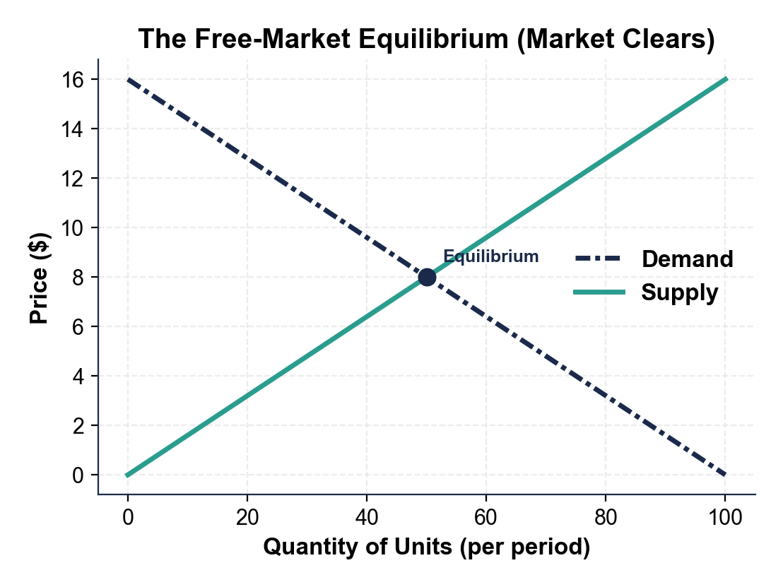
CHART REFERENCE 2: A BINDING PRICE CEILING CREATES A SHORTAGE (RENT CONTROL)
Use Chart Reference 2 (chart_price_ceiling_shortage) - the price-ceiling chart shown below.
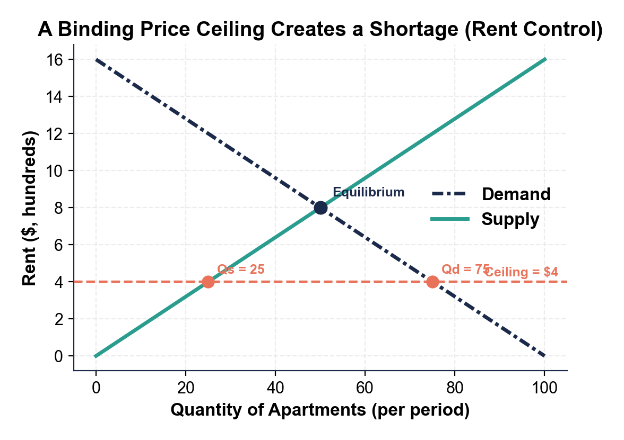
CHART REFERENCE 3: A BINDING PRICE FLOOR CREATES A SURPLUS (MINIMUM WAGE)
Use Chart Reference 3 (chart_price_floor_surplus) - the price-floor chart shown below.
