ECONOMICS

SHORTAGES AND SURPLUSES: WHEN MARKETS MISFIRE
ANSWER KEY ACTIVITY - ANSWER KEY

PART 1

Shortages and Surpluses Reference Guide - Complete the Missing Terms

Term | Definition
Shortage | When the quantity demanded is GREATER than the quantity supplied at the current price; buyers want more than sellers will provide, so goods sell out; happens when the price is below equilibrium
Surplus | When the quantity supplied is GREATER than the quantity demanded at the current price; sellers offer more than buyers will take, so goods pile up unsold; happens when the price is above equilibrium
Equilibrium | The price where quantity demanded EQUALS quantity supplied; the market clears with no shortage and no surplus
Price ceiling | A government-set MAXIMUM legal price; it only bites when set BELOW equilibrium, and then it causes a shortage
Price floor | A government-set MINIMUM legal price; it only bites when set ABOVE equilibrium, and then it causes a surplus
Binding price control | A price ceiling or floor that actually changes the market because it is set on the wrong side of equilibrium (ceiling below, floor above)
Rent control | A price CEILING on apartment rent; set below equilibrium it causes a housing SHORTAGE because more renters want apartments than landlords supply
Minimum wage | A price FLOOR on the wage (the price of labor); set above equilibrium it causes a labor SURPLUS, also called unemployment
Quantity demanded | How much buyers are willing to buy at a given price; on the chart it is the point on the DEMAND curve at that price
Black market | An illegal market that appears when a binding price ceiling creates a shortage and buyers pay more than the legal price to get scarce goods

PART 2

Apply the Terms - Shortages and Surpluses Vocabulary in Context
WORD BANK rent control · quantity demanded · price floor · equilibrium · shortage
1. Jordan Avery starts you off with the most important word. The one price where the demand and supply curves cross and quantity demanded equals quantity supplied - so the market clears with no shortage and no surplus - is the Equilibrium.
Equilibrium. It is the only price where quantity demanded equals quantity supplied, so the market clears with nothing left over.
2. When the quantity demanded is GREATER than the quantity supplied at the current price, buyers want more than sellers will provide and goods sell out. Economists call this gap a Shortage.
Shortage. It happens when the price is held below equilibrium, so buyers want more than sellers will provide and goods sell out.
3. A government-set MINIMUM legal price that only bites when it is set above equilibrium - and then props the price too high so a surplus appears - is called a price floor.
price floor
4. A price ceiling on apartment rent, which causes a housing shortage when a city sets it below the equilibrium rent, is called rent control.
rent control
5. The amount buyers are willing to buy at a given price, which you read off the DEMAND curve at that price, is the quantity demanded.
quantity demanded
PART 3

You Read All Three Charts with Jordan Avery and Measure the Gap
1. Use Chart Reference 1 (chart_equilibrium_baseline) - the equilibrium chart shown below - to read the baseline with Jordan Avery. The demand and supply curves cross at one point.
(a) Read the equilibrium: what are the price and quantity at the crossing point?
The equilibrium is at a price of $8 and a quantity of 50 units (the point where the demand and supply curves cross).
(b) At that equilibrium price, how does the quantity demanded compare to the quantity supplied?
At the equilibrium price, quantity demanded EQUALS quantity supplied (both are 50).
(c) Is there a shortage, a surplus, or neither at the equilibrium price? Explain in one sentence.
NEITHER - there is no shortage and no surplus, because the market clears: every buyer who will pay $8 is matched with a seller who will sell at $8.
2. Use Chart Reference 2 (chart_price_ceiling_shortage) - the price-ceiling chart shown below - to read the apartment market with Jordan Avery. The city set a rent ceiling (the coral dashed line).
(a) Is the ceiling ABOVE or BELOW the $8 equilibrium, and is it therefore binding?
The ceiling is set at $4, which is BELOW the $8 equilibrium, so it is BINDING (it forces the rent too low).
(b) At the legal ceiling, read the quantity demanded off the demand curve and the quantity supplied off the supply curve.
At the $4 ceiling, quantity demanded is 75 apartments (read off the demand curve) and quantity supplied is 25 apartments (read off the supply curve).
(c) Subtract to find the size of the gap.
The gap is Qd minus Qs = 75 - 25 = 50 apartments.
(d) Is this a SHORTAGE or a SURPLUS, and what real-world result does it cause in the apartment market?
This is a SHORTAGE of 50 apartments - more renters want apartments than landlords supply, so renters face long waitlists and no vacancies.

3. Use Chart Reference 3 (chart_price_floor_surplus) - the price-floor chart shown below - to read the labor market with Jordan Avery. The city raised the minimum wage (the coral dashed line).
(a) Is the floor ABOVE or BELOW the $8 equilibrium wage, and is it therefore binding?
The floor is set at $12, which is ABOVE the $8 equilibrium wage, so it is BINDING (it props the wage too high).
(b) At the legal floor, read the quantity supplied off the supply curve and the quantity demanded off the demand curve.
At the $12 floor, quantity supplied is 75 workers (read off the supply curve) and quantity demanded is 25 workers (read off the demand curve).
(c) Subtract to find the size of the gap.
The gap is Qs minus Qd = 75 - 25 = 50 workers.
(d) Is this a SHORTAGE or a SURPLUS, and what is this labor surplus called in the real world?
This is a SURPLUS of 50 workers - more workers want jobs than employers will hire. This labor surplus is called UNEMPLOYMENT.
4. COMPARE THE THREE CHARTS. Jordan Avery asks you to connect what you read.
(a) Which chart showed NO gap (the market clearing), and which two showed a gap?
Chart 1 (chart_equilibrium_baseline) showed NO gap - the market cleared at $8 and 50 units. Chart 2 (price ceiling) and Chart 3 (price floor) each showed a gap of 50.
(b) The ceiling and the floor each created a gap of the SAME size (50). State the rule that explains WHY a ceiling causes a shortage but a floor causes a surplus.
THE RULE: a CEILING set BELOW equilibrium forces the price too LOW, so quantity demanded exceeds quantity supplied (Qd > Qs) and you get a SHORTAGE; a FLOOR set ABOVE equilibrium props the price too HIGH, so quantity supplied exceeds quantity demanded (Qs > Qd) and you get a SURPLUS.
(c) In one sentence, state the single question you should ask to tell a shortage apart from a surplus.
THE QUESTION: at the controlled price, is quantity demanded bigger (a shortage) or is quantity supplied bigger (a surplus)?
PART 4

Diagnose Four Real Price-Control Scenarios with Jordan Avery
1. DIAGNOSE FOUR SCENARIOS. Jordan Avery hands you four real price-control situations. For EACH, decide whether it is a price CEILING or a price FLOOR, whether it is BINDING (on the wrong side of equilibrium) or non-binding, and whether it creates a SHORTAGE, a SURPLUS, or no effect.
Scenario | Ceiling or Floor? | Binding? | Shortage/Surplus/No Effect?
Gasoline capped at $2/gal (market is $4) | Price ceiling | Binding ($2 < $4, below equilibrium) | Shortage of gasoline (Qd > Qs)
Milk priced at a minimum $5/gal (market is $3) | Price floor | Binding ($5 > $3, above equilibrium) | Surplus of milk (Qs > Qd)
Maximum ticket price $200 (concerts sell for $80) | Price ceiling | Non-binding ($200 > $80, set above equilibrium) | No effect - market price is already legal
Minimum wage $7 (market wage is $15) | Price floor | Non-binding ($7 < $15, set below equilibrium) | No effect - market wage is already above the floor

2. WHICH WAY DOES THE GAP GO? For EACH controlled price below, decide whether quantity demanded or quantity supplied is the BIGGER number, and name the result. Remember the rule: a ceiling (low price) makes buyers want more, so Qd is bigger and you get a shortage; a floor (high price) makes sellers offer more, so Qs is bigger and you get a surplus.
Controlled Price | Bigger Quantity? | Result?
A binding rent ceiling | Quantity demanded (Qd > Qs) | Housing shortage
A binding minimum wage | Quantity supplied of labor (Qs > Qd) | Labor surplus (unemployment)
A binding price ceiling on bread during a crisis | Quantity demanded (Qd > Qs) | Bread shortage
A binding price floor on wheat to support farmers | Quantity supplied (Qs > Qd) | Wheat surplus

3. THE BINDING TRAP. Jordan Avery reminds you that a price control only matters when it is BINDING. For EACH statement, decide whether the control is BINDING or NON-BINDING and explain in a few words. Reminder: a ceiling bites only BELOW equilibrium; a floor bites only ABOVE equilibrium.
Statement | Binding? | Why?
A rent ceiling of $1,500 where apartments already rent for $900 | Non-binding | The ceiling ($1,500) is above the market rent ($900), so the market is already legal; no effect.
A minimum wage of $14 where the market wage is $10 | Binding | The floor ($14) is above the market wage ($10), so it props the wage up and creates a labor surplus.
A price ceiling on insulin set below what pharmacies currently charge | Binding | The ceiling is below the current price, so it forces the price down and creates a shortage of insulin.
A price floor on corn set below the current market price of corn | Non-binding | The floor is below the market price, so corn already sells above the floor; no effect.

4. PREDICT THE CONSEQUENCE.
Using only the rules you learned, predict what happens in each case and whether the gap fixes itself or sticks around. (a) A binding price ceiling on apartments. (b) A binding price floor on labor (minimum wage). (c) Why can the shortage in (a) NOT fix itself? (d) Why can the surplus in (b) NOT fix itself?
(a) A binding apartment ceiling creates a SHORTAGE (Qd > Qs) - waitlists, no vacancies, and possibly a black market. (b) A binding minimum wage creates a SURPLUS of labor (Qs > Qd) - unemployment. (c) The shortage cannot fix itself because normally the price would RISE until Qd = Qs, but the ceiling makes a higher rent ILLEGAL, so the price is stuck and the gap stays open. (d) The surplus cannot fix itself because normally the wage would FALL until Qs = Qd, but the floor makes a lower wage ILLEGAL, so the wage is stuck high and the gap stays open.
PART 5

Your Final Recommendation Memo to Jordan Avery
RECOMMENDATION MEMO
1. Jordan Avery closes the internship by handing you the assignment that goes to the city council.
The city is keeping the rent-control ceiling on apartments AND the higher minimum wage on labor, and the council wants to know what to expect from each policy before the next budget vote. In a 6-8 sentence memo, what should the city expect to happen in the apartment market and the labor market, and why? Use all four required terms - SHORTAGE, SURPLUS, PRICE CEILING, and PRICE FLOOR - at least once each, and address every element on the checklist below.
YOUR RESPONSE MUST:
☐ States that a market only clears at EQUILIBRIUM, where quantity demanded equals quantity supplied.
☐ Explains that rent control is a PRICE CEILING set below equilibrium, which causes a SHORTAGE (Qd > Qs) of apartments.
☐ Explains that the higher minimum wage is a PRICE FLOOR set above equilibrium, which causes a SURPLUS (Qs > Qd) of labor (unemployment).
☐ Quotes at least ONE specific number from the charts (the ceiling gives Qd 75 and Qs 25 for a shortage of 50; the floor gives Qs 75 and Qd 25 for a surplus of 50).
☐ Notes that a control only bites when BINDING (a ceiling below equilibrium, a floor above) and that the gap will not fix itself because the price cannot legally move.
☐ Closes with a clear one-sentence takeaway about how to predict a shortage vs a surplus from a price control.
MEMO
To: Jordan Avery, Market Analyst, City Economic Office
From: [student completes]
Date: [student completes]
Re: Expected effects of rent control and the higher minimum wage
GRADING RUBRIC
Grade the evidence and reasoning, not the conclusion — any defensible position is valid. Score against the 6 requirements above.
FULL CREDIT — clear position; meets all 6 requirements with accurate, specific numbers and evidence from the lesson.
PARTIAL — position stated, but misses 1-2 requirements or uses vague / incorrect numbers.
MINIMAL — no clear position, or missing most requirements and numbers.
CHART REFERENCE 1: THE FREE-MARKET EQUILIBRIUM (NO SHORTAGE, NO SURPLUS)
Use Chart Reference 1 (chart_equilibrium_baseline) - the equilibrium chart shown below.
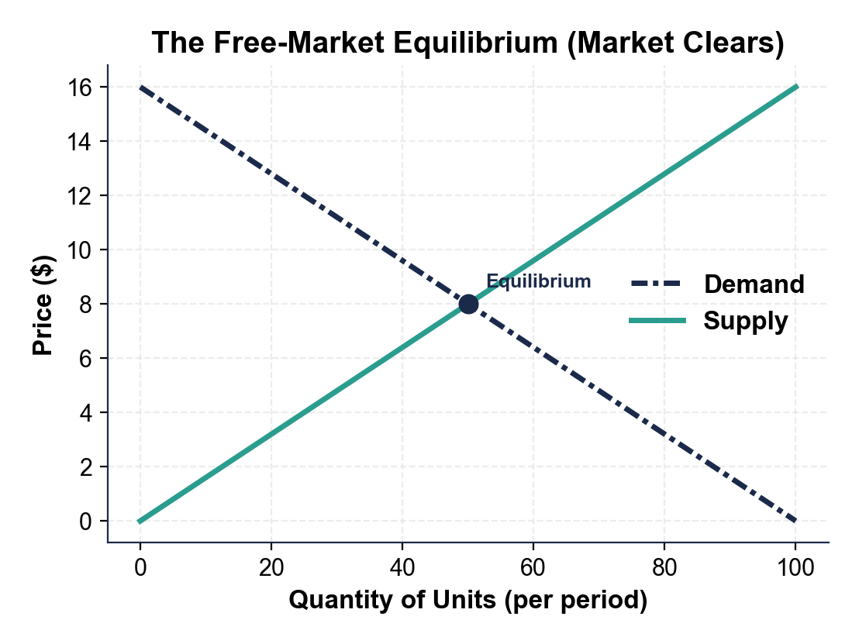
CHART REFERENCE 2: A BINDING PRICE CEILING CREATES A SHORTAGE (RENT CONTROL)
Use Chart Reference 2 (chart_price_ceiling_shortage) - the price-ceiling chart shown below.
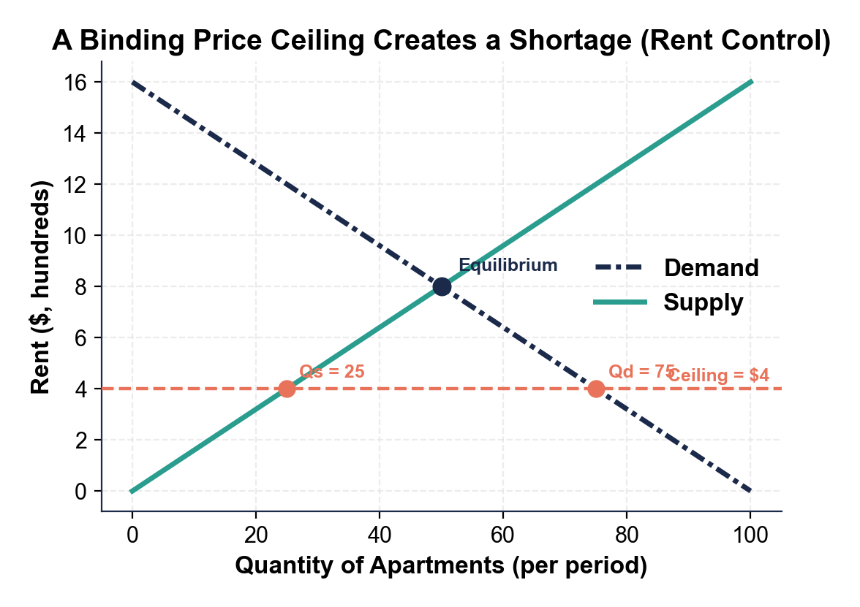
CHART REFERENCE 3: A BINDING PRICE FLOOR CREATES A SURPLUS (MINIMUM WAGE)
Use Chart Reference 3 (chart_price_floor_surplus) - the price-floor chart shown below.
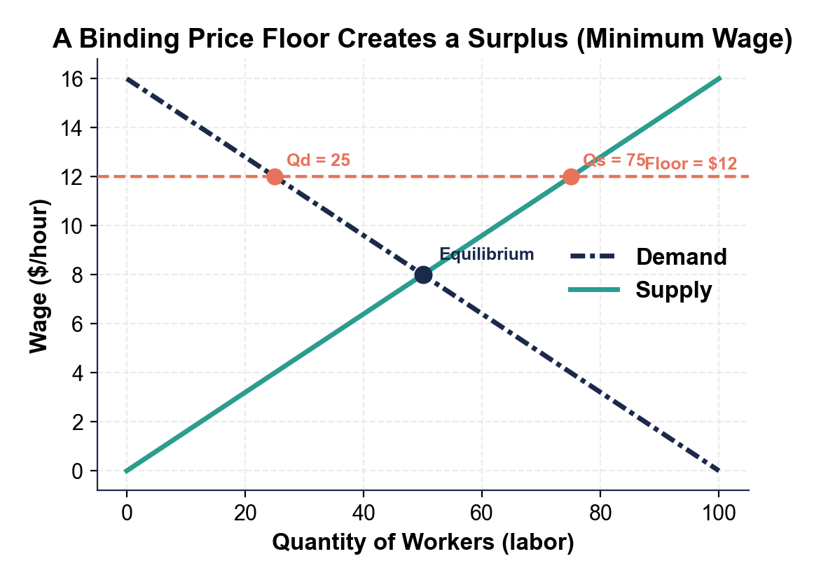

MORE LESSONS LESS PLANNING
Thank You!
If you enjoyed this product, please do not forget to rate and review to assist other teachers.

Looking for future discounts? Earn TPT credits by reviewing purchased products.

Please contact me if you have any issues with this product. Just like our students, I am always looking for opportunities to grow.

