Self-Employment Taxes: The Gig Worker's Surprise
STUDENT ACTIVITY
Name: | Date: | Period:
ESSENTIAL QUESTION
Why do self-employed and gig workers owe extra tax that a W-2 employee doesn't, and what three-part plan (quarterly payments, deducting expenses, setting money aside) keeps that tax bill from ever being a surprise?
THE SCENARIO
You are JORDAN REYES, a peer financial mentor running a community workshop for new freelancers and gig workers. CASEY just filed taxes for the first time after a year of driving rideshare and picking up freelance design jobs - and got a bill that was way bigger than expected.
BY THE END, YOU CAN:
✓ Explain why self-employed workers owe extra tax that a W-2 employee does not
✓ Apply the LABELED SE tax model (12.4% Social Security + 2.9% Medicare = 15.3%) to calculate SE tax on gig income
✓ Explain why gig workers make quarterly estimated tax payments instead of having tax withheld
✓ Calculate how deducting ordinary and necessary business expenses lowers SE tax owed on NET profit
HOW IT WORKS (do Parts 1–5 in order)
Part 1 — SE Tax Reference Guide - Complete the Missing Terms
Part 2 — Apply the Terms - SE Tax Vocabulary in Context
Part 3 — Calculate SE Tax on Gig Income - Use the 15.3% Model
Part 4 — Read the Chart and Work the Numbers - Tax Owed: W-2 Employee vs. Self-Employed on the Same Income
Part 5 — Advise Casey - Quarterly Payments, Deductions, and Setting Money Aside
TIME about 45 minutes YOU’LL NEED the lesson slides and your Guided Notes.

PART 1

SE Tax Reference Guide - Complete the Missing Terms
Fill in the missing term for each blank row — the definition is your clue. Your Guided Notes and the lesson slides have every term.

Term | Definition
___________ | Payment reported on IRS Form 1099-NEC instead of a W-2; gig and freelance workers receive 1099s and no employer withholds tax for them
Payroll tax | The combined Social Security and Medicare tax normally split between a W-2 employee (about 7.65%) and their employer (the other about 7.65%)
___________ | The 15.3% tax (12.4% Social Security + 2.9% Medicare) that self-employed workers pay to cover BOTH the employee and employer shares of payroll tax
Net profit | Gross self-employment income minus ordinary and necessary business expenses; SE tax is owed on net profit, not gross income
___________ | An ordinary and necessary cost of doing gig or freelance work (such as supplies or mileage) that can be deducted from gross income before SE tax is calculated
Quarterly estimated taxes | Tax payments a self-employed worker sends to the IRS four times a year because no employer is withholding tax from their pay
___________ | Tax an employer takes out of a W-2 employee's paycheck automatically; self-employed workers have none, so they must pay it themselves
Gross income | The total amount a gig or freelance worker is paid before any business expenses are subtracted
___________ | Reserving about 25%-30% of every gig payment in a separate account to cover taxes owed later
Freelancer / gig worker | A self-employed person who is paid per job or per task (such as rideshare driving or freelance design) rather than earning a W-2 salary

PART 2

Apply the Terms - SE Tax Vocabulary in Context
WORD BANK 1099 · withholding · set aside · self employment · business expense
1. Q1. Payment reported on a form instead of a W-2 - the way gig and freelance workers get paid, with no tax taken out - is income.

2. Q2. The 15.3% tax that covers BOTH the employee and employer shares of payroll tax, paid by people who work for themselves, is the - tax.

3. Q3. An ordinary and necessary cost of doing gig or freelance work, like supplies or mileage, that can be subtracted from gross income before SE tax is calculated, is a .

4. Q4. The tax an employer automatically takes out of a W-2 employee's paycheck - something self-employed workers do NOT have happening for them - is called .

5. Q5. Reserving about 25%-30% of every gig payment in a separate account to cover taxes owed later is the - rule of thumb.

PART 3

Calculate SE Tax on Gig Income - Use the 15.3% Model
1. As Jordan Reyes, warm up the SE tax model with Casey on a simple $20,000 NET profit. The SE tax rate is 15.3% (12.4% Social Security + 2.9% Medicare).
(a) What is the Social Security portion ($20,000 x 0.124)?

(b) What is the Medicare portion ($20,000 x 0.029)?

(c) What is the TOTAL SE tax ($20,000 x 0.153)?

2. As Jordan Reyes, now calculate the full SE tax on Casey's actual $28,000 in NET self-employment profit, band by band.
(a) Social Security portion: $28,000 x 0.124 = ?

(b) Medicare portion: $28,000 x 0.029 = ?

(c) Add the two parts for the TOTAL SE tax, and confirm it matches $28,000 x 0.153.

3. As Jordan Reyes, use Casey's $4,284 SE tax to bust a common assumption.
(a) If Casey wrongly assumed SE tax was the same as a W-2 employee's payroll tax (7.65%), what would they expect to owe on $28,000 ($28,000 x 0.0765)?

(b) What is the REAL SE tax you calculated in A3-Q2?

(c) In one sentence, why is the real number so much higher?

PART 4

Read the Chart and Work the Numbers - Tax Owed: W-2 Employee vs. Self-Employed on the Same Income
As Jordan Reyes, study the bar chart titled "Tax Owed: W-2 Employee vs. Self-Employed on the Same Income" (it appears with A4-Q1). Both bars show tax owed on the IDENTICAL $40,000 of net income - one bar for a W-2 employee, one bar for a self-employed gig worker. The same two values are listed in the data table below. Use the chart and table to answer A4-Q1 to A4-Q3, then work the deduction math in A4-Q4.

Worker type (on the same $40,000 income) | Tax owed
W-2 employee (7.65% employee share) | $3,060
Self-employed / gig worker (full 15.3% SE tax) | $6,120
GAP (extra tax the self-employed worker pays) | $3,060

Analysis
1. A4-Q1. As Jordan Reyes, study the bar chart on this page titled "Tax Owed: W-2 Employee vs. Self-Employed on the Same Income." Both bars show tax owed on the identical $40,000 of income. Read the chart and write the dollar amount of tax owed by (a) the W-2 employee and (b) the self-employed worker.
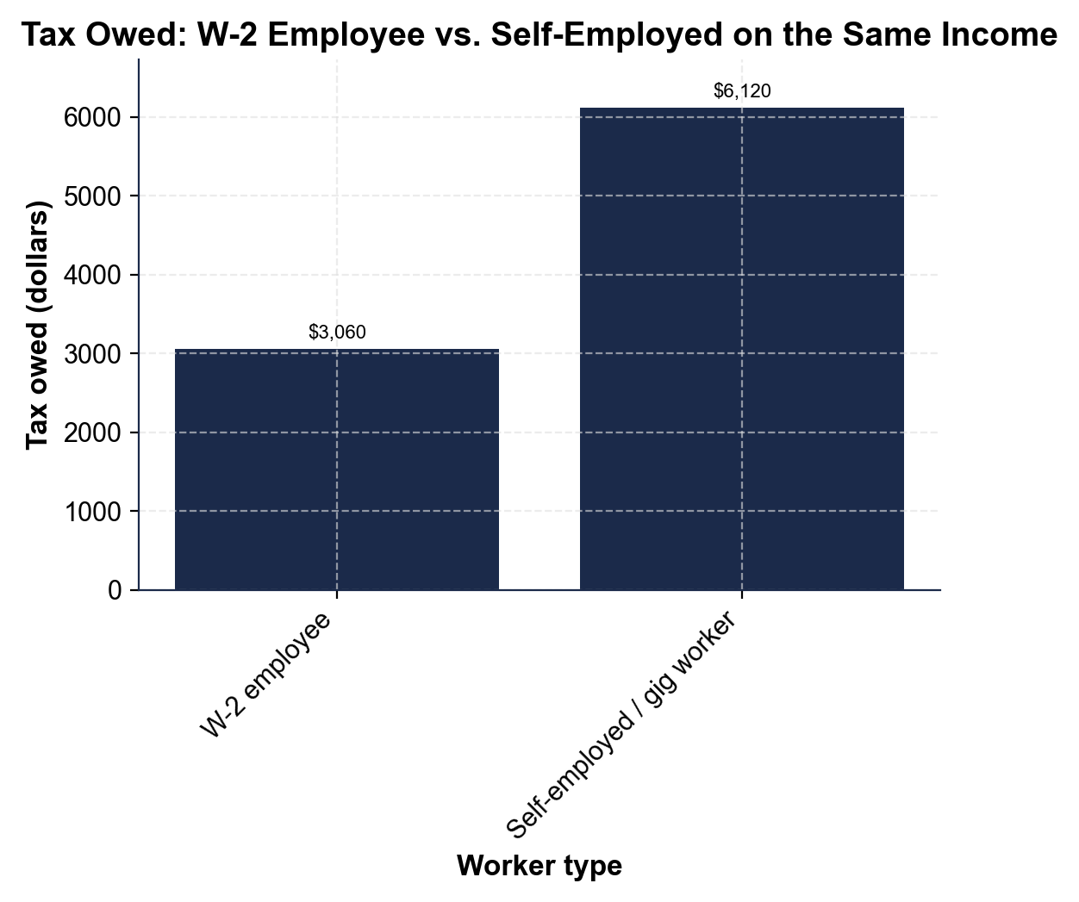

2. A4-Q2. As Jordan Reyes, use the same chart to make the key point to Casey. (a) How many times larger is the self-employed worker's bar compared to the W-2 employee's bar? (b) Explain in one sentence WHY the self-employed bar is exactly that much bigger, even though both workers earned the identical $40,000.

3. A4-Q3. As Jordan Reyes, confirm the chart and then work the quarterly-payment plan. (a) Add the gap between the two bars ($6,120 - $3,060) to confirm how much EXTRA the self-employed worker pays. (b) If Casey's own SE tax for the year comes to $5,508, what is Casey's quarterly estimated payment ($5,508 / 4)?

4. A4-Q4. As Jordan Reyes, show Casey how deducting real business expenses helps. Casey actually earned $45,000 GROSS in gig income this year, with $9,000 in real business expenses (mileage, equipment, supplies). (a) What is Casey's NET profit ($45,000 - $9,000)? (b) What would SE tax be if wrongly calculated on the full $45,000 GROSS ($45,000 x 0.153)? (c) What is the CORRECT SE tax calculated on the $36,000 NET profit ($36,000 x 0.153)? (d) How much does Casey SAVE by deducting expenses properly?

PART 5

Advise Casey - Quarterly Payments, Deductions, and Setting Money Aside
1. As Jordan Reyes, help Casey build a quarterly payment plan going forward. Casey expects to owe about $4,284 in SE tax next year (based on the $28,000 NET profit example).
(a) What would each of Casey's four quarterly payments be ($4,284 / 4)?

(b) In one sentence, why is paying quarterly better for Casey than waiting to pay it all at once in April?

2. As Jordan Reyes, remind Casey why keeping receipts matters. Suppose next year Casey earns $30,000 gross and has $6,000 in real business expenses.
(a) What is Casey's NET profit ($30,000 - $6,000)?

(b) What is the SE tax on that NET profit ($24,000 x 0.153)?

(c) What would SE tax have been if Casey ignored the deduction and paid on the full $30,000 gross ($30,000 x 0.153)?

(d) How much would Casey overpay by skipping the deduction?

3. As Jordan Reyes, help Casey set up the set-aside habit for a new $2,000 gig payment that just arrived.
(a) Using the 25%-30% rule of thumb, what is 25% of $2,000?

(b) What is 30% of $2,000?

(c) In one sentence, state the practical habit Casey should build the moment a gig payment arrives.

FINAL NOTE TO CASEY
4. FINAL NOTE TO CASEY. As Jordan Reyes, put your advice in writing for Casey. Write a 5-7 sentence note (120-180 words) that explains why the self-employed owe extra tax, uses at least one calculated result from this activity, and gives Casey a concrete three-part plan (quarterly payments, deducting expenses, setting money aside) for next year. Check off each required element as you include it.
YOUR RESPONSE MUST:
☐ EXPLAIN WHY THE SELF-EMPLOYED OWE MORE - say that with no employer to split payroll tax, Casey pays BOTH the employee and employer shares (the full 15.3% SE tax), not just the 7.65% a W-2 employee pays.
☐ USE A CALCULATED RESULT - include a figure from this activity (for example: on $40,000 of income the self-employed worker owes $6,120 versus $3,060 for a W-2 employee; or Casey's SE tax of $4,284 splits into $1,071 quarterly payments).
☐ RECOMMEND QUARTERLY PAYMENTS - tell Casey to pre-pay the IRS four times a year instead of waiting for one bill in April.
☐ RECOMMEND DEDUCTING BUSINESS EXPENSES - remind Casey that SE tax is owed on NET profit, so tracking real business expenses lowers the tax bill.
☐ RECOMMEND SETTING MONEY ASIDE - tell Casey to set aside about 25%-30% of every gig payment in a separate account right away.

