Risk vs Reward - Why You Can't Win Without Risk
STUDENT ACTIVITY
Name: | Date: | Period:
ESSENTIAL QUESTION
Why does a higher possible reward always come paired with higher risk (so you can't win without risk), what do volatility, risk tolerance, and time horizon tell you about how much risk fits you, and how does diversification lower risk without giving up much reward?
THE SCENARIO
You are helping DEVIN CARTER, who is 24 and has $1,000 to invest for the first time. Devin is comparing four places to put money - a savings account, bonds, stocks, and crypto - and trying to decide how much risk to accept.
BY THE END, YOU CAN:
✓ Explain the risk/reward tradeoff - why a higher possible reward always comes paired with higher risk, and why you cannot win without risk
✓ Explain what investment risk and volatility are and identify different types of investment risk
✓ Explain how your risk tolerance and time horizon decide how much investment risk fits you
✓ Explain how diversification lowers risk and describe an investment mix that fits your goals
HOW IT WORKS (do Parts 1–5 in order)
Part 1 — Risk & Reward Reference Guide - Complete the Missing Terms
Part 2 — Apply the Terms - Risk & Reward Vocabulary in Context
Part 3 — Read the Chart - Risk vs Reward Across Four Places to Invest
Part 4 — The Tradeoff and Diversification - Analyze Why You Can't Win Without Risk
Part 5 — Time Horizon, Risk Tolerance, and Your Recommendation
TIME about 45 minutes YOU’LL NEED the lesson slides and your Guided Notes.

PART 1

Risk & Reward Reference Guide - Complete the Missing Terms
Fill in the missing term for each blank row — the definition is your clue. Your Guided Notes and the lesson slides have every term.

Term | Definition
___________ | The rule that a higher possible reward always comes paired with higher risk; safe investments earn little
Return | The money you earn on an investment, usually shown as a percent per year - the reward side of investing
___________ | How much an investment's value swings up and down over time; the everyday face of risk
Market risk | The whole market can drop at once, like a recession, pulling most investments down together
___________ | Spreading your money across many different investments so no single one can wreck your whole plan
Company risk | One company can fail on its own and take the money you put in it down with it
___________ | How much risk - how big a swing or possible loss - you can handle, financially and emotionally, without panic-selling
Inflation risk | Money in a low-return savings account can lose buying power if prices rise faster than it grows
___________ | How long until you need the money; a long horizon can hold riskier investments because there is time to recover
Index fund | A single investment that owns hundreds of companies at once, an easy way to diversify

PART 2

Apply the Terms - Risk & Reward Vocabulary in Context
WORD BANK volatility · risk tolerance · diversification · risk/reward tradeoff · time horizon
1. Q1. The rule that a higher possible reward always comes paired with higher risk - so safe investments earn little - is the .

2. Q2. How much an investment's value swings up and down over time - the everyday face of risk - is called .

3. Q3. Spreading your money across many different investments so no single one can wreck your whole plan is called .

4. Q4. How much risk - how big a swing or possible loss - you can handle without panic-selling is your .

5. Q5. How long until you need the money - a long one can hold riskier investments because there is time to recover - is your .

PART 3

Read the Chart - Risk vs Reward Across Four Places to Invest
1. As you help Devin Carter, study the bar chart on this page titled "Risk vs Reward Across Four Places to Invest." It shows two bars at each of Devin's four choices: the typical yearly RETURN (the reward) and the typical yearly RISK (the swing). Read the chart and write the RETURN percent for:
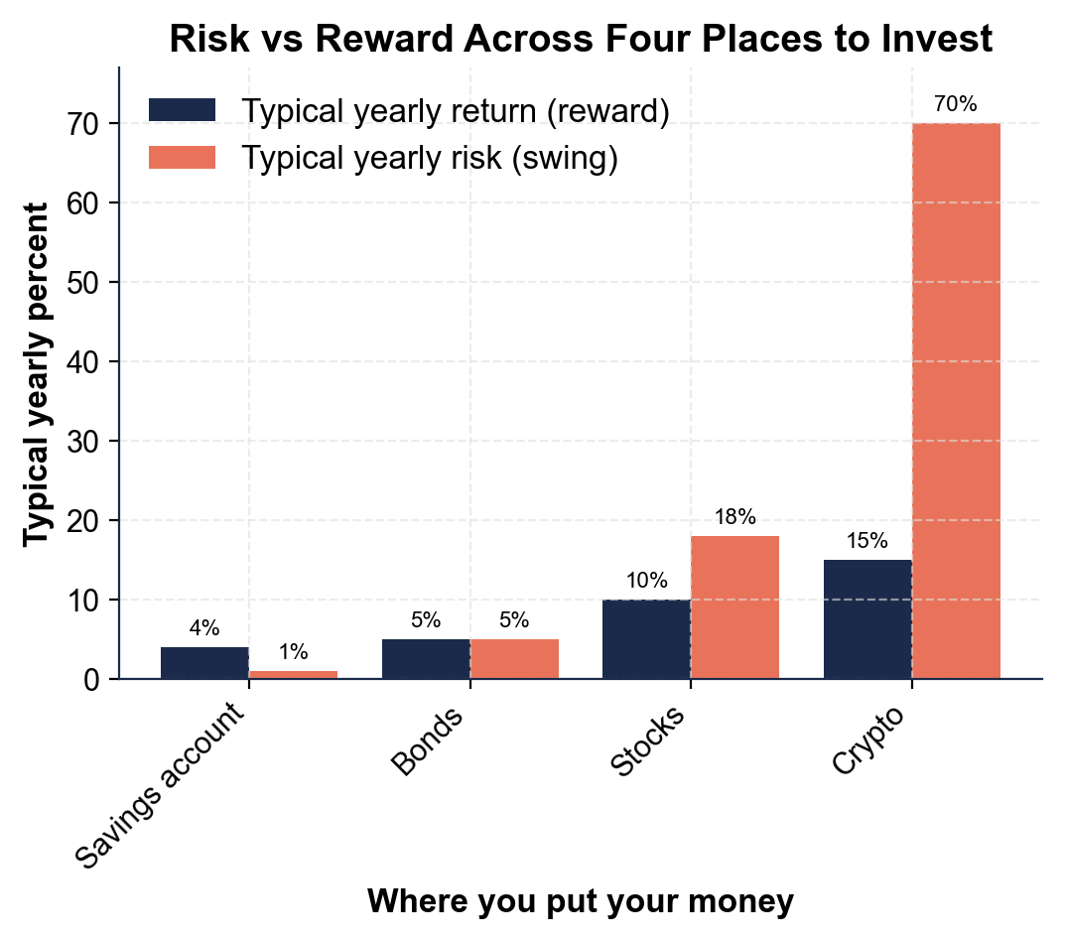
(a) a savings account

(b) crypto.

2. As you help Devin Carter, use the same chart to read the RISK (swing) percent for each choice:
(a) a savings account

(b) bonds

(c) stocks

(d) crypto.

3. As you help Devin Carter, compare the two bars as you move from the safest choice (savings) to the riskiest (crypto).
(a) Does the RETURN bar go up or down?

(b) Does the RISK bar go up or down?

(c) In one sentence, which bar climbs FASTER - return or risk?

4. As you help Devin Carter, look at the overall pattern. In one or two sentences, explain what the chart shows about risk and reward across the four choices. Start your answer with: "The chart shows that..."

PART 4

The Tradeoff and Diversification - Analyze Why You Can't Win Without Risk
1. As you help Devin Carter, explain the RISK/REWARD TRADEOFF in your own words.
(a) What happens to the possible reward as an investment gets riskier?

(b) Why can Devin NOT get a high return with no risk?

(c) Does that mean Devin should avoid all risk? Explain.

2. As you help Devin Carter, work the diversification example. Devin puts ALL $1,000 into ONE investment, and it drops 50%.
(a) What is the investment worth after the drop?

(b) How many dollars did Devin lose? Show your math.

3. As you help Devin Carter, work the OTHER case. Devin instead splits the $1,000 across 10 different investments ($100 each), and only ONE of them drops 50%.
(a) What is that one investment worth after the drop?

(b) How many dollars did Devin lose?

(c) How much of the $1,000 is untouched? Show your math.

4. As you help Devin Carter, compare the two cases from Q2 and Q3.
(a) In the all-in-one case, how much did Devin lose?

(b) In the diversified case, how much did Devin lose?

(c) By how many dollars did diversification cut the loss? Show your math.

5. As you help Devin Carter, put it together.
(a) In one sentence, explain how diversification lowered Devin's risk in this example.

(b) Does diversification make Devin give up the chance at a good return?

(c) Name one easy way Devin can diversify with a single purchase.

PART 5

Time Horizon, Risk Tolerance, and Your Recommendation
1. As you help Devin Carter, reason about TIME HORIZON. Devin is 24 and retirement is 40+ years away.
(a) Is that a long or a short time horizon?

(b) Does a long horizon let Devin take MORE or LESS risk, and why?

(c) Where should Devin put money that is needed next month for rent, and why?

2. As you help Devin Carter, reason about RISK TOLERANCE.
(a) What does risk tolerance mean?

(b) Name the two sides of it - the money side and the feelings side.

(c) Why is it a mistake for Devin to pick MORE risk than Devin can actually handle?

3. As you help Devin Carter, give practical advice for the $1,000. Devin has a long horizon and wants the money to grow.
(a) Should Devin keep all $1,000 in a savings account? Why or why not?

(b) How can Devin take on higher-reward investing while still lowering risk?

(c) Name one thing Devin should NOT do.

FINAL RECOMMENDATION
4. FINAL RECOMMENDATION. Devin asks you to put it in writing. Write a 5-7 sentence note (120-180 words) telling Devin what the risk/reward tradeoff means, how time horizon and risk tolerance should shape the decision, and how to use diversification. Check off each required element as you include it.
YOUR RESPONSE MUST:
☐ EXPLAIN THE RISK/REWARD TRADEOFF - state in your own words that a higher possible reward always comes with higher risk, so you cannot win without risk and the safest choices earn the least.
☐ USE A CHART NUMBER - name at least one return or risk percent you read off the chart in Part 3 (for example, crypto's 15% return and 70% risk, or savings' 4% return and 1% risk).
☐ USE THE DIVERSIFICATION RESULT - state the numbers you calculated in Part 4 (all $1,000 in one investment that drops 50% loses $500, but split across 10 the same drop loses only $50).
☐ APPLY TIME HORIZON AND RISK TOLERANCE - explain that Devin's long time horizon (40+ years) allows more risk, and that Devin should pick a risk level he can stick with without panic-selling.
☐ GIVE A CLEAR RECOMMENDATION - tell Devin how to invest the $1,000 (for example, a diversified index fund for long-term money, savings for money needed soon) and name one thing to avoid.

