PERSONAL FINANCE

RISK VS REWARD - WHY YOU CAN'T WIN WITHOUT RISK
ANSWER KEY ACTIVITY - ANSWER KEY

PART 1

Risk & Reward Reference Guide - Complete the Missing Terms

Term | Definition
Risk/reward tradeoff | The rule that a higher possible reward always comes paired with higher risk; safe investments earn little
Return | The money you earn on an investment, usually shown as a percent per year - the reward side of investing
Volatility | How much an investment's value swings up and down over time; the everyday face of risk
Market risk | The whole market can drop at once, like a recession, pulling most investments down together
Diversification | Spreading your money across many different investments so no single one can wreck your whole plan
Company risk | One company can fail on its own and take the money you put in it down with it
Risk tolerance | How much risk - how big a swing or possible loss - you can handle, financially and emotionally, without panic-selling
Inflation risk | Money in a low-return savings account can lose buying power if prices rise faster than it grows
Time horizon | How long until you need the money; a long horizon can hold riskier investments because there is time to recover
Index fund | A single investment that owns hundreds of companies at once, an easy way to diversify

PART 2

Apply the Terms - Risk & Reward Vocabulary in Context
WORD BANK volatility · risk tolerance · diversification · risk/reward tradeoff · time horizon
1. Q1. The rule that a higher possible reward always comes paired with higher risk - so safe investments earn little - is the Risk/reward tradeoff.
Risk/reward tradeoff
2. Q2. How much an investment's value swings up and down over time - the everyday face of risk - is called Volatility.
Volatility
3. Q3. Spreading your money across many different investments so no single one can wreck your whole plan is called Diversification.
Diversification
4. Q4. How much risk - how big a swing or possible loss - you can handle without panic-selling is your Risk tolerance.
Risk tolerance
5. Q5. How long until you need the money - a long one can hold riskier investments because there is time to recover - is your Time horizon.
Time horizon

PART 3

Read the Chart - Risk vs Reward Across Four Places to Invest
1. As you help Devin Carter, study the bar chart on this page titled "Risk vs Reward Across Four Places to Invest." It shows two bars at each of Devin's four choices: the typical yearly RETURN (the reward) and the typical yearly RISK (the swing). Read the chart and write the RETURN percent for:
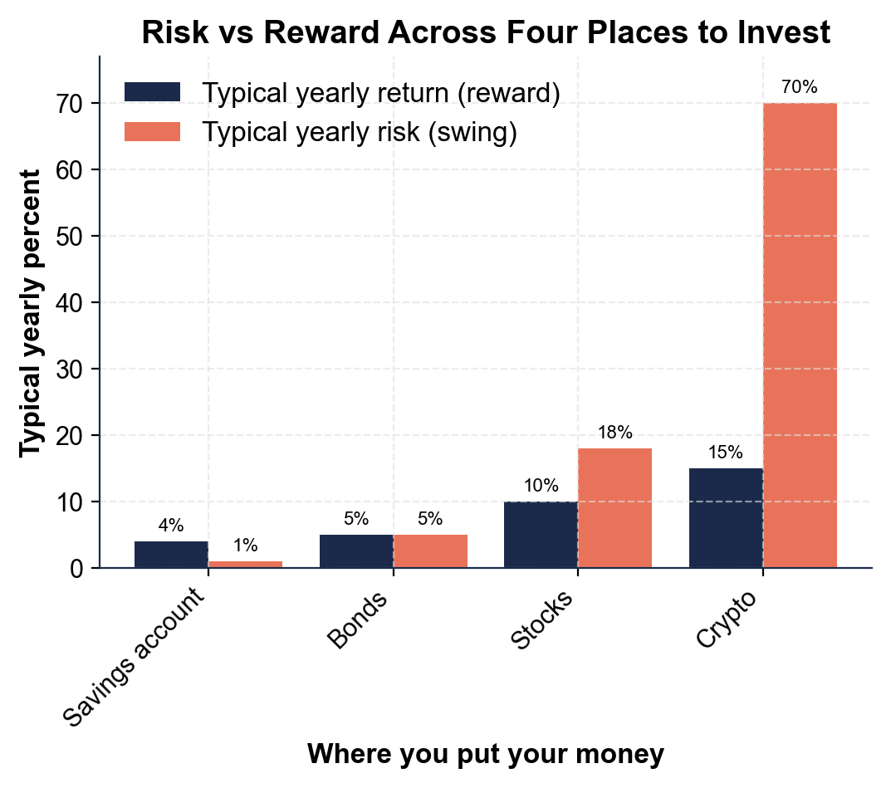
(a) a savings account
(b) crypto.
(1) A savings account has a typical yearly return of about 4%. (2) Crypto has a typical yearly return of about 15%. Accept 4% for savings and 15% for crypto.
2. As you help Devin Carter, use the same chart to read the RISK (swing) percent for each choice:
(a) a savings account
(b) bonds
(c) stocks
(d) crypto.
(1) Savings account risk is about 1%. (2) Bonds risk is about 5%. (3) Stocks risk is about 18%. (4) Crypto risk is about 70% - by far the biggest swing on the chart. Accept about 1%, 5%, 18%, and 70%.
3. As you help Devin Carter, compare the two bars as you move from the safest choice (savings) to the riskiest (crypto).
(a) Does the RETURN bar go up or down?
(b) Does the RISK bar go up or down?
(c) In one sentence, which bar climbs FASTER - return or risk?
(1) The RETURN bar goes UP (from about 4% to about 15%). (2) The RISK bar also goes UP (from about 1% to about 70%). (3) The RISK bar climbs FASTER - the return only about 3.75 times higher (4% to 15%) while the risk is 70 times higher (1% to 70%). Accept: both go up, and risk climbs faster than return.
4. As you help Devin Carter, look at the overall pattern. In one or two sentences, explain what the chart shows about risk and reward across the four choices. Start your answer with: "The chart shows that..."
The chart shows that as you move from a savings account to crypto, the possible return rises a little (from about 4% to about 15%) but the risk rises far more (from about 1% to about 70%), so a higher possible reward always comes paired with much higher risk - the risk/reward…

PART 4

The Tradeoff and Diversification - Analyze Why You Can't Win Without Risk
1. As you help Devin Carter, explain the RISK/REWARD TRADEOFF in your own words.
(a) What happens to the possible reward as an investment gets riskier?
(b) Why can Devin NOT get a high return with no risk?
(c) Does that mean Devin should avoid all risk? Explain.
(1) As an investment gets riskier, the possible reward goes UP - higher risk comes with higher possible reward (and higher possible loss). (2) Devin cannot get a high return with no risk because the only way to take almost no risk is to accept almost no return - safe places like savings barely grow. (3) No - avoiding all risk earns almost nothing (and can even lose to inflation), so Devin should MANAGE risk, not avoid it. Accept: reward rises with risk, no-risk means no-reward, and Devin should manage risk rather than avoid it.
2. As you help Devin Carter, work the diversification example. Devin puts ALL $1,000 into ONE investment, and it drops 50%.
(a) What is the investment worth after the drop?
(b) How many dollars did Devin lose? Show your math.
(1) After a 50% drop, $1,000 falls to $1,000 x (1 - 0.50) = $500. (2) The loss is $1,000 - $500 = $500. Accept $500 remaining and a $500 loss.
3. As you help Devin Carter, work the OTHER case. Devin instead splits the $1,000 across 10 different investments ($100 each), and only ONE of them drops 50%.
(a) What is that one investment worth after the drop?
(b) How many dollars did Devin lose?
(c) How much of the $1,000 is untouched? Show your math.
(1) That one $100 investment falls to $100 x (1 - 0.50) = $50. (2) The loss is $100 - $50 = $50. (3) The other 9 investments are untouched: $1,000 - $100 = $900 is safe. Accept $50 remaining in that investment, a $50 loss, and $900 untouched.
4. As you help Devin Carter, compare the two cases from Q2 and Q3.
(a) In the all-in-one case, how much did Devin lose?
(b) In the diversified case, how much did Devin lose?
(c) By how many dollars did diversification cut the loss? Show your math.
(1) All-in-one loss: $500. (2) Diversified loss: $50. (3) Diversification cut the loss by $500 - $50 = $450. Same bad event (one investment drops 50%), but spreading the money cut the loss from $500 down to $50. Accept $500, $50, and a $450 smaller loss.
5. As you help Devin Carter, put it together.
(a) In one sentence, explain how diversification lowered Devin's risk in this example.
(b) Does diversification make Devin give up the chance at a good return?
(c) Name one easy way Devin can diversify with a single purchase.
(1) Diversification lowered risk because Devin's money was spread across 10 investments, so when one dropped 50% it only cost $50 instead of $500 - no single investment could wreck the whole plan. (2) No - diversification lowers risk WITHOUT giving up much expected return, because Devin still owns higher-reward assets like stocks, just many of them. (3) An index fund is an easy way to diversify with a single purchase (it owns hundreds of companies at once). Accept: spreading money limited the loss, it does not cost much return, and an index fund diversifies in one purchase.

PART 5

Time Horizon, Risk Tolerance, and Your Recommendation
1. As you help Devin Carter, reason about TIME HORIZON. Devin is 24 and retirement is 40+ years away.
(a) Is that a long or a short time horizon?
It is a LONG time horizon (40+ years until the money is needed for retirement).
(b) Does a long horizon let Devin take MORE or LESS risk, and why?
A long horizon lets Devin take MORE risk, because there is time to ride out the swings and recover from any drop before the money is actually needed.
(c) Where should Devin put money that is needed next month for rent, and why?
Money needed next month for rent should go somewhere SAFE and low-volatility, like a savings account, because there is no time to recover if the market drops right before rent is due.
2. As you help Devin Carter, reason about RISK TOLERANCE.
(a) What does risk tolerance mean?
RISK TOLERANCE is how much risk - how big a swing or possible loss - Devin can handle, financially and emotionally, without panic-selling.
(b) Name the two sides of it - the money side and the feelings side.
The money side (ability): could Devin afford the loss, or is the money needed soon? The feelings side (willingness): would a big drop make Devin panic and sell?
(c) Why is it a mistake for Devin to pick MORE risk than Devin can actually handle?
Picking more risk than Devin can handle is a mistake because the moment the market drops, Devin panic-sells at a low and locks in the loss - a risk level you can STICK WITH and hold through a downturn beats a bold one you bail on.
3. As you help Devin Carter, give practical advice for the $1,000. Devin has a long horizon and wants the money to grow.
(a) Should Devin keep all $1,000 in a savings account? Why or why not?
No - keeping all $1,000 in a savings account earns almost nothing (about 4%) and can even lose buying power to inflation, and with a 40-year horizon Devin can afford more risk for more growth.
(b) How can Devin take on higher-reward investing while still lowering risk?
Devin can invest in higher-reward assets like stocks but DIVERSIFY - for example, buy a diversified index fund - so no single investment can wreck the plan; that takes on reward while lowering risk.
(c) Name one thing Devin should NOT do.
Accept any sound answer: do NOT put all $1,000 in one investment, do NOT put it all in crypto (too volatile), do NOT pick more risk than Devin can hold, do NOT panic-sell in a downturn.
FINAL RECOMMENDATION
4. FINAL RECOMMENDATION. Devin asks you to put it in writing. Write a 5-7 sentence note (120-180 words) telling Devin what the risk/reward tradeoff means, how time horizon and risk tolerance should shape the decision, and how to use diversification. Check off each required element as you include it.
YOUR RESPONSE MUST:
☐ EXPLAIN THE RISK/REWARD TRADEOFF - state in your own words that a higher possible reward always comes with higher risk, so you cannot win without risk and the safest choices earn the least.
☐ USE A CHART NUMBER - name at least one return or risk percent you read off the chart in Part 3 (for example, crypto's 15% return and 70% risk, or savings' 4% return and 1% risk).
☐ USE THE DIVERSIFICATION RESULT - state the numbers you calculated in Part 4 (all $1,000 in one investment that drops 50% loses $500, but split across 10 the same drop loses only $50).
☐ APPLY TIME HORIZON AND RISK TOLERANCE - explain that Devin's long time horizon (40+ years) allows more risk, and that Devin should pick a risk level he can stick with without panic-selling.
☐ GIVE A CLEAR RECOMMENDATION - tell Devin how to invest the $1,000 (for example, a diversified index fund for long-term money, savings for money needed soon) and name one thing to avoid.
GRADING RUBRIC
Grade the evidence and reasoning, not the conclusion — any defensible position is valid. Score against the 5 requirements above.
FULL CREDIT — clear position; meets all 5 requirements with accurate, specific numbers and evidence from the lesson.
PARTIAL — position stated, but misses 1-2 requirements or uses vague / incorrect numbers.
MINIMAL — no clear position, or missing most requirements and numbers.

MORE LESSONS LESS PLANNING
Thank You!
If you enjoyed this product, please do not forget to rate and review to assist other teachers.

Looking for future discounts? Earn TPT credits by reviewing purchased products.

Please contact me if you have any issues with this product. Just like our students, I am always looking for opportunities to grow.

