Renting Your First Apartment - Leases, Deposits & Roommates
STUDENT ACTIVITY
Name: | Date: | Period:
ESSENTIAL QUESTION
How do you read a lease and identify the costs and obligations of renting - the rent, the security deposit, the fees, and the term - and how does a first-time renter calculate the up-front move-in cost and split the rent and deposit with a roommate?
THE SCENARIO
You are JORDAN LEE, a renting advisor at a community housing center who helps first-time renters read a lease and budget to move in. SAM just got a job and wants to rent a first apartment with a roommate, but has never signed a lease: 'How much does it really cost to move in, and what am I signing up for?' Your job is to teach Sam how to read a lease, add up the true up-front cost, protect the security deposit, and split the costs with a roommate.
BY THE END, YOU CAN:
✓ Read a residential lease and identify its key terms: monthly rent, lease term, security deposit, late fee, and tenant obligations
✓ Calculate the up-front cost of moving in using a labeled model (move-in cost = first month's rent + security deposit + application fee)
✓ Explain the purpose of a security deposit and the conditions under which a tenant does or does not get it back
✓ Split rent and a shared security deposit among roommates and explain the risks of a shared (joint) lease
HOW IT WORKS (do Parts 1–5 in order)
Part 1 — Renting Reference Guide - Complete the Missing Terms
Part 2 — Apply the Terms - Renting Vocabulary in Context
Part 3 — Calculate Move-In Cost and the Roommate Split - Use the Labeled Models
Part 4 — Read the Sample Residential Lease - Pull the Terms and Do the Move-In Math
Part 5 — Advise a First-Time Renter - Help Sam Rent on Purpose
TIME about 45 minutes YOU’LL NEED the lesson slides and your Guided Notes.

PART 1

Renting Reference Guide - Complete the Missing Terms
Fill in the missing term for each blank row — the definition is your clue. Your Guided Notes and the lesson slides have every term.

Term | Definition
___________ | A binding contract between a landlord and tenant that sets the rent, term, and rules for renting a home
Rental application | A form a landlord uses to check your income, rental history, and credit before renting to you
___________ | Money paid up front that the landlord holds and returns if you leave the place undamaged
Credit check | A review of your credit report a landlord runs to decide whether to approve your application
___________ | The total up-front money to move in: first month's rent plus the security deposit plus any fees
Lease term | The length of time the lease lasts, such as 12 months, during which the rent is locked in
___________ | A lease all roommates sign together, making each person responsible for the whole rent
Late fee | An extra charge the lease adds when rent is paid after the due date or grace period
___________ | People who share a rented home and split the rent, deposit, and household costs
Tenant rights | Legal protections a renter has, such as a habitable home and the return of a fair deposit

PART 2

Apply the Terms - Renting Vocabulary in Context
WORD BANK lease · move-in cost · roommates · joint lease · security deposit
1. The binding contract between a landlord and tenant that sets the rent, term, and rules for renting a home is a .

2. The money you pay up front that the landlord holds and returns if you leave the place undamaged is the .

3. The total up-front money to move in - first month's rent plus the security deposit plus any fees - is the .

4. A lease all roommates sign together, which makes each person responsible for the whole rent, is a .

5. People who share a rented home and split the rent, deposit, and household costs are .

PART 3

Calculate Move-In Cost and the Roommate Split - Use the Labeled Models
1. As Jordan Lee, work Sam's move-in cost alone (renting solo). The sample lease has monthly rent $1,200, a security deposit of $1,200, and a $50 application fee.
(a) Using MOVE-IN COST = first month's rent + security deposit + application fee, how much cash does Sam need to move in? Show your addition.

(b) In one sentence, explain to Sam why this is so much more than one month's rent.

2. As Jordan Lee, work the ROOMMATE SPLIT. Sam decides to rent the same $1,200/month apartment with one roommate (2 people total) on a joint lease; the security deposit is $1,200.
(a) Using ROOMMATE SPLIT = total monthly rent / number of roommates, what is each person's share of the monthly rent?

(b) What is each person's share of the $1,200 security deposit? Show your division for both.

3. As Jordan Lee, show Sam how much cheaper it is to move in with a roommate. Use your answers from A3-Q1 and A3-Q2.
(a) The total move-in cost is $2,450. Split two ways, how much does EACH roommate pay to move in? Show your division.

(b) How much LESS is each roommate's move-in share than the $2,450 Sam would pay renting solo? Show your subtraction.

(c) In one sentence, explain the tradeoff of splitting with a roommate.

PART 4

Read the Sample Residential Lease - Pull the Terms and Do the Move-In Math
As Jordan Lee, study the Sample Residential Lease shown on this page. It puts every lease term on one document - the monthly rent, the security deposit, the application fee, the late fee, the lease term, and Sam's obligations (pay rent on time, keep the unit clean and undamaged, and do not sublet without the landlord's approval). The same values are listed in the reference table below so you can read them clearly. Use the lease and the table to answer A4-Q1 to A4-Q3, then connect the terms to Sam's agreement in A4-Q4.
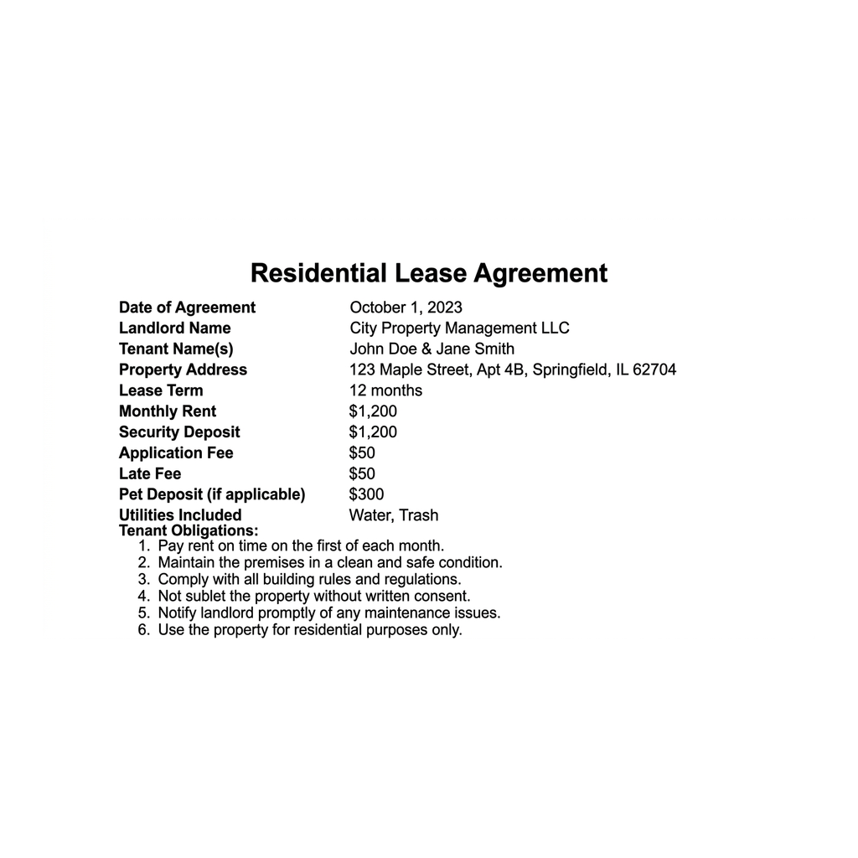

Lease field | Value
Monthly rent | $1,200
Security deposit | $1,200
Application fee | $50
Late fee | $50
Lease term | 12 months

Analysis
1. A4-Q1. As Jordan Lee, study the Sample Residential Lease shown on this page. Read the lease and write each value: (a) the monthly rent, (b) the security deposit, (c) the application fee, (d) the late fee, and (e) the lease term.

2. A4-Q2. As Jordan Lee, use the values from the Sample Residential Lease to compute Sam's move-in cost. (a) Using MOVE-IN COST = first month's rent + security deposit + application fee, add the rent, deposit, and application fee off the lease. Show your addition. (b) In one sentence, tell Sam how the move-in cost compares to the $1,200 monthly rent.

3. A4-Q3. As Jordan Lee, use the same lease to plan for a roommate. Sam will split this $1,200/month apartment with one roommate (2 people). (a) Using ROOMMATE SPLIT = total monthly rent / number of roommates, what is each person's monthly rent share? (b) In one sentence, warn Sam what a JOINT LEASE means if the roommate stops paying.

4. A4-Q4. As Jordan Lee, connect the lease terms to what Sam is agreeing to. (a) The $1,200 security deposit on the lease is money the landlord does what with - holds and returns, or keeps for good? (b) Name one thing on this lease that Sam owes if the rent is paid late. (c) In one sentence, name one obligation the lease puts on Sam as the tenant.

PART 5

Advise a First-Time Renter - Help Sam Rent on Purpose
1. As Jordan Lee, answer Sam's first question: 'What is a lease, and what do I need to read on it before I sign?'
(a) In one to two sentences, explain what a lease is and why signing it matters.

(b) In one sentence, name at least four things Sam must find and read on the lease before signing.

2. As Jordan Lee, walk Sam through the money. The lease has $1,200 rent, a $1,200 deposit, and a $50 application fee.
(a) Use MOVE-IN COST to tell Sam how much cash it takes to move in solo, naming the model.

(b) Then Sam asks what it costs with one roommate - use ROOMMATE SPLIT to give each person's rent share and each person's move-in share.

(c) In one sentence, explain how the security deposit can come back to Sam.

3. As Jordan Lee, help Sam decide about a roommate and a joint lease.
(a) In one to two sentences, explain the upside of renting with a roommate, using the numbers.

(b) In one sentence, warn Sam about the risk of a joint lease and give one way to reduce that risk.

FINAL RENTING ADVICE FOR SAM
4. FINAL RENTING ADVICE FOR SAM. As Jordan Lee, put your advice in writing for Sam. Write a 5-7 sentence explanation (120-180 words) that explains what a lease is and names the key terms Sam must read, uses MOVE-IN COST to work the up-front cost off the sample lease ($1,200 + $1,200 + $50 = $2,450), uses ROOMMATE SPLIT to show the two-roommate rent share ($600 each) and move-in share ($1,225 each), explains how Sam gets the security deposit back, and warns Sam about the joint-lease risk. Check off each required element as you include it.
YOUR RESPONSE MUST:
☐ EXPLAIN THE LEASE - a lease is a binding contract that sets the rent, lease term, security deposit, fees, and obligations; read every term before signing because it is binding.
☐ USE MOVE-IN COST - show MOVE-IN COST = first month's rent + security deposit + application fee = $1,200 + $1,200 + $50 = $2,450 to move in solo.
☐ USE ROOMMATE SPLIT - show the rent splits $1,200 / 2 = $600 each and the move-in cost splits $2,450 / 2 = $1,225 each with one roommate.
☐ EXPLAIN THE SECURITY DEPOSIT - the $1,200 deposit comes back if Sam leaves the place clean and undamaged, pays all rent, and gives proper notice.
☐ WARN ABOUT THE JOINT LEASE - on a joint lease each roommate is responsible for the WHOLE rent, so Sam owes it all if the roommate stops paying.

